Go to <https://webtools.verizon.com/Request/Applications/ADOM/AccessRequest.aspx?Domain=USWIN&ObjectName=SDLC_HQDV_JIRA_USERS>

Raise request

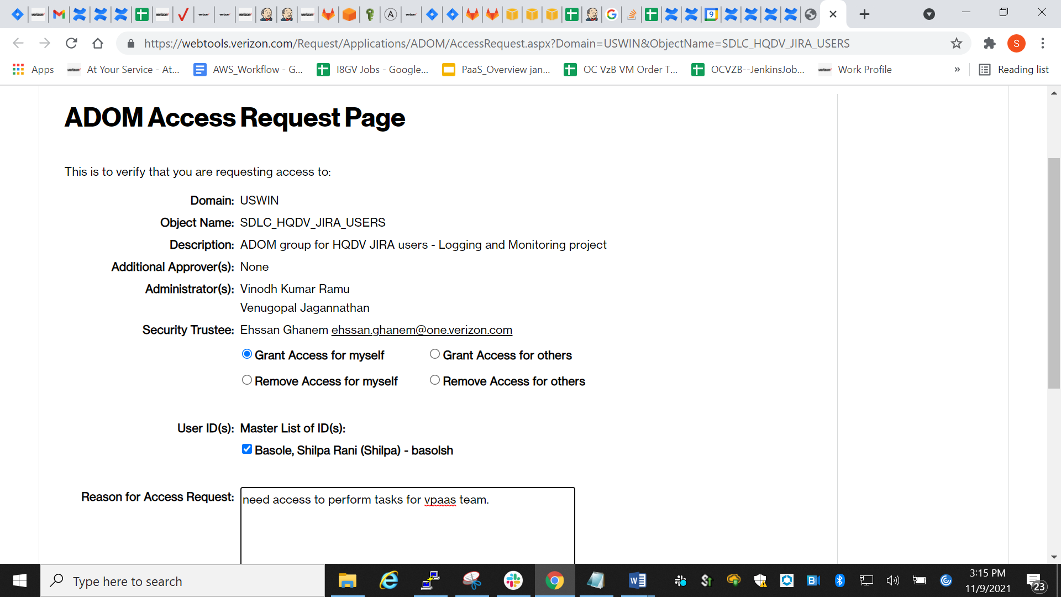

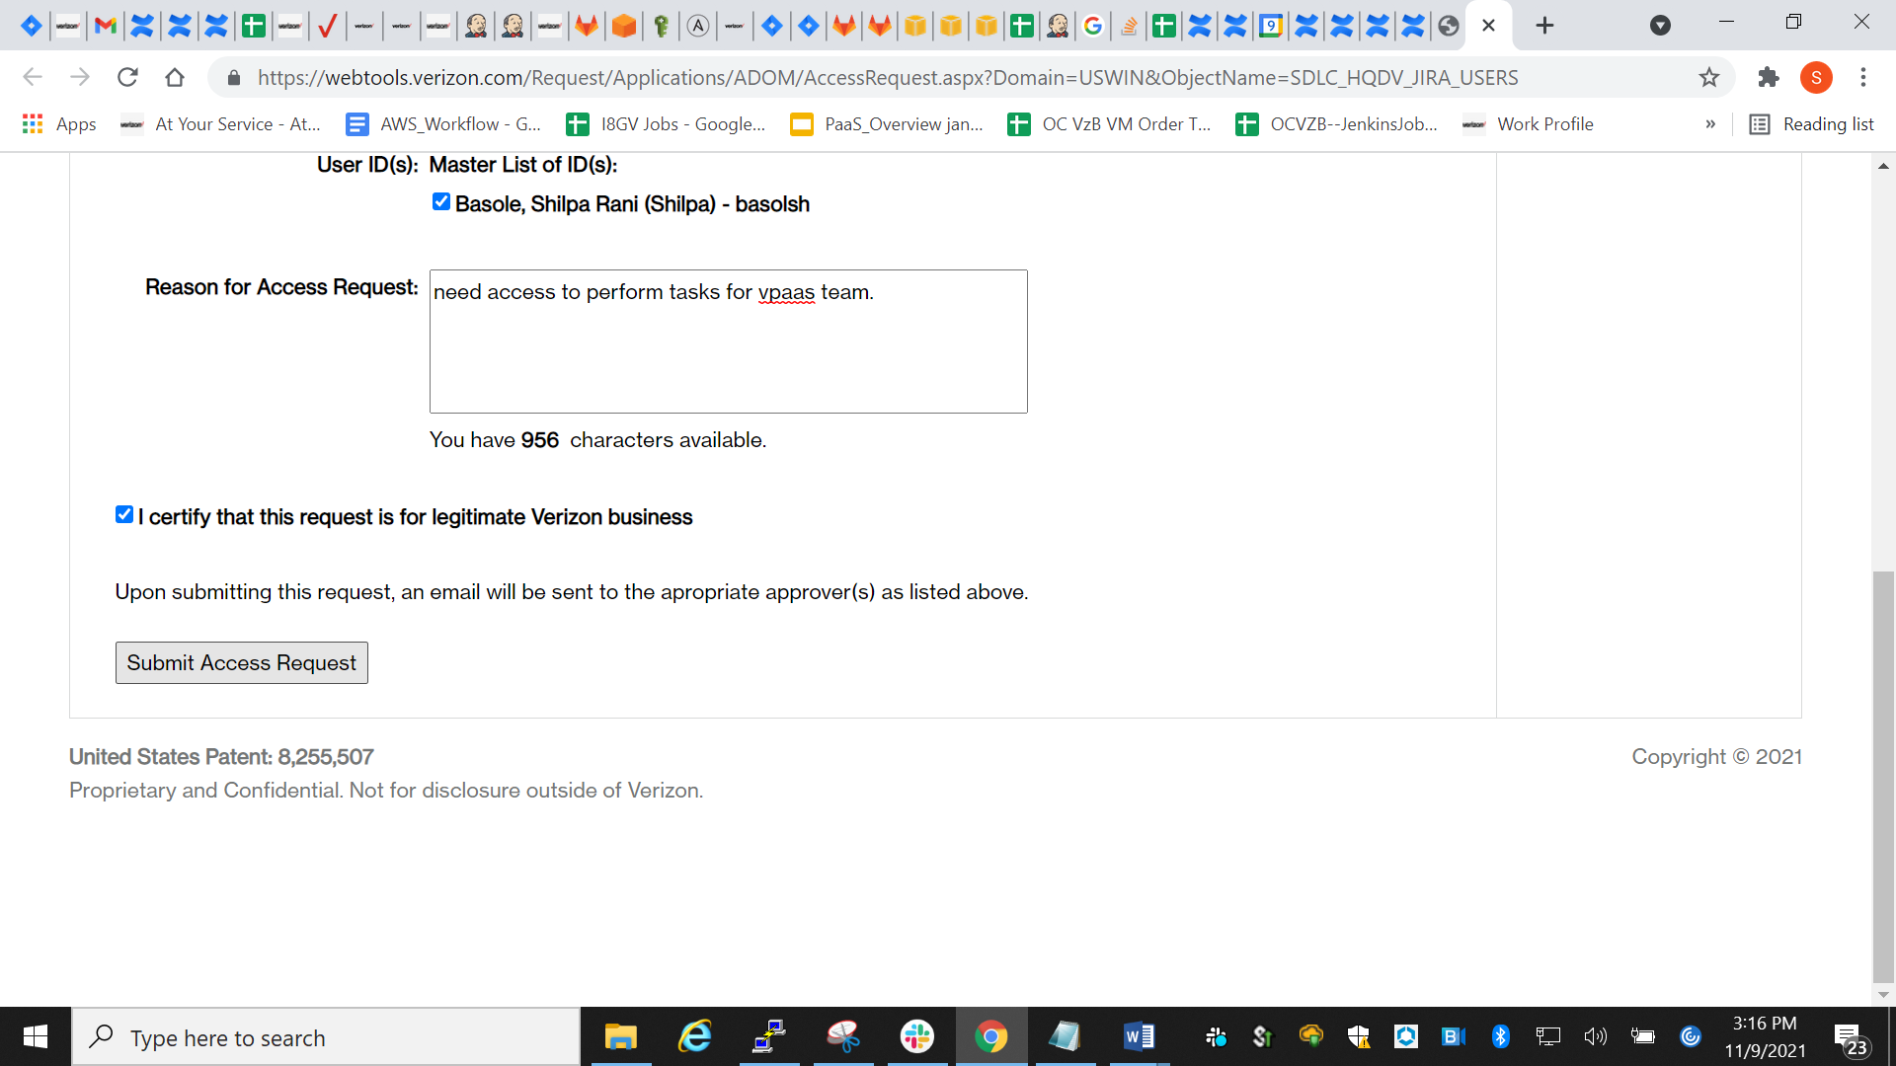  
click submit access request.

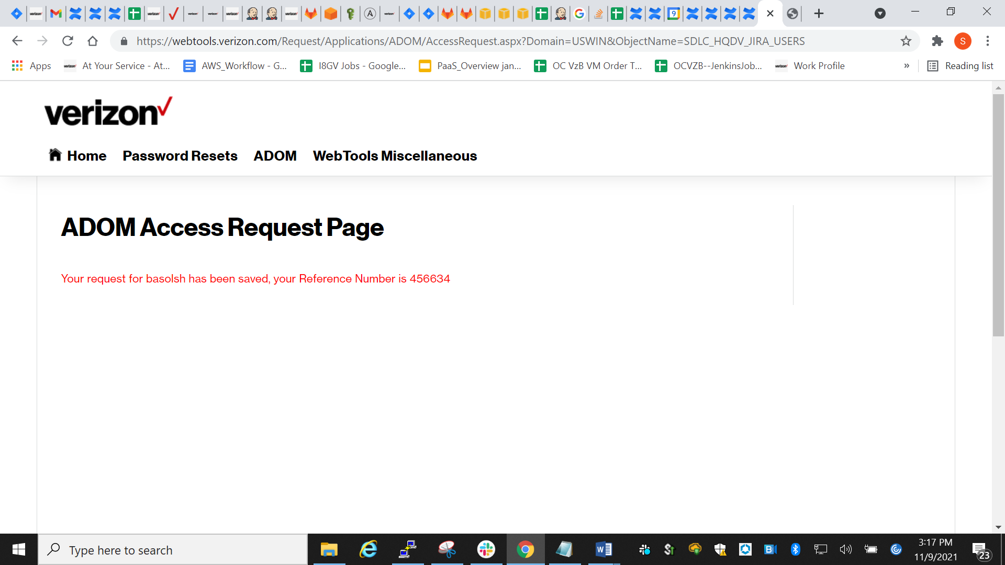

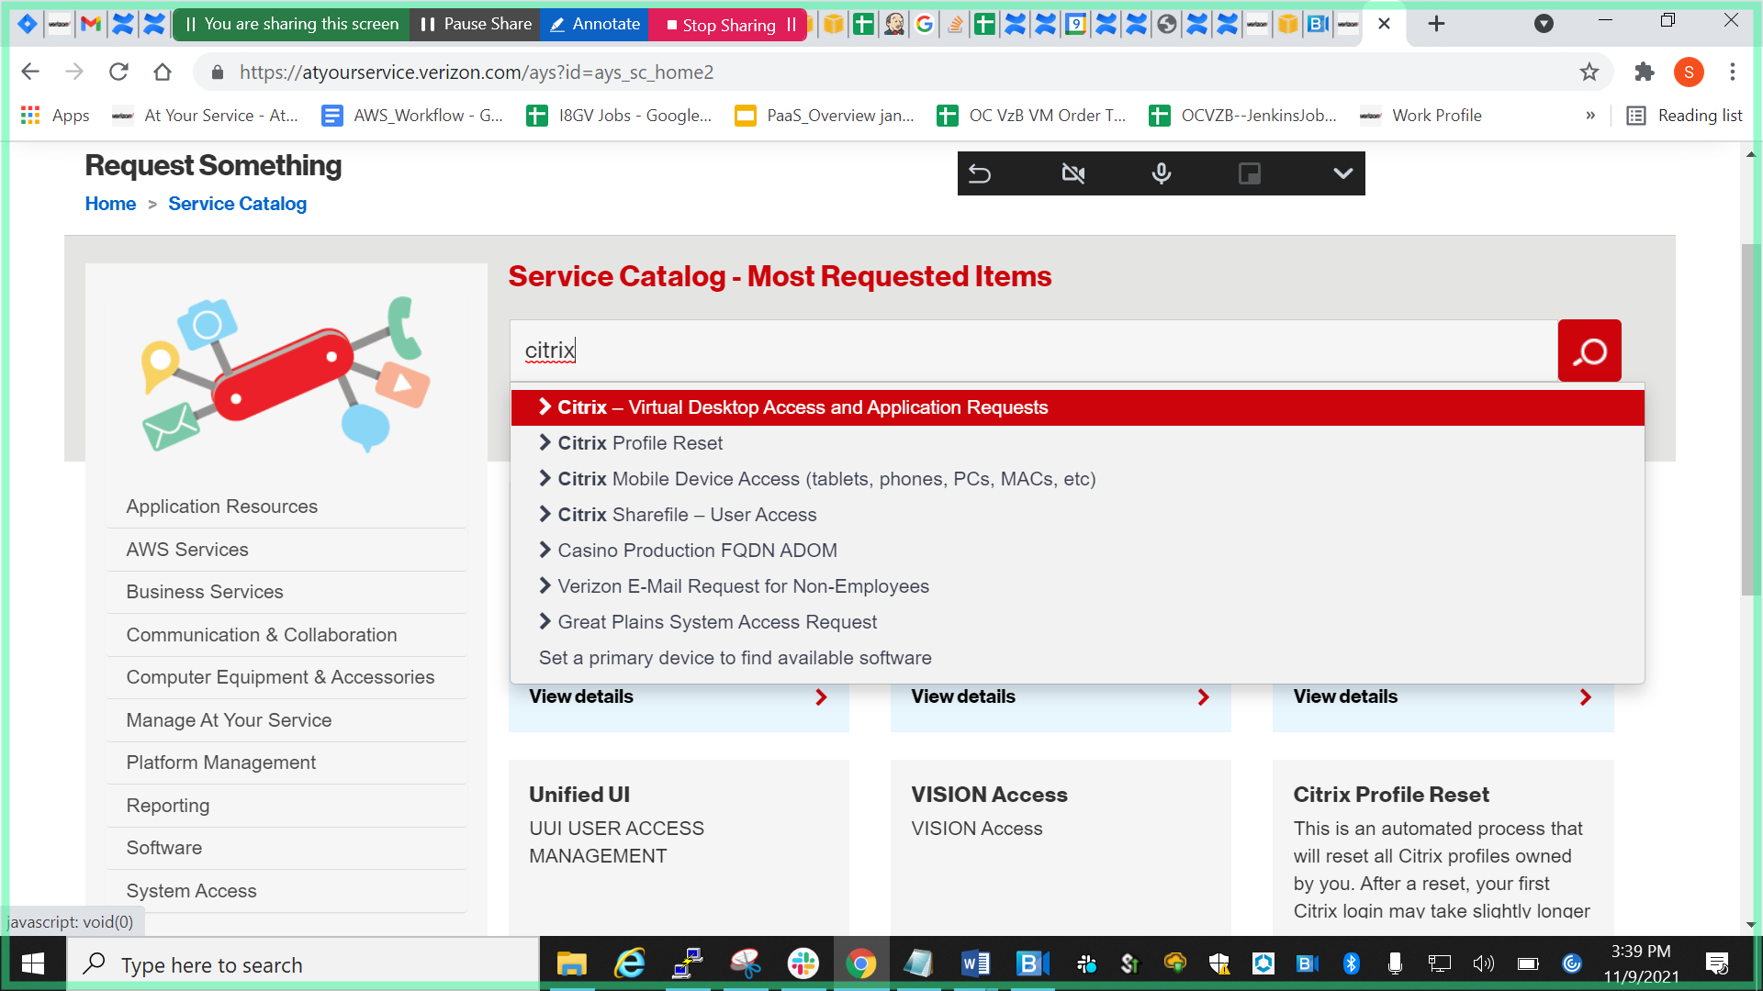

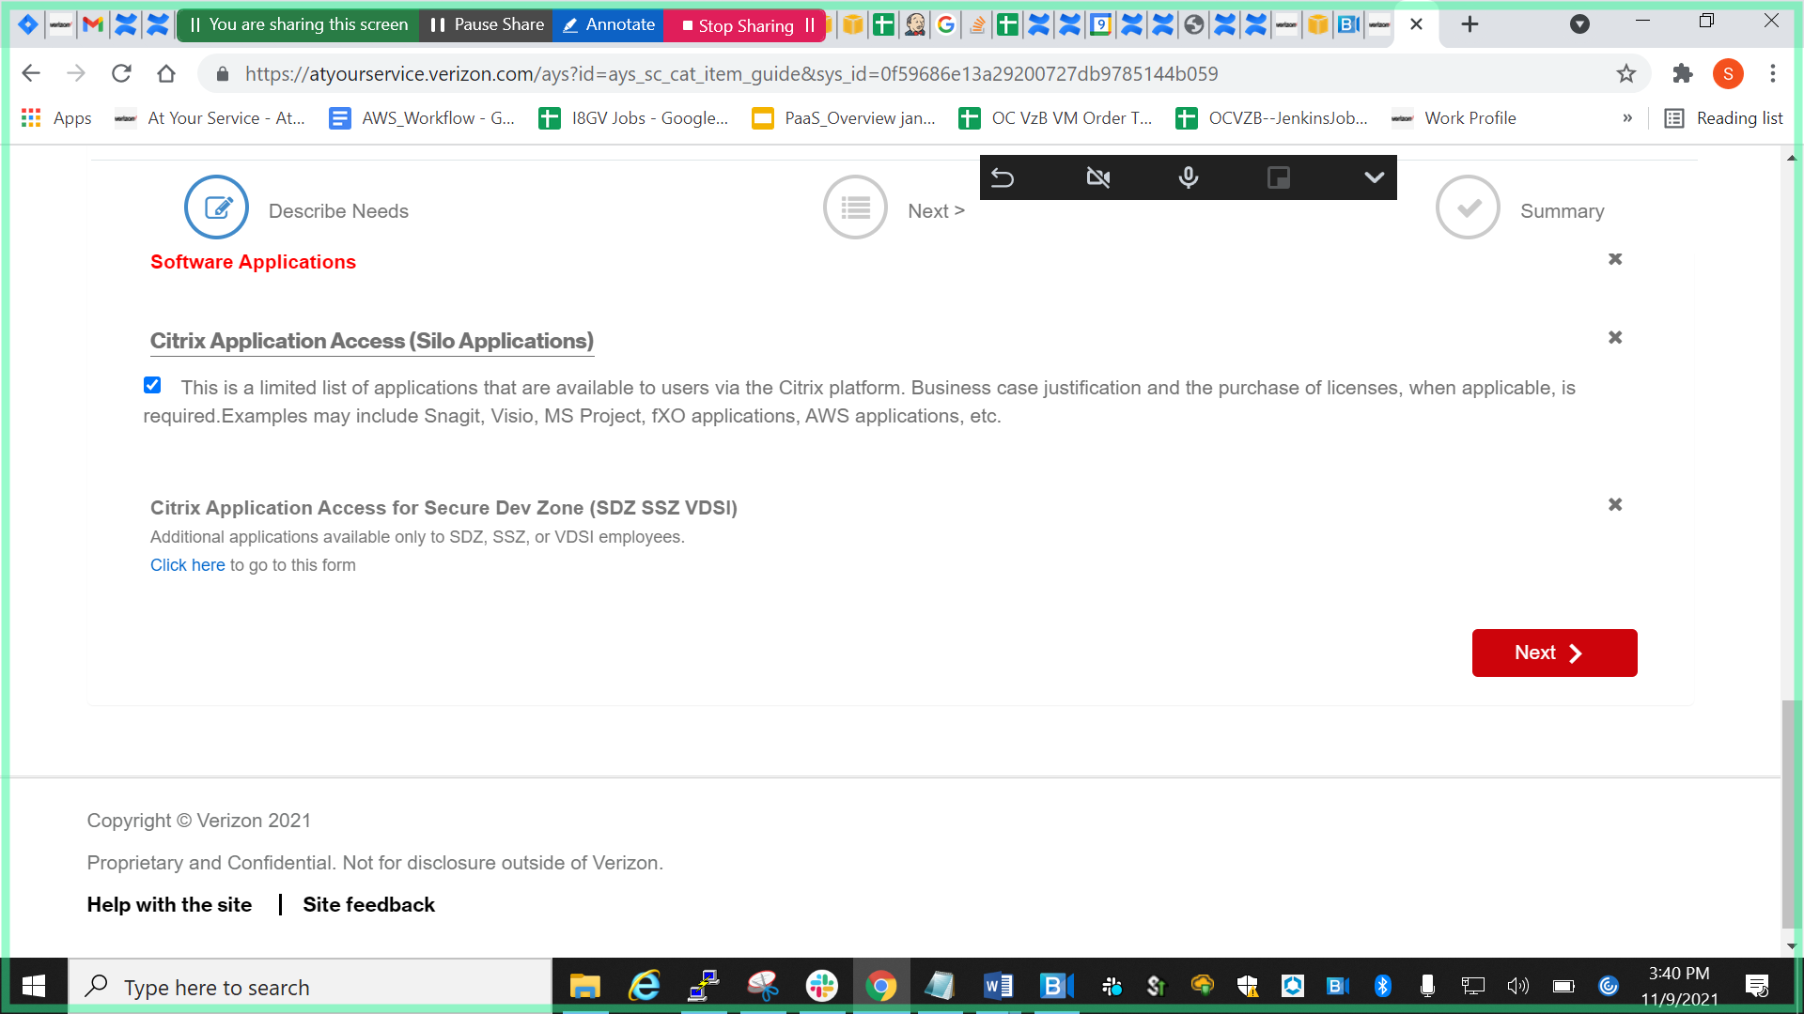

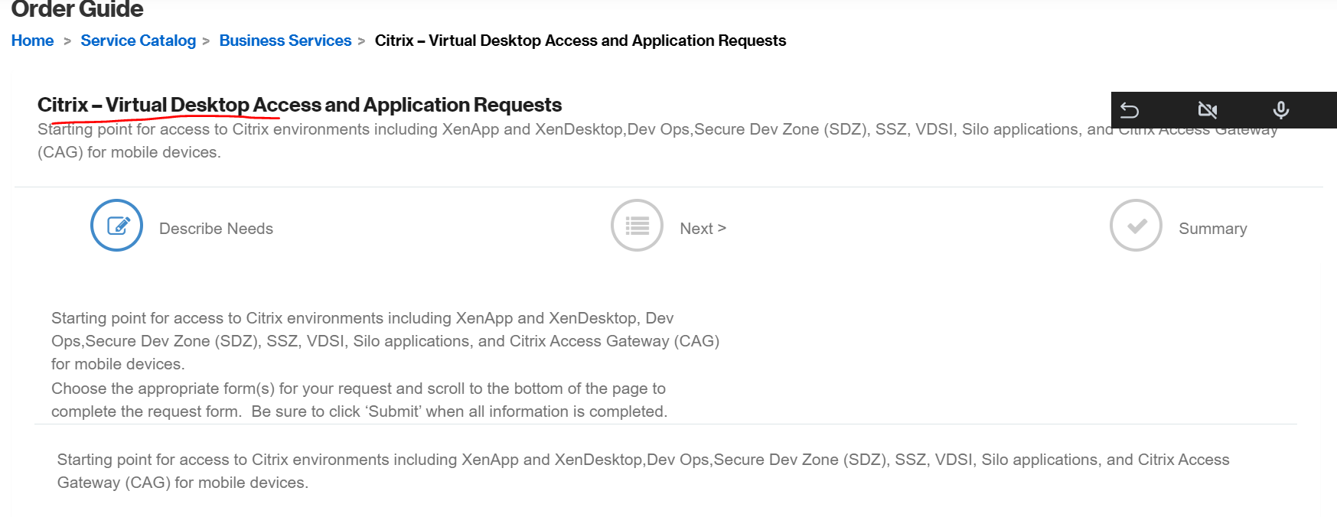

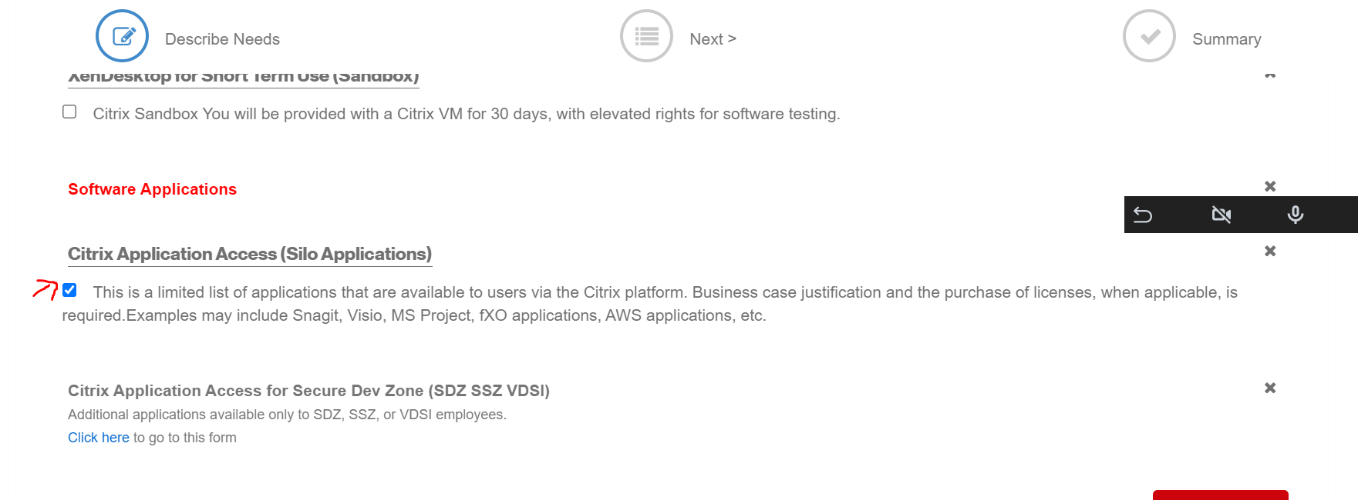

Click next and following page will appear

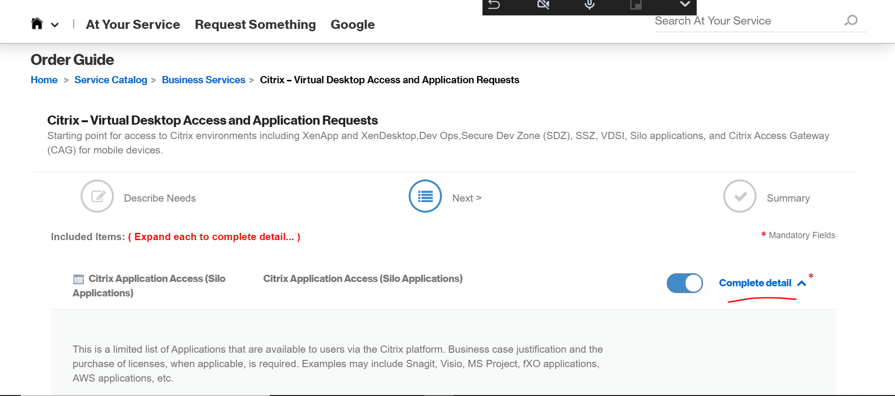

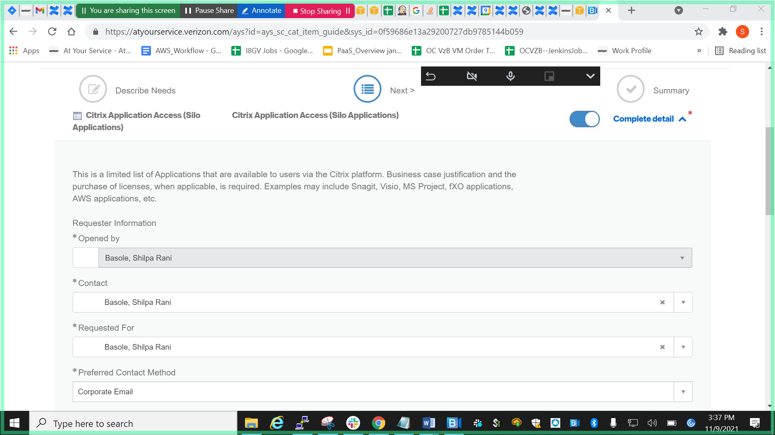

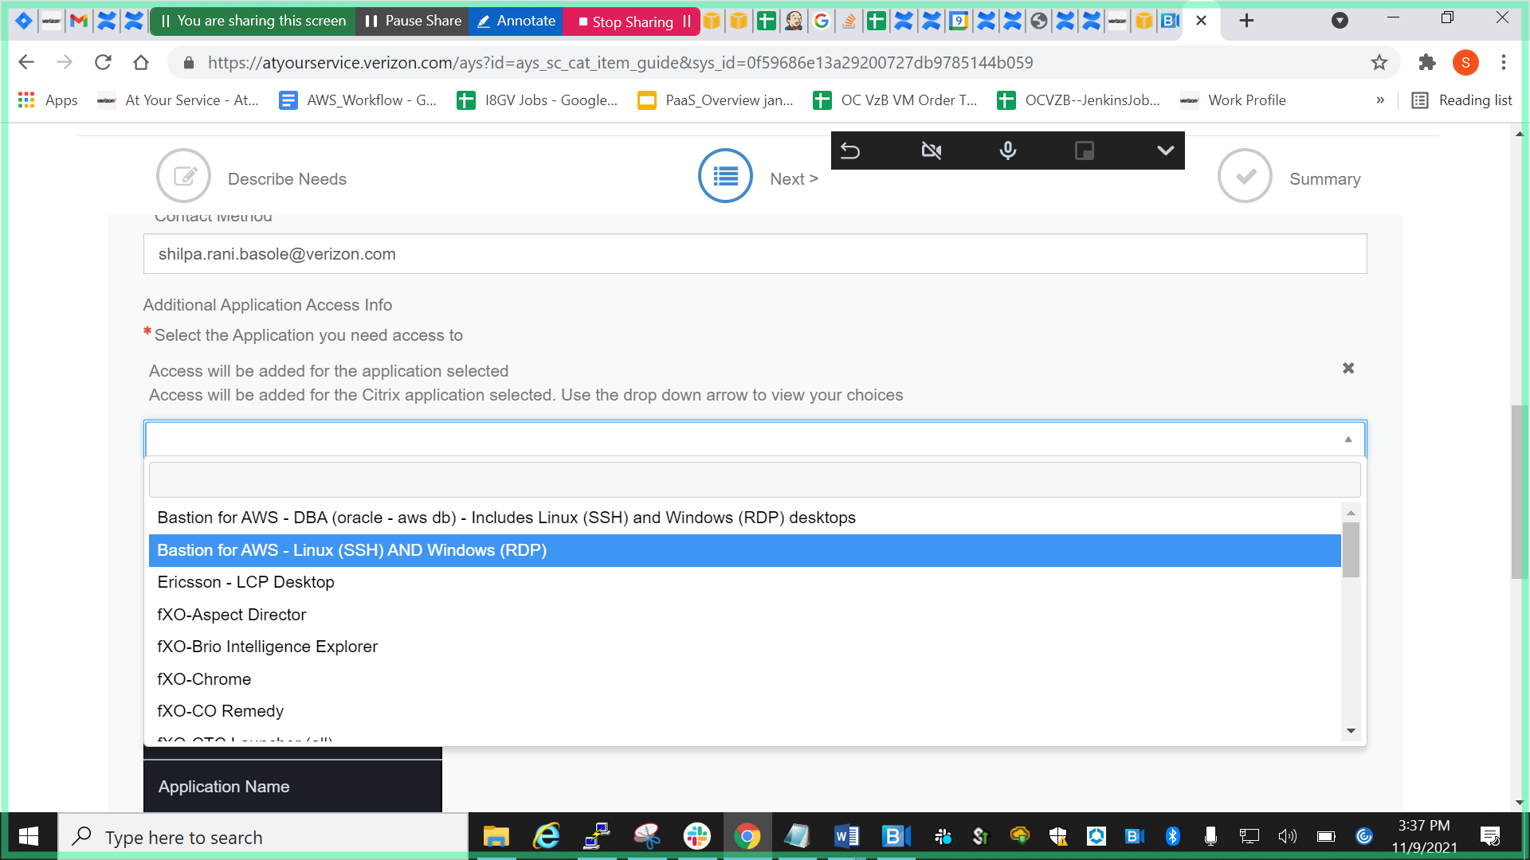

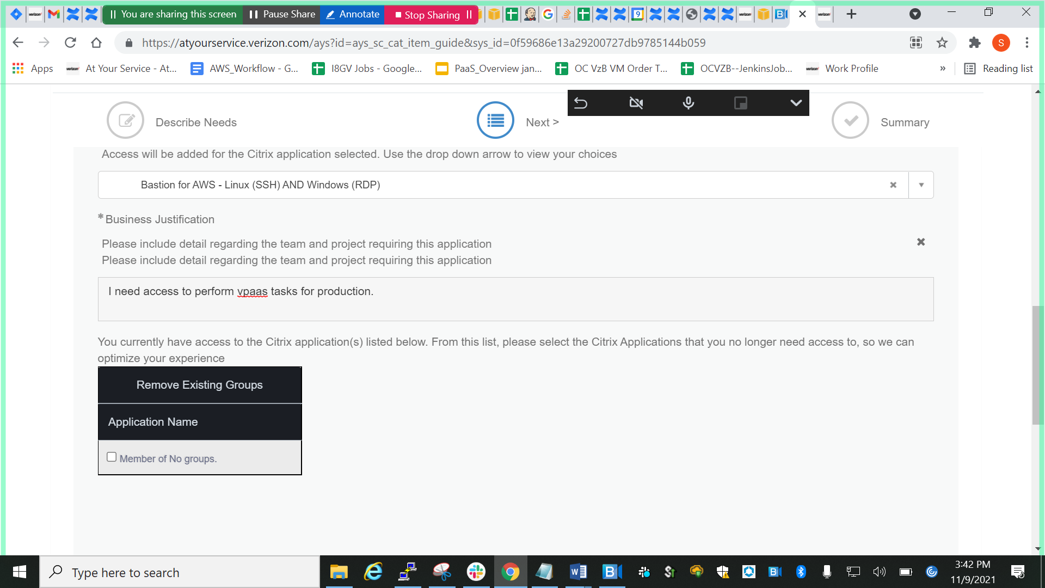

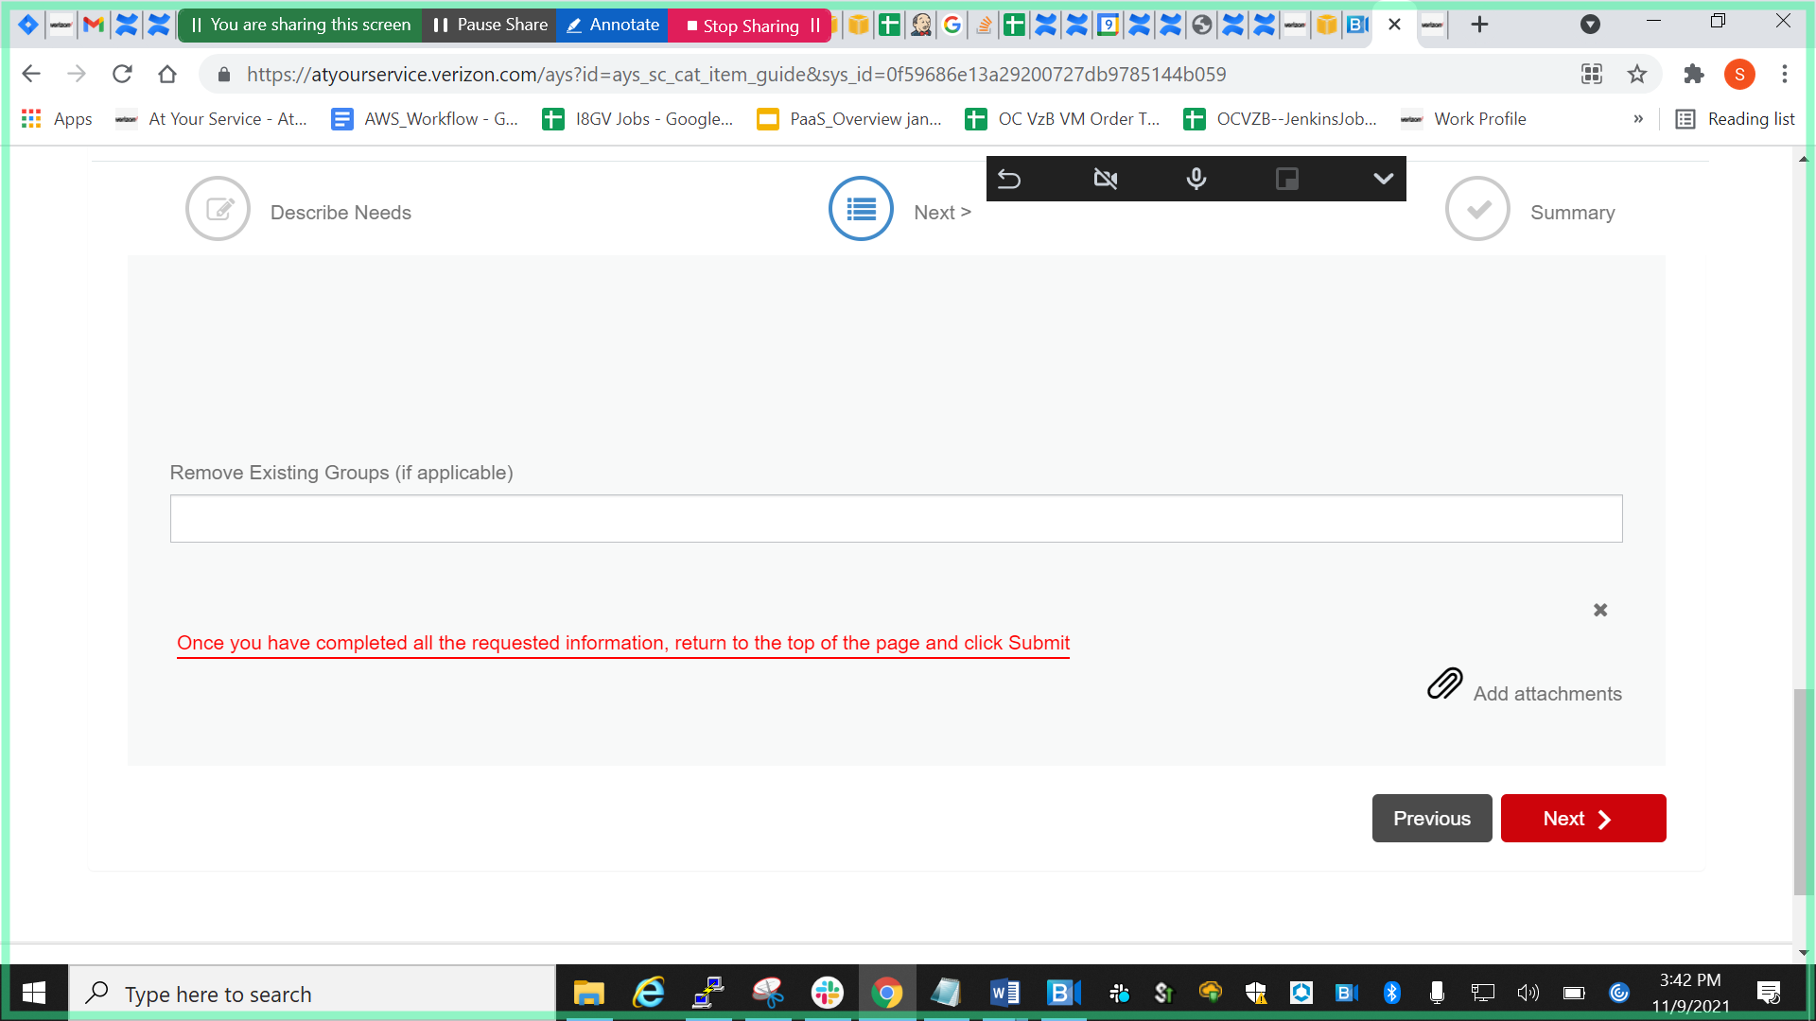

Click next

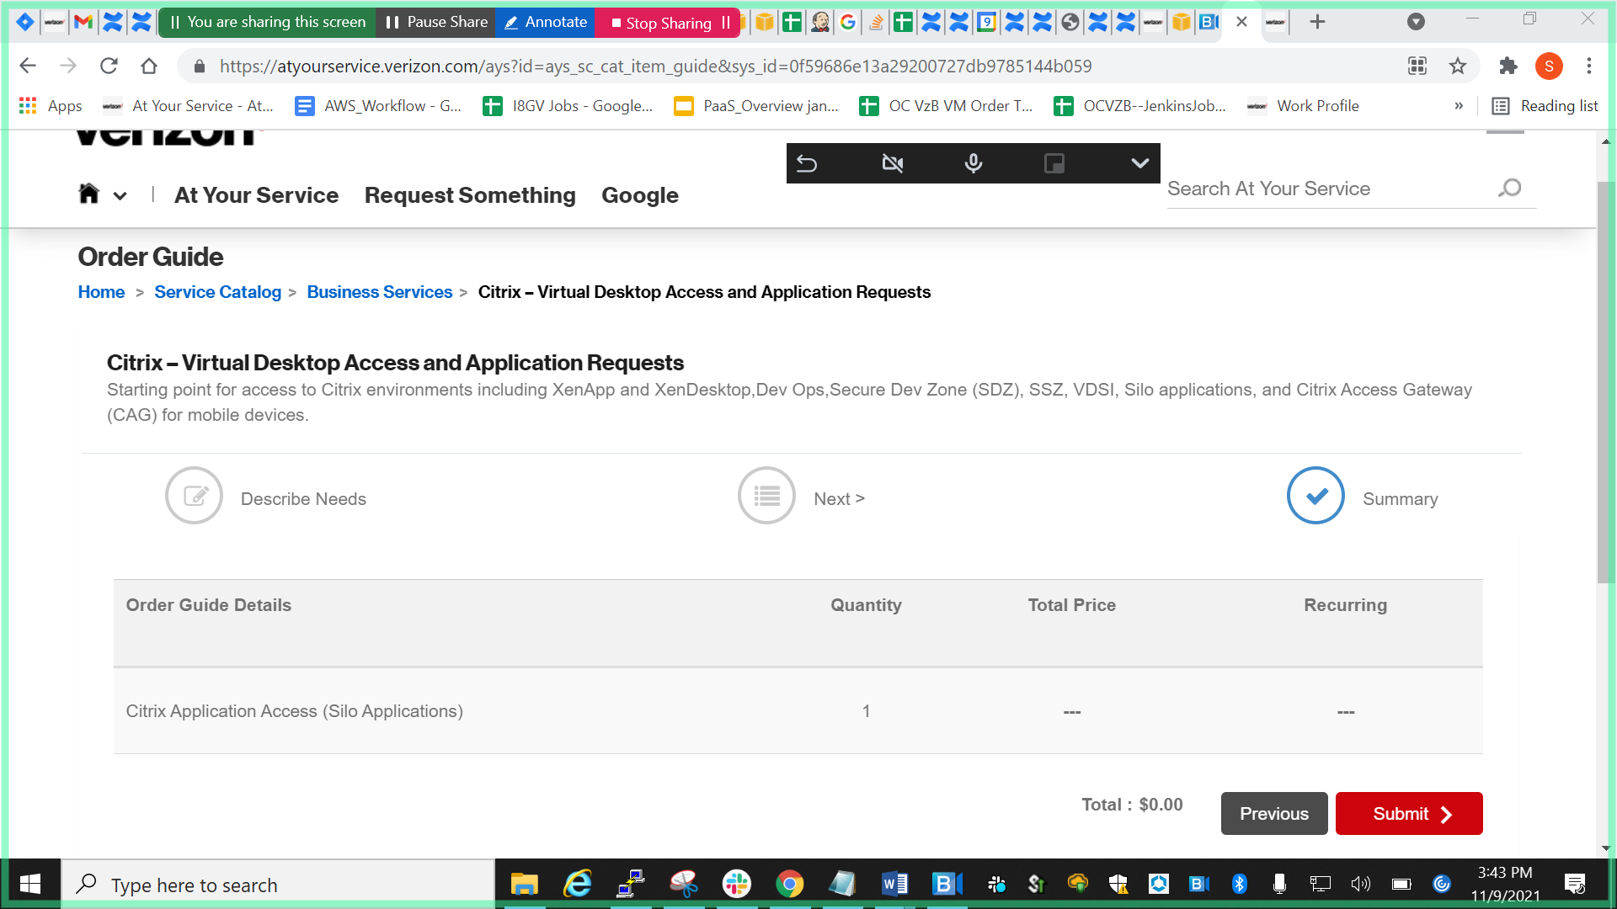

Click submit

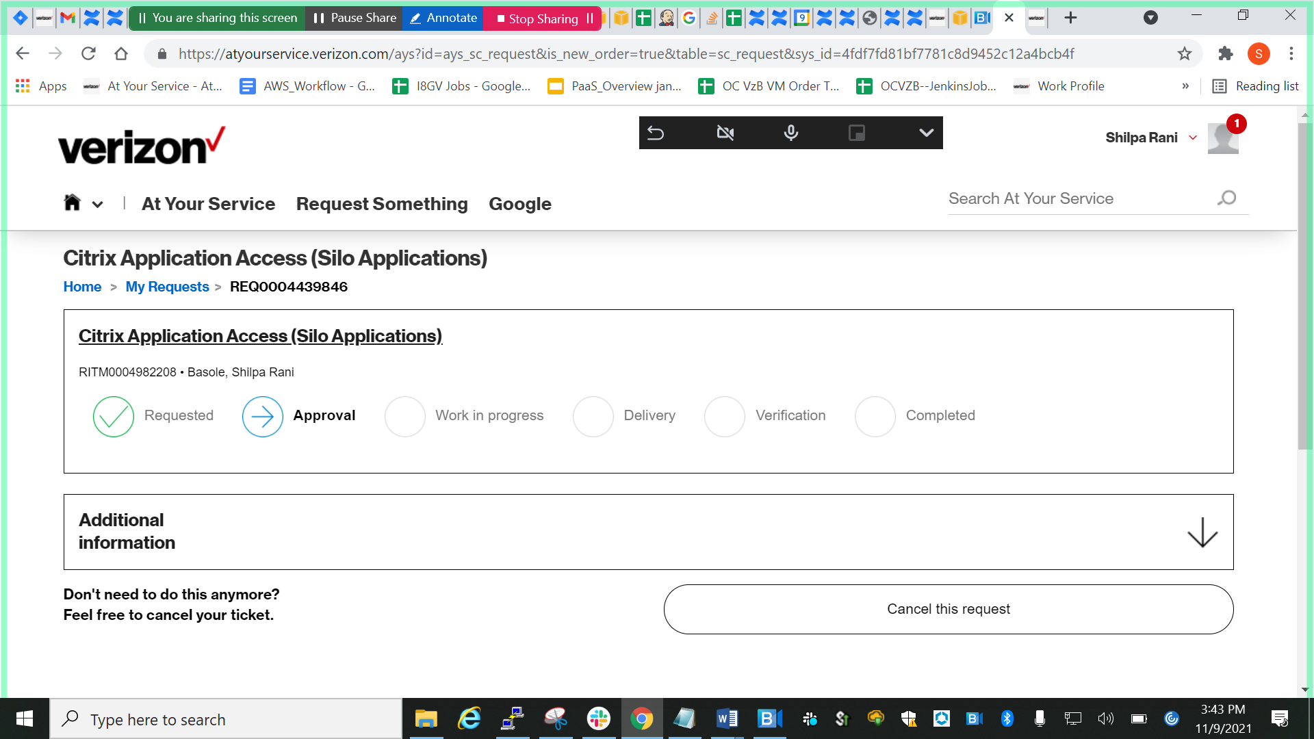

After getting all above permissions we have to follow following process to configure splunk:

1. <https://awslogsearch1.vpc.verizon.com:8000/en-US/account/login?return_to=%2Fen-US%2F>

splunk reference ticket --🡪 <https://onejira.verizon.com/browse/NTSCS-2651>

1. REQ0004570921

https://atyourservice.verizon.com/ays?id=ays_sc_request&is_new_order=true&table=sc_request&sys_id=7e7589101b24859c409852c12a4bcb1c