Click the link

<https://oseis.verizon.com:1443/shopping_cart/gencertapi.cgi>

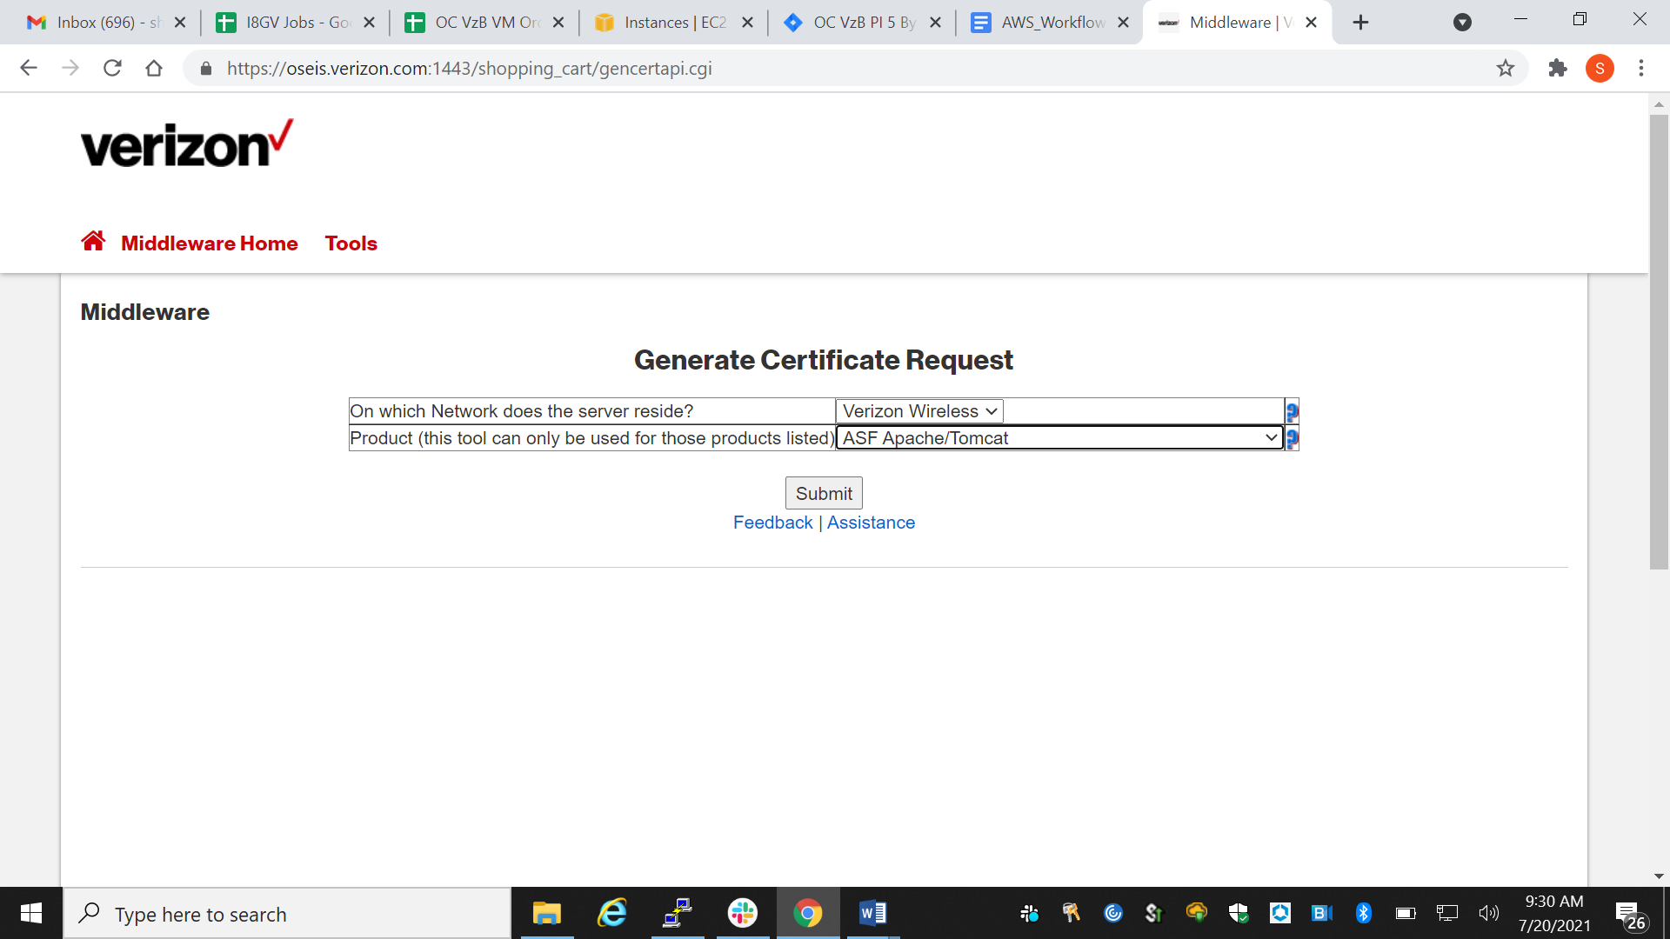

We will get above page. Select Verizon Wireless and ASF Apache/Tomcat from drop down

We wiill get below page, enter details as shown in the pic.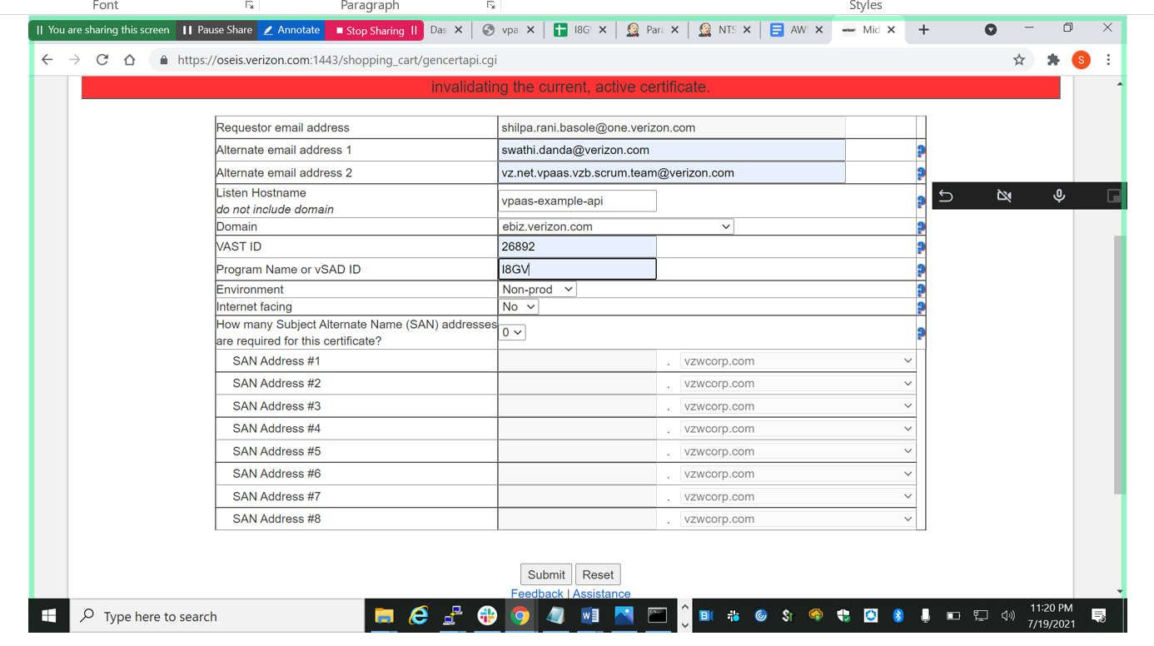

Click submit, then following page will be displayed.

In listen host name tab give the domain name which we want to use for that particular application.

Enter details as shown in pic

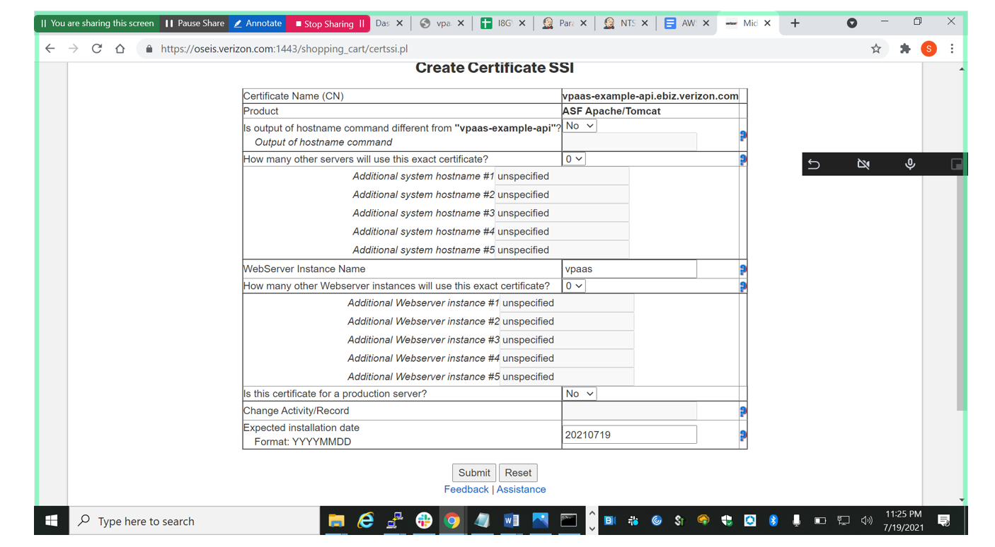

Click submit

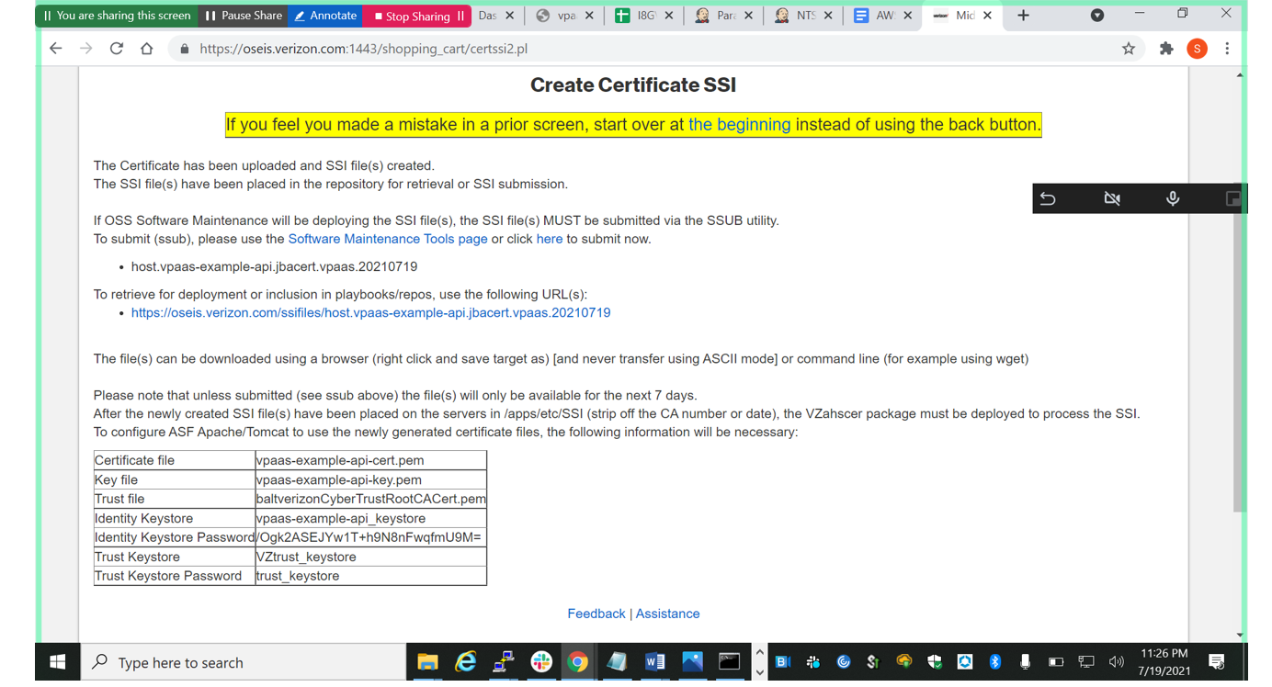

Download jbacert form the link displayed in above pic

|  |  |
| --- | --- |
| Certificate file | vpaas-example-api-cert.pem |
| Key file | vpaas-example-api-key.pem |
| Trust file | baltverizonCyberTrustRootCACert.pem |
| Identity Keystore | vpaas-example-api_keystore |
| Identity Keystore Password | /Ogk2ASEJYw1T+h9N8nFwqfmU9M= |
| Trust Keystore | VZtrust_keystore |
| Trust Keystore Password | trust_keystore |
|  |  |

Download relevant certs from artifactory into local system and open following files and make the changes mentioned below:

In host.HOSTNAME.apache.I8GV_VPM replace the following

**Before**

SSLCERTPATH="/apps/opt/ASF-Apache/domains/httpd/I8GV_VPM/ssl/vpaas-i8gv-np-cert.pem"

SSLKEYPATH="/apps/opt/ASF-Apache/domains/httpd/I8GV_VPM/ssl/vpaas-i8gv-np-key.pem"

**After**

SSLCERTPATH="/apps/opt/ASF-Apache/domains/httpd/I8GV_VPM/ssl/vpaas-np-api-cert.pem"

SSLKEYPATH="/apps/opt/ASF-Apache/domains/httpd/I8GV_VPM/ssl/vpaas-np-api-key.pem"

In httpd.conf replace the following

**Before**

SSLCertificateFile /apps/opt/ASF-Apache/domains/httpd/I8GV_VPM/ssl/vpaas-i8gv-np-cert.pem

SSLCertificateKeyFile /apps/opt/ASF-Apache/domains/httpd/I8GV_VPM/ssl/vpaas-i8gv-np-key.pem

SSLCertificateChainFile /apps/opt/ASF-Apache/domains/httpd/I8GV_VPM/ssl/baltverizonCyberTrustRootCACert.pem

**After**

SSLCertificateFile /apps/opt/ASF-Apache/domains/httpd/I8GV_VPM/ssl/vpaas-np-api-cert.pem

SSLCertificateKeyFile /apps/opt/ASF-Apache/domains/httpd/I8GV_VPM/ssl/vpaas-np-api-key.pem

SSLCertificateChainFile /apps/opt/ASF-Apache/domains/httpd/I8GV_VPM/ssl/baltverizonCyberTrustRootCACert.pem

## In host.HOSTNAME.tomcat.I8GV_VPM replace the following

Before

KEYPASS=”veoejlLW2exGUXNUb7dOtoGTDg4=”

After

KEYPASS=”R3mUUghDqpd6GhtEUfbf4Fky21M=”

### **Now download the jbacert**

<https://oseis.verizon.com/ssifiles/host.vpaas-np-api.jbacert.vpaas.20210503>

1. The file is downloaded as host.vpaas-np-api.jbacert.vpaas.20210503
2. In the cert directory the jbacert name is host.HOSTNAME.jbacert.I8GV_VPM remove this file
3. Copy the file host.vpaas-np-api.jbacert.vpaas.20210503 to the cert directory
4. Rename the file to host.HOSTNAME.jbacert.I8GV_VPM

5.Next push the changed set of certs from local to artifactory (to do this we have to go to oneartifactory select the I8GV_NONPROD repo and click deploy. Then select multiple files and select the certs files that we have changed and enter new repo name. click deploy)

6. we have to run software install job by selecting our new certs (we should add these certs in the configuration page of the job)----- <https://onejenkinscloud.vpc.verizon.com/nts/job/NTS.I8GV.SOFTWARE.INSTALL/configure>

7. Next go to cd /etc/httpd/conf.d then do vi ssl.conf and do following changes 