First deploy an instance with name NTS-I8GV-FORTIFY-AGENT (name can change) ditaws job and change instance type to  t3.xlarge.

(1)Run following job to install fortify on NTS-I8GV-FORTIFY.

[https://jenkins-nts3.vpc.verizon.com/nts3/job/NTS.I8GV.VENDOR_PORTAL.DITAWS-NEW](https://jenkins-nts3.vpc.verizon.com/nts3/job/NTS.I8GV.VENDOR_PORTAL.DITAWS-NEW/)

(runs on build server in east)

(2) Once instance is created,stop it and change instance type to  t3a.2xlarge

(3) Add agent.jar at /apps/opt on the NTS-I8GV-FORTIFY-AGENT from below link

<https://jenkins-nts3.vpc.verizon.com/nts3/computer/NTS.I8GV.VPAAS.BUILDAGENT-fortify/>  {this agent has all changes needed for fortify scan jobs to run successfully —- changes are in configure tab (working dir and environmental variables) that are specific for fortify software installation and running scan jobs)

(4)Run following job to install fortify software on NTS-I8GV-FORTIFY-AGENT

<https://jenkins-nts3.vpc.verizon.com/nts3/job/NTS.I8GV.FORTIFY-SOFTWARE-INSTALL/>

Following files and directories will be installed once above job is successful.

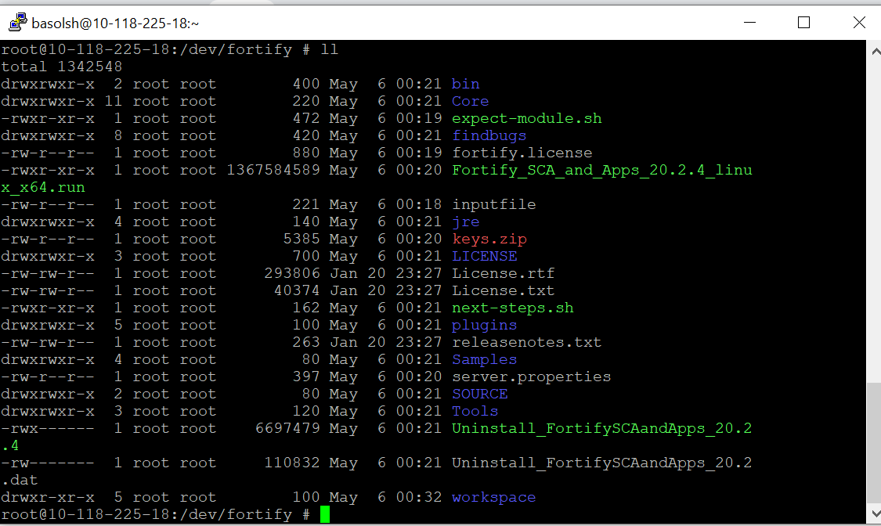

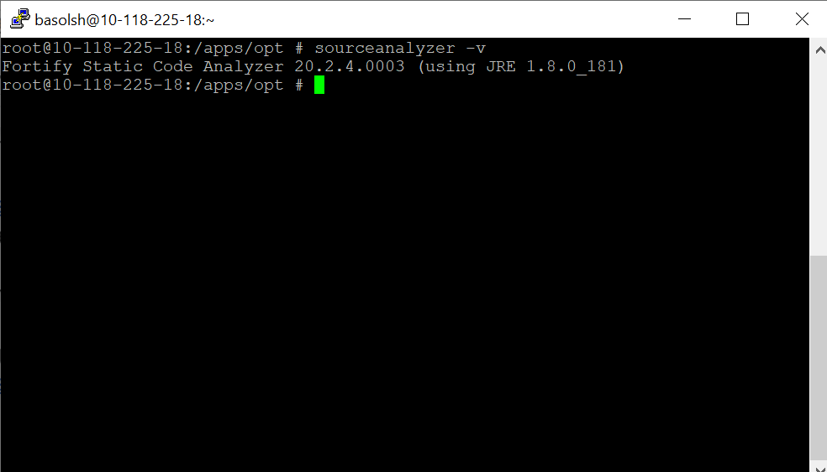

Once above job is successful, cross check if fortify software is working or not by command

Sourceanalyzer -v and we have to get output as shown in above pic.

Once we get above output, we can run scan jobs:

<https://jenkins-nts3.vpc.verizon.com/nts3/job/NTS.I8GV.UI-VPO.Fortify.Scan/configure> (this job runs on fortify server)

<https://jenkins-nts3.vpc.verizon.com/nts3/job/NTS.I8GV.MS.Fortify.Scan/> (this job runs on fortify server)

Below is pic on server which shows xml and mbs files are generated once vpo scan is done

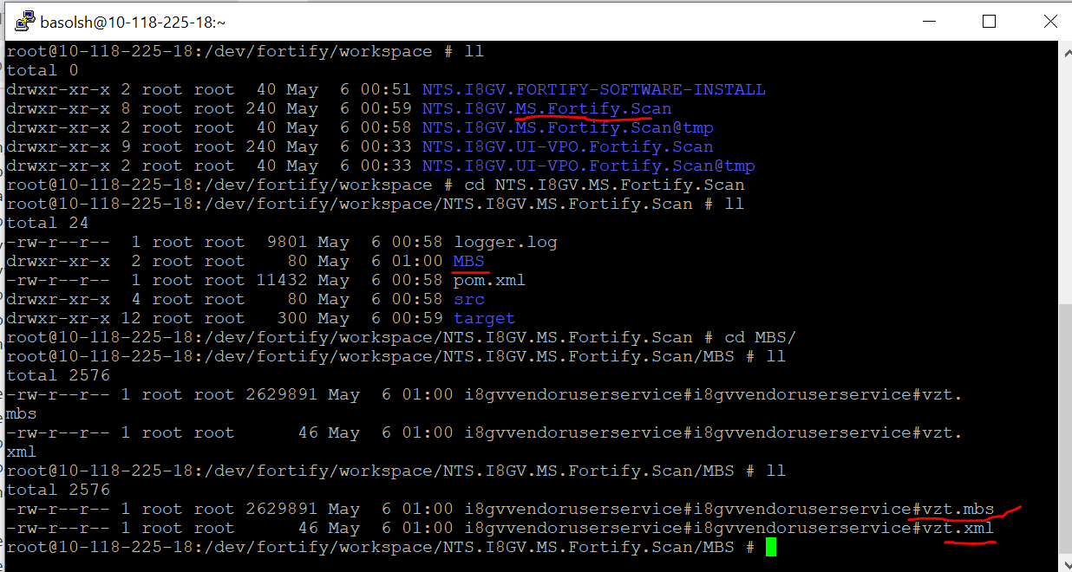

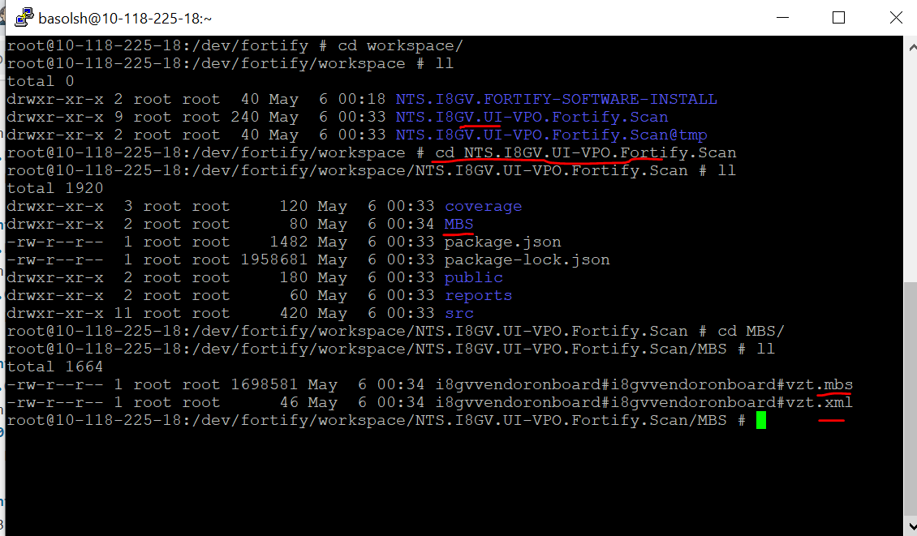

Below is the pic on server once API scan job is successful:

We will get email as following :

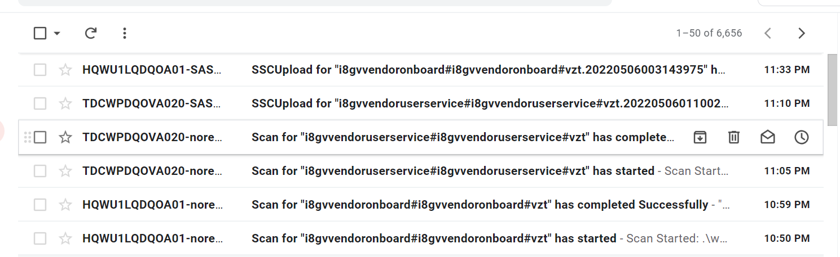

<https://oneconfluence.verizon.com/display/ASAS/Fortify+Build+Manager+-+Self+Service+Guide#FortifyBuildManagerSelfServiceGuide-InstallingFortifyNon-WindowsDistribution(Linux,Solaris,HPUX,OSX,AIX%E2%80%A6)>  ---fortiy process conluence

<https://oneconfluence.verizon.com/display/ASAS/Fortify+20.2+Plugin+Documentation?preview=/650950281/650950275/Fortify_Maven_ANT_MF_12042020.pdf> ----> fortify scanning process

—------------------------------**Upgrading fortify to 22.1**  —---------------->

<https://oneconfluence.verizon.com/display/EPSA/Steps+to+Install+Fortify+upgrade+22.1>

_________________________________

sftp download@SAST-LPAD.verizon.com

[2:58](https://vz-gnt.slack.com/archives/D047MTHJX1Q/p1666385915684629)

password LetMeSe3MyFiles!

/dev/fortify

Fortify_SCA_and_Apps_22.1.1_Linux.tar.gz

chmod +x Fortify_SCA_and_Apps_22.1.1_Linux.tar.gz

tar -xvf Fortify_SCA_and_Apps_22.1.1_Linux.tar.gz

./Fortify_SCA_and_Apps_22.1.1_linux_x64.run

26 times enter

Do you accept this license? [y/n]:  y

Installation Directory [/opt/Fortify/Fortify_SCA_and_Apps_22.1.1]:  /dev/fortify/Fortify_SCA_and_Apps_22.1.1

Full path to fortify.license [/dev/fortify/fortify.license]:

Will you use a license from a LIM server? [y/N]: N

Update server URL [<https://update.fortify.com>]: ENTER

Proxy host []: ENTER

Proxy port []: ENTER

Do you want to migrate from a previous SCA installation? [y/N]: N

Do you want to install sample source code projects with this installation? [Y/n]: Y

Do you want to continue? [Y/n]: Y

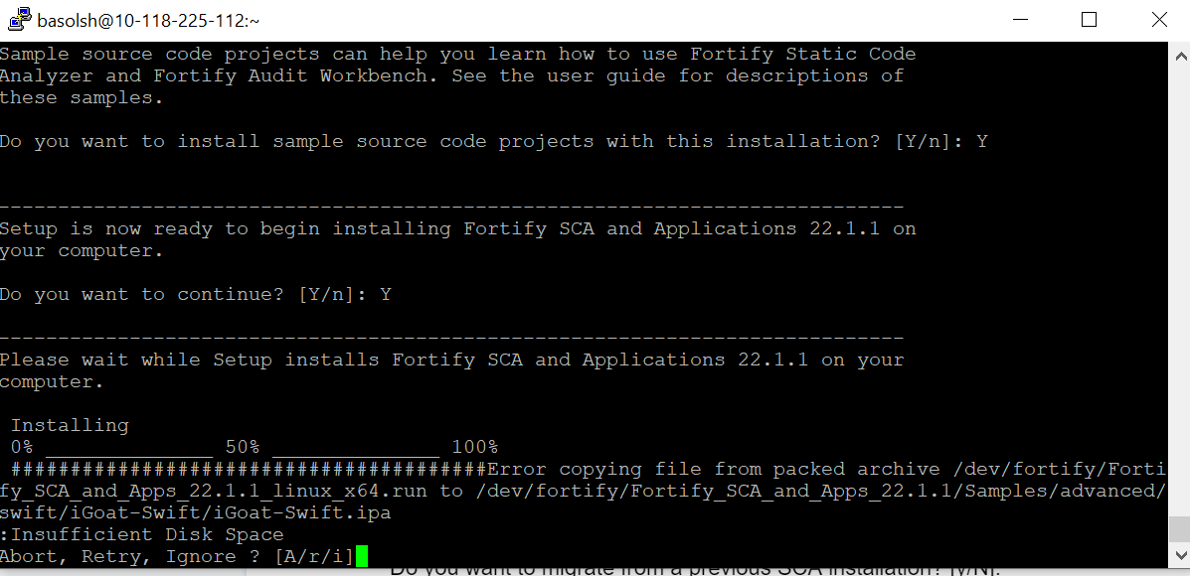

Because of above disk space problem, i changed instance type to t3a.2xlarge

cp -R keys /dev/fortify/Core/config

cp -R server.properties /dev/fortify/Core/config

**export PATH=$**[**PATH:/dev/fortify/**](http://path/The%20path)**bin {already done through automation}**

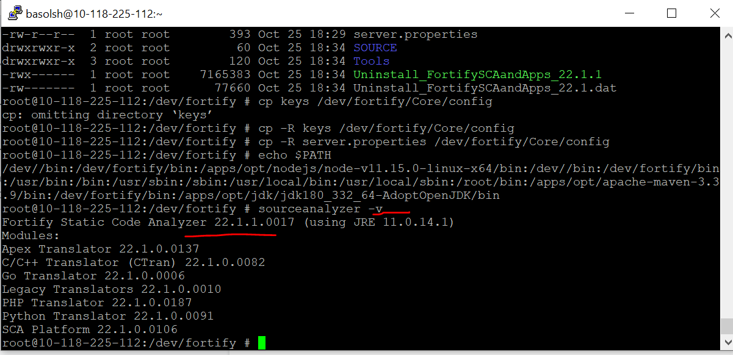

Login to sast portal @ <https://sast-vzw-hr.verizon.com/ssc/html/ssc/versions#!/> to check if scans got uploaded or not

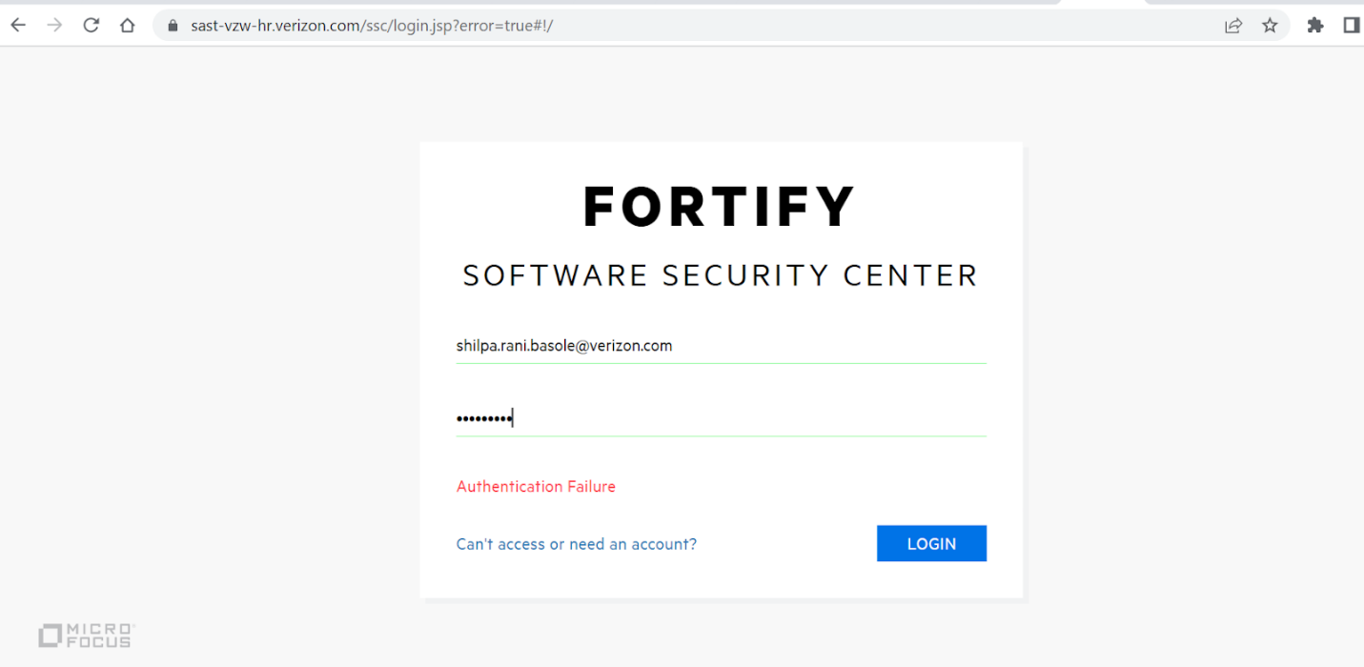

<https://onesecurity.verizon.com/secure/applications/fortify/scanactivity.jsp> — onesecurity portal to raise tickets related to fortify 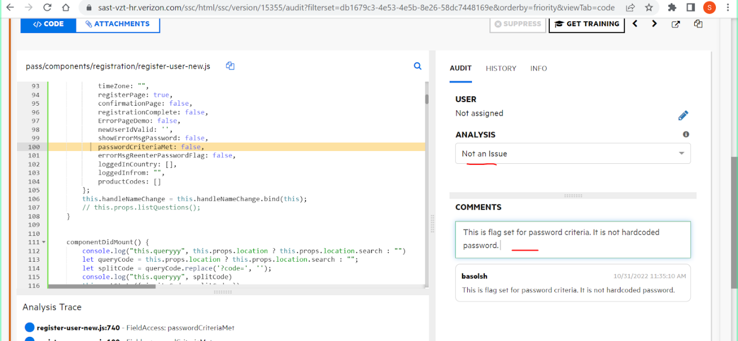

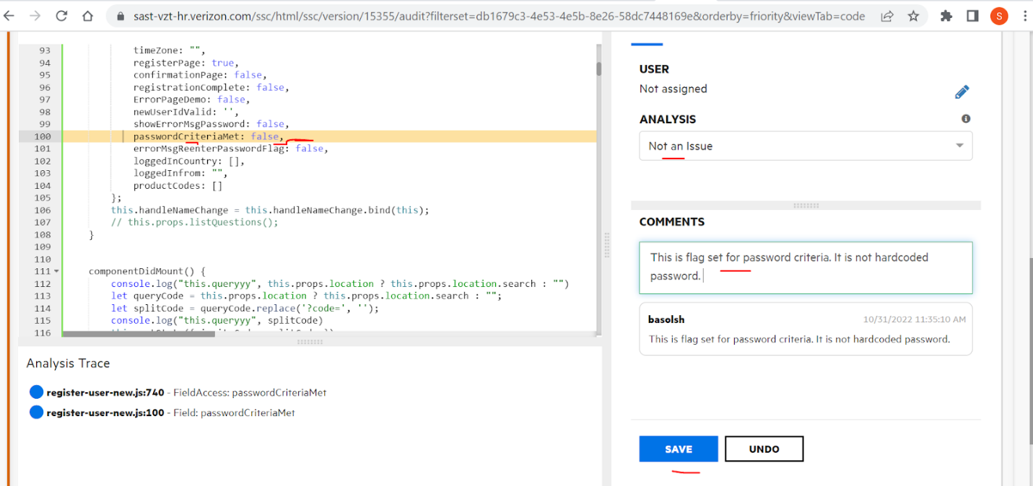

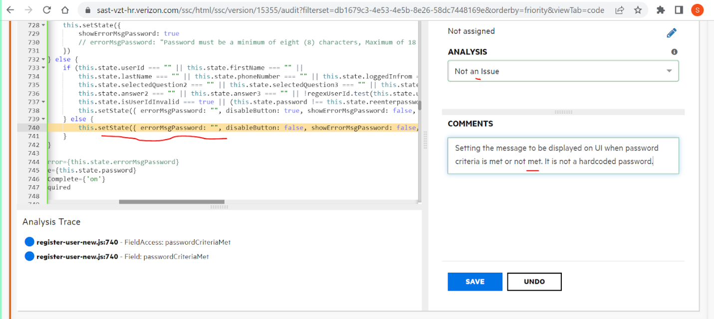

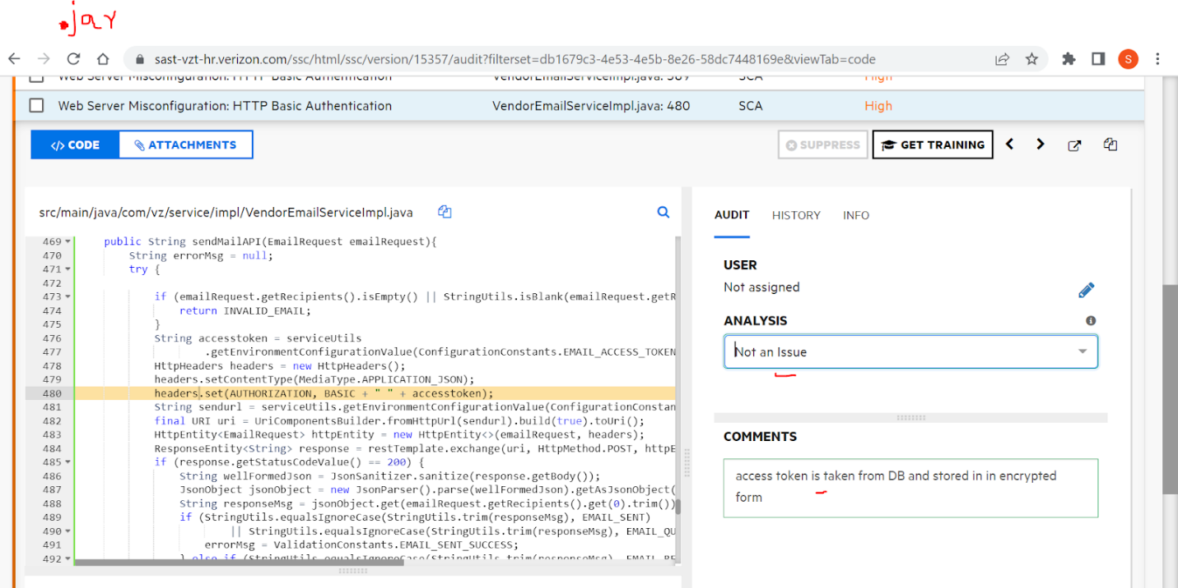

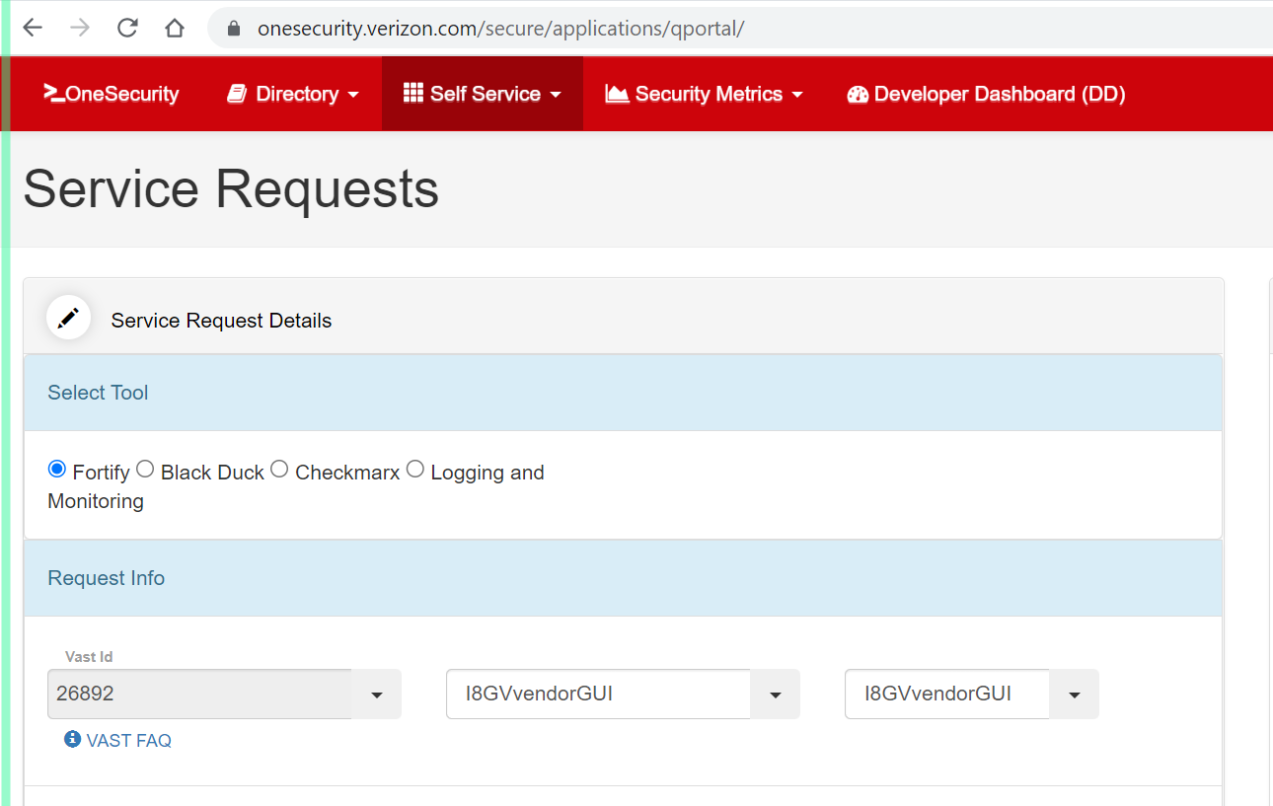

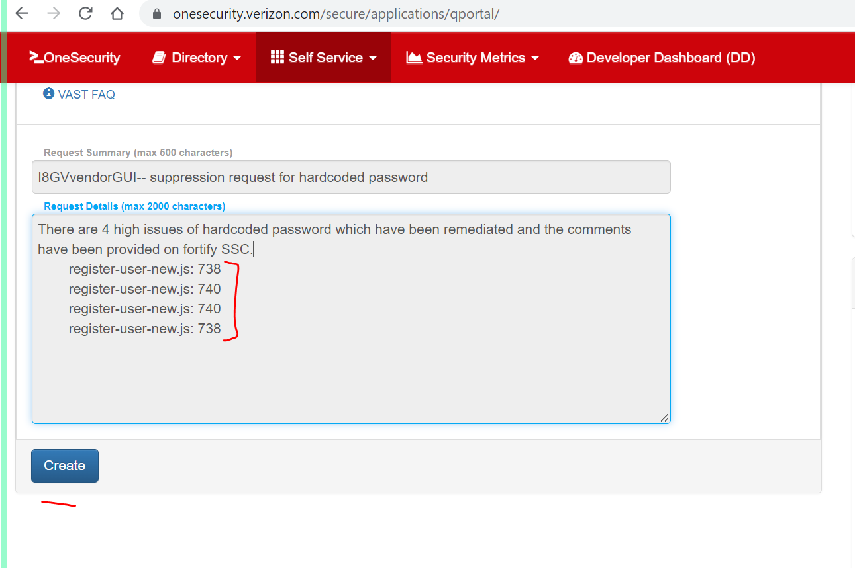

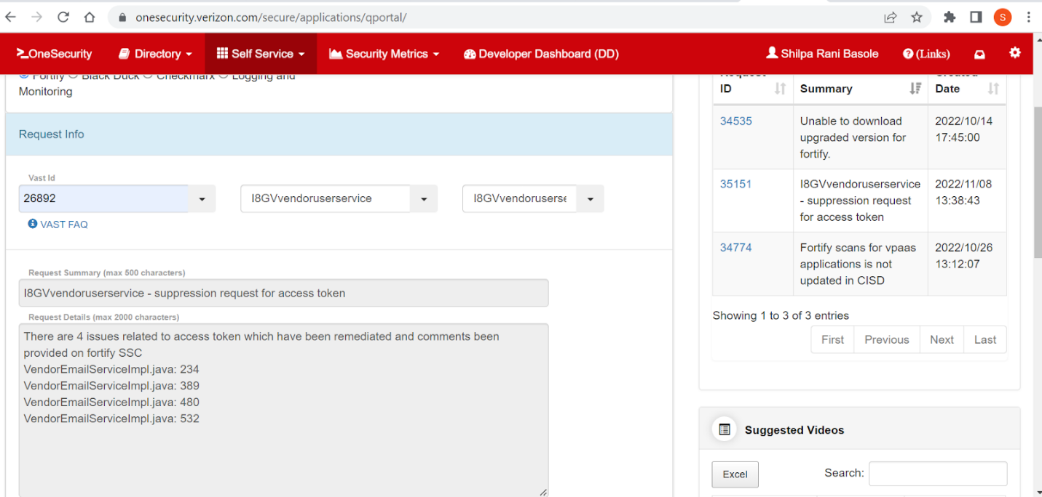

<https://onesecurity.verizon.com/secure/applications/qportal/index.jsp?key=34884&pType=qp>

<https://docs.google.com/document/d/1gBerH6Z5I0l7Q2Ph4Vt-0KGuKXIfHrPICIRAhoD92BA/edit> —- link for suppression request on fortify issues.