1. Create a test project in TestLink demo site and create test cases for the following screen,

In <https://www.google.lk/> web page:

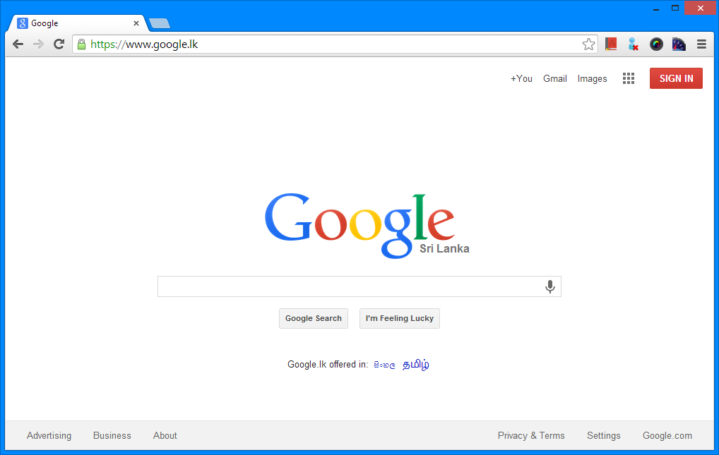

Create test cases for following;

I. Verify the country

II. Verify suggestions

III. Verify users can login

IV. Verify empty search

V. Verify search

VI. Verify the action on “I’m feeling Lucky”

VII. Verify functionality of “Settings” link (bottom-right corner)

IX. Verify “Enter” key functionality after typing on search text box

X. Verify calculate functionality in the search box

2) Automate any selected 5 test cases from above list, using Selenium and Junit (you may use Firefox WebDriver for this task).