

School of Computer Engineering
Manipal Institute of Technology, Bengaluru
(A Constituent Institute of Manipal Academy of Higher Education)

Database Systems Lab [CSSS2201]
Mini Project Report

UniTrack — Student Registration & Course Performance Management System
A Relational Database Application for Academic Performance Tracking

Submitted by

Sl. No. | Registration No. | Name of the Student | Sem-Branch
1 | 245891082 | Romansh Rathee | IV-CYS-C
2 | 245891408 | Aanya Gupta | IV-CYS-C

Under the guidance of

Ms. Chaitra Desai
Assistant Professor
School of Computer Engineering
Manipal Institute of Technology, Bengaluru
Academic Year: 2025-2026

SCHOOL OF COMPUTER ENGINEERING
Manipal Institute of Technology, Bengaluru

April 2026

CERTIFICATE
This is to certify that the Mini Project titled UniTrack — Student Registration & Course Performance Management System is a report of the bona fide work carried out by Romansh Rathee (24591082) and Aanya Gupta (245891408), submitted in partial fulfillment of the requirements of the course CSSS2201 — Database Systems Lab of the IV Semester, in the School of Computer Engineering, Manipal Institute of Technology, Bengaluru, Karnataka (a Constituent Institute of Manipal Academy of Higher Education), during the academic year 2025-2026.

Ms. Chaitra Desai  Assistant Professor  SOCE, M.I.T, Bengaluru | Program Coordinator  Associate Professor  SOCE, M.I.T, Bengaluru

ACKNOWLEDGEMENT
We express our sincere gratitude to Ms. Chaitra Desai, Assistant Professor, School of Computer Engineering, Manipal Institute of Technology, Bengaluru, for her invaluable guidance, continuous encouragement, and constructive feedback throughout the course of this project. Her expertise in database systems greatly enriched our understanding and approach.

We extend our thanks to the Department of Computer Science and Engineering and the School of Computer Engineering at Manipal Institute of Technology, Bengaluru, for providing the necessary infrastructure and resources to carry out this work.

We are also grateful to the faculty members of CSSS2201 — Database Systems Lab for their timely clarifications and support, and to our peers for constructive discussions during the development of this project.

Finally, we thank our families for their constant encouragement and support throughout the academic year 2025-2026.

Romansh Rathee
Aanya Gupta

ABSTRACT
Academic institutions managing student registrations, course assessments, and grade reporting have traditionally relied on fragmented spreadsheet-based systems. These flat-file approaches introduce significant data redundancy, update anomalies, and integrity violations when dealing with multi-course, multi-semester academic environments. The rapid growth of digital university management demands a structured, scalable, and consistent approach to academic data. UniTrack — Student Registration & Course Performance Management System addresses this critical need by replacing legacy spreadsheet records with a normalised relational database, enabling reliable and consistent access to academic data across multiple stakeholders including administrators, teachers, and students.

The methodology adopted centres on the design and implementation of a Third Normal Form (3NF) relational schema using MySQL as the database engine. Eight interrelated tables were designed: users, student, teacher, course, registration, assessment, marks, and gradecutoff, each enforcing referential integrity through FOREIGN KEY constraints and domain validity through NOT NULL and UNIQUE constraints. The schema cleanly separates authentication concerns (users table) from academic entity profiles (student, teacher), and models the many-to-many student-course relationship through a registration junction table. A flexible assessment model allows teachers to define any number of assessments per course with configurable weightages and maximum marks.

The project successfully demonstrates a fully functional normalised relational database with all constraints enforced and seed data supporting multiple departments, semesters, courses, and assessment types. The system correctly prevents duplicate enrollments through UNIQUE(student_id, course_id) enforcement, and prevents duplicate mark entries through UNIQUE(registration_id, assessment_id). Teacher-defined grade cutoff boundaries per course allow flexible grading policies across departments.

The primary conclusion is that relational database design with proper normalisation and constraint enforcement eliminates data quality issues inherent in flat-file academic management. The system demonstrates core DBMS concepts including 3NF decomposition, foreign key enforcement, junction table modelling, and structured SQL querying. Future enhancements could include automated grade computation, a REST API layer, and a web dashboard for real-time performance analytics.

TABLE OF CONTENTS
Acknowledgement | i
Abstract | ii
List of Tables | iii
List of Figures | iv
Chapter 1 — Introduction | 1
1.1 Overview of the Project
1.2 Purpose and Objectives
1.3 Scope of the System
1.4 Problem Definition
Chapter 2 — Literature Survey and Gaps
2.1 Existing Systems and Similar Applications
2.2 Limitations and Research Gaps
Chapter 3 — Problem Statement and Objectives
3.1 Problem Statement
3.2 Objectives
Chapter 4 — System Architecture
4.1 Architecture of the System
4.2 ER Diagram
4.3 Relational Schema Overview
Chapter 5 — Relational Data Model and Functionalities
5.1 Tables with Attributes and Constraints
5.2 Normalisation
5.3 Functionalities
Chapter 6 — Technologies Used and System Design
6.1 Technologies Used
6.2 System Design and Sample Queries
Chapter 7 — Data Flow, Results and Discussions
7.1 Data Flow Across Modules
7.2 Output and Query Results
Chapter 8 — Conclusions and Future Scope
8.1 Conclusions
8.2 Future Scope
References

LIST OF TABLES
Table No. | Table Title | Page No.
Table 5.1 | Relational Schema: users | 7
Table 5.2 | Relational Schema: student | 7
Table 5.3 | Relational Schema: teacher | 8
Table 5.4 | Relational Schema: course | 8
Table 5.5 | Relational Schema: registration | 8
Table 5.6 | Relational Schema: assessment | 9
Table 5.7 | Relational Schema: marks | 9
Table 5.8 | Relational Schema: gradecutoff | 10
Table 6.1 | Technologies Used | 11

LIST OF FIGURES
Figure No. | Figure Title | Page No.
Figure 4.1 | Three-Tier Architecture of UniTrack | 6
Figure 4.2 | Entity-Relationship Diagram | 6

CHAPTER 1 — INTRODUCTION

1.1 Overview of the Project
UniTrack is a relational database-backed academic management system designed to manage student registrations, course assignments, teacher profiles, assessments, marks, and grade cutoffs within a university environment. The system replaces fragmented spreadsheet-based records with a normalised MySQL relational schema, enforcing data integrity and enabling consistent multi-role access for administrators, teachers, and students.

The project was developed as part of the CSSS2201 — Database Systems Lab course at Manipal Institute of Technology, Bengaluru, and demonstrates practical application of relational database design principles including Third Normal Form (3NF) normalisation, foreign key enforcement, junction table modelling, and role-based access control through a single users authentication table.

1.2 Purpose and Objectives
The primary purpose of this system is to demonstrate that a well-designed relational database eliminates the data quality problems inherent in spreadsheet-based academic record-keeping. The key objectives are:
- Design a normalised relational schema in 3NF by decomposing entities to eliminate partial and transitive dependencies.
- Implement referential integrity using FOREIGN KEY constraints and domain validation using UNIQUE and NOT NULL constraints at the schema level.
- Model role-based authentication through a unified users table with an ENUM role field supporting admin, teacher, and student roles.
- Represent the many-to-many student-course relationship through a registration junction table with UNIQUE(student_id, course_id) enforcement.
- Support dynamic per-course assessment creation allowing teachers to define any number of assessments with configurable weightages.
- Enforce mark uniqueness per student per assessment through UNIQUE(registration_id, assessment_id) in the marks table.

1.3 Scope of the System
The system scope includes the full DDL definition of eight normalised tables with all applicable constraint types (PRIMARY KEY, FOREIGN KEY, UNIQUE, NOT NULL, DEFAULT, AUTO_INCREMENT), DML seed data insertion, and support for multi-department, multi-semester academic environments. The system supports three user roles: admin, teacher, and student. Each teacher may be assigned to one or more courses, and each student may register for multiple courses per semester. Grade boundaries are defined per course by the assigned teacher.

The system does not include a web-based frontend, real-time notifications, or automated email reporting, which are identified as future enhancements.

1.4 Problem Definition
Traditional academic data management relies on spreadsheets and flat-file records. These systems suffer from data redundancy: storing a student's department in every marks row means a department change requires updating hundreds of records. They also lack referential integrity, making it possible to record marks for a student not enrolled in the course, or to assign a course to a non-existent teacher. Duplicate enrollment records and duplicate mark entries cannot be prevented at the data layer.

UniTrack addresses all these gaps: student and teacher details are stored once in dedicated tables, course-teacher assignments are enforced through a foreign key, enrollment uniqueness is enforced through a UNIQUE constraint on the registration junction table, and marks uniqueness is enforced per assessment per enrollment.

CHAPTER 2 — LITERATURE SURVEY AND GAPS

2.1 Existing Systems and Similar Applications
Existing academic management systems in production environments typically use large-scale relational database management systems such as Oracle Database, Microsoft SQL Server, or PostgreSQL. Systems such as Banner (Ellucian), PeopleSoft Campus Solutions, and Moodle handle student registration, grade management, and course delivery across highly distributed university architectures.

Academic and research-oriented systems, including open-source projects available on GitHub, commonly model student-course relationships but often do so using flat schemas without enforced relational constraints or without separating authentication from entity profiles. Many such projects couple the user login identity directly with the student or teacher profile table rather than normalising authentication into a dedicated users table.

2.2 Limitations of Current Systems and Research Gaps
The key limitations identified in existing approaches are as follows:
- Flat-file storage: Marks and grade data are often stored in CSV or Excel files with no enforced relationships between students, courses, and assessments, leading to redundancy and inconsistency.
- Absence of constraint enforcement: Spreadsheet-based systems cannot prevent duplicate enrollment records, invalid teacher assignments, or marks exceeding the defined maximum for an assessment.
- No structured query interface: Analysis requires in-memory tools such as pandas or Excel pivot tables, which are less expressive and scalable than SQL for relational queries.
- Static assessment structure: Most academic schemas define a fixed set of assessment columns (Midterm, Final) in the marks table. UniTrack addresses this with a dynamic assessment entity allowing any number of assessments per course.
- No flexible grade boundaries: Existing systems commonly use hardcoded grading logic. UniTrack provides a gradecutoff table allowing teachers to define per-course grade boundaries independently.
UniTrack addresses all of these gaps through a 3NF schema, full constraint enforcement, a dynamic assessment model, and teacher-defined grade cutoffs.

CHAPTER 3 — PROBLEM STATEMENT AND OBJECTIVES

3.1 Problem Statement
University academic data management currently relies on fragmented flat-file records distributed across multiple spreadsheets and CSV files. This fragmentation creates three categories of problems. First, data redundancy arises when the same student name, department, or course title is stored in multiple tables, so a single factual change requires updates across many rows, increasing the risk of inconsistency. Second, integrity violations occur because flat files cannot enforce that a marks record must reference a valid enrollment or that an enrollment must reference a valid student and course. Third, structured querying is impractical because cross-entity analysis requires manual cross-referencing across files in application memory, which does not scale as student populations and course offerings grow.

The need for a relational database solution is clear: student and teacher details should be stored once in dedicated entity tables and referenced everywhere else through foreign keys, constraints should be enforced at the schema level, and all cross-entity queries should be expressed as SQL JOIN operations executed by the database engine.

3.2 Objectives
- Design a fully normalised relational schema in Third Normal Form (3NF), decomposing all partial and transitive dependencies across eight tables.
- Implement all applicable SQL constraint types: PRIMARY KEY, FOREIGN KEY, UNIQUE, NOT NULL, and DEFAULT in the DDL definition.
- Separate authentication from entity profiles by maintaining a unified users table with role-based access (admin / teacher / student).
- Model the many-to-many student-course relationship using a registration junction table with UNIQUE(student_id, course_id) enforcement.
- Support dynamic, teacher-defined assessments per course through a dedicated assessment entity with weightage and max_marks attributes.
- Enforce mark uniqueness per student per assessment through UNIQUE(registration_id, assessment_id) in the marks table.
- Provide teacher-defined per-course grade boundaries through the gradecutoff table, allowing flexible grading policies across departments.

CHAPTER 4 — SYSTEM ARCHITECTURE

4.1 Architecture of the System
UniTrack follows a layered architecture with clear separation of concerns across the authentication layer, entity profile layer, academic transaction layer, and grading configuration layer.
- Authentication Layer: The users table stores login credentials and role assignments for all system actors. Every student and teacher record is linked to exactly one users record through a UNIQUE foreign key, ensuring one-to-one profile binding.
- Entity Profile Layer: The student and teacher tables store academic profile data separately from login credentials. This separation ensures that personal details such as department and semester can be updated independently of login information.
- Academic Transaction Layer: The course, registration, assessment, and marks tables model the core academic operations. A course is assigned to one teacher. Students enroll in courses through the registration junction table. Teachers create assessments per course. Marks are recorded per student per assessment.
- Grading Configuration Layer: The gradecutoff table stores teacher-defined grade boundaries per course, allowing different courses to use different grading scales without modifying the core schema.

4.2 ER Diagram
The Entity-Relationship model identifies five primary entities and three dependent/junction entities, connected by six relationship types:
- users (1) to student (1): One-to-one relationship. A student account corresponds to exactly one users record. Enforced by UNIQUE on student.user_id.
- users (1) to teacher (1): One-to-one relationship. A teacher account corresponds to exactly one users record. Enforced by UNIQUE on teacher.user_id.
- teacher (1) to course (many): One teacher is assigned to many courses. Modelled via teacher_id FK in the course table (NULL allowed for unassigned courses).
- student (many) to course (many): Many-to-many relationship resolved via the registration junction table with UNIQUE(student_id, course_id).
- course (1) to assessment (many): One course can have many assessments. Modelled via course_id FK in the assessment table.
- registration (1) to marks (many): One enrollment record corresponds to many mark entries (one per assessment). Modelled via registration_id FK in the marks table.

4.3 Relational Schema Overview
The complete relational schema is presented in Chapter 5. All foreign key relationships are enforced at the MySQL level. No student can be enrolled in a course that does not exist, and no marks record can be inserted without a valid registration and assessment reference. The schema uses surrogate integer AUTO_INCREMENT primary keys throughout to support clean foreign key references without coupling entity tables to natural key changes such as USN format updates.

CHAPTER 5 — RELATIONAL DATA MODEL AND FUNCTIONALITIES

5.1 Tables with Attributes and Constraints
Table 5.1: users
Column | Data Type | Constraints
user_id | INT | PRIMARY KEY, AUTO_INCREMENT
username | VARCHAR(50) | UNIQUE, NOT NULL
password | VARCHAR(255) | NOT NULL
role | ENUM | NOT NULL — admin / teacher / student
created_at | TIMESTAMP | DEFAULT NOW()

Table 5.2: student
Column | Data Type | Constraints
student_id | INT | PRIMARY KEY, AUTO_INCREMENT
user_id | INT | FOREIGN KEY -> users(user_id), UNIQUE
usn | VARCHAR(20) | UNIQUE, NOT NULL
student_name | VARCHAR(100) | NOT NULL
email | VARCHAR(100) | —
department | VARCHAR(50) | —
semester | INT | —

Table 5.3: teacher
Column | Data Type | Constraints
teacher_id | INT | PRIMARY KEY, AUTO_INCREMENT
user_id | INT | FOREIGN KEY -> users(user_id), UNIQUE
teacher_name | VARCHAR(100) | NOT NULL
email | VARCHAR(100) | —
department | VARCHAR(50) | —

Table 5.4: course
Column | Data Type | Constraints
course_id | INT | PRIMARY KEY, AUTO_INCREMENT
course_code | VARCHAR(20) | UNIQUE, NOT NULL
course_name | VARCHAR(100) | NOT NULL
credits | INT | —
department | VARCHAR(50) | —
teacher_id | INT | FOREIGN KEY -> teacher(teacher_id), NULL allowed

Table 5.5: registration
Column | Data Type | Constraints
registration_id | INT | PRIMARY KEY, AUTO_INCREMENT
student_id | INT | FOREIGN KEY -> student(student_id), NOT NULL
course_id | INT | FOREIGN KEY -> course(course_id), NOT NULL
semester | VARCHAR(20) | —
academic_year | VARCHAR(10) | —
registration_date | DATE | —
(composite) | — | UNIQUE (student_id, course_id)

Table 5.6: assessment
Column | Data Type | Constraints
assessment_id | INT | PRIMARY KEY, AUTO_INCREMENT
course_id | INT | FOREIGN KEY -> course(course_id), NOT NULL
assessment_name | VARCHAR(100) | NOT NULL
assessment_type | VARCHAR(50) | exam / assignment / quiz
max_marks | DECIMAL(5,2) | NOT NULL
weightage | DECIMAL(5,2) | NOT NULL
created_at | TIMESTAMP | DEFAULT NOW()

Table 5.7: marks
Column | Data Type | Constraints
mark_id | INT | PRIMARY KEY, AUTO_INCREMENT
registration_id | INT | FOREIGN KEY -> registration(registration_id), NOT NULL
assessment_id | INT | FOREIGN KEY -> assessment(assessment_id), NOT NULL
obtained_marks | DECIMAL(5,2) | NOT NULL
(composite) | — | UNIQUE (registration_id, assessment_id)

Table 5.8: gradecutoff
Column | Data Type | Constraints
grade_id | INT | PRIMARY KEY, AUTO_INCREMENT
course_id | INT | FOREIGN KEY -> course(course_id), NOT NULL
grade_name | VARCHAR(5) | NOT NULL — A, B, C, D, F
min_marks | DECIMAL(5,2) | NOT NULL
max_marks | DECIMAL(5,2) | NOT NULL

5.2 Normalisation
The schema is designed in Third Normal Form (3NF). The normalisation process proceeded through three stages:
- First Normal Form (1NF): All attributes contain atomic values. No repeating groups exist across any table. Each table has a well-defined primary key. Assessment data is not stored as comma-separated values inside the course record but as a separate entity in the assessment table.
- Second Normal Form (2NF): All non-key attributes are fully dependent on the entire primary key. In the registration table, semester and academic_year describe the enrollment event, not just the student or just the course. In the marks table, obtained_marks is determined by the combination of registration_id and assessment_id, not by either alone.
- Third Normal Form (3NF): No transitive dependencies exist. Student department and semester are stored only in the student table. Teacher department is stored only in the teacher table. Course credits and department are stored only in the course table. No non-key attribute in any table transitively depends on another non-key attribute.

The critical 3NF enforcement is the use of surrogate foreign keys: the registration table stores student_id and course_id (not student names or course titles), and the marks table stores registration_id and assessment_id (not USN or assessment names). This eliminates all transitive dependencies and ensures zero redundancy.

5.3 Functionalities
The system supports the following core functional operations:
- Student enrollment query: JOIN across registration, student, and course to return a list of all enrolled students per course with enrollment dates and academic year.
- Course-wise marks report: Multi-table JOIN across marks, registration, student, and assessment to return a complete marks sheet per course with student names and assessment details.
- Grade computation: JOIN across marks, registration, assessment, and gradecutoff to compute weighted total marks and derive the corresponding grade for each student.
- Assessment management: INSERT and SELECT operations on the assessment table to allow teachers to create and view assessments for their courses.
- Teacher course load: JOIN across course and teacher to return all courses assigned to a given teacher.

CHAPTER 6 — TECHNOLOGIES USED AND SYSTEM DESIGN

6.1 Technologies Used
Component | Technology / Version
Database Engine | MySQL 8.x
Schema Definition | SQL DDL — CREATE TABLE with constraints
Query Language | SQL DML — SELECT, INSERT, UPDATE, DELETE
Development Environment | MySQL Workbench / CLI
Schema Diagram Tool | draw.io / MySQL Workbench EER Diagram
Documentation | Microsoft Word (DOCX)

6.2 System Design and Sample Queries
The following representative queries illustrate the JOIN-based approach used across the system:

Student Marks Report per Course
SELECT s.usn, s.student_name, a.assessment_name, m.obtained_marks, a.max_marks FROM marks m JOIN registration r ON m.registration_id = r.registration_id JOIN student s ON r.student_id = s.student_id JOIN assessment a ON m.assessment_id = a.assessment_id WHERE r.course_id = 1;

Grade Computation per Student per Course
SELECT s.student_name, SUM(m.obtained_marks * a.weightage / 100) AS weighted_total, g.grade_name FROM marks m JOIN registration r ON m.registration_id = r.registration_id JOIN student s ON r.student_id = s.student_id JOIN assessment a ON m.assessment_id = a.assessment_id JOIN gradecutoff g ON r.course_id = g.course_id AND SUM(m.obtained_marks * a.weightage / 100) BETWEEN g.min_marks AND g.max_marks GROUP BY s.student_id, r.course_id;

All Courses with Teacher Details
SELECT c.course_code, c.course_name, c.credits, t.teacher_name, t.department FROM course c LEFT JOIN teacher t ON c.teacher_id = t.teacher_id;

All queries are designed to minimise redundancy by leveraging the normalised schema. Student names, course titles, and assessment metadata are stored once in their respective entity tables and dynamically resolved through JOIN operations at query time. This reinforces the benefits of 3NF, where data consistency is maintained without duplication. The LEFT JOIN in the course-teacher query ensures that courses without an assigned teacher are still returned, which is supported by the NULL-allowed teacher_id FK in the course table.

CHAPTER 7 — DATA FLOW, RESULTS AND DISCUSSIONS

7.1 Data Flow Across Modules
The data flow in UniTrack follows a structured path from authentication through entity creation to academic transaction recording:
- User Creation: An admin inserts records into the users table, assigning a role of student or teacher. A corresponding profile record is then inserted into the student or teacher table with a UNIQUE foreign key reference to users.user_id.
- Course Setup: Admin inserts course records into the course table. A teacher_id FK is assigned to link the course to its instructor. Teacher can be NULL for courses pending assignment.
- Student Enrollment: Admin or system inserts records into the registration junction table linking student_id and course_id. UNIQUE(student_id, course_id) prevents duplicate enrollments at the schema level.
- Assessment Creation: The assigned teacher inserts assessment records for their course into the assessment table, specifying assessment_name, assessment_type, max_marks, and weightage.
- Marks Entry: The teacher inserts marks records into the marks table referencing registration_id and assessment_id. UNIQUE(registration_id, assessment_id) prevents duplicate mark entries.
- Grade Lookup: Grade is determined by querying the gradecutoff table for the relevant course_id and matching the student's computed weighted total against defined grade boundaries.

7.2 Output and Query Results
The system produces the following verified outputs upon schema initialisation and query execution:
- The enrollment endpoint correctly enforces UNIQUE(student_id, course_id): attempting to insert a duplicate enrollment for the same student and course returns a Duplicate entry error at the MySQL level.
- The marks endpoint correctly enforces UNIQUE(registration_id, assessment_id): attempting to record a second mark for the same student and assessment returns a Duplicate entry constraint violation.
- The LEFT JOIN course-teacher query correctly returns courses with NULL teacher assignments, verifying that unassigned courses are visible in course listings without being excluded.
- The grade computation query correctly applies weightage-adjusted marks and maps the total against the relevant course's gradecutoff boundaries, returning the correct grade per student.
- The FK constraint on course.teacher_id prevents assignment of a non-existent teacher to a course, verifying referential integrity at the schema level.

All observations confirm that constraint enforcement operates at the MySQL schema level and is independent of application code, which was a primary design objective of the system.
Sample screenshots
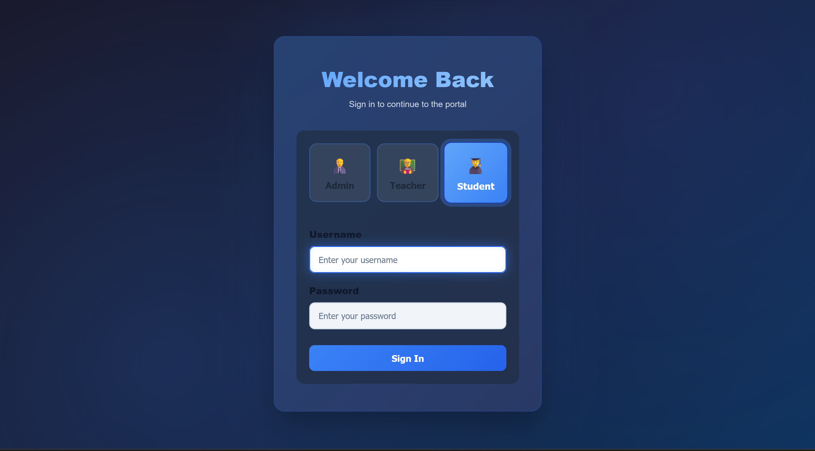

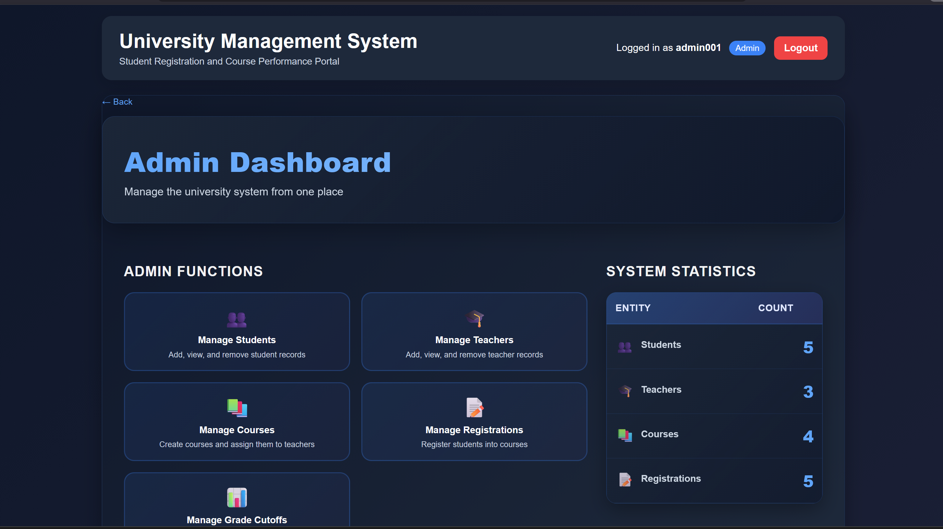





CHAPTER 8 — CONCLUSIONS AND FUTURE SCOPE

8.1 Conclusions
UniTrack — Student Registration & Course Performance Management System successfully demonstrates that a well-designed relational database with proper normalisation and constraint enforcement eliminates the data redundancy, update anomalies, and integrity violations that characterise spreadsheet-based academic management. The 3NF schema ensures that every non-key attribute is determined solely by the primary key of its table, with no transitive dependencies: student names are stored once in the student table, course titles once in the course table, and assessment metadata once in the assessment table — all referenced universally through foreign keys.

The separation of authentication from entity profiles through the users table with a role ENUM demonstrates how role-based access can be enforced at the schema level. The registration junction table with UNIQUE(student_id, course_id) cleanly models the many-to-many student-course relationship while preventing duplicate enrollments. The dynamic assessment model — where assessments are defined as rows in the assessment table rather than columns — proves that flexible academic structures can be modelled in a fully normalised schema without schema modification as new assessment types are introduced.

All primary objectives of the project were met: the schema is in 3NF, all applicable SQL constraint types are implemented, and the marks uniqueness constraint prevents data quality violations. The gradecutoff table demonstrates that configurable business rules can be stored within the relational schema itself rather than hardcoded in application logic.

8.2 Future Scope
The first area of future enhancement is a REST API and web dashboard. The current system is a pure database layer. Future versions could add a Flask or Node.js REST API layer exposing endpoints for enrollment, marks entry, and grade retrieval, connected to an interactive web dashboard for real-time performance analytics and per-student progress visualisation.

The second area of future work is automated grade computation and report generation. Currently, grade computation requires a manual multi-table JOIN query. A future enhancement could implement a MySQL stored procedure or trigger that automatically computes and stores the final grade in a separate results table whenever all marks for a student's assessments are recorded, enabling automated mark sheet generation.

The third area of future scope is attendance integration and at-risk student detection. A future schema extension would add an attendance entity tracking per-student per-session attendance against course schedules. Combined with the existing marks data, this would enable identification of at-risk students whose attendance and performance fall below defined thresholds, supporting early academic intervention.

REFERENCES
Reference Books
[1] R. Elmasri and S. B. Navathe, "Fundamentals of Database Systems," Pearson Education, 7th Edition, ISBN: 978-0133970777, 2016.
[2] R. Ramakrishnan and J. Gehrke, "Database Management Systems," McGraw-Hill, 3rd Edition, ISBN: 978-0072465631, 2003.
[3] A. Silberschatz, H. F. Korth, and S. Sudarshan, "Database System Concepts," McGraw-Hill, 7th Edition, ISBN: 978-0078022159, 2019.
Web References
[1] MySQL 8.x Reference Manual — Constraints, dev.mysql.com
[2] MySQL Foreign Key Documentation, dev.mysql.com/doc/refman
[3] Database Normalization Tutorial, tutorialspoint.com
[4] MANIPAL Academy of Higher Education, manipal.edu

