CET257 Enterprise Project: Assignment 2
Task B3: Report Evaluating Client Interactions
Team Speed (Team 6) · Lift Right: 360° Manual Handling Training Simulation
Client: Sulav G. Raj, Vantec

1. Overview
Over the project, Team Speed had six kinds of contact with our client, Sulav G. Raj, who also acted as our module tutor: an introductory email, a consultancy call, a requirement review, a prototype demonstration, follow-up emails, and a final client presentation. Table 1 summarises them. This report evaluates what worked and what did not, and recommends how we could have communicated better. The evidence (C1 to C11) is in the appendices.
No. | Date | Contact | Purpose and outcome | Evidence
1 | 16 July | Introductory email | Introduced the team and asked for a 15-to-20-minute call. | C1
2 | 16 or 18 July | Consultancy call (phone) | Introduced Lift Right. The client confirmed that current training is routine and easy to forget. A follow-up review was agreed. | C2, C3
3 | 10 August | Requirement review (Google Meet) | Walked through the six checkpoints, scoring and supervisor view. The client was largely satisfied and gave feedback on scope. | C4, C5
4 | 3 September | Prototype demonstration (in person) | Full team demonstrated navigation, the quiz sequence and live scoring. Positive response, with two small scope adjustments requested. | C6, C7, C8
5 | 12 September | Final thank-you email | Shared the live prototype link and thanked the client. | C9
6 | Final session | Client presentation | Rated 4, 5, 5, 5 and 5 out of 5, with four improvement comments. | C10, C11
Table 1: Summary of client interactions

2. Best Aspects
- The early introduction and call set the direction. The client confirmed that posters and PDF inductions do not stick with staff. That gave the project a clear purpose, which shaped every later decision.
- Meetings matched the project stages. Discovery, requirement validation and demonstration each had a stated purpose, and the next meeting was booked before the previous one ended.
- Follow-up was consistent. We emailed after each contact, restating what we heard and what came next. This kept the relationship professional.
- The in-person demonstration was the most productive. The client reacted to a working build, not documents, and the later presentation rating of 24/25 reflected this.

3. Worst Aspects
- Feedback was recorded without detail. Our logs say "feedback on scope" and "two small scope adjustments" but do not name them. Only the replay feature (FR14) can be traced to a requirement, so we cannot show clearly how each comment was handled.
- Records contained avoidable errors. The call is logged on 16 July but the thank-you email is dated 18 July. The follow-up email is dated 11 August for a meeting held on 10 August. One email calls Thursday 3 September a "Tuesday". Some action dates were left as placeholders and client signature fields are blank. These errors weaken the evidence.
- Contact was too infrequent and too late. There were 24 days between the requirement review and the demonstration, and no meeting after the demo to confirm the adjustments. The most useful feedback (layout, varied scoring and engagement) came at the final presentation, when there was little time left to build it.
- Too few of us spoke to the client. The consultancy call was led by one person. The people building the system met the client only at the demonstration, so technical questions went unasked.
- The client's dual role added ambiguity. Because our client was also our tutor, it was sometimes hard to separate project advice from assessment expectations.

4. Evaluation of the Consultancy Session
The call had a clear purpose and the client spoke openly about his own experience, which confirmed our problem statement. However, it was short, and our records show no prepared list of questions. We did not record questions about the devices workers use, IT restrictions, the number of trainees, languages, accessibility, or how success would be measured. These gaps later surfaced as assumptions in our design, for example the choice of browser-only, client-side storage. The session confirmed the problem well but produced few concrete requirements.

5. Recommendations
- Prepare: send an agenda and question list (devices, users, constraints, success measures) at least 48 hours before each session.
- Share the roles: have two team members at every contact, one leading and one taking notes, and include a technical team member at the first consultancy session.
- Keep a feedback register: record each comment with an ID, the client's exact words, date, owner, linked requirement and status, and update it within 24 hours.
- Confirm in writing: email minutes within 24 hours and ask the client to confirm or correct them, instead of leaving blank signatures and placeholder dates.
- Add checkpoints: include a mid-build check around Week 6 and a short post-demo confirmation, so the final presentation holds no surprises.
- Ask for feedback earlier: book the presentation feedback session while there is still time to build the changes.
- Agree boundaries: at the start, agree how the client's advice differs from the marking criteria.

6. Conclusion
Our client interaction gave the project a clear purpose and a positive final response. It was weakest in preparation, record keeping and timing. Following the recommendations above would make each contact more useful and the evidence more reliable.

Appendix A: Evidence Index
The original documents are provided in the evidence folder, and the screenshots of emails are reproduced in Appendix C.
Ref | Evidence | File | Date
C1 | Introductory email to the client | Evidence screenshot 1 | 16 July
C2 | Meeting 1 log: introductory call | Meeting_1_Introductory_Call | 16 July
C3 | Thank-you email after the call | Evidence screenshot 2 | 18 July
C4 | Meeting 2 log: requirement review | Meeting_2_Requirement_Review | 10 August
C5 | Email after the requirement review, proposing the demo | Evidence screenshot 3 | 11 August
C6 | Email confirming the prototype demonstration | Evidence screenshot 4 | 1 September
C7 | Meeting 3 log: prototype demonstration | Meeting_3_Prototype_Demonstration | 3 September
C8 | Thank-you email after the demonstration | Evidence screenshot 5 | 6 September
C9 | Final thank-you email with the prototype link | Evidence screenshot 6 | 12 September
C10 | Client presentation feedback form | feedback.pdf | Presentation day
C11 | Presentation slides, plan and weekly minutes recording client contact | Lift_Right_Presentation.pptx, weekly minutes | Weeks 1 to 8

Appendix B: Meeting Minutes Summary
Meeting | Meeting 1: Introductory call | Meeting 2: Requirement review | Meeting 3: Prototype demonstration
Date and place | 16 July, 10:30 AM, phone call | 10 August, 11:00 AM, Google Meet | 3 September, 8:30 AM, university classroom
Attendees | Shilu Chuke, Sulav G. Raj | Shilu Chuke, Swikriti Bashyal, Sulav G. Raj | All four team members, Sulav G. Raj
Purpose | Introduce Lift Right and hear the client's view of manual-handling training | Present early requirements and confirm the brief was understood | Demonstrate the working prototype
Client feedback | Existing training does not stick. Shared operational context. | Largely satisfied. Feedback on scope used to finalise requirements. | Positive response. Two small scope adjustments requested.
Agreed actions | Take feedback into requirements. Follow-up meeting booked. | Finalise Requirements. Continue the prototype. Schedule the demo. | Carry the two adjustments through and keep the project plan up to date.
Next meeting | 10 August, Google Meet | 3 September, in person | Not yet scheduled

Table B1: Summary of the three client meeting logs

Appendix C: Email Evidence
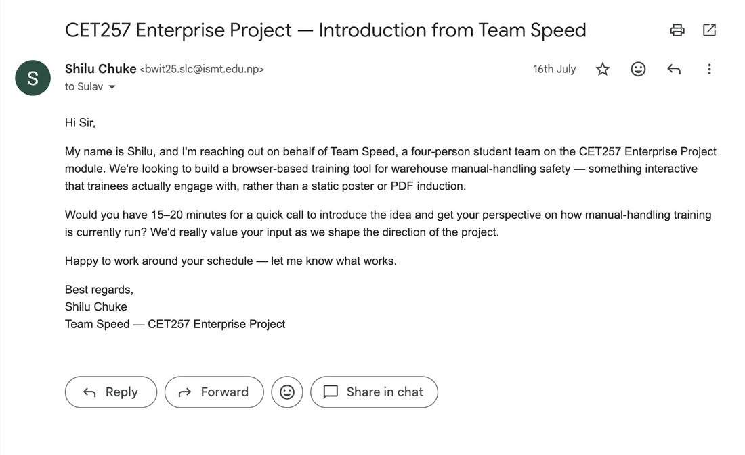
C1: Introductory email to the client, 16 July
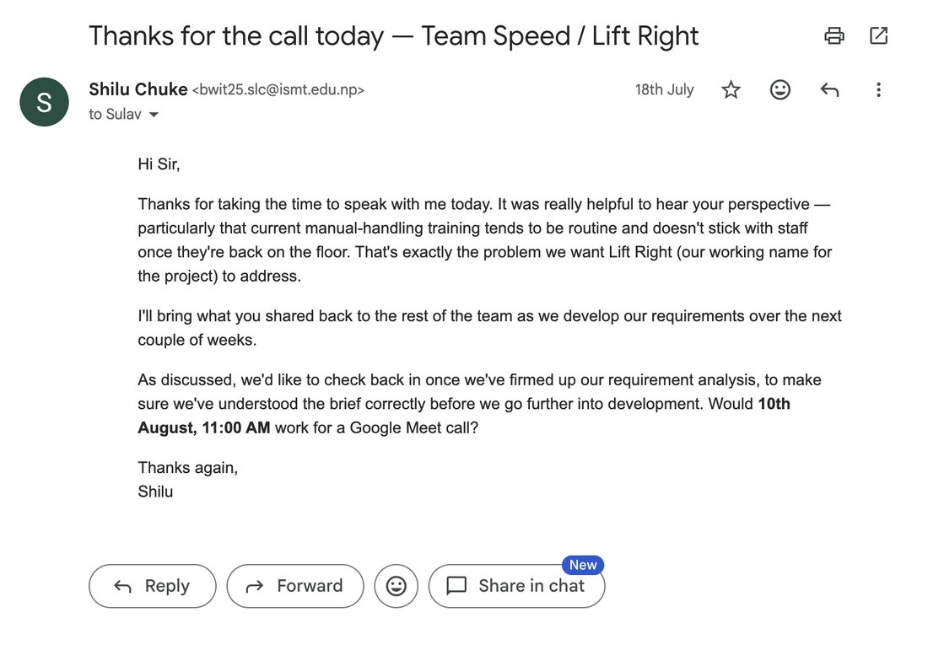
C3: Thank-you email after the call, 18 July
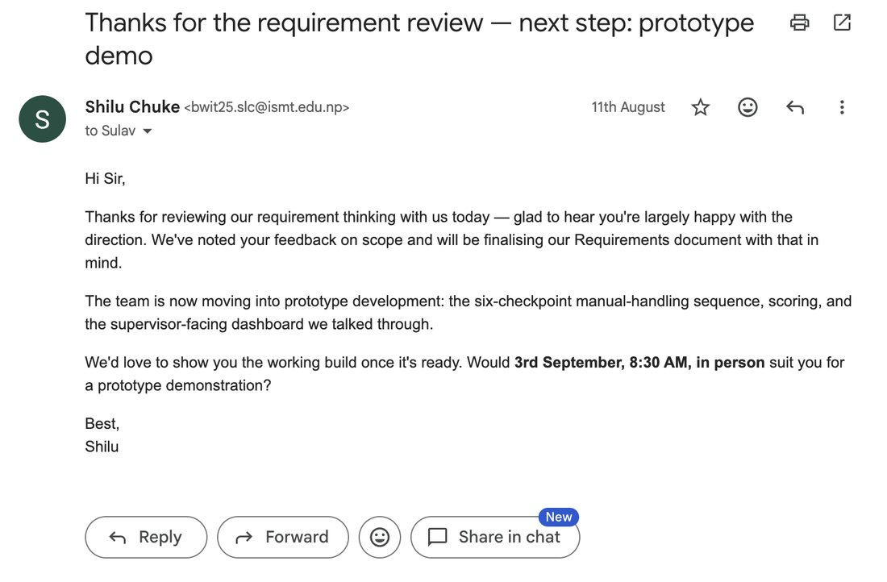
C5: Email after the requirement review, 11 August
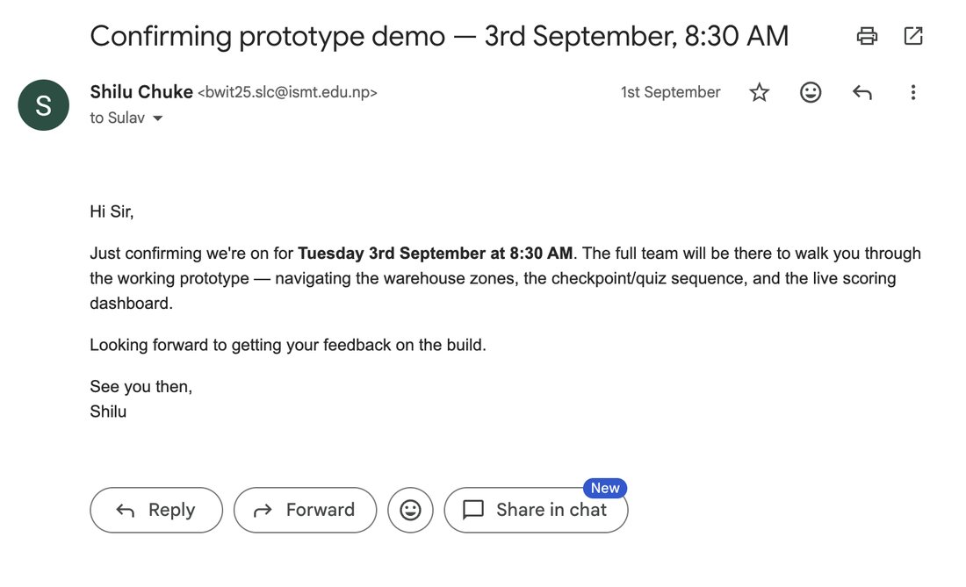
C6: Email confirming the prototype demonstration, 1 September
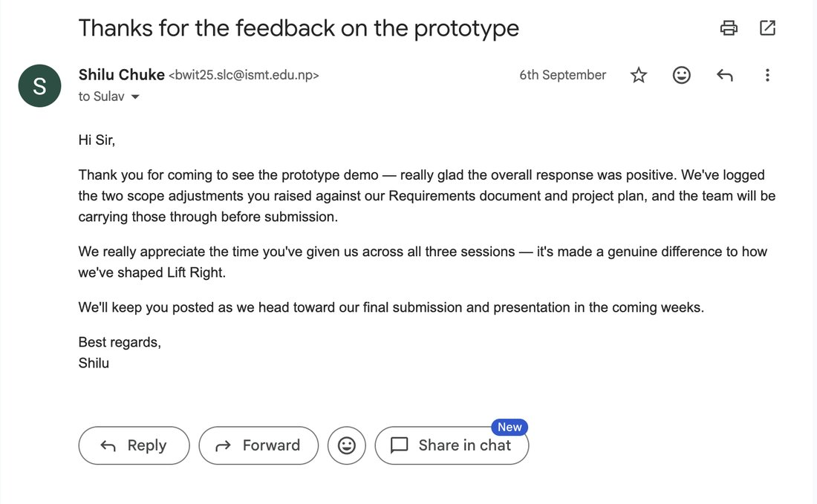
C8: Thank-you email after the demonstration, 6 September
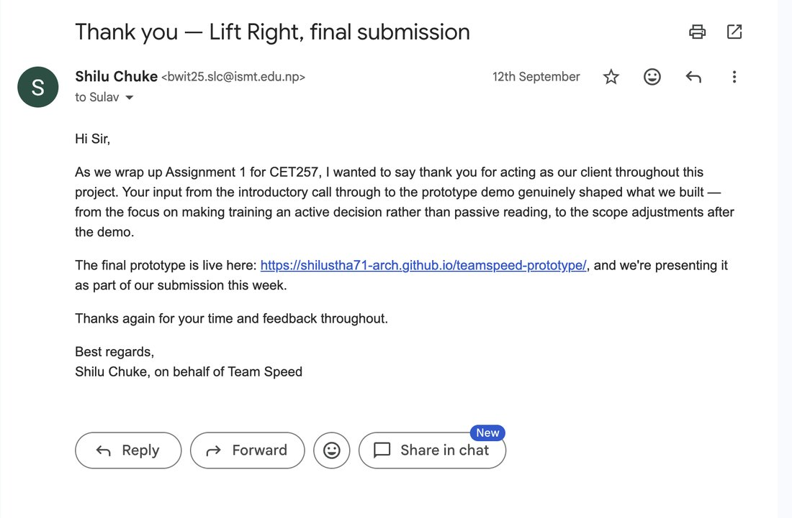
C9: Final thank-you email, 12 September

Appendix D: Client Presentation Feedback
The client rated our presentation 4, 5, 5, 5 and 5 out of 5, left four comments and signed the form (page 2). The team intended to update the layout for selecting options, give the point system more variation, add more ways to earn points, and make the experience more engaging and interactive.
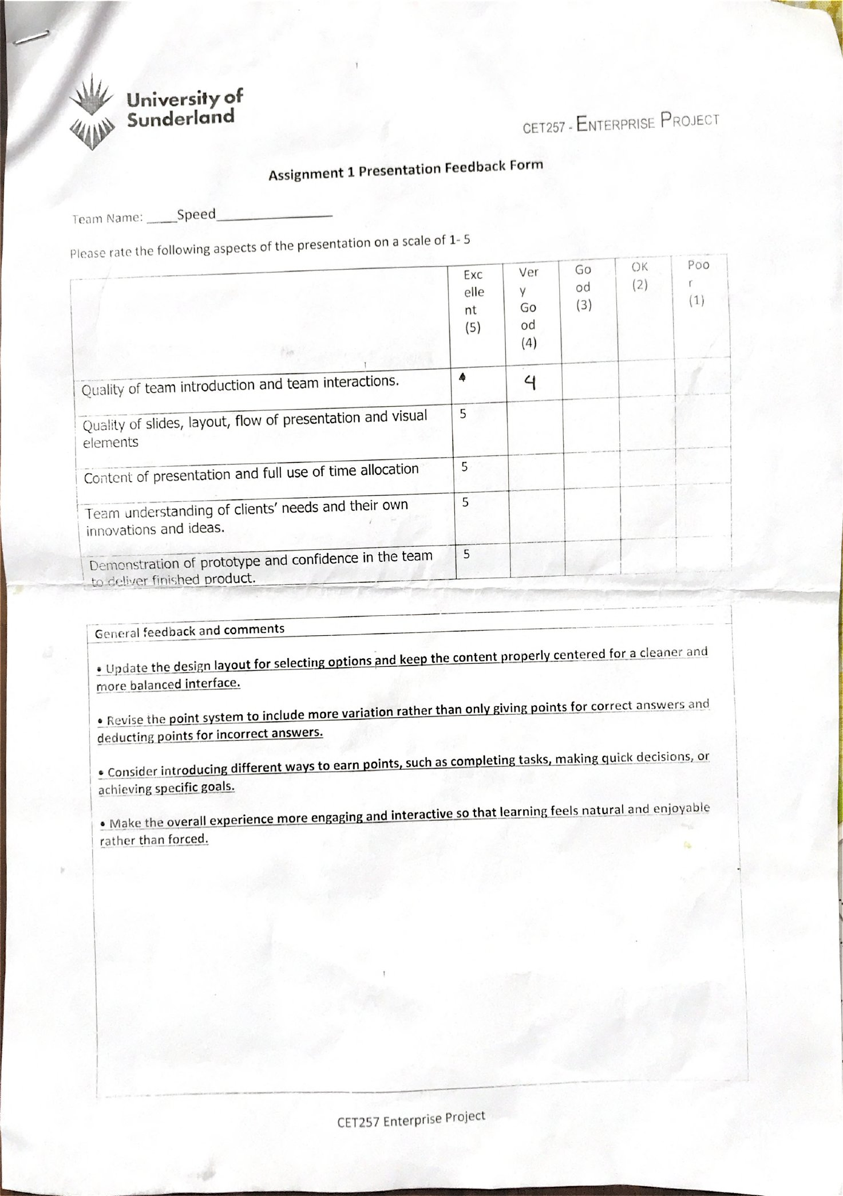
C10: Client presentation feedback form (page 1)
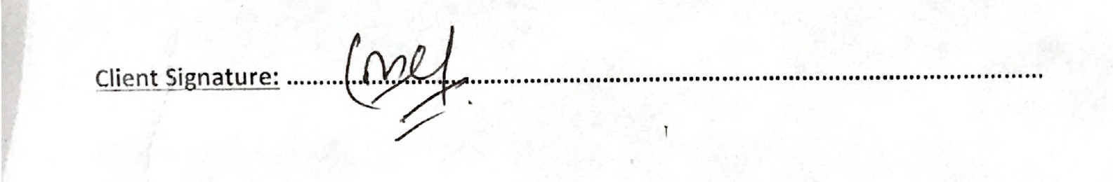
C10: Client signature on the feedback form (page 2)

