CET257 Enterprise Project
Assignment 2: Group Assignment
Task B1: Design, Testing and User Documentation

Detail | Information
Team | Team Speed (Team 6)
Product | Lift Right: 360° Manual Handling Training Simulation
Client | Sulav G. Raj
Team members | Shilu Chuke (Team Leader), Swikriti Bashyal (UI/UX Designer), Namshu Hang Zhyedi Magar (Frontend Developer), Sparas Shrestha (Backend Developer)
Contents | 2. User design and development  3. System design and development (including 3.6 Testing plan)  4. User guides (worker and supervisor)  5. Changes made after client feedback

1. Purpose
This document builds on our Assignment 1 design pack (Introduction, PACT analysis, Requirements and diagrams). It gives the user-centred and system-level design evidence behind Lift Right, the plan we used to test it, user guides for both types of user, and an honest account of how client feedback changed the system. Requirement references (FR and NFR) are those in our Requirements document.

2. Evidence of User Design and Development

2.1 Who we designed for
Our PACT analysis identified three user groups. Each shaped specific design decisions:
User group | What we found | Design consequence
Warehouse operatives | Wide range of ages, fitness and gaming experience. Some are new starters on their first day. | Controls limited to mouse-look and W-A-S-D, with a short pre-start briefing instead of a long tutorial.
Workers who use English as a second language | The floor is expected to include them. | Short, plain prompts paired with visual cues such as a highlighted load and marker colour.
Supervisors and training administrators | Time-poor and non-technical. They need a fast answer to who is trained. | A single summarised Admin Command Center table with a one-click CSV export.

2.2 User stories and acceptance criteria
We wrote user stories from the PACT findings and the client's feedback, then gave each testable acceptance criteria. Priorities follow the MoSCoW levels in our Requirements document, and each story links to the requirement and the test case that checks it (section 3).
ID | User story | Acceptance criteria | Req. | Test
US1 | As a worker, I want to create an account and log in so my results are saved to me. | Account can be created and used to log in. Wrong credentials are refused. Password is hidden by default. | FR3, NFR4 (Must) | T1 to T3
US2 | As a worker, I want to look around and walk the warehouse so training feels real. | Mouse looks a full 360°. W-A-S-D moves between Loading Dock, Warehouse Floor and Racking Aisle. | FR1, FR2 (Must) | T4
US3 | As a worker, I want a clear sequence of six checkpoints so I know what to do next. | Six zones are cleared in order and ticked on the sequence list. | FR4 (Must) | T5
US4 | As a worker, I want a short safety question at each checkpoint so I learn why. | A question appears and an explanation is shown whether the answer is right or wrong. | FR6 (Must) | T6
US5 | As a worker, I want to choose how to move each load so I learn to match method to weight. | Only methods suitable for the load's weight are offered. | FR5 (Must) | T7
US6 | As a worker, I want to see my score so I know how I am doing. | Six correct answers score 100, each wrong answer costs 15, score is capped at 100 and 40 passes. | FR7 (Must) | T8 to T10
US7 | As a worker, I want a live timer, score and zone so I can pace myself. | HUD shows countdown, score and zone and updates without lag. | FR10 (Must) | T11
US8 | As a worker, I want a bonus round when I do well so training feels rewarding. | Three correct in a row triggers the Golden Crate Drill. | FR8 (Should) | T12
US9 | As a worker who keeps getting it wrong, I want a recovery drill so I can relearn the hazards. | Three wrong in a row triggers the Hazard-Spotting Stand-Down. | FR9 (Should) | T13
US10 | As a worker, I want my attempts saved so progress is not lost when I log out. | Attempts, time and best score persist between sessions on the same device. | FR11, NFR8 (Must) | T14, T15
US11 | As a supervisor, I want one table of who has trained so I can answer audits quickly. | Admin view lists logins, attempts, time and best score per worker. | FR12 (Must) | T16
US12 | As a supervisor, I want to export training records so I can keep them as evidence. | One click downloads a CSV of all workers. | FR13 (Should) | T17
US13 | As a worker, I want to replay a run without losing my best score so I can improve. | Replay is available and the previous best is kept. | FR14 (Could) | T18
US14 | As a client, I want to try the system without installing anything. | Runs in a modern browser with no install. | NFR2, NFR6 (Must) | T19, T20

2.3 Use cases
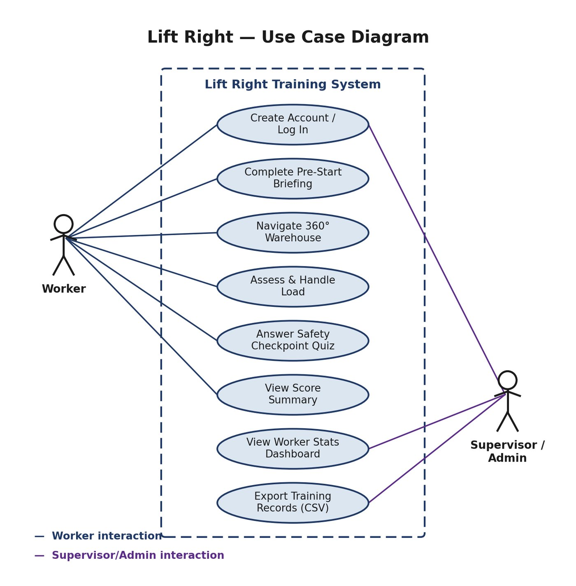  Figure 1: Use case diagram for workers and supervisors | The diagram shows two actors. The worker creates an account, completes the briefing, navigates the 360° warehouse, assesses and handles loads, answers checkpoint quizzes and views a score summary. The supervisor logs in, views worker statistics and exports training records.  Both actors share the log-in use case, which is how the system keeps worker and administrator access separate.

Use case 1: Complete a training run
Item | Description
Actor | Worker
Precondition | Worker has an account and is logged in.
Main flow | 1. Read the briefing and start. 2. Walk into each glowing checkpoint. 3. Answer the knowledge check. 4. Stand at the load and choose a handling method for its weight. 5. Lift, carry and set the load down in the next zone. 6. Repeat for six zones. 7. View the score summary.
Alternative flows | Wrong answers deduct points and may trigger the stand-down drill. Three correct answers in a row trigger a bonus round. If the timer reaches zero, the run ends and the attempt is recorded.
Postcondition | Score, time and attempt count are saved to the worker's record.

Use case 2: Review worker records
Item | Description
Actor | Supervisor
Precondition | Supervisor has an administrator account.
Main flow | 1. Log in as administrator. 2. Open the Command Center. 3. Review the competency map and worker register. 4. Export the records to CSV.
Alternative flows | If no workers have trained, the register is empty. The supervisor can remove a worker's data or clear all worker data.
Postcondition | Supervisor has a current picture of who is trained, and a CSV copy if requested.

3. Evidence of System Design and Development
We used several complementary views of the system so that each design decision can be traced.

3.1 Architecture
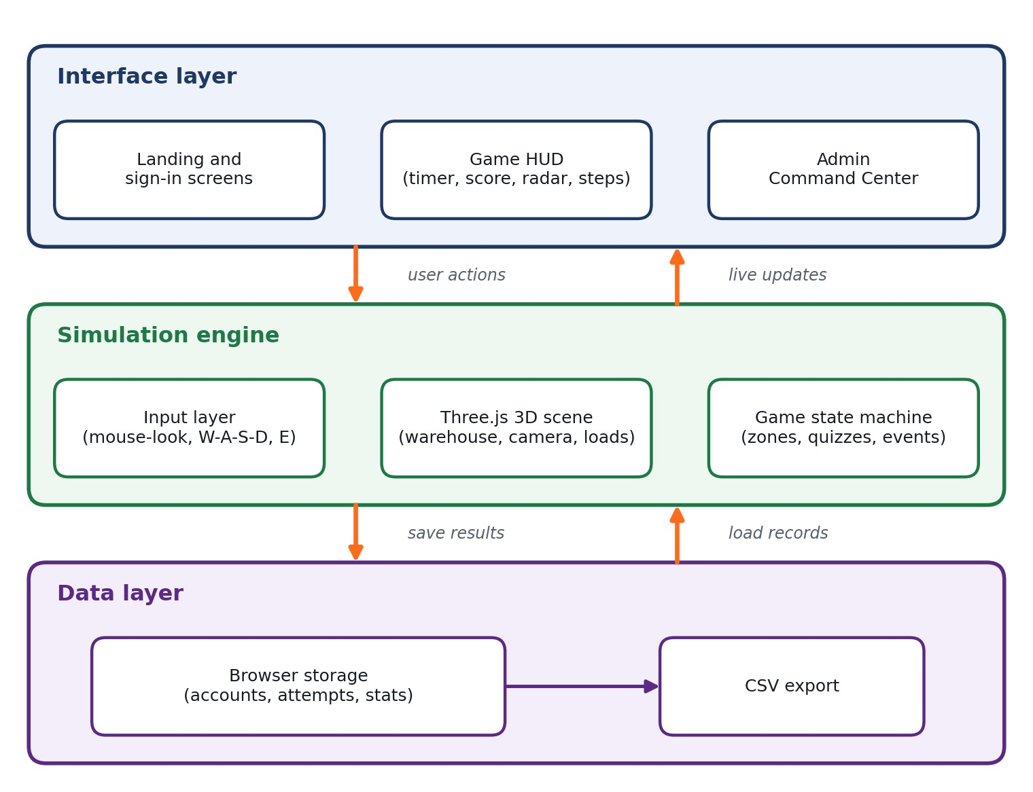
Figure 2: Three-layer architecture (interface, simulation engine, data layer)
The interface layer holds the landing and sign-in screens, the in-game HUD and the admin dashboard. The simulation engine combines pointer-lock input, the Three.js scene and a game state machine for zones, quizzes and events. The data layer is browser storage with a CSV export. We chose client-side storage because the PACT analysis found that no on-site server could be assumed for a first client trial.

3.2 Process flowchart and attempt states
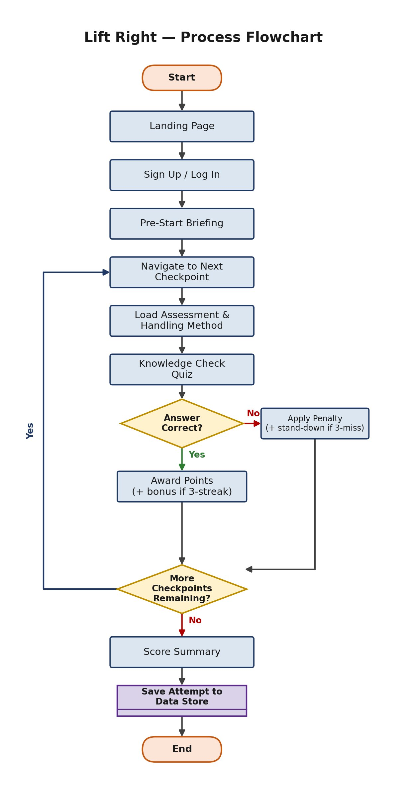  Figure 3: Process flowchart | 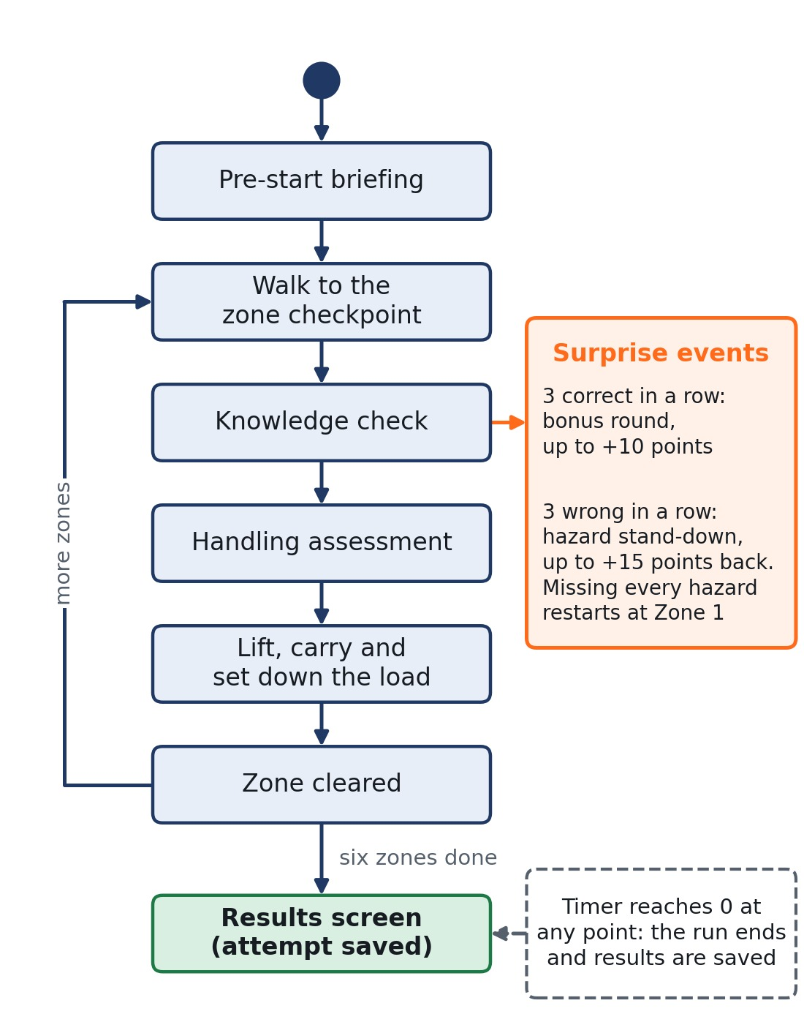  Figure 4: State flow of one training attempt, including bonus and recovery events

The flowchart shows one pass through a checkpoint: navigate, assess the load, answer the knowledge check, then award points or apply a penalty, repeat until every checkpoint is done, then save the attempt. The state diagram adds the two surprise events and the timeout, which the flowchart leaves out for clarity.

3.3 Data flow
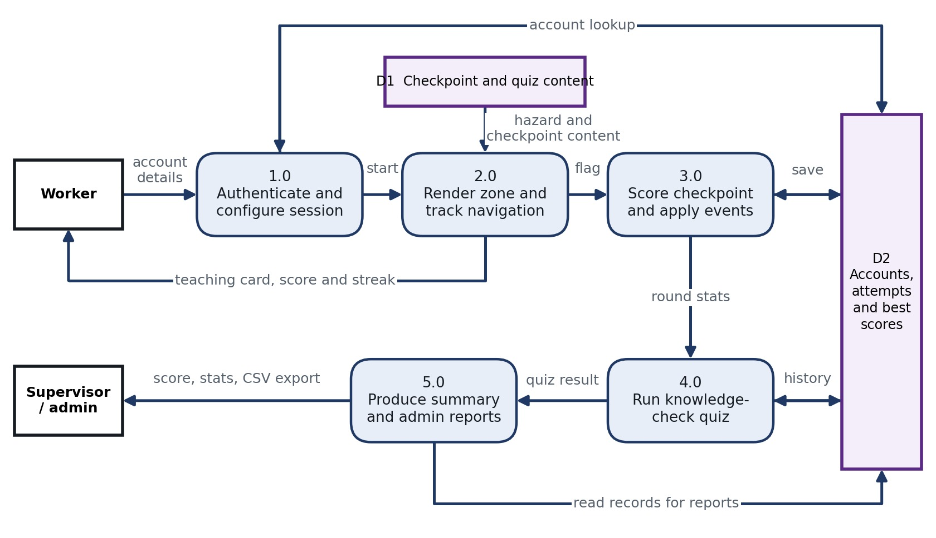
Figure 5: Level 1 data flow diagram
The data flow diagram has no server: both data stores (checkpoint content and attempt records) live in the browser. Supervisors receive their reports through the export process.

3.4 Data model
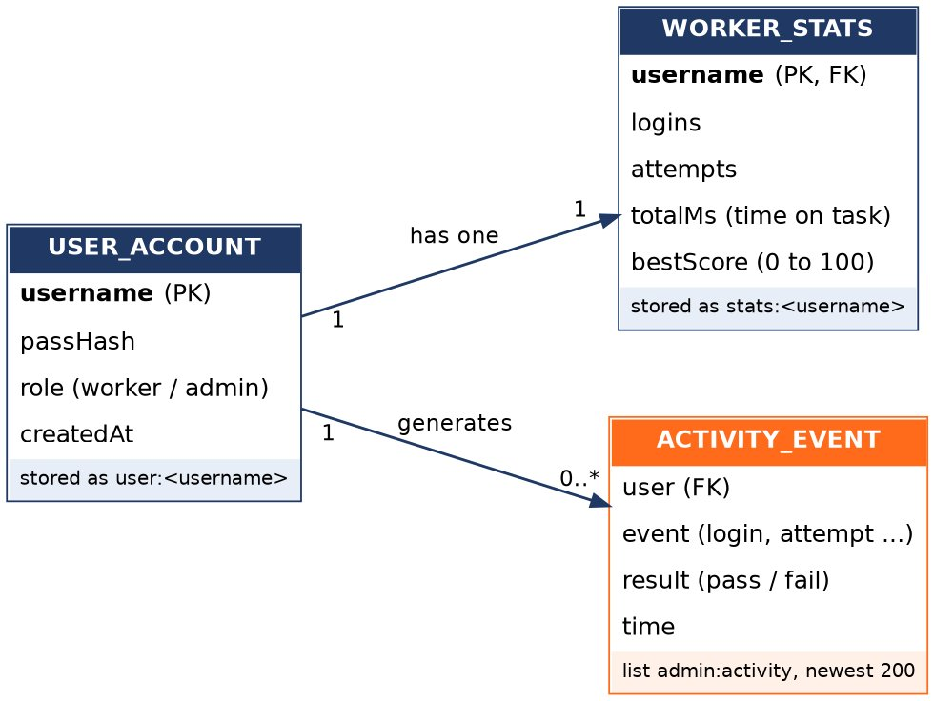
Figure 6: Entity relationship diagram of stored data
Each worker has one account record and one statistics record, and generates many activity events. Statistics are kept as running totals (logins, attempts, time on task and best score), so each attempt is aggregated and not stored individually. The activity log keeps the newest 200 events.

3.5 Scoring sequence
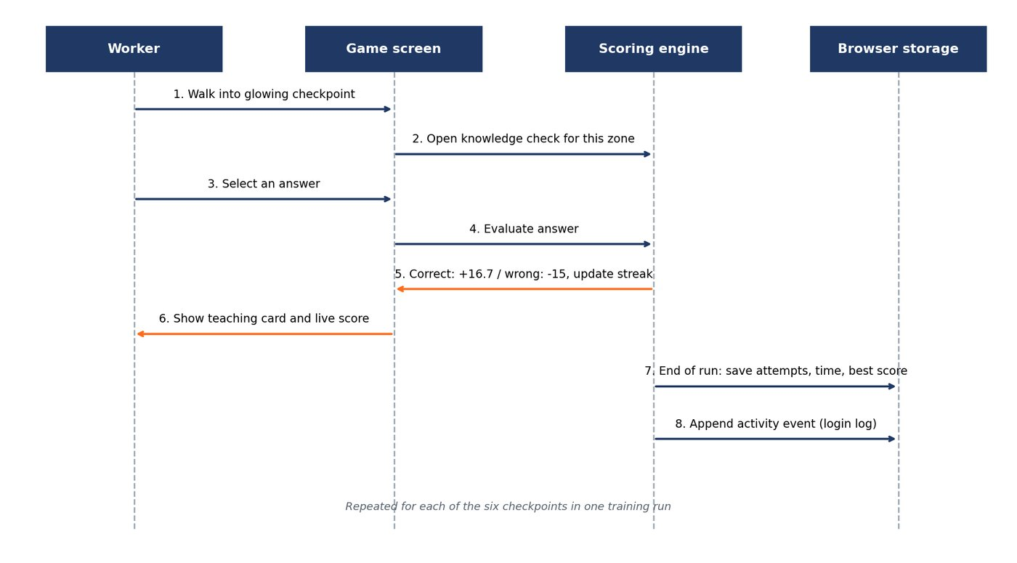
Figure 7: Sequence diagram for answering a checkpoint and saving results
The sequence shows how a worker's answer reaches the scoring engine, how the streak is updated, and when data is written to storage at the end of a run.

3.6 Testing plan
Our test approach combines scripted functional tests drawn from each requirement, usability checks within the team, and a cross-browser smoke test before each client demo. Each test case links back to a user story. On 11 October 2026 we ran the logic tests as an automated script against the submitted prototype in a simulated browser. Three tests (T4, T11 and T19) need a person using real browsers, so they are marked manual. Test T7 passed only in part, test T20 failed as expected, and the security test T21 failed. These are covered in our security report (B4).
ID | Req. | Steps | Expected result | Result and date
T1 | FR3 | Open the app, choose sign up, enter a new username and password, submit. | Account is created and the worker can log in. | Pass (automated, 11 Oct 2026)
T2 | FR3 | Log in with a correct username and a wrong password. | Login is refused with a clear message. | Pass (automated)
T3 | NFR4 | Look at the password field when typing. | Characters are masked unless the worker chooses to show them. | Pass (automated)
T4 | FR1, FR2 | Click to lock the cursor, move the mouse and press W, A, S, D. | View turns 360° and the player walks between zones. | Pass(Manual)
T5 | FR4 | Start a run and clear each zone. | Six zones clear in order and are ticked on the sequence list. | Pass (automated): six steps in order
T6 | FR6 | Walk into a checkpoint and answer correctly, then wrongly on another. | A question appears and an explanation is shown either way. | Pass (automated): explanation shown for right and wrong answers, 4 options
T7 | FR5 | Reach loads of different weights, up to the heaviest. | Only methods suitable for the weight are offered. | Partial (automated): filtered by weight, but every in-game load is 5 to 20 kg so all three methods always appear
T8 | FR7 | Answer all six questions correctly. | Final score is 100. | Pass (automated)
T9 | FR7 | Answer one question wrongly. | 15 points are deducted. | Pass (automated). Note: score can go below 0
T10 | FR7 | Score above 100 through a bonus. | Score is capped at 100. A score of 40 or more is a pass. | Pass (automated)
T11 | FR10, NFR5 | Play a run and watch the HUD. | Timer, score and zone update without visible lag. | Pass(Manual)
T12 | FR8 | Answer three questions correctly in a row. | Golden Crate Drill bonus round starts. | Pass (automated)
T13 | FR9 | Answer three questions wrongly in a row. | Hazard-Spotting Stand-Down starts. | Pass (automated)
T14 | FR11 | Let the timer reach zero, then log in again. | Attempt, time and best score are recorded. | Pass (automated): attempt, 60 s and best score recorded
T15 | NFR8 | Log out and back in on the same browser. | Stats are still present. | Pass (automated)
T16 | FR12 | Log in as administrator after two workers have trained. | Command Center lists each worker with attempts and best score. | Pass, data layer only (automated)
T17 | FR13, NFR9 | Click Export CSV with up to 100 workers. | A CSV downloads in under 2 seconds with all workers. | Pass (automated): 101 rows in 71 ms
T18 | FR14 | Finish a run, replay it, score lower. | Previous best score is kept. | Pass (automated): best score kept after a lower run
T19 | NFR2 | Repeat T1 to T5 in Chrome, Edge and Firefox. | Same behaviour in all three. | Pass (Manual)
T20 | NFR6, NFR7 | Open the app with no internet connection. | App starts and runs offline. Known issue: the 3D library and fonts load from the internet. | Fail (automated): 3D library loads from cdnjs
T21 | Security | Log in with a worker account while Administrator is selected. | Login is refused and the admin screen stays hidden. | Fail (automated): admin screen opens for a worker account

Automated results come from a script that loads the submitted index.html, creates accounts, answers questions and exports data. They confirm the program logic and do not replace testing the 3D scene by hand.

4. User Guides

4.1 Worker guide: how to complete your training
You need a laptop or PC with Chrome, Edge or Firefox and an internet connection when you first open the page. You do not need to install anything.
Step | What to do
1 | Open the Lift Right web address your supervisor gave you.
2 | Choose Sign up, pick a username and password, then Log in. Next time, just log in.
3 | Read the briefing. It shows the controls, what is on screen and how scoring works. Then press Start Training.
4 | Click the screen once so the cursor locks to your view. Walk with W A S D and look around with the mouse.
5 | Walk into the glowing checkpoint and answer the safety question. You get an explanation either way.
6 | Stand next to the load and press E. Choose the handling method (manual, team or trolley) that suits the weight shown.
7 | Carry the load to the next zone and press E to set it down. Repeat until all six zones are done.
8 | Check your score on the results screen. 40 or more is a pass. Your attempts and best score are saved to your record.

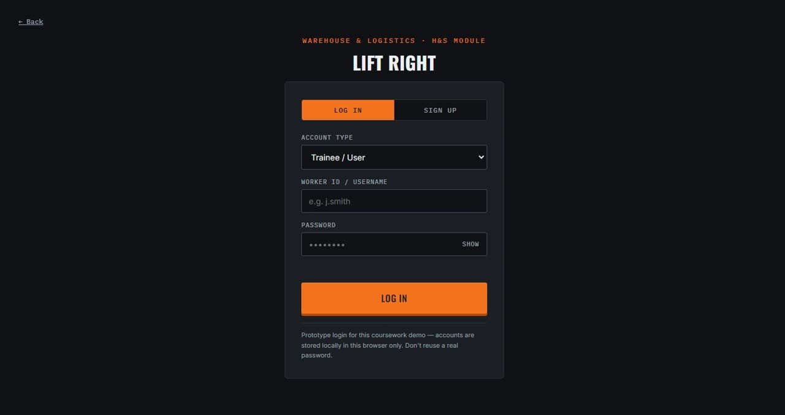  Sign in screen |  | 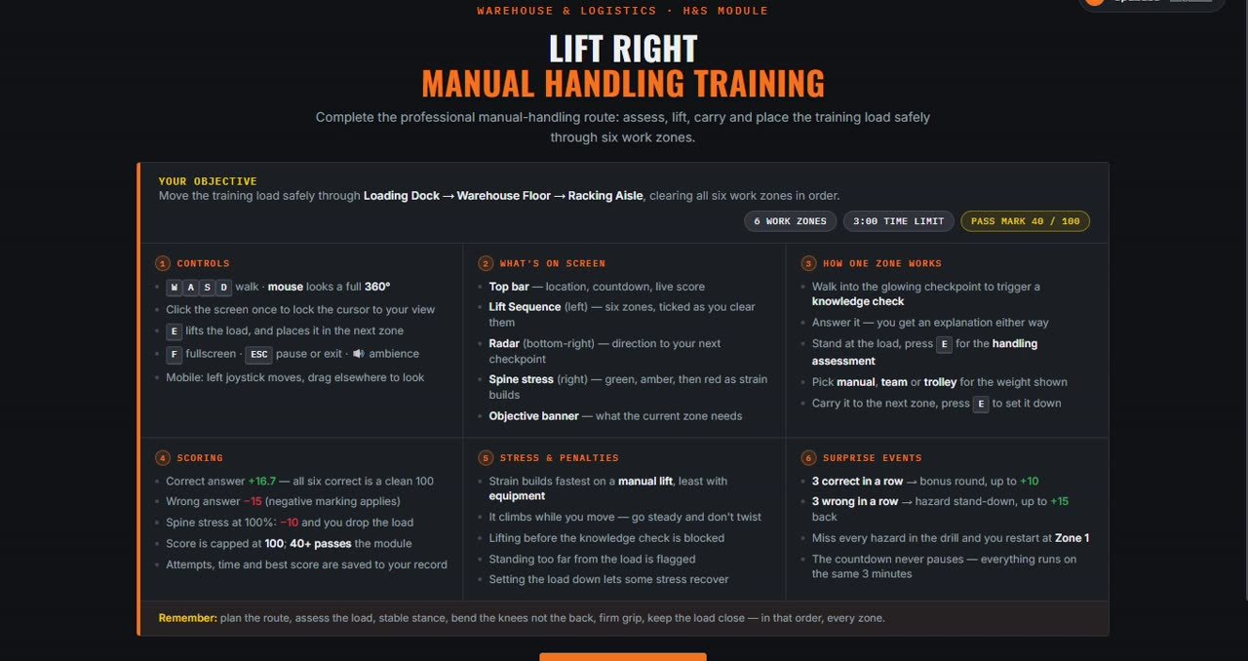  Briefing screen
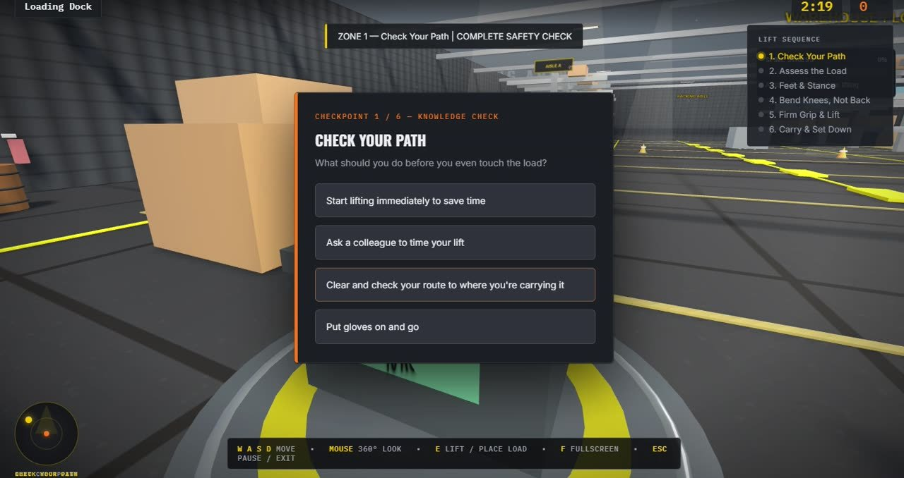  A safety question at a checkpoint |  | 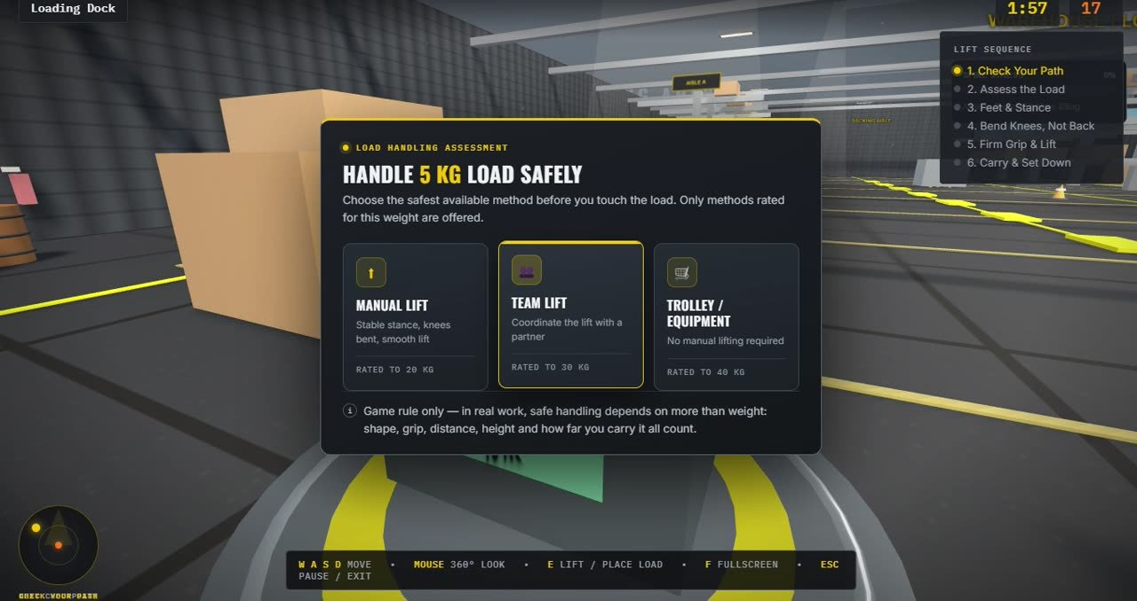  Choosing a handling method
Key | Action
W A S D | Walk
Mouse | Look around in 360° (click the screen once to lock the cursor)
E | Lift the load, and set it down in the next zone
F | Full screen
ESC | Pause or exit
Phone or tablet | Left joystick moves and dragging elsewhere looks around

Scoring in brief: a correct answer scores about 16.7 points, so six correct answers make 100. A wrong answer costs 15 points. Three correct in a row starts a bonus round, and three wrong in a row starts a hazard stand-down. The 3-minute countdown never pauses. Watch the spine-stress meter: it rises fastest on a manual lift, and at 100% you lose points and drop the load.
If something goes wrong:
- The screen is blank or the scene does not load: check your internet connection and refresh the page.
- You cannot look around: click the screen once to lock the cursor.
- You cannot lift the load: answer the knowledge check first and stand closer to the load.
- You forgot your password: ask your supervisor to remove your account so you can sign up again.

4.2 Supervisor guide: how to review training records
Step | What to do
1 | Open the same address and choose Log in, then set the account type to Administrator.
2 | Enter your administrator ID and password. Your training administrator gives you these. To create a new administrator account you need the authorised registration code.
3 | The Command Center opens on the Overview: registered workers, total logins, training attempts, average best score and a safety competency map by checkpoint.
4 | Use the Workers view to see each worker's logins, attempts, minutes, best score and pass or fail result. The Activity Log lists recent logins and attempts.
5 | Click Export CSV to download the records. Open the file in Excel or Google Sheets to keep as evidence.
6 | Use Delete beside a worker only when that person has left or asked for removal. Clearing all worker data cannot be undone, so export a CSV first.
7 | Click Log out when you finish so the next person on a shared PC cannot see the records.

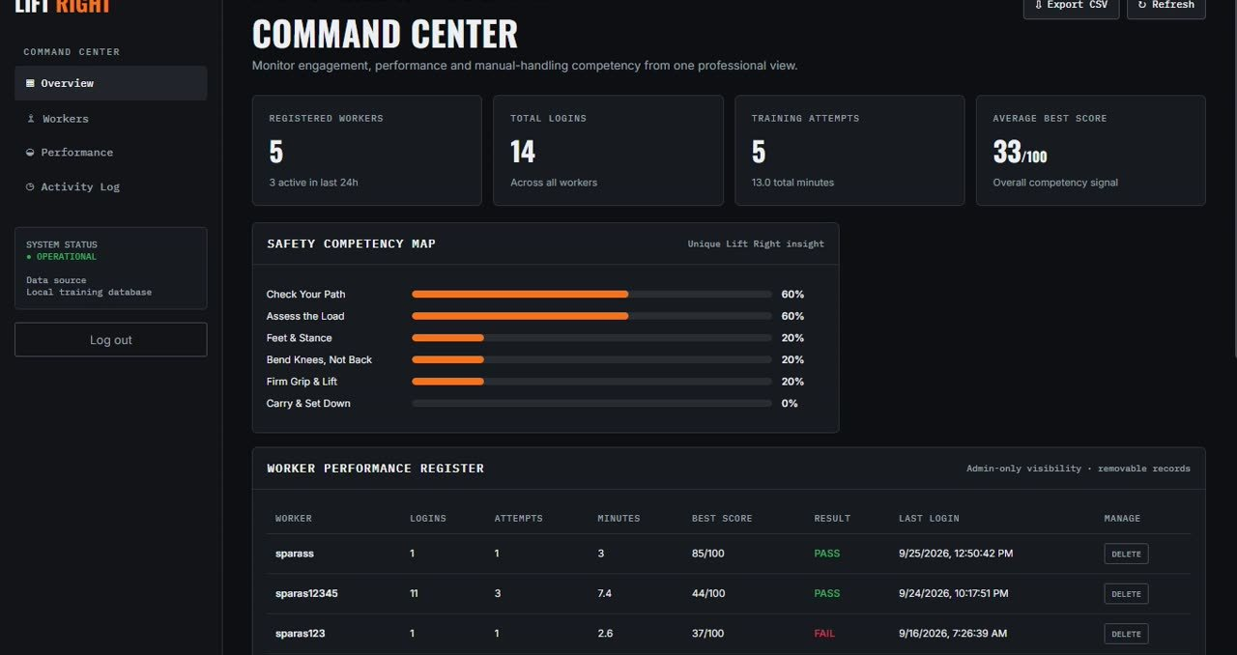  Command Center overview | 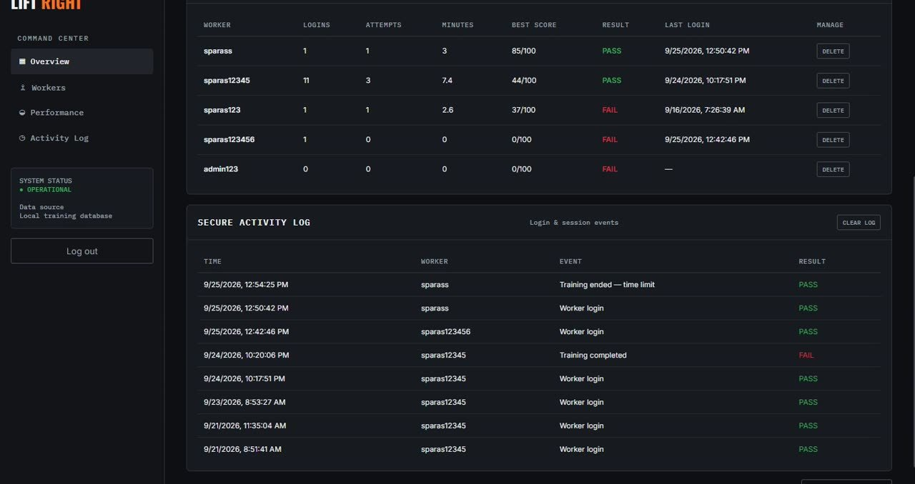  Worker register and activity log

Good practice: do not share the administrator password or the registration code, and always log out on shared computers. In this prototype, records are stored in the browser on that one computer, so export a CSV regularly.

5. Changes Made After Client Feedback
We logged feedback from each client contact and traced it to our requirements and plan. The table shows what the client said, what we did, and the honest status. Where we did not act on feedback in the submitted prototype, we say so.
Source | Client feedback | Our response | Status
Introductory call, Week 3 (about 31 July) | Existing manual-handling training (posters, PDFs, briefings) is routine and does not stick with staff. | This confirmed the problem and became our design principle: an interactive, scored, first-person simulation with explanations at every checkpoint and a short run time. | Implemented
Requirement review, 10 August | Largely satisfied with the direction. Raised feedback on scope. | We used it to finalise the Requirements document and continued the prototype build against it. | Implemented
Prototype demonstration, 3 September (meeting log and client logs) | Positive overall response to the working prototype. Small scope adjustments requested. | Logged against the Requirements document, the Client Interaction Log and the project plan. The replay feature (FR14, a Could requirement) was added as a small scope addition after the client feedback. The meeting log records the other adjustment without further detail. | Implemented (FR14)
Presentation feedback form | Update the layout for selecting options and keep content centred. | Reviewed. Considered for the next iteration. | Planned
Presentation feedback form | Make the point system more varied, with more ways to earn points such as tasks, quick decisions and goals. | We analysed our scoring, which gives points only for correct answers and deducts for wrong ones, apart from bonus and recovery events. We weighed a time bonus and points for completing each step, and noted the risk that speed rewards could penalise careful workers. Not shipped in this prototype. | Explored, planned
Presentation feedback form | Make the experience more engaging and interactive so that learning feels natural. | Playtested ideas in short sessions. The prototype already includes bonus rounds, hazard drills, a spine-stress meter and a radar, and we recommend further work on varied scoring. | Explored, planned

Other feedback we acted on. Playtest feedback from within the team led to polished HUD visuals (radar, timer and step tracker) and smoother camera movement in Week 6, and bug fixes to the stand-down recovery flow in Week 7. This improved usability even though they did not come from the client.
What we learned. Requirements traceability worked well: we could point from each client comment to a requirement and a task. Our weakness was timing. The most significant client feedback arrived at the final presentation, when there was little time left to build it. In future we would book a feedback session earlier and add each piece of feedback to the project plan as a task with an owner and a date as soon as it is received.

