CET257 Enterprise Project: Assignment 2
Task B2: Finalised Zero-Budget Marketing Plan
Team Speed Studios · Lift Right
Client: Sulav G. Raj

1. Summary
Team Speed Studios is a four-person software team. Our first product is Lift Right, a browser-based 360° manual-handling training simulation for warehouse and logistics teams. This is the final version of our marketing plan. It uses no money: every action costs only the team's time. All channels lead to one place, our company website, where a visitor can read about us and try the working prototype.
Section 6 is an honest log of what has already been done in practice and what is prepared and ready to post. We record an action as done only when it has really happened, and we attach the evidence.

2. Company, Product and Brand
Item | Final decision
Company | Team Speed Studios
Product | Lift Right: 360° manual-handling training simulation
Logo | Navy rounded square with two stacked amber lift arrows and speed lines, beside the wordmark TEAM SPEED STUDIOS (files: TeamSpeedStudios_Logo.png and .svg)
Mission | To make workplace manual-handling training something people actually remember, by letting them practise the decisions rather than just reading about them.
Tagline (final) | Learn safe handling by doing it.
Colours | Deep navy #12233D, amber #F2B544, dark amber #D97706
Website | Live at https://shresthasparas.github.io/Team-Speed/TeamSpeedStudios_Website/ (and a ZIP of the files)

3. Problem, Customers and Message
Our client confirmed that manual-handling induction (posters, PDFs, one-off briefings) is routine and easy to forget once staff are back on the floor. Training is usually approved by more than one person, so each message is aimed at a specific role.
Role | What they care about | Our message
Health and safety manager | Proof that training changed behaviour | Training that proves understanding, not attendance.
Operations or site manager | Cost and time away from the shift | A five-to-ten minute run on the computers you already have.
Warehouse staff and team leaders | Not being lectured at again | Six checkpoints. One warehouse. Can you beat your best score?

Positioning: for warehouse and logistics teams whose manual-handling training is sat through and forgotten, Lift Right is a 360° training simulation that scores the decisions behind a safe lift, not attendance at a session.

4. Zero-Budget Channels and Actions
Channel | What we do | Owner | Target | Status
Company website | Four-page site with logo, mission, team and services, and a "Try Lift Right" button on every page | Swikriti, Sparas | Live by 11 October | Done
Live demo | Demonstrate the working prototype to the client at the presentation | All four | Presentation day | Done
Existing client | Share the live prototype link with our client and ask for feedback | Shilu | 12 September | Done
LinkedIn company page | Create the page and add all four members' profiles | Shilu | This week | Ready to do
LinkedIn posts | Three formats: demo clip, "spot the mistake" and "behind the build" | Shilu, Swikriti | Weekly | Ready to post
Direct outreach | Personal emails to local warehouse and logistics employers offering a free demo, with one follow-up | Shilu, Sparas | 5 emails | Ready to send
Demo reel | Three short vertical clips (15 to 30 seconds) with captions | Namshu | This week | Storyboard ready

Every post and email points to the website. We chose LinkedIn because our customers (health and safety, operations and learning professionals) are there, and it costs nothing.

5. Measuring Success
We review these at our weekly meeting: whether each prepared action goes out on schedule, how many outreach emails get a reply, how many people open the prototype link, and whether any prospective client asks for a pilot. Our target is five outreach emails and a first post within one week of submission.

6. Evidence of Enactment
Entries marked "Done" have happened and have evidence. Other rows stay empty until the team has really done the action, and then the date and a screenshot or link are added.
No. | Action | Date | Evidence | Result
1 | Company website published | 11 October 2026 | Website URL and ZIP submitted with B2 | Site live with logo, mission, team and services
2 | Live demo and presentation to the client | Presentation day | Team photo and signed feedback form (see B3, Appendix D) | Client rating 24/25
3 | Prototype link shared with the client | 12 September | Email screenshot (B3, C9) | Link shared and client thanked
4 | LinkedIn company page created
5 | First LinkedIn post (Appendix D graphics)
6 | Outreach emails sent (Appendix B)
7 | First demo clip posted (Appendix C)

7. Risks and Ethics
Risk | How we manage it
A prospect's computer cannot run the live demo | Test on our own laptops first and keep the recorded demo video as a backup.
Few replies to outreach | Personalise each email, follow up once, and start with contacts we already have.
Limited time alongside coursework | Stick to the fixed actions in section 4 and avoid an open-ended campaign.
A student team may not be trusted | Offer a free live demo so people can judge the product itself.

All marketing is honest. We will not name a client without permission, invent statistics, or claim Lift Right is certified or replaces formal safety training. It supports existing training. We use no person's name, photo, quote or score publicly without their consent, and we say openly that the prototype stores data in the browser.

Appendix A: Ready-to-Use LinkedIn Copy

Company page "About" text
Team Speed Studios is a four-person software team building interactive training simulations that run in a web browser. Our first product, Lift Right, puts warehouse staff inside a 360° warehouse to practise safe manual handling, with scored checkpoints and a supervisor dashboard. We are a student team, and we are honest about what we have built. Try the prototype and tell us what you think.

Post 1: Launch
Most manual-handling training is a poster and a signature. We built something different. Lift Right is a 360° warehouse you walk through in your browser. You check your route, assess the load, choose how to lift it, and a score tells you how well you decided. No headset, no install. We are a student team and this is a working prototype. Try it and tell us what we should improve: https://shresthasparas.github.io/Team-Speed/TeamSpeedStudios_Website/

Post 2: Spot the mistake (use the graphic in Appendix D)
A quick one from checkpoint 1 of Lift Right. What should you do before you even touch the load? A, B, C or D? Answer in the comments, and we will share the right one tomorrow (it is C: clear and check your route first). Try the full warehouse: https://shresthasparas.github.io/Team-Speed/TeamSpeedStudios_Website/

Post 3: Behind the build
I am [name] and I built [the part you built, such as the scoring engine] for Lift Right. The hardest part was [one real challenge]. What I learned: [one real lesson]. Try what we built: https://shresthasparas.github.io/Team-Speed/TeamSpeedStudios_Website/

Appendix B: Outreach Email Template
Subject: A free 10-minute demo: Lift Right, a browser-based manual-handling training simulation
Hi [Name],
I am [your name] from Team Speed Studios, a small student software team. We have built Lift Right, a training simulation where warehouse staff walk through a virtual warehouse and make safe-lifting decisions at six checkpoints. It runs in a normal web browser and gives supervisors a record of who has trained.
Would you be open to a free 10-minute demo, or would you prefer to try it yourself at https://shresthasparas.github.io/Team-Speed/TeamSpeedStudios_Website/? We are a student team and the prototype is early, so we would value your honest feedback on [Company]'s manual-handling training.
Best regards,
[Your name], Team Speed Studios
Follow-up (send once, after 3 or 4 days): "Hi [Name], I wanted to check whether you had a chance to look at the Lift Right demo. Happy to keep it to ten minutes at a time that suits you."

Appendix C: Demo Reel Storyboard
Clip | Shows | On-screen caption | Source in demo video
1 (20 s) | Walking to a checkpoint and answering the safety question | "Before you lift: what do you check first?" | About 4:00 to 4:20 of prototype_Video.mp4 (B6 folder)
2 (20 s) | Choosing a handling method for a load of a given weight | "Same load. Which method is safest?" | About 4:20 to 4:40
3 (25 s) | Supervisor view and CSV export | "Evidence, not attendance." | About 8:00 to 8:25
Export each clip vertically (9:16), add open captions so it works without sound, and end on the website address.

Appendix D: Social Media Graphics
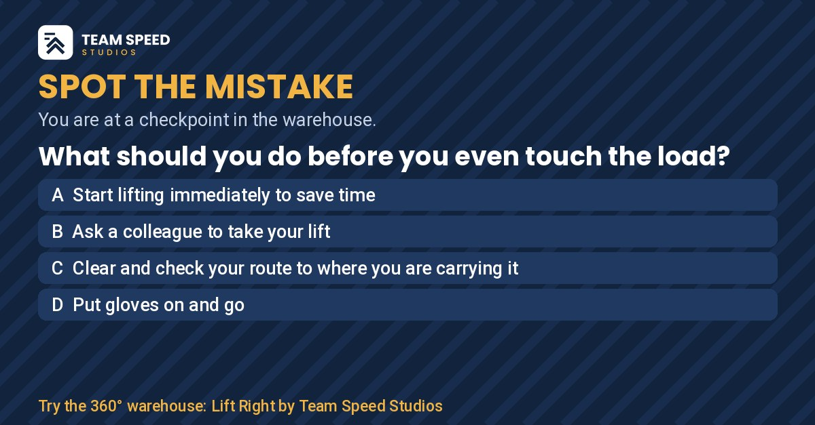
Graphic for Post 2: Spot the mistake
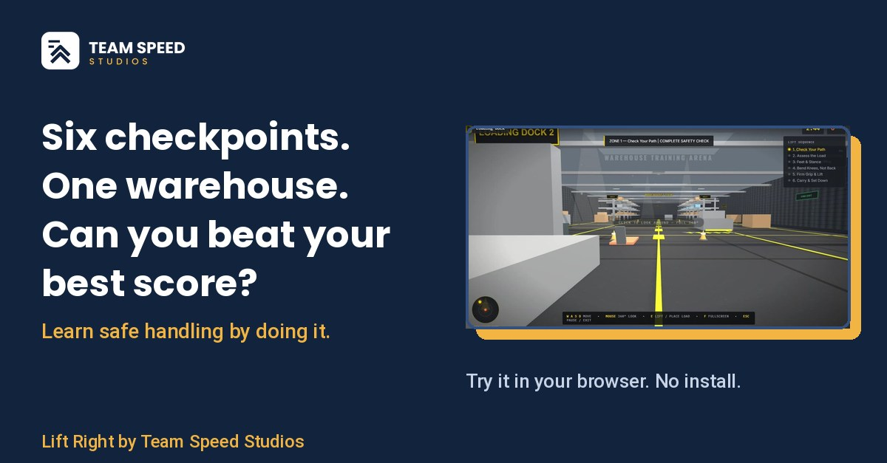
Graphic for Post 1: Feature card

Appendix E: Posting Checklist
- Create the LinkedIn company page with the logo and the About text from Appendix A.
- Each member adds Team Speed Studios and Lift Right to their own profile.
- Post the feature card (Post 1), and add the website link.
- Send five personal outreach emails and note each date.
- Take a screenshot of every post and email, and add the date and screenshot to the table in section 6.

