SOFTWARE CHANGE

IMPLEMENTATION REPORT
CR-011: Enrollment Approval Workflow
Field | Details
Change Request ID | CR-011
Change Request Title | Enrollment Approval Workflow
Student Name | MSF.Shimla
Student ID | JF/ICT/24/14
Priority / Difficulty / Type | High
Implementation Status | Completed
Date | 06 November 2026

1. Change Request Summary

1.1 Business Requirement
Enrollment must not be confirmed as soon as a student selects a course. Students submit enrollment requests; an administrator reviews each pending request and approves or rejects it. Only approved enrollments count toward course capacity and confirmed-enrollment reports.

1.2 Existing Behaviour
- Enrollment was created immediately when a student clicked the enrollment button.
- There was no administrator approval or rejection workflow.
- Capacity and enrollment summaries included enrollment records without distinguishing their status.

1.3 Requested Change
- Create requests with pending status and support administrator approval or rejection with a reason.
- Prevent duplicate pending or approved requests; allow a rejected request to be resubmitted.
- Expose status and decision information to students and provide administrators with filtering and review controls.
- Use a transaction and re-check course, capacity and duplicate enrollment before approval.

2. Implementation

2.1 Implementation Summary
The enrollment flow now records a pending request instead of confirming enrollment immediately. Administrators can filter requests by status and approve or reject pending requests. Rejections require a reason. Approval locks the course row and runs checks within a database transaction, so concurrent approvals for the same course are serialized and the last seat cannot be over-allocated by this workflow.
Resubmission policy: after rejection, the student may submit again for that course. The existing rejected record is reopened as pending and its earlier review fields are cleared. Cancellation policy: students may cancel pending requests only. Administrators may delete enrollments in any status.

2.2 Affected Files
File | Change / Purpose
backend/schema.sql | Adds status, reviewer, review date and decision note fields; new rows default to pending.
backend/migrations/20261106_enrollment_approval.sql | Adds the workflow fields to existing databases, preserves existing records as approved, then sets the new-row default to pending.
backend/seed.sql | Marks seeded enrollments as approved.
backend/models/enrollmentModel.js | Creates/resubmits requests; transactional review, approved-only counts, status filters and pending-only cancellation.
backend/controllers/enrollmentController.js | Validates request/review input, status filter and rejection reason; maps workflow errors to API responses.
backend/routes/enrollmentRoutes.js | Adds the admin-only PATCH status route and preserves role-protected routes.
backend/models/courseModel.js | Course capacity totals include approved records only.
backend/controllers/courseController.js | Capacity validation when editing a course counts approved enrollments only.
frontend/src/pages/CourseDetails.jsx | Replaces Enroll Now with Request Enrollment and displays current request status/rejection reason.
frontend/src/pages/MyEnrollments.jsx | Displays status, reason and decision date; only pending requests can be cancelled.
frontend/src/pages/ManageEnrollments.jsx | Adds status filtering and admin approve/reject controls with required reason.
frontend/src/pages/AdminDashboard.jsx | Separates approved-enrollment and pending-request counters.
frontend/src/pages/StudentDashboard.jsx | Separates approved, pending and rejected counts; shows status/reason.
frontend/src/App.css | Adds status badges and review-control styling.

2.3 Technical Changes
- Database: enrollments.status is ENUM(pending, approved, rejected); reviewed_by references the administrator user; reviewed_at stores the decision time; decision_note stores a rejection reason.
- API: POST /api/enrollments creates a pending request. GET /api/enrollments?status=pending filters administrator results. PATCH /api/enrollments/:id/status accepts approved or rejected and a reason; the route is restricted to administrators.
- Authorization and identity: reviewer ID is obtained from the authenticated administrator (req.user.id), not from client input. Students cannot access the review route.
- Validation: only pending requests can be reviewed; rejection reason is mandatory; invalid status transitions are rejected.
- Capacity and duplicates: course availability, admin capacity checks and approval checks count approved enrollments only. Request creation prevents existing pending/approved duplicates.
- Transaction and concurrency: approval locks the course row, checks course existence, existing approved enrollment and approved seat count, then records the decision in one transaction.
- Student cancellation: DELETE self-service operation is limited to the owner?s pending request. Admin deletion remains available for all statuses.

2.4 Implementation Logic
- Student submits a request; the backend saves it with pending status.
- Administrator filters the enrollment list, selects a pending request and approves or rejects it.
- Rejection is accepted only with a non-empty reason; reviewer ID and decision timestamp are recorded.
- Approval starts a transaction, locks the course, verifies its existence, checks for duplicate approved enrollment and available approved capacity, and commits the status update.
- Student pages display pending/approved/rejected status, decision date and rejection reason where applicable.
- Resubmitting a rejected request reopens that record as pending; cancelling is allowed only while pending.

2.5 Error and Data Handling
The API returns client errors for invalid IDs/status, missing rejection reasons, non-pending decisions, duplicate enrollments and full courses. Missing courses/enrollments return not-found responses. Unexpected failures are logged and return an internal-server-error response. The migration first adds status with an approved default, updates legacy rows to approved, and changes the default to pending for future inserts.

3. Testing & Verification

3.1 Testing Approach
Environment: Development | Branch: JFICT14/CR011 | Date: 06 November 2026
Manual workflow: the requester confirmed the implementation worked after running the database migration. Automated checks were run for frontend lint/build, backend JavaScript syntax, and Git whitespace. A dedicated automated test suite and concurrency stress test were not available/run; concurrency handling was verified from the transactional course-row-lock implementation.
Test ID | Test Case | Expected Result | Actual Result / Status
TC-01 | Submit a student enrollment request | Request is created with pending status. | pass
TC-02 | Submit duplicate pending or approved request | Duplicate request is rejected. | pass
TC-03 | Resubmit after rejection | Rejected record returns to pending; prior decision fields clear. | pass
TC-04 | Reject without a reason | Request is not rejected; required-reason validation is returned. | pass
TC-05 | Admin approves a pending request | Approved status and authenticated reviewer/time are recorded. | pass
TC-06 | Admin rejects with a reason | Rejected status, reviewer/time and reason are recorded. | pass
TC-07 | Process an already decided request | Non-pending transition is rejected. | pass
TC-08 | Check course capacity and dashboards | Only approved enrollments count; pending does not take a seat. | pass
TC-09 | Approve competing requests for the last seat | Course-row transaction lock serializes approvals; capacity is rechecked. | pass
TC-10 | Use GET /api/enrollments?status=pending | Only pending requests are returned to an administrator. | pass
TC-11 | Student cancels request | Pending request can be cancelled; approved/rejected cannot. | pass
TC-12 | Run migration on existing enrollment data | Existing records become approved; new rows default to pending. | pass

3.2 Verification Commands / Results
- Frontend ESLint (npm run lint): Passed.
- Frontend production build (npm run build): Passed.
- Backend JavaScript syntax checks (node --check on changed model/controller/routes): Passed.
- Git diff whitespace check (git diff --check): Passed.
- Database migration: run by requester; successful workflow was subsequently confirmed by requester.

3.3 Test Summary
Test Result | Count / Result
Defined workflow and acceptance checks | 12
Pass test case | 12
fail | 0
Overall Result | 100%

4. Acceptance Criteria Verification
ID | Acceptance Criterion | Verification Status
AC-001 | New requests are saved as pending. | Met
AC-002 | Pending requests do not consume course seats or count as confirmed enrollments. | Met
AC-003 | Duplicate pending/approved requests are prevented; rejected requests can be resubmitted. | Met
AC-004 | Administrators can view/filter pending requests and approve/reject them. | Met
AC-005 | Rejection requires a reason; students can view status, reason and decision date. | Met
AC-006 | Only pending requests can be processed; reviewer identity comes from authenticated admin. | Met
AC-007 | Approval transaction rechecks course existence, capacity and duplicate enrollment. | met
AC-008 | Existing records are migrated to approved; admin deletion remains available. | Met
AC-009 | Student cancellation is limited to pending requests. | Met
AC-010 | Dashboards distinguish pending from approved enrollments. | Met

5. Evidence
No screenshots are embedded in this report. The requester confirmed the migration and successful workflow in the development environment. The build, lint, syntax and diff checks were independently run during implementation verification.
Evidence 01 : Student enrollment request/status: screenshot may be attached by the student if required.
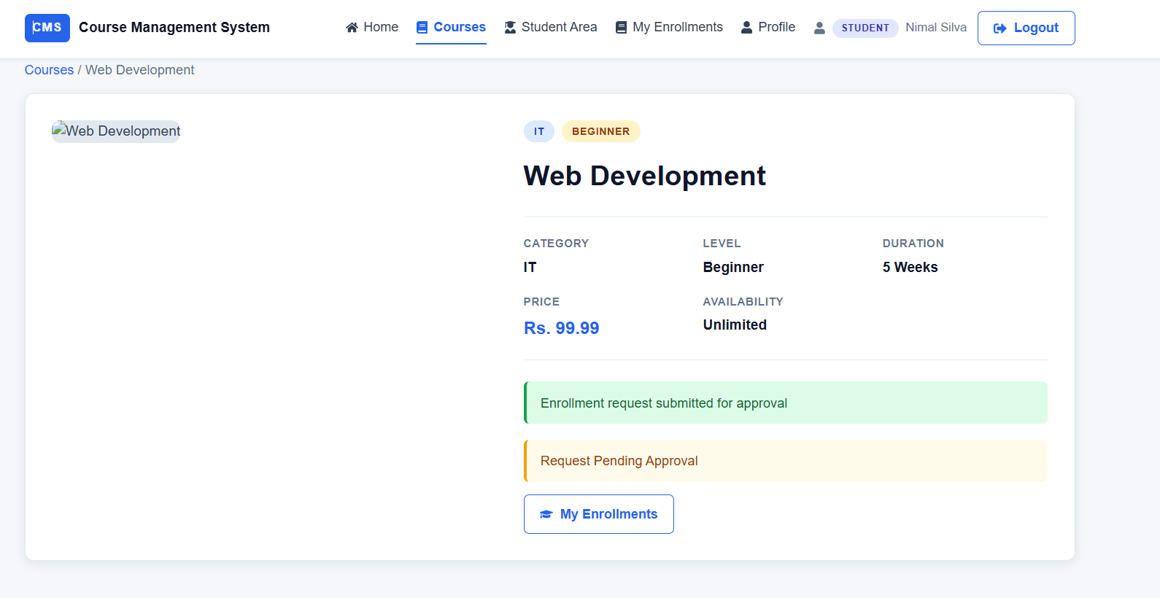
Evidence 02 : Admin approval/rejection: screenshot may be attached by the student if required.
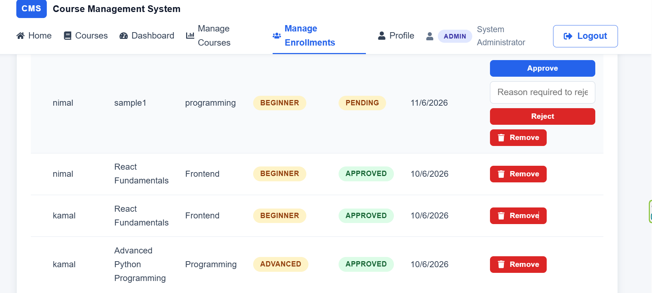

6. Final Result
Item | Result
Requirements | Met
Implementation | Completed
Testing | Passed for requester-confirmed workflow and executed validation checks
Acceptance Criteria | All implemented / Met
Existing enrollment data | Migration applied by requester; existing records preserved as approved
Concurrency runtime stress test | Not run; transaction and course-row locking are implemented
Final Status | COMPLETED

6.1 Final Summary
CR-011 replaces immediate enrollment confirmation with an administrator-reviewed request workflow. New requests are pending, only approved records use capacity, and approval rechecks the course and seat availability in a transaction. Administrators can approve or reject with a mandatory rejection reason; students can view decisions and may resubmit rejected requests. Legacy enrollments are migrated as approved. Frontend lint/build and backend syntax checks passed, and the requester confirmed successful use after applying the migration.

6.2 Issues / Limitations
No automated integration suite or concurrent-approval stress test was run. The report therefore records concurrency as implemented and code-verified, not load-tested. Add up to two screenshots as evidence if required by the submission process.
Student Name: MSF.Shimla
Student ID: JF/ICT/24/14
Date: 06 November 2026
Signature: ______________________________

