Computer Engineering Department

Distributed and Operating Systems

Executing Document

|  |  |
| --- | --- |
| Shima Osamah | 11716299 |
| Shatha Abu Hanesh | 11717777 |

**How to Run our Design?**

1. 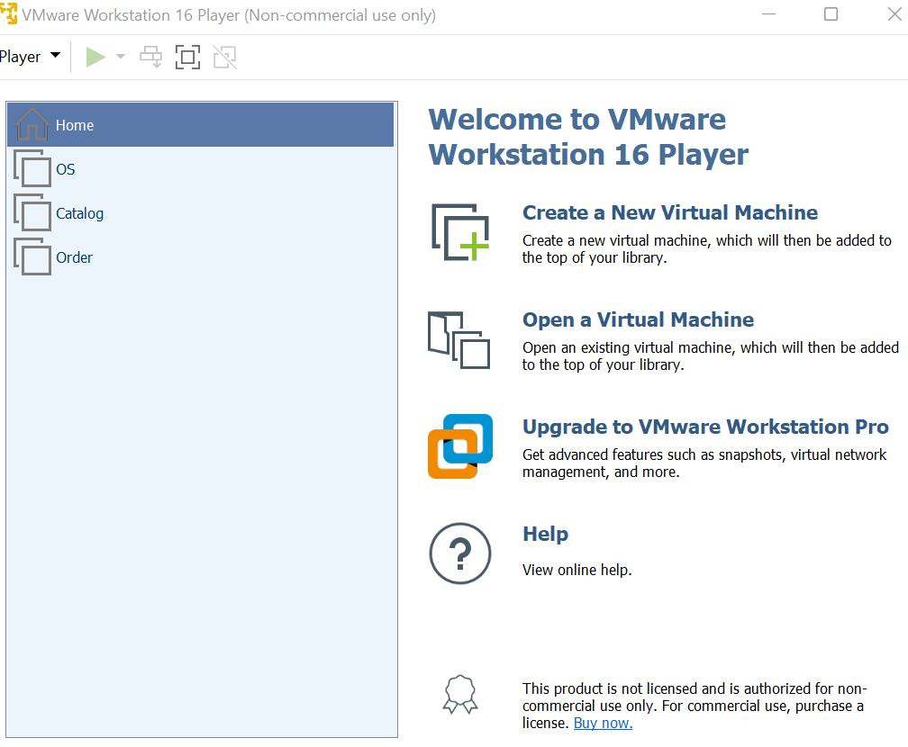Create three virtual machines:

* OS machine will contain frontend services.
* Catalog will handle query services and DB.
* Order will handle purchase service.

1. On each machine there will be its python implementation (each VM will have one folder from our repository).
2. Now we have to change the host address of each python file:

*host address is the IPv4 for each machine.

* + main.py in front folder.

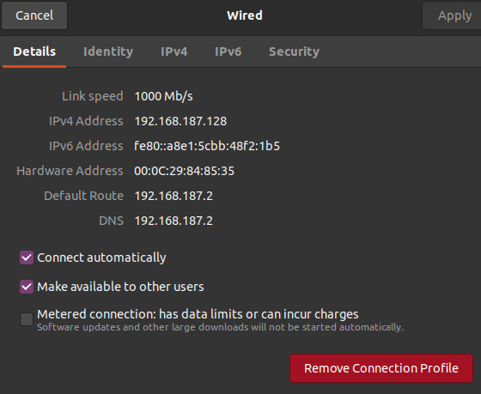

* + order.py in order folder.

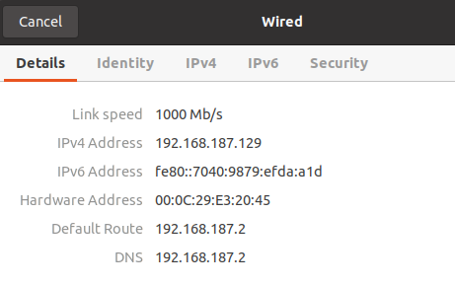

* + query.py in catalog folder.

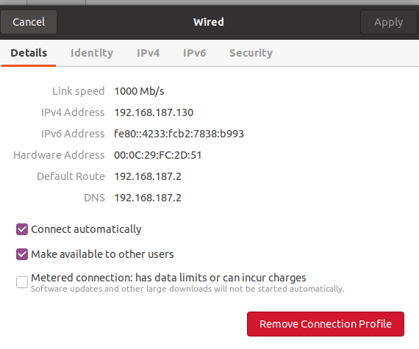

* On each file we will replace the host value with its IPv4 address.

For example, in main.py the host address will be like this:



1. more modification in main.py and order.py:
   * in main.py:
     + lines (23,28,33,38) the request address must be as the host address in catalog VM.
     + line 34 the request address must be as the host address in order VM.
   * In order.py:
     + Lines (23,31) the request address must be as the host address in catalog VM.
2. Finally, we will run the three python files each on its VM.

*make sure that (flask, flask_cors, and pandas) are installed. If not, then simply run (pip install <lib_name>) on the terminal.

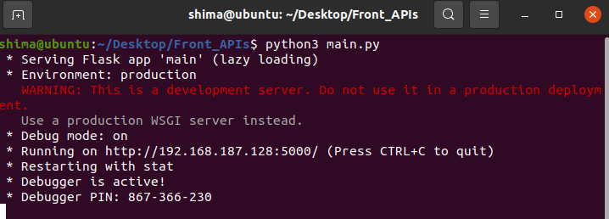

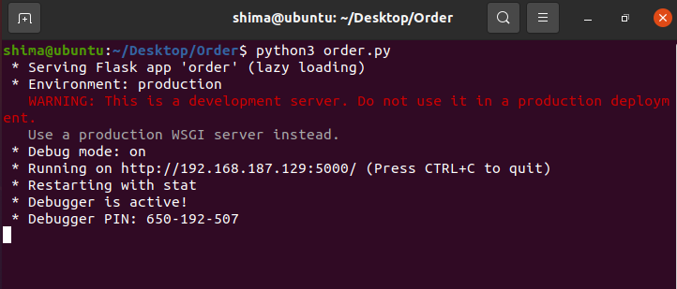

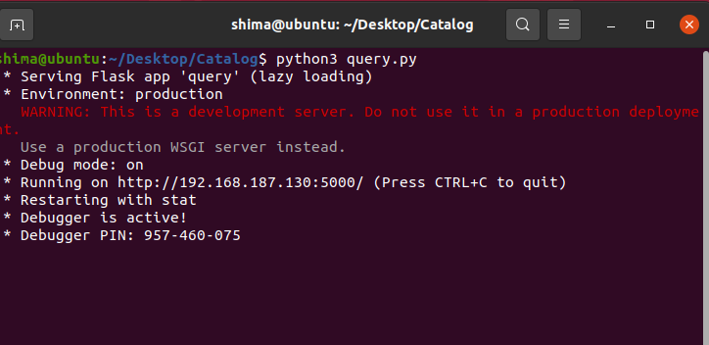

1. On Postman we will try to buy a book:

