-present simple and present continuous

-past simple and present perfect

email:

----------

-tall sentence

-informal regards

-misspelling

-too many details

-exclamation marks

-emoji’s

-uppercase

-informal end

-informal words

Good things:

-conscience

-good use of spacing

-grammar

------------------------------------------------------------------------------------------------------------------------------------------

Vocabulary:

value for money: something that is good value is not expensive, or is worth what you pay for it.

Upmarket: designed for or used by people who have a lot of money.

Durable: staying in good condition for a long time, even if used a lot (hard-wearing), continuing for a long time.

Inexpensive: cheap (cost little money)

Fashionable: popular, especially for a short period of time

Sexy: exciting, attractive, and interesting

Timeless: remaining attractive and not becoming old-fashioned

Cool: attractive, fashionable, interesting, in a way that people admire – used in order to show approval

well-made

reliable: dependable, something that is reliable can be trusted or depended

sophisticated: very well designed and very advanced and often works in a complicated way

fun: very enjoyable and exciting

----------------------------------------------------

Loyalty: the tendency to always buy a particular brand

Image: the ideas and beliefs people have about a brand

Stretching: using an existing name on another type of product

Awareness: how familiar people are with a brand (logo, products)

Name: the title given to a product by its company

Launch: the introduction of a product to the market

Lifecycle: the length of time people continues to buy a product

Range: the set of products made by a company

Placement: when products are used in films or TV programs

Endorsement: the use of a well-known person to advertise products

Leader: the best-selling product or brand in a market

Challenger: the second best-selling product or brand in a market

Segment: customers of a similar age, income level or social group

Research: information about what consumers want or need

Share: the percentage of sales a company has

----------------------------------------------------------------------------------------------------------------------------------------------------------------------------------------

Present simple (play/plays):

-facts, companies’ activities

- routine activities or habits

Keywords: usually/often/nowadays/everyday/once a month/sometimes

Present continuous (am /are/is playing)

- ongoing situations and projects

- temporary situations

Currently/ now/ at that moment/this year/these days

Future:

Going to:

- intend to do and have already decided to do

-more sure

Will:

- quick decision

-ideas and thoughts

-perhaps (not confirmed)

Present continuous:

-fixed arrangement (steps/pay/book)

Present simple:

- timetable or program (The flight/eaves Ho Chi Minh City at 11:30 on Tuesday. It arrives in Danang at 12:40)

-schedule

Past:

Past simple (played/went):

-actions finished

-have no effect now

Present perfect (has/have gone):

-unfinished events (till now, since, how long)

-finished (have an effect now (this year, this month, this year, this week))

-life experience (ever/never)

-news/recent events (just, yet, recently)

-present results

------------------------------------------------------------------------------------------------------------------------------------------

1 not enough leg room

2 lost or delayed baggage

3 long queues at check-in

4 poor quality food and drinks

5 no baggage trolleys

6 overbooking of seats

7 flight delays and cancellation

8 tiredness and jet lag

9 delays for security check

10 oversized hand luggage in the cabin

Jet lag: the tired and confused feeling that you can get after flying a very long distance, especially because of the difference in time between the place you left and the place you arrived at

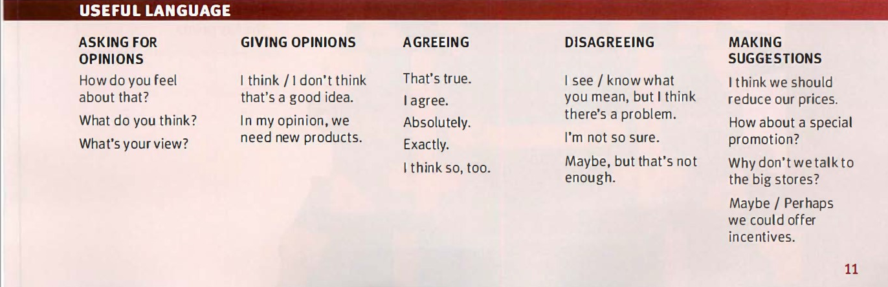

Peak travel: at times when the largest number of people are traveling.

Upgrade: a change to a better seat or level of service.

Boarding bass: a card you must show in order to get on a plane.

Frequent-flyer points: awarded by airlines to reward customer loyalty.

Lounge: a room in a hotel/airport where people can sit and relax.

Ground staff: all the people who work at an airport, but not the pilots or cabin crew.

Check-in: you go to the desk at a hotel/airport to say you have arrived.

Innovative: something is new, different, and better than those that existed before

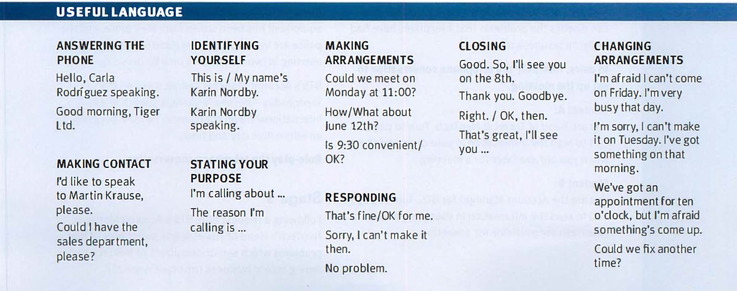

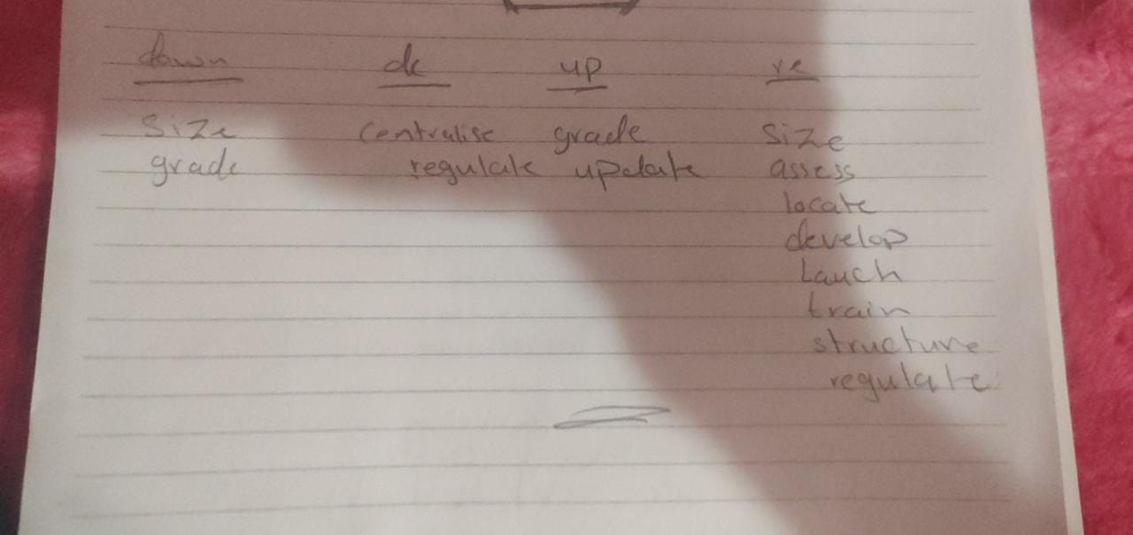 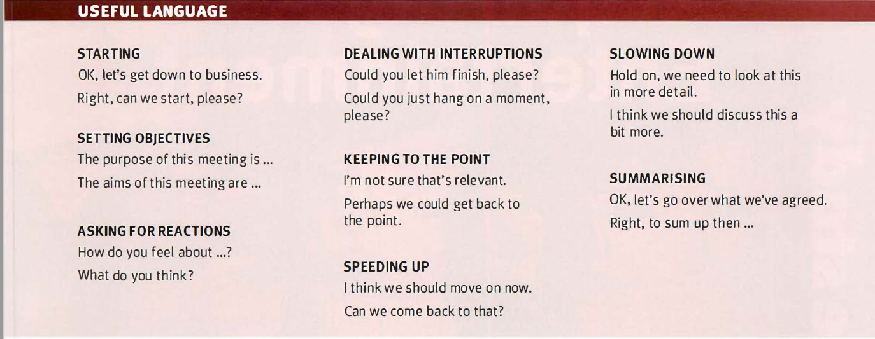

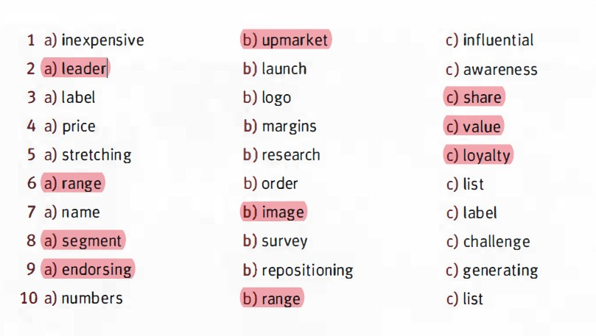

33]2]travel:

---------------------

1]will

2]is going

3]will

4]will

34]1]

1] reassessing / reassess /

2]is downsizing / downsize

3]update /updating /

4]deregulate

5]retrain

34]2] past simple and present perfect:

--------------------------------------------------

A: How long have your offices been (your offices I be) in this area?

B: Since April 2007.

A: Where were you before that?

B: In the city center. But the rent was (be) outrageously expensive, so we decided (decide) to relocate to the suburbs.

A: And have you ever regretted (you I ever I regret) your decision?

B: Frankly, we were (be) slightly worried about all the changes in the first couple of months, but we soon realized (soon I realize) that it was the right move. This part of town is extremely attractive, and in fact, it has developed (develop) enormously over the last two

or three years.

A: So it seems you have had (have) a very good year so far.

B: Absolutely! Sales stood (stand) at €14m at the end of the last quarter, and they have already increased (already I increase) by 6%.

A: What about your market share?

B: It remained (remain) stable since 2008, but we are confident it will increase when we

launch our new product.

A: have you had to (you I have to) make anyone redundant?

B: No. At lortex, we pride ourselves on the fact that there have not been any redundancies for over eight years.