Subsidiary: a company which is at least half-owned by another company

Factory/plant: large building or group of buildings where goods are made (using machinery)

Service Center: a place where faulty products are mended

Warehouse: a building for storing goods in large quantities

Outlet: a place through which products are sold

Accomplishments: success in doing something

Initiative: the ability to make decisions and take action without waiting for someone to tell you what to do

Autonomy: the ability or opportunity to make your own decisions without being controlled by anyone

Empowerment: giving people the power to do something

We can combine two or more nouns in several ways.

1 's possessive: the company's logo

2 one noun used as an adjective: labor costs

3 phrases with of: director of operations

4 compound nouns forming one word: workforce 00

10-year plan

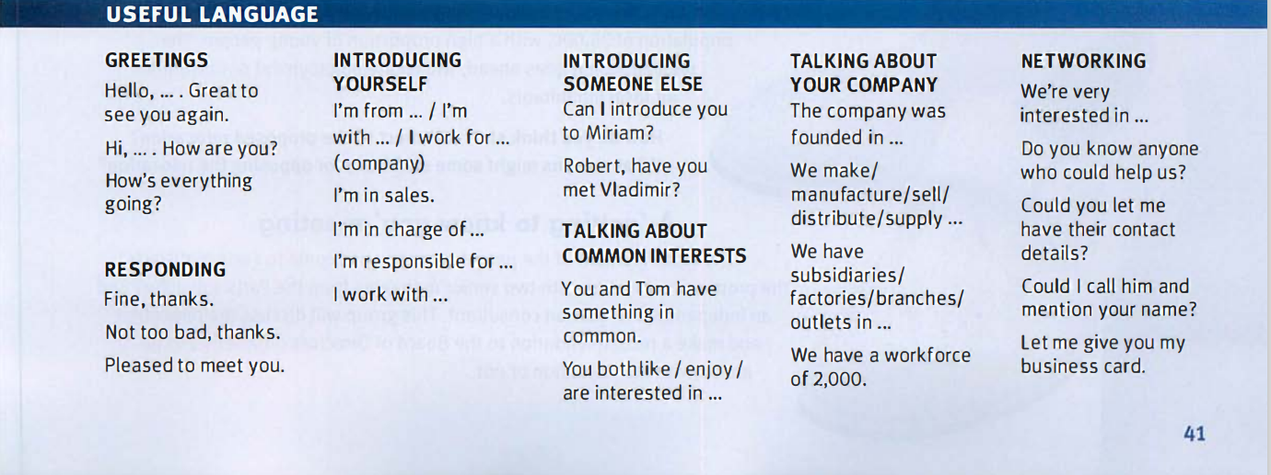

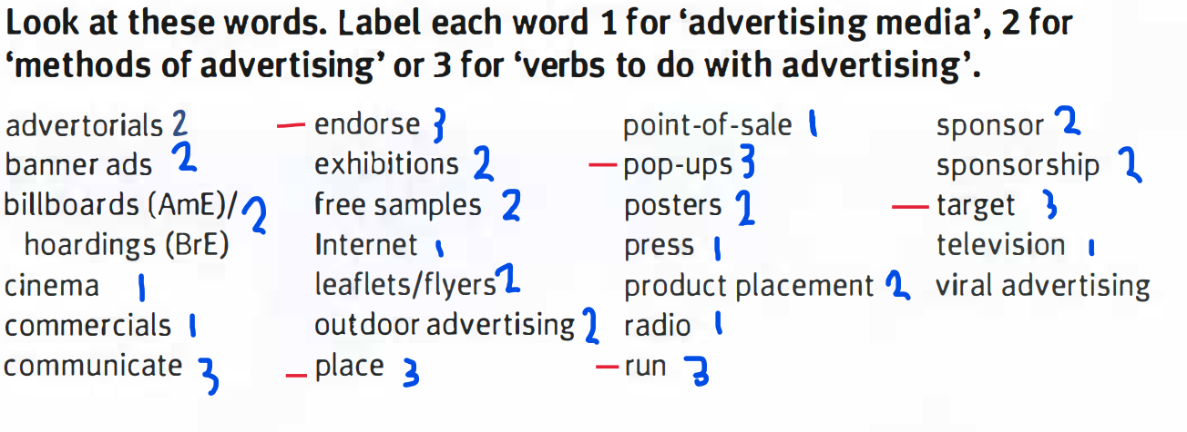

Stunt: something done to get people attention

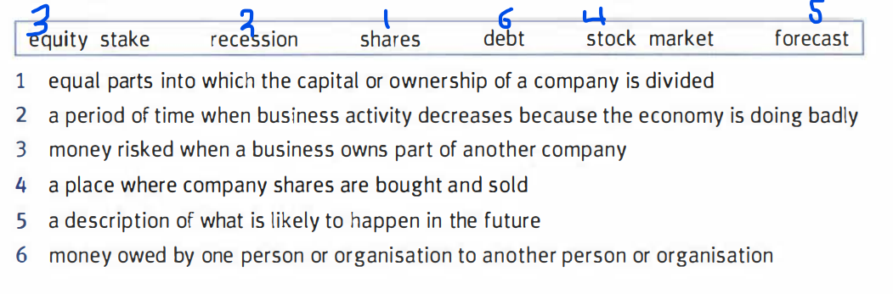

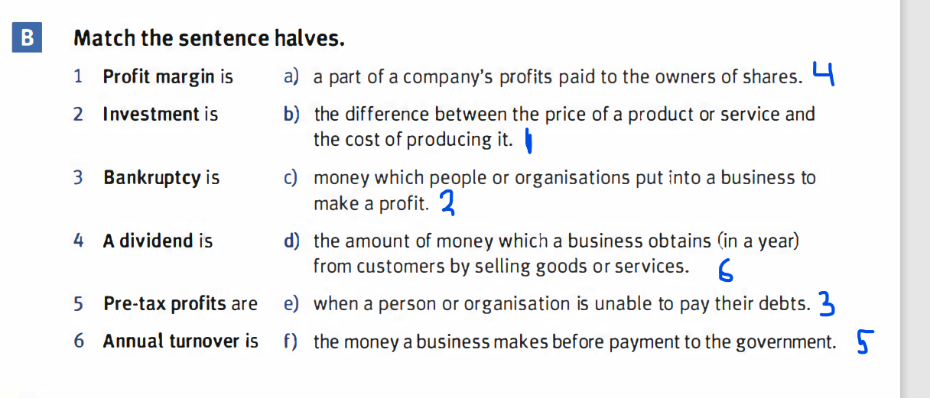

**A bear market** : a financial market in which prices are falling

Investor/stock trader: people who deal in shares and bonds

**A financial analyst** : someone who carefully examines Ihe financial state of a company

decline

gain

drop

increase

rocket

plummet

double

fall

halve

level off

triple

recover

decrease

fluctuate

improve

peak

rise

jump

Revision B:

-draw up a contract

-install and maintain system

-keep records

-train staff

-carry out research

-issue press releases

-------------------------------------------------------------------------------------

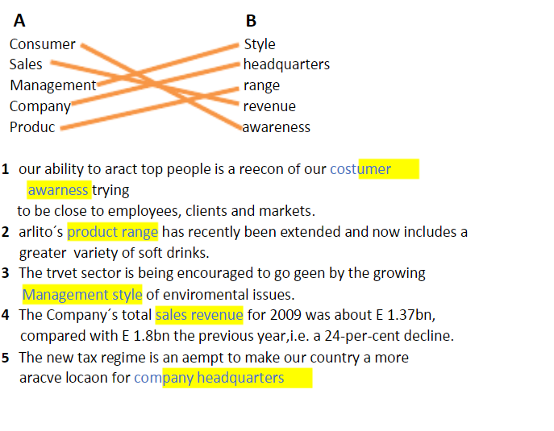

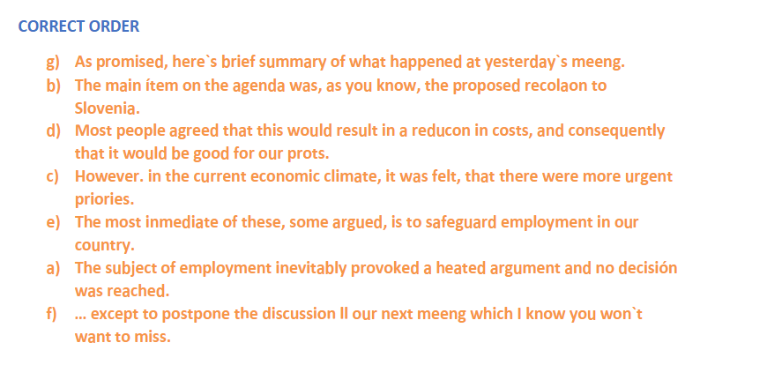

You may disagree that advertising is an art.

You may even find it irritating at times.

But it has certainly become part of our life.

The newspaper article that you started reading turns out to be an advertorial.

The programme you are watching on tv is suddenly interrupted by a series of commercials for various consumer goods, including one for Crips, endorsed by your favorite film star.

And no sooner do you start surfing the internet that pop-ups invade your screen.

So you stick a break and go for a stroll, only to take it in once more how much hoardings have indeed change your cityscape.

Then, on entering your local supermarket, you notice immediately that point-of-sale advertising is alive and well, but do not refuse the ..given away that day.

Finally you just do it – yes, you buy three packets of Crips and walk back home with a spring in your step.

