Experiment-2

TIC-TAC-TOE PROBLEM

Submitted by:

Shimonee Singh

RA1911003011052

Code:

import random

import sys

board=[i for i in range(0,9)]

player, computer = '',''

# Corners, Center and Others, respectively

moves=((1,7,3,9),(5,),(2,4,6,8))

# Winner combinations

winners=((0,1,2),(3,4,5),(6,7,8),(0,3,6),(1,4,7),(2,5,8),(0,4,8),(2,4,6))

# Table

tab=range(1,10)

def print_board():

x=1

for i in board:

end = ' | '

if x%3 == 0:

end = ' \n'

if i != 1: end+='---------\n';

char=' '

if i in ('X','O'): char=i;

x+=1

print(char,end=end)

def select_char():

chars=('X','O')

if random.randint(0,1) == 0:

return chars[::-1]

return chars

def can_move(brd, player, move):

if move in tab and brd[move-1] == move-1:

return True

return False

def can_win(brd, player, move):

places=[]

x=0

for i in brd:

if i == player: places.append(x);

x+=1

win=True

for tup in winners:

win=True

for ix in tup:

if brd[ix] != player:

win=False

break

if win == True:

break

return win

def make_move(brd, player, move, undo=False):

if can_move(brd, player, move):

brd[move-1] = player

win=can_win(brd, player, move)

if undo:

brd[move-1] = move-1

return (True, win)

return (False, False)

# AI goes here

def computer_move():

move=-1

# If I can win, others don't matter.

for i in range(1,10):

if make_move(board, computer, i, True)[1]:

move=i

break

if move == -1:

# If player can win, block him.

for i in range(1,10):

if make_move(board, player, i, True)[1]:

move=i

break

if move == -1:

# Otherwise, try to take one of desired places.

for tup in moves:

for mv in tup:

if move == -1 and can_move(board, computer, mv):

move=mv

break

return make_move(board, computer, move)

def space_exist():

return board.count('X') + board.count('O') != 9

player, computer = select_char()

print('Player is [%s] and computer is [%s]' % (player, computer))

result='%%% Deuce ! %%%'

while space_exist():

print_board()

print('# Make your move ! [1-9] : ', end='')

move = int(input())

moved, won = make_move(board, player, move)

if not moved:

print(' >> Invalid number ! Try again !')

continue

#

if won:

result='* Congratulations ! You won ! *'

break

elif computer_move()[1]:

result='=== You lose ! =='

break;

print_board()

print(result)

Ouptut:

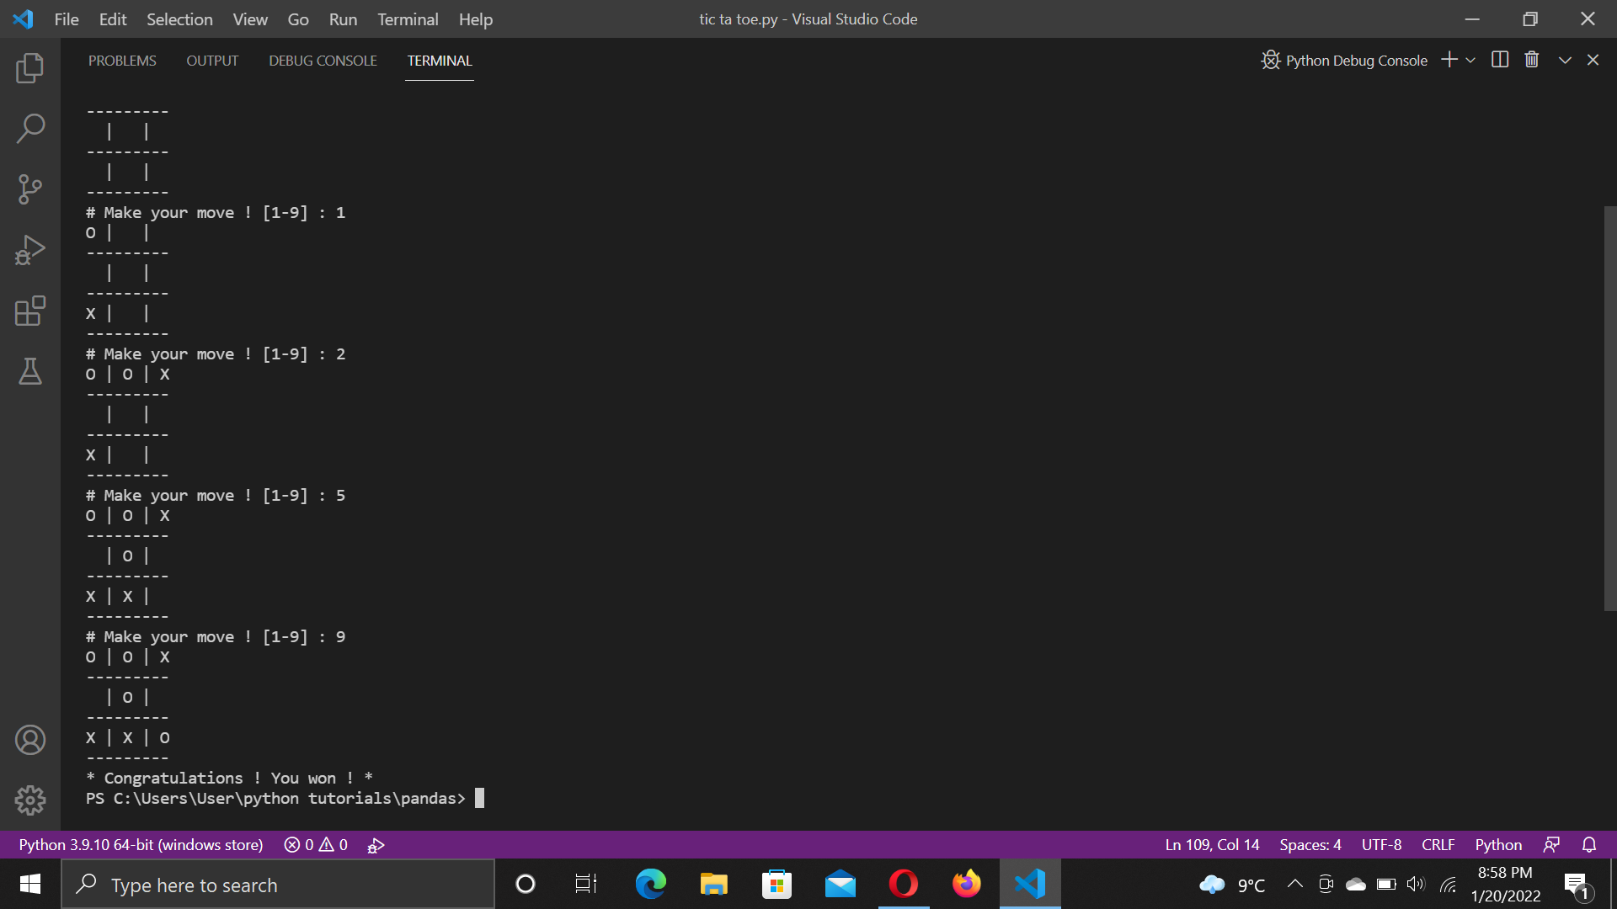

Conclusion:

Program for tic-tac-toe problem worked successfully.