A Project Paper
On
RFID Based Door Lock System Using Arduino With LCD Display

The dissertation has been submitted for the partial fulfillment of the requirements for the degree of Bachelor of Science (B.Sc.Engineering) in Electrical and Electronic Engineering
Submitted By
Hussain Abdulah Saleh Shimanto
Roll No: 1815052
Reg No: 1189
Session: 18-19
Department of Electrical and Electronic Engineering
Islamic University, Kushtia-7003
Bangladesh
Supervised By
Professor Dr.Md. Shahjahan Ali
Department of Electrical and Electronic Engineering
Islamic University, Kushtia-7003
Bangladesh
Submission Date-01/06/2024

Department of Electrical and Electronic Engineering, Islamic University, Kushtia-7003

DEDICATED
TO
MY PARENTS
APPROVAL CERTIFICATE
This is to certify that Hussain Abdulah Saleh Shimanto, Roll-1815052, Registration No: 1189, has successfully completed a project on the development of a RFID Based Door Lock System Using Arduino With LCD Display. The project was carried out under the guidance of Professor Dr. Md. Shahjahan Ali, Department of Electrical and Electronic Engineering, Islamic University, Kushtia-7003.
The project demonstrates a comprehensive understanding of RFID technology, microcontroller applications, and sensor integration for automated water pump control. The developed system has the potential to improve water management efficiency and facilitate remote monitoring.
Hussain Abdulah Saleh Shimanto has exhibited excellent research skills, problem-solving abilities, and a strong grasp of technical concepts. The project reflects a high degree of dedication and commitment to innovation in the field of water resource management.

SUPERVISOR
Professor Dr. Md. Shahjahan Ali
Department of Electrical and Electronic Engineering
Islamic University, Kushtia-7003
Bangladesh
SIGNATURE

ACKNOWLEDGEMENT
First of all, I would like to express my deepest gratitude to Allah, the almighty, for His mercy extended to me to this project work, manage each and everything soundly.

I feel immense pleasure to express my gratitude to Professor Dr. Md. Shahjahan Ali, Department of Electrical and Electronic Engineering, IU, Kushtia-7003, Bangladesh under whose constant guidance and supervision the project was carried out. I am grateful to him for his assistance in performing this project work and to write the procedure of report and every aspect of this project and made significant suggestions for classifying and improving presentation. I am also grateful to chairman of exam committee.

I am also grateful to all my teachers Department of Electrical and Electronic Engineering, IU, Kushtia-7003, Bangladesh for their continuous encouragement and generous cooperation during the course of this work.

I owe to gratitude to my parents who sacrificed a lot for carrying out this study.

Hussain Abdulah Saleh Shimanto
Department of Electrical and Electronic Engineering, Islamic University, Kushtia-7003. Bangladesh
DECLEARATION

I’m Hussain Abdulah Saleh Shimanto, hereby declare that the project entitled “RFID Based Door Lock System Using Arduino With LCD Display” is original. It has been submitted as project to the Department of Electrical and Electronic Engineering, Faculty of Engineering and technology, Islamic University, Bangladesh, in partial Fulfillment of the requirements for the Degree of Bachelor of Science (B.Sc.) in Engineering in Electrical and Electronic Engineering.
The study is conducted under the supervision of Professor Dr. Md. Shahjahan Ali Department of Electrical and Electronic Engineering, Faculty of Engineering and technology, Islamic University, Bangladesh.
I further declare that neither any part nor the whole of this dissertation has been submitted for any degree to any other universities or institutions and to the best of my knowledge, my dissertation does not infringe upon anyone’s copyright nor violet any proprietary rights.
Hussain Abdulah Saleh Shimanto
(Examinee)
Roll: 1815036
Reg.no: 1173
Department of Electrical and Electronic Engineering
Islamic University, Bangladesh.
ABSTRACT
This research paper presents the design and implementation of an RFID-based door lock system using an Arduino Nano and an LCD display. The system aims to enhance security and automate access control for secure areas. By integrating RFID technology with an Arduino Nano, the system reads RFID tags and allows access only to authorized users. The LCD display provides real-time feedback to users about the status of their access attempts. This paper details the system design, component selection, circuit implementation, software development, and testing results.

Table of Contents
Certificate i
Acknowledgement ii
Declearation iii
Abstract iv
Contents v
List of Figure
Chapter 01
1. Introduction 1
1.1 Introduction 1
1.2 Potential Benefits 2
1.3 Historical Background 3
Chapter 02
2. Literature Review 5
Chapter 03
3. Aim & Scope of the project 6
3.1 Aim & Objectives 6
3.2 Proposed System 7
3.3 Working 7
Chapter 04
4. Methodology 10
4.1 Introduction 10
4.2. Hardware Required 10
4.2.1 Arduino NANO 11
4.2.2 RC522 RFID Card Reader 19
4.2.3 RFID tags 20
4.2.4 LCD Display (16x2) 21
4.2.5 I2C LCD adapter module 22
4.2.6 Servo Motor 23
4.2.7 Active buzzer 24
4.3 Hardware Implementation 25
4.4 Software Implementation 27
Chapter 05
5. Results & discussion 28
Chapter 06
6. Conclusion & future scope 29
6.1 Conclusion
6.2 Future Scope 30

The List of Figure
Name of Figure Page No
3.1: RFID Base Door Lock using Arduino Diagram 6
3.2: Automatic access control system using Arduino and RFID 7
4.1: Arduino NANO 11
4.2: Arduino NANO Pinout 13
4.3 RC522 RFID Card Reader Module 19
4.4: RFID tags 20
4.5: LCD 16x2 display 21
4.6: I2C LCD adapter module 22
4.7: Servo Motor 23
4.8: Active Buzzer 5v 24
4.9: RFID Base Door lock system Using Arduino 25

Chapter One
Introduction
  - Introduction
Security is a critical concern in today's world, and traditional lock-and-key systems often fail to provide adequate protection. RFID technology offers a more secure and convenient alternative by allowing access through RFID tags, which can be easily carried and managed. This project leverages an Arduino microcontroller to build an RFID-based door lock system that enhances security and provides a user-friendly interface through an LCD display.
  - Potential Benifits
Enhanced Security:
- Non-Duplicable Access: Unlike traditional keys, RFID tags are difficult to duplicate, enhancing the security of the access control system.
- Encrypted Communication: RFID systems can use encryption to protect the data transmitted between the tag and the reader, reducing the risk of eavesdropping and unauthorized access.
- Multi-Layer Authentication: The system can be integrated with other authentication methods, such as passwords or biometrics, for multi-factor authentication, further strengthening security.
Convenience and Ease of Use :
- Contactless Access: Users can gain access without the need to physically insert a key or card, making it more convenient and faster, especially in high-traffic areas.
- User Feedback via LCD: The LCD display provides real-time feedback, such as "Access Granted" or "Access Denied," making the system user-friendly and easy to understand.
- Simple Management: Adding or removing authorized users can be done easily by updating the RFID tag database, eliminating the need to change locks or redistribute keys.
Flexibility and Scalability:
- Scalable System: The system can be easily scaled to accommodate more users by simply adding more RFID tags and updating the database.
- Remote Management: With appropriate modifications, the system can be managed remotely, allowing administrators to control access from anywhere.
- Modular Design: Using Arduino and modular components like RFID readers and LCD displays allows for easy upgrades and integration with other systems.
Cost-Effective Solution:
- Affordable Components: Arduino, RFID modules, and LCD displays are relatively inexpensive and widely available, making the system cost-effective to build and maintain.
- Low Maintenance: RFID systems have fewer moving parts compared to traditional locks, reducing wear and tear and the need for frequent maintenance.
- Energy Efficient: The system can be designed to be energy efficient, with the Arduino Nano and other components consuming minimal power.
Improved Access Control Management
- Audit Trails: The system can log access attempts, providing a detailed record of who accessed the door and when, which is useful for security audits and monitoring.
- Time-Based Access: Access permissions can be configured to be time-based, allowing or denying entry during specific times or days, enhancing control over access.
  - Historical Background

RFID Technology
Early Development
- 1940s-1950s: The origins of RFID can be traced back to World War II, where radar technology was used to distinguish between friendly and enemy aircraft. This concept evolved into the use of transponders for automatic identification.
Commercialization
- 1970s: The first commercial applications of RFID technology emerged. These were primarily in the form of Electronic Article Surveillance (EAS) systems used in retail to prevent theft.
- 1980s: Advancements in microchip technology and the development of standards led to more widespread adoption of RFID. Key applications included livestock tracking and toll collection systems.
- 1990s: RFID technology saw significant growth in industrial and logistics applications. The introduction of passive RFID tags, which do not require an internal power source, made the technology more versatile and cost-effective.
Modern Era
- 2000s-Present: RFID technology has become ubiquitous, used in various sectors including retail, healthcare, transportation, and security. The development of Ultra High Frequency (UHF) RFID and integration with the Internet of Things (IoT) has expanded its capabilities and applications.

Arduino
- 2005: The Arduino project was initiated in Italy by Massimo Banzi, David Cuartielles, Tom Igoe, Gianluca Martino, and David Mellis. It was designed to provide a simple and affordable platform for students and hobbyists to create interactive projects.
Evolution and Community Growth
- 2005-2010: The Arduino platform quickly gained popularity due to its open-source nature, ease of use, and extensive community support. Various models, including the Arduino Uno, Mega, and Nano, were introduced, catering to different needs and applications.
- 2010s-Present: Arduino has become a staple in the maker community, educational institutions, and prototyping industry. The ecosystem has expanded to include a wide range of shields, modules, and accessories, enabling more complex and diverse projects.

Chapter Two

Literature Review

Radio-Frequency Identification (RFID) technology has been widely adopted in various industries for applications such as inventory management, access control, and asset tracking. RFID systems consist of tags, readers, and a backend database system. RFID tags, which can be active or passive, contain unique identifiers that are read by RFID readers via radio waves. The ability to read tags without line-of-sight and over varying distances makes RFID a versatile and powerful tool in numerous contexts. Access control systems are crucial for maintaining the security of restricted areas. Traditional methods, such as mechanical locks and keys, have several limitations, including the risk of key duplication and loss. RFID-based access control systems offer a more secure alternative. These systems use RFID tags assigned to authorized individuals, allowing for seamless and contactless access. Research has demonstrated that RFID systems can significantly enhance security and streamline access management processes (Banerjee, 2016). Arduino's open-source nature allows for extensive customization and integration with various sensors and modules, making it an ideal choice for prototyping and educational purposes (Blum, 2013). This literature review provides an overview of the key concepts and prior research relevant to the development of an RFID-based door lock system using Arduino Nano and an LCD display. It sets the stage for understanding the current state of the technology and its applications, as well as the challenges and opportunities for future development.

Chapter Three

AIM AND SCOPE OF PROPOSED SYSTEM

3.1 AIM AND OBJECTIVE:
- To design a secure door lock system using RFID technology.
- To implement an Arduino Nano-based control unit for managing the door lock.
- To provide real-time access status feedback via an LCD display.
- To ensure ease of use, reliability, and scalability of the system.
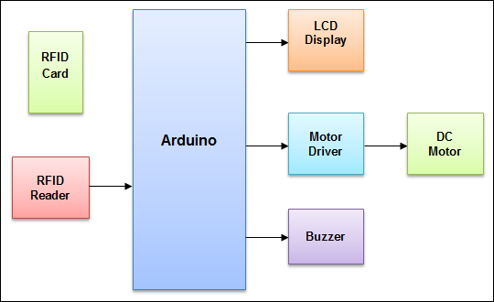
Figure 3.1:- RFID Base Door Lock using Arduino Diagram

3.2 PROPOSED SYSTEM:
The proposed system aims to create a secure and efficient door lock mechanism using RFID technology controlled by an Arduino Nano. The system will feature an LCD display to provide user feedback, a servo motor to operate the door lock, and RFID tags to manage access control. This section outlines the overall architecture, components, and functioning of the proposed system.
3.3 WORKING :
The RFID door lock system using Arduino Nano provides a secure and user-friendly method for controlling access. The integration of an RFID reader, LCD display, and servo motor controlled by an Arduino Nano offers an efficient solution for modern access control needs. The system's ability to read RFID tags, authenticate them, control a locking mechanism, and provide user feedback makes it suitable for various applications, including residential, commercial, and institutional security.
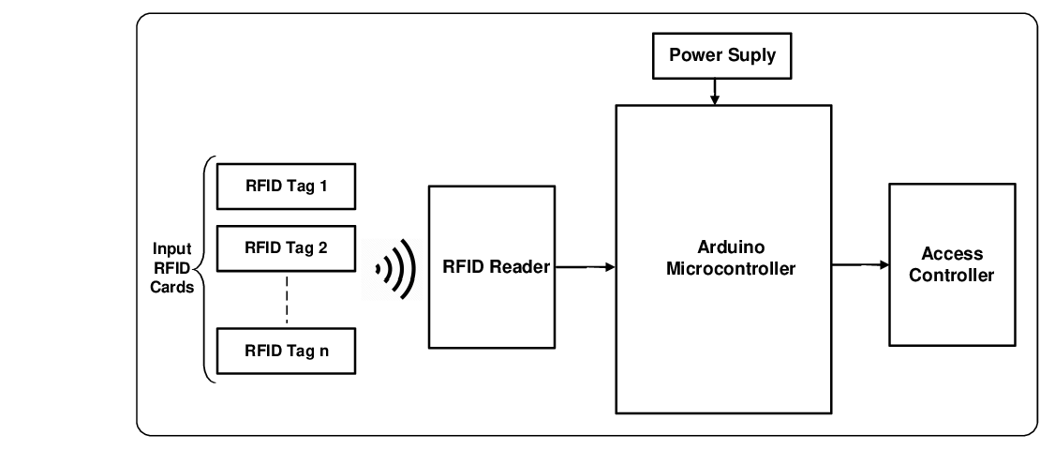
Fig- 3.2: Automatic access control system using Arduino and RFID

Step-by-Step Working Process
1. System Initialization
When the system is powered on, the Arduino Nano initializes all components:
- RFID Reader: The RC522 module is set up to start scanning for RFID tags.
- LCD Display: The display is initialized to show a welcome message or default status.
- Servo Motor: The servo motor is positioned in the locked state.

2. RFID Tag Detection
The system continuously scans for RFID tags:
- RFID Reader: Checks if a new RFID tag is present.
- Tag Reading: If a tag is detected, the reader captures its UID.

3. Authentication
The Arduino Nano compares the read UID with a list of authorized UIDs stored in its memory:
- Authorized UID Check: If the UID matches an authorized UID, access is granted.
- Unauthorized UID Check: If the UID does not match, access is denied.
- 4. Controlling the Servo Motor
- Based on the authentication result, the Arduino Nano controls the servo motor:
- Access Granted: The servo motor is turned to the unlock position (90 degrees).
- Access Denied: The servo motor remains in the locked position (0 degrees).
- 5. Providing User Feedback
- The LCD display provides immediate feedback to the user about the access attempt:
- Access Granted: Displays "Access Granted" and the door unlocks.
- Access Denied: Displays "Access Denied" and the door remains locked.
- Default Message: After a short delay, the LCD resets to the default message "RFID Lock System."
APPLICATIONS
- Residential Security
- Office and Corporate Security
- Educational Institutions
- Healthcare Facilities
- Hotels and Hospitality
- Transportation and Logistics
- Event Management
ADVANTAGES:
RFID technology provides several advantages over traditional security methods:
- Non-contact Reading: RFID systems do not require direct contact or line-of-sight between the tag and reader, making them more convenient and faster to use.
- High Speed: RFID systems can quickly read multiple tags simultaneously, improving efficiency in high-traffic areas.
- Data Storage: RFID tags can store additional data beyond just an identifier, enabling more sophisticated access control and tracking.
- Security: RFID tags can incorporate encryption and other security measures to prevent unauthorized access and data tampering.
Chapter Four

Methodology

4.1 INTRODUCTION
In this chapter, the procedure for design and development of RFID Based Door Lock System Using Arduino With LCD Display is explained. The methodology section outlines the detailed steps and procedures followed to design, develop, and implement the RFID door lock system using Arduino Nano. This includes the hardware setup, software development, system integration, and testing phases.

4.2 HARDWARE REQUIRED
- Arduino Nano: The microcontroller unit that coordinates all operations.
- RFID Reader (RC522): A module to read RFID tags.
- RFID Tags: Used for user authentication.
- LCD Display (16x2): Provides user feedback.
- Servo Motor: Mechanism to lock/unlock the door.
- Active Buzzer 5v
- Breadboard and Wires: For prototyping the circuit.
- Power Supply: To power the components

4.2.1 Arduino NANO :

Arduino Nano is one type of microcontroller board, and it is designed by Arduino.cc. It can be built with a microcontroller like Atmega328. This microcontroller is also used in Arduino UNO. It is a small size board and also flexible with a wide variety of applications. Other Arduino boards mainly include Arduino Mega, Arduino Pro Mini, Arduino UNO, Arduino YUN, Arduino Lilypad, Arduino Leonardo, and Arduino Due. And other development boards are AVR Development Board, PIC Development Board, Raspberry Pi, Intel Edison, MSP430 Launchpad, and ESP32 board.

This board has many functions and features like an Arduino Duemilanove board. However, this Nano board is different in packaging. It doesn’t have any DC jack so that the power supply can be given using a small USB port otherwise straightly connected to the pins like VCC & GND. This board can be supplied with 6 to 20 volts using a mini USB port on the board.

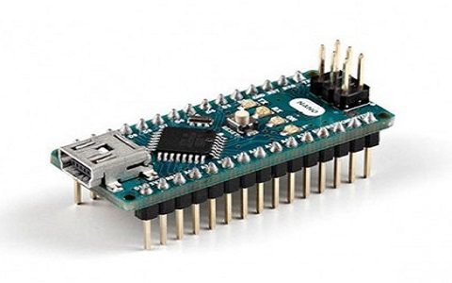
Fig 4.1- Arduino NANO

Arduino Nano Features
- ATmega328P Microcontroller is from 8-bit AVR family
- Operating voltage is 5V
- Input voltage (Vin) is 7V to 12V
- Input/Output Pins are 22
- Analog i/p pins are 6 from A0 to A5
- Digital pins are 14
- Power consumption is 19 mA
- I/O pins DC Current is 40 mA
- Flash memory is 32 KB
- SRAM is 2 KB
- EEPROM is 1 KB
- CLK speed is 16 MHz
- Weight-7g
- Size of the printed circuit board is 18 X 45mm
- Supports three communications like SPI, IIC, & USART

Arduino Nano Pinout

4.2ArduinoNANOPinout
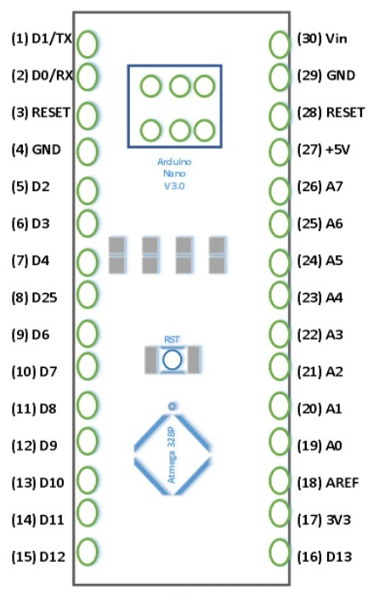
Power Pin (Vin, 3.3V, 5V, GND): These pins are power pins

- Vin is the input voltage of the board, and it is used when an external power source is used from 7V to 12V.
- 5V is the regulated power supply voltage of the nano board and it is used to give the supply to the board as well as components.
- 3.3V is the minimum voltage which is generated from the voltage regulator on the board.
- GND is the ground pin of the board

RST Pin( Reset): This pin is used to reset the microcontroller

Analog Pins (A0-A7): These pins are used to calculate the analog voltage of the board within the range of 0V to 5V

I/O Pins (Digital Pins from D0 – D13): These pins are used as an i/p otherwise o/p pins. 0V & 5V

Serial Pins (Tx, Rx): These pins are used to transmit & receive TTL serial data.

External Interrupts (2, 3): These pins are used to activate an interrupt.

PWM (3, 5, 6, 9, 11): These pins are used to provide 8-bit of PWM output.

SPI (10, 11, 12, & 13): These pins are used for supporting SPI communication.

Inbuilt LED (13): This pin is used to activate the LED.

IIC (A4, A5): These pins are used for supporting TWI communication.

AREF: This pin is used to give reference voltage to the input voltage
Arduino Nano Communication

The communication of an Arduino Nano board can be done using different sources like using an additional Arduino board, a computer, otherwise using microcontrollers. The microcontroller using in Nano board (ATmega328) offers serial communication (UART TTL). This can be accessible at digital pins like TX, and RX. The Arduino software comprises of a serial monitor to allow easy textual information to transmit and receive from the board.
The TX & RX LEDs on the Nano board will blink whenever information is being sent out through the FTDI & USB link in the direction of the computer. The library-like SoftwareSerial allows serial communication on any of the digital pins on the board. The microcontroller also supports SPI & I2C (TWI) communication.

Arduino Nano Programming

The programming of an Arduino nano can be done using the Arduino software. Click the Tools option and select the nano board. Microcontroller ATmega328 over the Nano board comes with preprogrammed with a boot loader. This boot loader lets to upload new code without using an exterior hardware programmer. The communication of this can be done with the STK500 protocol. Here the boot loader can also be avoided & the microcontroller program can be done using the header of in-circuit serial programming or ICSP with an Arduino ISP.

BASIC ARDUINO CODE DEFINITIONS:

setup( ): A function present in every Arduino sketch.
Run once before the loop( ) function.
Often used to set pinmode to input or output. The setup( ) function looks like:

void setup( ){
//code goes here
}

loop( ): A function present in every single Arduino sketch. This code happens over and over again. The loop( ) is where (almost) everything happens. The one exception to this is setup( ) and variable declaration. ModKit uses another type of loop called “forever( )” which executes over Serial. The loop( ) function looks like:

void setup( ){
//code goes here

input: A pin mode that intakes information

output: A pin mode that sends information.

HIGH: Electrical signal present (5V for Uno). Also ON or True in boolean logic.

LOW: No electrical signal present (0V). Also OFF or False in boolean logic.

digitalRead: Get a HIGH or LOW reading from a pin already declared as an input

digitalWrite: Assign a HIGH or LOW value to a pin already declared as an output.

analogRead: Get a value between or including 0 (LOW) and 1023 (HIGH). This allows you to get readings from analog sensors or interfaces that have more than two states.

analogWrite: Assign a value between or including 0 (LOW) and 255 (HIGH). This allows you to set output to a PWM value instead of just HIGH or LOW

PWM: Stands for Pulse-Width Modulation, a method of emulating an analog signal through a digital pin. A value between or including 0 and 255. Used with analogWrite

CODES USED IN THIS PROJECT

#include <SPI.h>
#include <MFRC522.h>
#include <Servo.h>
#include <LiquidCrystal_I2C.h>
#define SS_PIN 10
#define RST_PIN 9
#define servoPin 3
MFRC522 mfrc522(SS_PIN, RST_PIN); // Create MFRC522 instance.
const int buzzer = 2;
Servo servo;
LiquidCrystal_I2C lcd(0x27,16,2);
void setup()
{
pinMode(buzzer,OUTPUT);

Serial.begin(9600); // Initiate a serial communication
SPI.begin(); // Initiate SPI bus
mfrc522.PCD_Init(); // Initiate MFRC522
Serial.println("Approximate your card to the reader...");
Serial.println();
servo.write(0);
servo.attach(servoPin);
lcd.init();
lcd.backlight();

}
void loop()
{
// Look for new cards
if ( ! mfrc522.PICC_IsNewCardPresent())
{
return;
}
// Select one of the cards
if ( ! mfrc522.PICC_ReadCardSerial())
{
return;
}
//Show UID on serial monitor
Serial.print("UID tag :");
String content= "";
byte letter;
for (byte i = 0; i < mfrc522.uid.size; i++)
{
Serial.print(mfrc522.uid.uidByte[i] < 0x10 ? " 0" : " ");
Serial.print(mfrc522.uid.uidByte[i], HEX);
content.concat(String(mfrc522.uid.uidByte[i] < 0x10 ? " 0" : " "));
content.concat(String(mfrc522.uid.uidByte[i], HEX));
}
Serial.println();
Serial.print("Message : ");
content.toUpperCase();
if (content.substring(1) == "B3 B4 D6 2F") //change here the UID of the card/cards that you want to give access
{
Serial.println("Authorized access");
Serial.println();
tone(buzzer,1000);
delay(500);
noTone(buzzer);
delay(1000);
servo.write(90);
delay(500);
servo.write(0);
lcd.clear();
lcd.setCursor(0,0);
lcd.print("Unblocked");
delay(1500);
lcd.clear();
}
else
{
Serial.println(" Access denied");

}
}
4.2.2. : RC522 RFID Card Reader Module :
The RC522 RFID card reader module is a widely used device for reading RFID tags and is known for its low cost and easy integration with microcontroller platforms like Arduino. Here is a detailed overview of the RC522 module and its operation in the RFID door lock system using Arduino Nano.
Overview of RC522 RFID Card Reader Module
Key Features:
- Frequency: Operates at 13.56 MHz.
- Communication Interface: Uses SPI (Serial Peripheral Interface), but also supports I2C and UART.
- Reading Distance: Typically up to 5 cm, depending on the tag and environmental conditions.
- Supply Voltage: Operates at 3.3V, with some modules having onboard voltage regulators to accept 5V inputs.
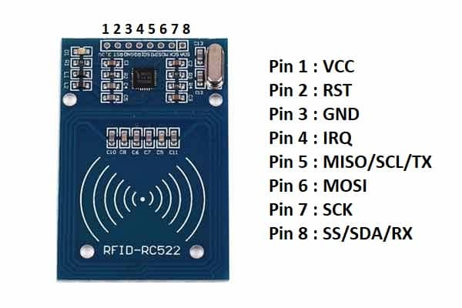
Fig 4.3-: RC522 RFID Card Reader Module
Pin Configuration:
- VCC: Power supply pin (3.3V).
- GND: Ground.
- RST: Reset pin.
- SDA: Serial Data pin (acts as SS for SPI communication).
- SCK: Serial Clock pin.
- MOSI: Master Out Slave In pin.
- MISO: Master In Slave Out pin.
- IRQ: Interrupt pin (optional, not commonly used).

4.2.3 : RFID Tags :
RFID tags, also known as RFID cards or transponders, are small electronic devices that contain a unique identification number. These tags consist of an integrated circuit (IC) and an antenna.
By combining the power of the Arduino Nano board, LCD screen, RFID reader, and servo motor, we can create an affordable and reliable solution to control access to our doors.

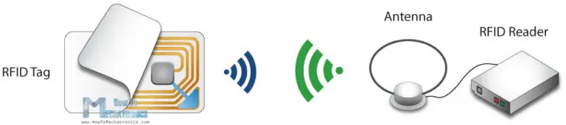
Figure 4.4:- RFID tags

4.2.4. : LCD Display (16x2)

An LCD 16x2 display is a popular type of character liquid crystal display, commonly used in electronic projects and embedded systems. This display module can show 16 characters per line on two lines, making it ideal for displaying text and basic symbols. Each character is displayed in a 5x8 pixel matrix, allowing for clear and legible output. The LCD 16x2 typically includes a built-in controller, such as the HD44780, which simplifies the interface with microcontrollers. It operates using a standard 16-pin interface, which can be connected in 4-bit or 8-bit mode, and requires a power supply, usually 5V, along with a few control lines for sending data and commands. Features like adjustable backlighting and contrast settings improve visibility in various lighting conditions. Due to its simplicity, ease of use, and low cost, the LCD 16x2 display is widely used in DIY electronics, robotics, and various other applications where a simple and efficient text display is needed.
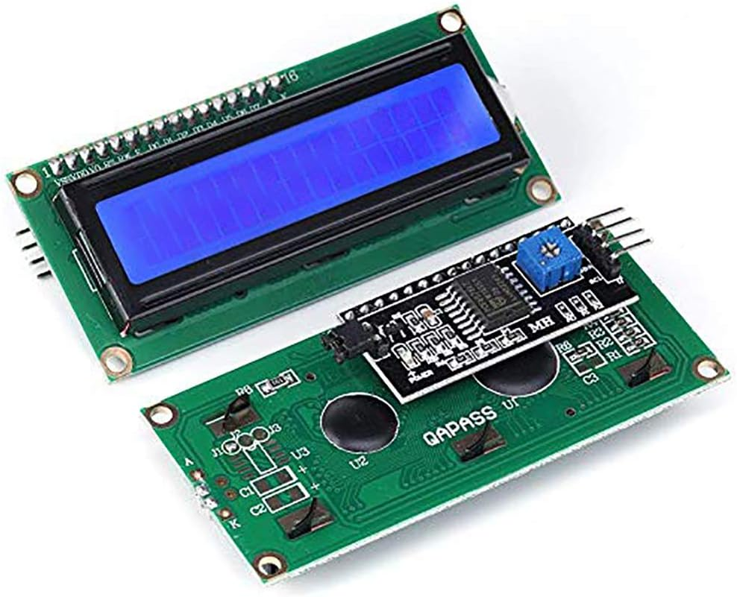
Figure 4.5:- LCD 16x2 display

4.2.4.1: I2C LCD adapter module

The I2C LCD adapter module is an interface board that allows for easy connection between an LCD display and a microcontroller or other electronic devices using the I2C (Inter-Integrated Circuit) communication protocol. This module is particularly useful when working with limited GPIO pins on microcontrollers, as it reduces the number of connections required to interface with the LCD. The I2C LCD adapter typically features a small PCB board with a built-in I2C communication chip, such as the PCF8574, and a connector for attaching the LCD display. It also includes potentiometers for adjusting contrast and backlight brightness, as well as jumpers or solder pads for configuring the I2C address of the module. By connecting the I2C LCD adapter to the microcontroller's I2C bus and supplying power, developers can easily control the LCD display using simple I2C commands, making it suitable for a wide range of applications, including robotics, home automation, and data logging projects.

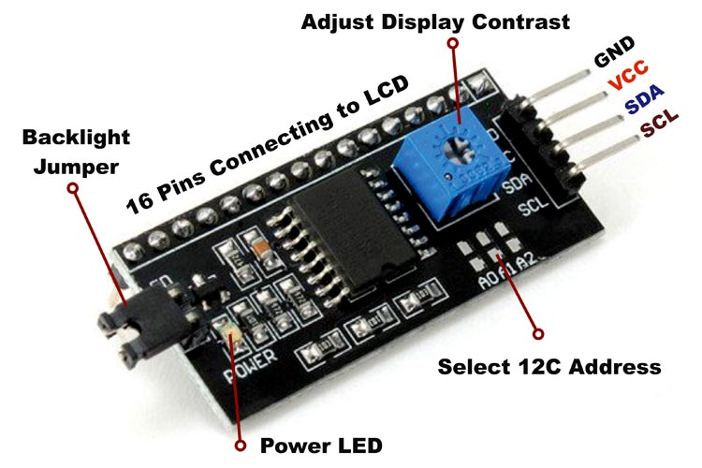
Figure 4.6:- I2C LCD adapter module
4.2.5: Servo Motor
A servo motor is a type of rotary actuator that provides precise control of angular or rotational movement. It consists of a motor, gearbox, and control circuitry packaged in a compact housing. Servo motors are widely used in various applications requiring accurate and controlled motion, such as robotics, RC vehicles, CNC machinery, and industrial automation. One of the key features of servo motors is their ability to maintain a specific position or angle when commanded, making them ideal for tasks like positioning, tracking, and stabilization. This is achieved through a feedback mechanism, typically using a potentiometer or an optical encoder, which continuously monitors the motor's position and adjusts the input signal to maintain the desired position. Servo motors are available in different sizes, torque ratings, and speed ranges to suit a wide range of applications, and they can be controlled using various methods, including PWM (Pulse Width Modulation), analog voltage, or digital signals. Overall, servo motors offer precise control, high reliability, and versatility, making them essential components in many electromechanical systems.
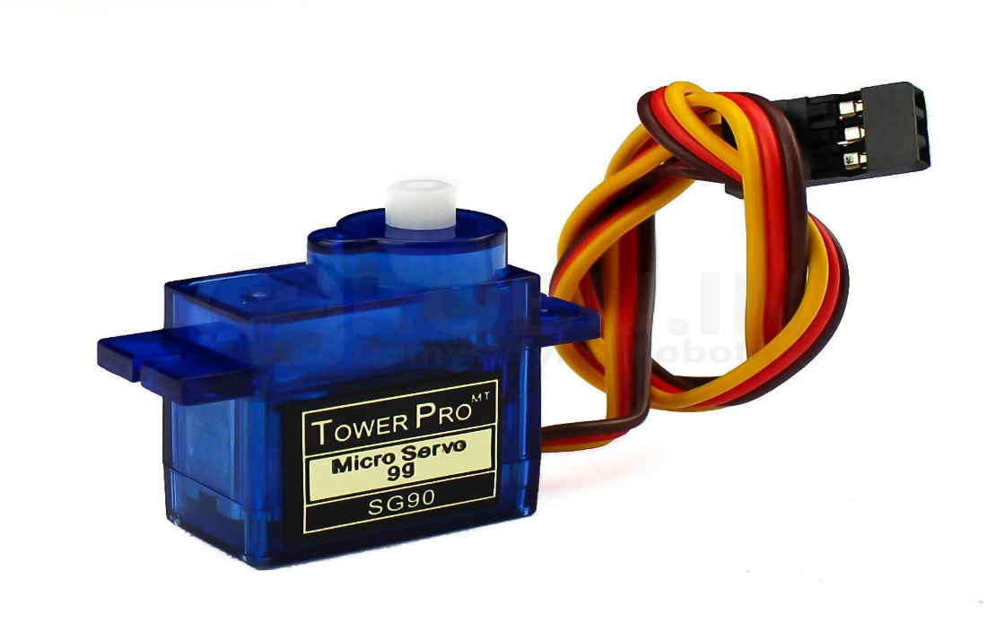
Fig 4.7:- Servo Motor
4.2.6: Active Buzzer
An active buzzer is an electronic component that generates sound or alarm signals when powered by a DC voltage. Unlike a passive buzzer, which requires an external oscillating signal to produce sound, an active buzzer has a built-in oscillator that allows it to produce a tone or beep directly when connected to a power supply. This makes it simpler to use in various applications since it doesn't need additional driving circuitry. Active buzzers are commonly used in devices where an audible alert is necessary, such as in alarms, timers, and confirmation signals in electronic devices. They are characterized by their ease of integration, reliability, and ability to operate at low voltages, typically ranging from 3V to 12V. The sound frequency and volume are predefined by the design of the active buzzer, providing a straightforward solution for implementing sound notifications in electronic projects and consumer electronics.

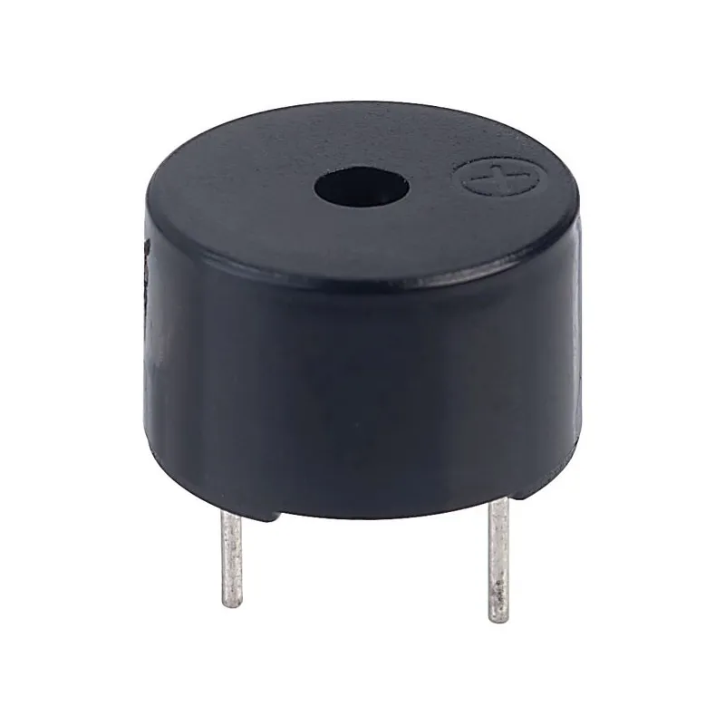
Figure 4.8:-Active Buzzer 5v
4.3. Hardware implementation

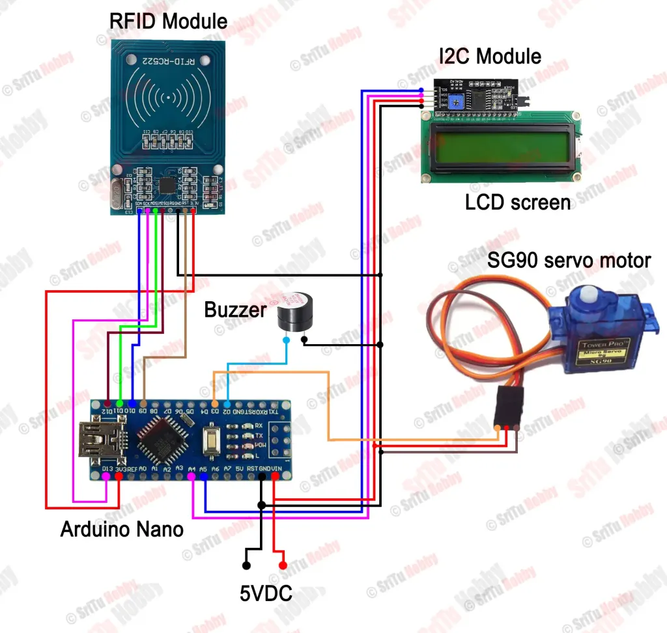
Figure 4.9:- RFID Base Door lock system Using Arduino

4.3.1:Connect the RC522 RFID Reader Module:
  - Connect VCC of the RC522 to 3.3V on the Arduino Nano.
  - Connect GND of the RC522 to GND on the Arduino Nano.
  - Connect SDA (SS) of the RC522 to D10 on the Arduino Nano.
  - Connect SCK of the RC522 to D13 on the Arduino Nano.
  - Connect MOSI of the RC522 to D11 on the Arduino Nano.
  - Connect MISO of the RC522 to D12 on the Arduino Nano.
  - Connect RST of the RC522 to D9 on the Arduino Nano.

4.3.2:Connect the 16x2 LCD Display via I2C Module:
  - Connect VCC of the I2C module to 5V on the Arduino Nano.
  - Connect GND of the I2C module to GND on the Arduino Nano.
  - Connect SDA of the I2C module to A4 on the Arduino Nano.
  - Connect SCL of the I2C module to A5 on the Arduino Nano.

4.3.3:Connect the Servo Motor:
  - Connect the power line (usually red) of the servo to 5V on the Arduino Nano.
  - Connect the ground line (usually brown or black) of the servo to GND on the Arduino Nano.
  - Connect the signal line (usually yellow or white) of the servo to D3 on the Arduino Nano.

4.3.4:Powering the System:
  - Connect the Arduino Nano to a power source. You can use a USB cable connected to a computer or a 5V battery pack.

4.5: software implementation
Before powering up the system, ensure all connections are secure and correct as per the circuit diagram. Use a multimeter to check for continuity and ensure there are no shorts.
Uploading the Code
- Install Required Libraries:
  - Open the Arduino IDE.
  - Go to Sketch -> Include Library -> Manage Libraries.
  - Search and install MFRC522 for the RFID module.
  - Search and install LiquidCrystal_I2C for the LCD.
  - Install Servo library if not already installed.
- Upload the Code:
  - Connect the Arduino Nano to your computer via USB.
  - Open the Arduino IDE.
  - Copy and paste the provided code into the IDE.
  - Select the correct board and port from Tools -> Board and Tools -> Port.
  - Click the upload button to upload the code to the Arduino Nano.

CHAPTER-5

RESULTS AND DISCUSSION

The RFID Door Lock System using Arduino Nano successfully met its objectives, delivering a secure, efficient, and user-friendly access control solution. The system accurately read RFID tags and reliably distinguished between authorized and unauthorized tags, triggering the servo motor to unlock the door for authorized tags and displaying "Access Granted" on the LCD, while unauthorized tags kept the door locked and displayed "Access Denied." The 16x2 LCD provided clear visual feedback, and the buzzer offered intuitive audible cues, with a long beep indicating access granted and three short beeps indicating access denied. The servo motor operated smoothly and responded quickly to RFID tag readings, demonstrating operational efficiency. The system operated effectively on a 5V power supply, ensuring suitability for various installation environments. Challenges in hardware integration, such as ensuring stable connections and managing power fluctuations, were addressed successfully. The project proved to be cost-effective due to the affordability of the components used. The system's scalability and flexibility were highlighted, allowing for easy expansion and future enhancements such as network integration, remote monitoring, and advanced security features. Overall, the project demonstrated a reliable and user-friendly solution for secure access control, with potential for further improvements and broader applications.

CHAPTER 6

CONCLUSION AND FUTURE SCOPE

6.1:Conclusion
The RFID Door Lock System using Arduino Nano is a practical and secure solution for access control. This project leverages RFID technology to provide an efficient and user-friendly method for managing entry permissions. By integrating the RC522 RFID reader, an Arduino Nano, a 16x2 LCD display, a servo motor, and a buzzer, the system offers a robust mechanism to ensure secure and controlled access.
Key Achievements:
- Security: The use of RFID technology ensures that only authorized users can gain access, significantly enhancing security.
- User Feedback: The LCD display provides real-time feedback, informing users whether access is granted or denied, while the buzzer offers an audible indication of the access status.
- Automation: The servo motor automates the locking and unlocking process, making the system both convenient and efficient.
- Scalability: The system can be easily scaled by adding more authorized RFID tags or integrating additional security features such as logging entry data or integrating with a networked system.
Benefits:
- Ease of Use: Users can quickly gain access by simply presenting their RFID tag.
- Cost-Effective: The components used in this project are relatively inexpensive, making it an affordable solution for home or office security.
- Versatility: The system can be adapted for various applications, including homes, offices, and other secure areas.

6.2: Future Scope

There are several avenues for enhancing and expanding the functionality of the RFID Door Lock System:
- Network Integration:
  - IoT Connectivity: Integrate the system with the Internet of Things (IoT) to allow remote monitoring and control. This could include unlocking the door remotely, receiving notifications of access attempts, and maintaining an online log of entries and exits.
  - Cloud Storage: Store access logs in the cloud for easy access and analysis.
- Enhanced Security Features:
  - Biometric Authentication: Add biometric authentication methods, such as fingerprint or facial recognition, for multi-factor authentication, providing an additional layer of security.
  - Encryption: Implement encryption protocols for communication between the RFID reader and the Arduino to prevent data interception.
- Mobile Integration:
  - Mobile App: Develop a mobile application that can be used to manage RFID tags, monitor access logs, and receive real-time alerts.
  - Bluetooth/NFC: Integrate Bluetooth or NFC technology to allow smartphones to be used as access tokens.
- Advanced User Management:
  - User Database: Create a more sophisticated user management system that allows for easy addition, deletion, and modification of authorized users.
  - Access Levels: Implement different access levels and time-based access control, allowing certain users access only during specified times.
- Power Management:
  - Battery Backup: Incorporate a battery backup system to ensure the door lock remains functional during power outages.
  - Energy Efficiency: Optimize the power consumption of the system to prolong battery life and reduce energy costs.
- Integration with Other Security Systems:
  - Alarm Systems: Connect the door lock system with alarm systems to trigger alarms in case of unauthorized access attempts.
  - CCTV: Integrate with CCTV cameras to record video footage of users accessing the door.

Final Thoughts

The RFID Door Lock System using Arduino Nano is a robust and effective solution for access control, offering a balance of security, convenience, and scalability. With the potential for further enhancements and integration with modern technologies, this system can evolve to meet the increasingly complex demands of security in various environments. By continuing to innovate and expand on the foundational work of this project, future developments can provide even greater functionality and protection for users.

REFERENCE

- Banzi, M., & Shiloh, M. (2014). Getting Started with Arduino: The Open Source Electronics Prototyping Platform (3rd ed.). O'Reilly Media.

- Monk, S. (2016). Programming Arduino: Getting Started with Sketches (2nd ed.). McGraw-Hill Education.

- Meyers, J. (2018). RFID Programming Made Simple and Fun! CreateSpace Independent Publishing Platform.

- https://srituhobby.com/how-to-make-an-rfid-door-lock-system-using-an-arduino-nano-board/

- "Arduino for Beginners: Step-by-Step Guide to Arduino (Volume 1)" by Mark Banerjee, published in 2016

- "Exploring Arduino: Tools and Techniques for Engineering Wizardry" by Jeremy Blum, published in 2013.

