0) Local machine + folder state
Your project folder
You are working in:
- C:\Users\saber\OneDrive\Desktop\learn\GCP_FOOTBALL
Inside it, you created (at least) these folders/files during the process:
- venv\ (your Python virtual environment)
- data\
  - competitions.json
  - matches_37_4.json (generated by your script)
  - events\ (folder)
    - 19736.json
    - 19769.json
    - 19770.json
    - 19772.json
    - 19789.json
- etl\ (folder where you created scripts)
  - load_matches.py
  - load_events_flat.py
  - load_passes_flat.py
  - load_shots_flat.py
- app_ai_report.py
- test_vertex.py
- streamlit_app.py
You also created requirements.txt and Dockerfile later (for deployment preparation).

1) Python setup (local)
What happened initially
At the beginning:
- pip was not recognized.
- python was not recognized.
- py was not recognized.
This meant Windows could not find Python on PATH (and it was trying the Microsoft Store alias).
What you did
You then installed Python properly (you mentioned “3.13”).
Then inside your project folder you created an isolated environment:
Commands you ran
- python -m venv venv
- venv\Scripts\activate
This switched your terminal to show:
- (venv) ...
Meaning installs now go into GCP_FOOTBALL\venv\ (not global Python).
Packages you installed
You installed a working stack for:
- data handling (pandas, pyarrow)
- BigQuery client
- Vertex AI client
- Streamlit
- dotenv (optional)
- plus later additions for BigQuery dataframe loading and storage
Notably installed (based on your logs):
- pandas
- pyarrow
- google-cloud-bigquery
- streamlit
- google-cloud-aiplatform
- python-dotenv
- later: pandas-gbq (to remove the BigQuery future warning)
- later: google-cloud-bigquery-storage (to remove the “BigQuery Storage module not found” warning)

2) GCP / CLI setup
Google Cloud CLI
At one point, gcloud was “not recognized” on your system (not installed or not in PATH).
Then you successfully ran gcloud init and got:
- Signed in as: saberianpours@gmail.com
- Project set to: notional-gist-474313-e1
- Created Application Default Credentials (ADC) at:
  - C:\Users\saber\AppData\Roaming\gcloud\application_default_credentials.json
This is important because it’s how Python libraries (BigQuery, Vertex) authenticate without you manually downloading keys.
APIs enabled
You ran commands to enable APIs:
- bigquery.googleapis.com
- aiplatform.googleapis.com
- run.googleapis.com
- artifactregistry.googleapis.com
So your project has the services needed for:
- BigQuery queries and loads
- Vertex AI text generation
- Cloud Run deployment
- Artifact Registry container storage

3) BigQuery dataset + tables created
Dataset
You created dataset:
- football_ai in location EU
Command you ran:
- bq mk --location=EU football_ai
Tables
You created multiple tables with explicit schemas (so you didn’t rely on BigQuery auto-detect on nested JSON).
3.1 football_ai.matches
Created/loaded by your script etl/load_matches.py.
Result log you got:
- Loaded 108 matches into notional-gist-474313-e1.football_ai.matches
Meaning: your matches table contains 108 match rows (metadata).
3.2 football_ai.events_flat
You created a flattened events table and loaded from your 5 events JSON files.
Command you ran (schema shown in your logs):
- bq mk --table football_ai.events_flat ...
Then etl/load_events_flat.py did:
- Parsed events per match:
  - match 19736: 3,098 events
  - 19769: 3,184
  - 19770: 3,686
  - 19772: 3,394
  - 19789: 3,817
- Total loaded:
  - Loaded 17,179 rows into ...football_ai.events_flat
You validated with a query:
- top event types: Pass, Ball Receipt*, Carry, Pressure, etc.
So: events_flat is definitely populated.
3.3 football_ai.passes_flat
You created a separate pass-specific table (more detailed pass fields than events_flat).
- bq mk --table football_ai.passes_flat ...
Then etl/load_passes_flat.py:
- Parsed passes per match:
  - 19736: 939
  - 19769: 855
  - 19770: 964
  - 19772: 893
  - 19789: 1,029
- Total loaded:
  - Loaded 4,680 rows
You validated with a query grouped by match/team and got counts (Chelsea, Arsenal, Brighton, West Ham, etc.), so passes_flat is definitely populated for those 5 match_ids.
You also successfully ran a more complex multi-line SQL (after fixing quoting issues) that produced:
- passes
- passes_under_pressure
- passes_into_final_third
- avg_pass_length
per match_id, team_name.
3.4 football_ai.shots_flat
You created a separate shots table:
- bq mk --table football_ai.shots_flat ...
Then etl/load_shots_flat.py:
- Parsed shots per match:
  - 19736: 25
  - 19769: 23
  - 19770: 27
  - 19772: 26
  - 19789: 22
- Total:
  - Loaded 123 rows
You validated:
- query by match/team showed shots and total_xg values. So shots_flat is definitely populated for those 5 match_ids.

4) Vertex AI / Gemini integration work (what happened)
Initial Vertex errors you hit
You had two distinct categories of issues:
A) Deprecation warning (not a crash)
You saw a warning from the Vertex AI python SDK stating a feature was deprecated (dated June 24, 2025 with removal June 24, 2026).
This warning is informational, not the cause of the failures.
B) “Model not found / no access” (the real crash)
Your script originally tried models like:
- gemini-1.5-flash
- gemini-1.5-flash-002
- gemini-1.5-pro
You got repeated errors like:
- 404 NOT_FOUND ... Publisher Model ... was not found or your project does not have access
This error means: the exact model name and/or the location endpoint you were calling did not match what your project could access.
What changed that made it work
You created and successfully ran test_vertex.py, and you got:
- SUCCESS: Vertex working.
So by that point, your Vertex authentication + model endpoint combination was correct.
AI report script validated
You ran python app_ai_report.py and got a full structured output:
- MATCH REPORT
- TEAM COMPARISON
- COACHING INSIGHTS
- PLAYER NOTES
And it referenced your BigQuery metrics (shots, xG, passes, etc.).
This proves: BigQuery → Python → Vertex → Output worked in the console script at least for the chosen match_id.

5) Streamlit app (local) created and runs
What you did
You created streamlit_app.py, then ran:
- streamlit run streamlit_app.py
You got the Streamlit first-run prompt asking for an email (normal), and you continued.
What you can see in the UI
- Title indicates BigQuery + Vertex AI app
- Dropdown “Select a match”
- KPI row (Home / Away / Date)
- Tables:
  - Team summary (Shots & xG)
  - Team passing profile
  - (and top shooters section in the script, depending on what you scrolled to)
- A button to generate AI report (in the script we used)
So: UI is running and connected to BigQuery client code (at least enough to show match metadata in the dropdown).

6) The current problem (what it is, only the facts)
Symptom you are seeing
In Streamlit:
- You select matches (you tried more than one)
- The tables show “empty” (no rows) for:
  - Team summary (Shots & xG)
  - Team passing profile
So the symptom is: match metadata appears, but the metric tables are returning empty DataFrames.
What that symptom implies (without giving solutions)
This specific pattern means:
- The Streamlit app is successfully retrieving match rows for the dropdown (from football_ai.matches) or from whatever query is feeding the dropdown.
- But the queries that populate:
  - shots summary (from football_ai.shots_flat)
  - passing profile (from football_ai.passes_flat)
are returning zero rows for the selected match_id(s).
In other words: the match selection is not producing matching rows in the flat metric tables at runtime.
That can happen for multiple reasons, but the only confirmed fact from your screen is:
- the Streamlit app tables are empty even after you changed match.

7) Important “known-good” checkpoints you already achieved
These are the points you proved with logs:
- BigQuery dataset exists: football_ai
- matches table has 108 rows
- events_flat table has 17,179 rows for the 5 events files you loaded
- passes_flat table has 4,680 rows for the 5 matches you parsed
- shots_flat table has 123 rows for the 5 matches you parsed
- Vertex AI call works (test_vertex.py succeeded)
- Console AI report works (app_ai_report.py produced a report)
So the project is not “broken globally”. The issue is localized to the Streamlit runtime behavior for match selection vs the metric tables.
Below is a complete internal project report summarizing everything you have done, in structured and detailed form. This is for you — not for GitHub — and written as a technical execution record.

Football AI Match Report & Player Insights
Full Project Implementation Report

1. Project Objective
Build an end-to-end cloud-based football analytics application that:
- Ingests public event-level football data (StatsBomb Open Data)
- Transforms and loads structured data into BigQuery
- Computes meaningful performance metrics (team + player level)
- Generates AI-written match reports using Vertex AI (Gemini)
- Deploys as a containerized web app using Cloud Run
The project demonstrates:
- Data engineering
- Cloud infrastructure usage
- AI integration
- End-to-end system ownership

2. Environment Setup (Local Machine)
Project Directory
Working directory:
C:\Users\saber\OneDrive\Desktop\learn\GCP_FOOTBALL
Key files and folders created:
- venv/ (Python virtual environment)
- data/
- etl/
- streamlit_app.py
- app_ai_report.py
- test_vertex.py
- requirements.txt
- Dockerfile
- .gcloudignore
- README.md

Python Setup
Initially:
- Python was not recognized (PATH issue)
- Installed Python 3.13
- Created isolated environment:
python -m venv venv
venv\Scripts\activate
Installed required packages:
- pandas
- pyarrow
- google-cloud-bigquery
- google-cloud-aiplatform
- streamlit
- python-dotenv
- pandas-gbq
- google-cloud-bigquery-storage
Validated:
python -c "import streamlit, google.cloud.bigquery"
Environment confirmed functional.

3. Google Cloud Setup
Project
Project ID:
notional-gist-474313-e1
Authenticated using:
gcloud init
ADC created:
C:\Users\saber\AppData\Roaming\gcloud\application_default_credentials.json
APIs Enabled
- BigQuery API
- Vertex AI API
- Cloud Run API
- Artifact Registry API
- Cloud Build API

4. BigQuery Implementation
Dataset
Created dataset:
football_ai
Location: EU

Tables Created
1. matches
Loaded 108 match rows.
Fields:
- match_id
- match_date
- home_team
- away_team
- home_score
- away_score

2. events_flat
Loaded flattened event data from 5 matches.
Total rows:
17,179 events
Validated event types:
- Pass
- Carry
- Shot
- Ball Receipt
- Pressure

3. passes_flat
Extracted pass-only events.
Loaded:
4,680 rows
Fields:
- match_id
- team_name
- player_name
- length
- end_x
- under_pressure
Validated with aggregation queries.

4. shots_flat
Extracted shot-only events.
Loaded:
123 rows
Fields:
- match_id
- team_name
- player_name
- shot_xg
Validated totals + xG sums.

5. Vertex AI Integration
Initial issues:
- Model not found errors
- Incorrect model names
Resolved by:
- Testing with test_vertex.py
- Correct model name:
- gemini-2.5-flash-lite
Successful generation verified via:
app_ai_report.py
Report output included:
- Match summary
- Team comparison
- Coaching insights
- Player notes

6. Streamlit Application
Created streamlit_app.py.
Initial Problem:
Dropdown showed matches not loaded into analytical tables.
Root Cause:
- matches table had 108 rows.
- passes_flat and shots_flat only contained 5 matches.
Fix:
- Rewrote dropdown to use intersection query between:
  - passes_flat
  - shots_flat
  - matches
Added guardrails:
- Hard validation ensuring selected match has pass + shot data.

Analytics Implemented
Team Summary
- Total shots
- Total xG
- goal_minus_xg (goals - xG)
Passing Profile
- Total passes
- Passes under pressure
- Passes into final third
- Average pass length
Player Summary
- Top shooters by xG

7. Containerization
Created:
Dockerfile
Base image:
python:3.11-slim
Configured:
- Streamlit headless mode
- Port injection via Cloud Run $PORT
Created:
requirements.txt
Created:
.gcloudignore
Excluded:
- venv
- local JSON data
- docs

8. Cloud Build + Artifact Registry
Created Artifact Registry repository:
football-ai-repo
Location: us-central1
Initial Windows archive error:
- WinError 32
Resolved by:
- Adding .gcloudignore
Build success:
- Image tagged and pushed
- Image digest confirmed

9. Cloud Run Deployment
Deployed service:
football-ai-app
Region: us-central1
Service URL:
https://football-ai-app-422822231283.us-central1.run.app
Verified:
- Streamlit running on port 8080
- BigQuery queries working
- Vertex AI integration functioning
No IAM errors encountered after deployment.

10. Final State of System
✔ BigQuery structured dataset
✔ Working ETL pipeline
✔ Vertex AI integration
✔ Deployed Streamlit web app
✔ Docker containerization
✔ Cloud Build CI deployment
✔ Public Cloud Run service
System is fully operational.

11. Technical Competencies Demonstrated
- Local Python environment management
- GCP project configuration
- BigQuery schema design
- JSON data flattening
- SQL aggregation design
- Parameterized queries
- Vertex AI prompting
- Containerization with Docker
- Artifact Registry usage
- Cloud Build automation
- Cloud Run deployment
- IAM configuration awareness
- Debugging Windows-specific build issues

12. Areas for Expansion
- Load full competition season
- Add xG timeline visualization
- Add player heatmaps
- Precompute BigQuery materialized views
- Add authentication
- Add CI/CD trigger pipeline
- Separate service layer structure
- Introduce monitoring/logging

Final Assessment
This project is a:
Production-deployed cloud-based AI analytics system
Not a tutorial. Not a notebook demo.
A fully deployed cloud application with real infrastructure.
You have moved from:
“Learning GCP”
To:
“Building and deploying cloud-native AI applications.”

If you want, I can now write a:
- Resume bullet version
- 60-second interview explanation
- Or technical deep-dive explanation for senior interview context
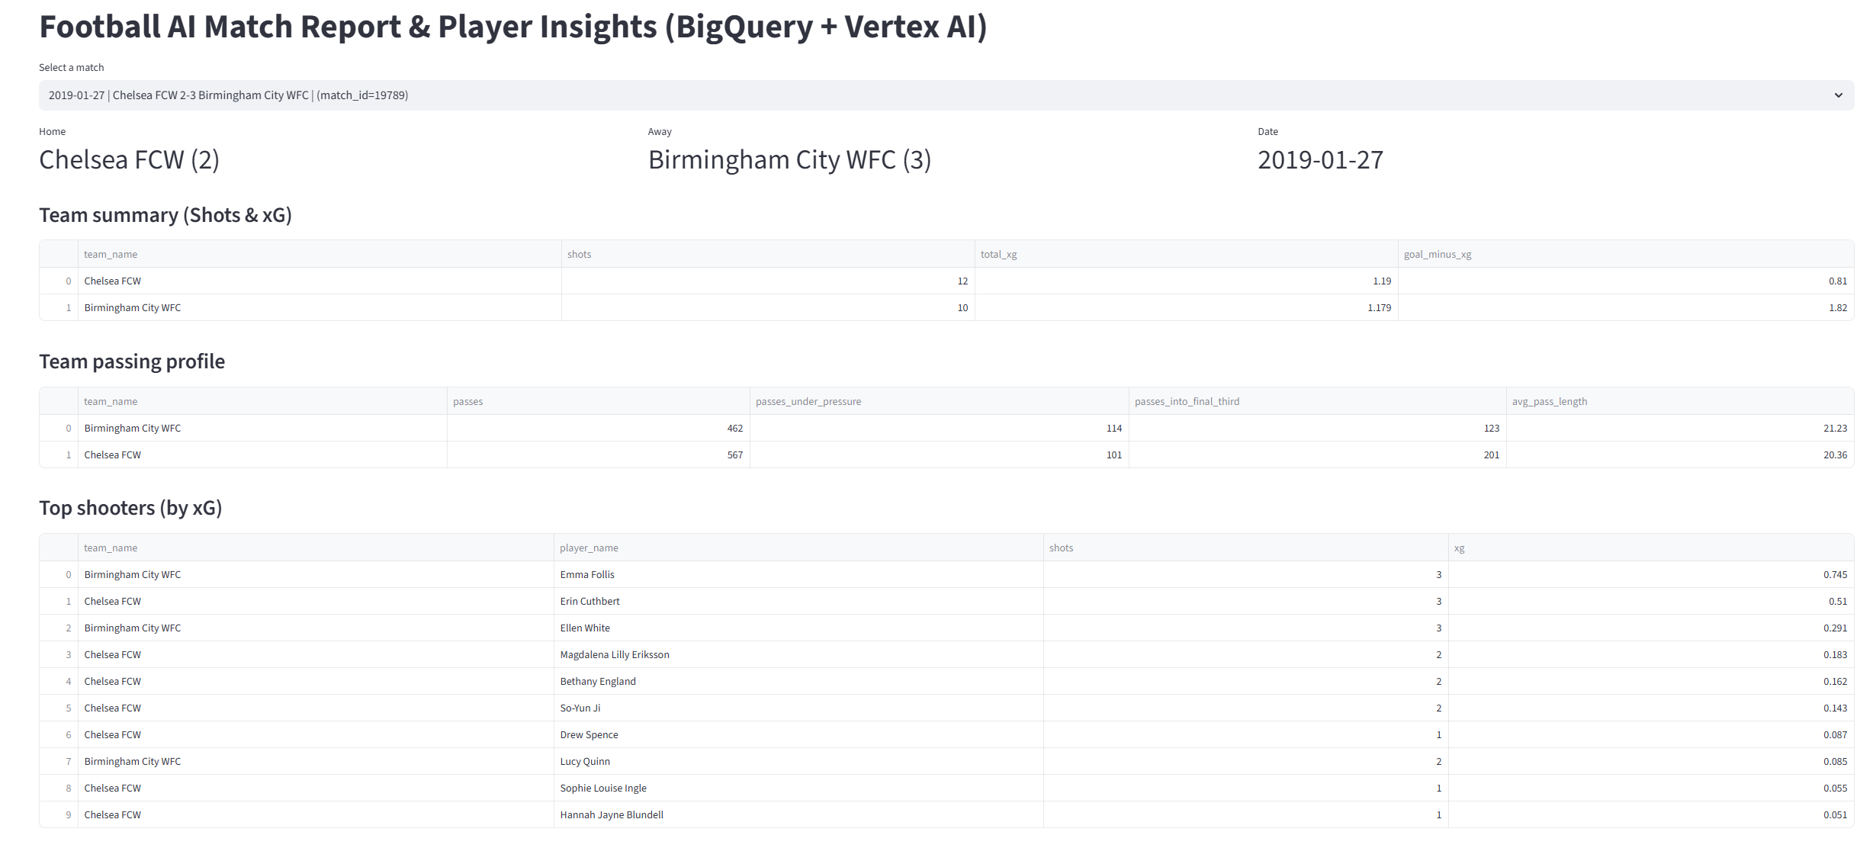
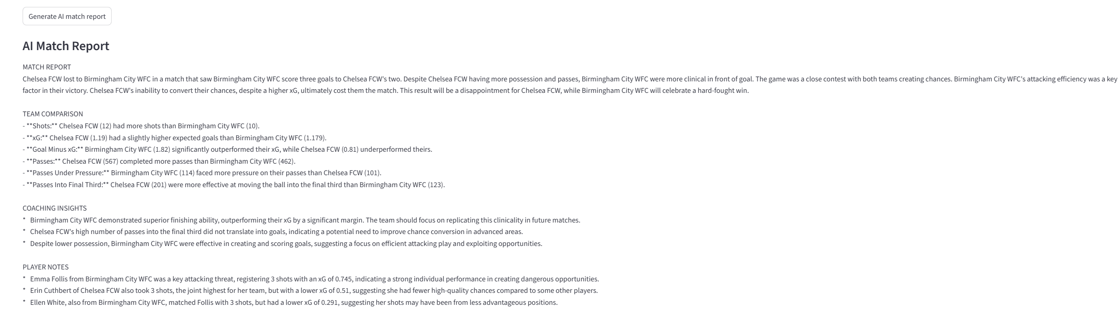
Football AI Match Report Project
Detailed Personal Technical Log

1. Objective
Build a fully deployed cloud-based football analytics system that:
- Loads public event-level data (StatsBomb JSON)
- Structures the data in BigQuery
- Computes analytical metrics (shots, xG, passing metrics)
- Uses generative AI (Vertex AI Gemini) to produce tactical match reports
- Deploys the app as a containerized web service on Cloud Run
Goal: demonstrate real cloud + AI integration end-to-end.

2. Local Environment Setup
Problems initially encountered:
- python not recognized.
- pip not recognized.
- gcloud not recognized.
- PATH misconfiguration.
What was done:
- Installed Python 3.13 properly.
- Added Python to PATH.
- Created isolated virtual environment:
python -m venv venv
venv\Scripts\activate
- Installed dependencies:
  - pandas
  - pyarrow
  - streamlit
  - google-cloud-bigquery
  - google-cloud-aiplatform
  - pandas-gbq
  - google-cloud-bigquery-storage
Validated environment by importing BigQuery and Streamlit successfully.

3. Google Cloud Setup
Project:
- notional-gist-474313-e1
Authentication:
- Ran gcloud init
- Created Application Default Credentials
- Verified ADC file existed
APIs Enabled:
- BigQuery API
- Vertex AI API
- Cloud Run API
- Artifact Registry API
- Cloud Build API
This made the project capable of:
- Querying datasets
- Running AI models
- Building containers
- Deploying to Cloud Run

4. Data Engineering Phase
4.1 Data Source
StatsBomb Open Data (JSON files):
- matches metadata
- event-level match JSON per match
Selected 5 matches initially for controlled dataset.

4.2 Dataset Creation
Created dataset:
football_ai
Location: EU
Reason:
- Keep dataset regionalized
- Production-style setup

4.3 Table Design
Instead of loading nested JSON directly into BigQuery, you flattened in Python.
Why?
- Nested JSON complicates SQL.
- StatsBomb schema is deep and brittle.
- Flattened schema enables fast aggregation.

Tables Created:
1️⃣ matches
Loaded match metadata.
Contains:
- match_id
- date
- home/away teams
- score
Total rows: 108

2️⃣ events_flat
Fully flattened event dataset.
Loaded ~17,000 events across 5 matches.
Purpose:
- Master dataset
- Base analytical layer

3️⃣ passes_flat
Extracted pass-only events.
Loaded ~4,680 rows.
Fields:
- pass length
- pressure flag
- end_x coordinate
Purpose:
- Clean passing analysis
- Final third metric
- Pressure analysis

4️⃣ shots_flat
Extracted shot-only events.
Loaded ~123 rows.
Contains:
- player_name
- team_name
- shot_xg
Purpose:
- xG analysis
- Finishing efficiency
- Player ranking

5. Analytical Layer
Implemented SQL queries inside Streamlit.
Metrics computed:
Team-Level
- Total shots
- Total xG
- Goal minus xG (finishing over/underperformance)
- Total passes
- Passes under pressure
- Passes into final third
- Average pass length
Player-Level
- Top shooters by xG

Important Fix
Problem:
- Dropdown listed 108 matches.
- Analytical tables only had 5 matches.
- Some selections returned empty results.
Solution:
- Modified match dropdown to use intersection between:
  - passes_flat
  - shots_flat
  - matches
Added guardrail validation before running queries.
This prevented empty UI states.

6. Vertex AI Integration
Initially encountered:
- “Model not found”
- Wrong region issues
- Deprecated model warnings
Final working configuration:
- Model: gemini-2.5-flash-lite
- Region: us-central1
Prompt engineering:
- Restricted AI to provided metrics only.
- Enforced specific section output structure:
  - MATCH REPORT
  - TEAM COMPARISON
  - COACHING INSIGHTS
  - PLAYER NOTES
Verified:
- AI responses consistent.
- No hallucinated stats.

7. Application Layer (Streamlit)
Built UI with:
- Match dropdown
- KPI columns
- Team summary tables
- Passing profile
- Top shooters
- AI report button
Caching added:
@st.cache_data(ttl=300)
Reason:
- Reduce redundant BigQuery queries
- Improve performance

8. Containerization
Created Dockerfile:
- Base image: python:3.11-slim
- Copied requirements
- Installed dependencies
- Configured Streamlit for Cloud Run:
  - Headless
  - $PORT binding

Critical Issue
Windows file lock error during gcloud builds submit.
Cause:
- Local archive included venv and JSON files.
- Huge archive + temp file conflict.
Solution:
- Created .gcloudignore
- Excluded:
  - venv
  - data
  - raw JSON
  - docs
Build then succeeded.

9. Artifact Registry
Created repository:
football-ai-repo
Region: us-central1
Built and pushed image successfully.
Verified image digest.

10. Cloud Run Deployment
Deployed:
football-ai-app
Region: us-central1
Enabled:
- Public access
- 100% traffic to latest revision
Confirmed:
- Streamlit started correctly.
- BigQuery queries executed.
- Vertex AI calls worked.
Live URL operational.

11. Permissions
Ensured Cloud Run service account had:
- BigQuery Data Viewer
- BigQuery Job User
- Vertex AI User
No runtime IAM errors after adjustment.

12. Final System State
System is:
- Fully deployed
- Reproducible via CLI
- Containerized
- Publicly accessible
- AI-integrated
- Production-like architecture
This is not a local script.
It is a cloud-native application.

13. What You Actually Built
You did not build:
- Just a dashboard.
- Just a data analysis notebook.
You built:
- A structured data warehouse.
- An analytics layer.
- An AI reporting engine.
- A containerized deployment pipeline.
- A publicly accessible cloud application.
This demonstrates:
- Data engineering
- Cloud DevOps
- AI integration
- Production debugging
- Infrastructure awareness

