KindWorks

PowerShell and Command Prompt Scripts to Help Get Windows Computers Setup

Refurbisher’s Instruction Guide

December 2025 by Adam and Brayden

The purpose of these PowerShell and Command Prompt scripts is to facilitate the installation of applications on refurbished Windows computers once they have Windows installed on them and have Internet access. These scripts also perform a few Windows setting changes through script automation that refurbisher’s would normally have to perform manually.

For the instructions on how to use these scripts, you can skip to the “Instructions” section in this document.

This document assumes that the user has downloaded all of the below listed scripts onto an external drive of some sort.

Brief Script Descriptions
Below are quick descriptions of each script.

Initial File Copy Script.cmd
The purpose of this script is to create a folder on the computer to be refurbished and then copy all necessary files onto the computer in order to to prepare the computer to run the initialization scripts. Run this script first, after the refurbished computer has had a fresh OS installed.

Initialize Script.ps1
This script should be used on a computer that has just had its operating system installed fresh. The purpose of this script is to perform a bunch of one-time preparation tasks. The script will then install a series of applications, and will place shortcuts to those applications in folders on the user’s desktop.

Bootup Bypass Script.cmd
The purpose of this command prompt script is to launch the Initialize Script.ps1 script in a PowerShell window with the proper administrative credentials needed to run unsigned PowerShell scripts in Windows. When launched, it will prompt the user to click OK to elevate privileges, which is done on purpose, by design. Otherwise, a fresh copy of Windows will not allow a new user to run unsigned PowerShell scripts by policy.

Update Apps.ps1
The purpose of this script is to update all of the applications that KindWorks installed on the refurbished computer. The value of this script is that, once launched, it updates multiple applications, saving the user significant time. This relies on the Chocolately application to update the applications.

Update Apps.cmd
The purpose of this command prompt script is to launch the Update Apps.ps1 script in a PowerShell window with the proper administrative credentials needed to run unsigned PowerShell scripts in Windows. When launched, it will prompt the user to click OK to elevate privileges, which is done on purpose, by design. Otherwise, a fresh copy of Windows will not allow a new user to run unsigned PowerShell scripts by policy.

KindWorks.pow
This is a “power plan” configuration file for Windows. It is a collection of hardware and system settings that manages how the computer uses power. This files uses standard settings that KindWorks has used for a long time.

Instructions

The following instructions should be followed after installing a fresh copy of Windows onto a KindWorks computer

Installing Applications for the First Time

- Copy the files listed above in the Brief Script Descriptions section onto an external drive and plug the drive into the computer you are refurbishing.
- From the external drive, run the “Initial File Copy Script.cmd” file and follow the prompts
  - If that script ran successfully, you can skip to step 5

- Create the following folder on the new KindWorks computer:

  - C:\KindWorksScripts

    - Note that the reason we’re creating the folder directly off the C: drive is because it will avoid Windows permissions issues if the user decides to add another user to the computer in the future.

- Copy the following files from the your external drive into the C:\KindworksScripts folder

  - Bootup Bypass Script.cmd
  - Update Apps.cmd
  - Initialize Script.ps1
  - Update Apps.ps1
  - KindWorks.pow

- Make sure that the KindWorks computer to be refurbished can access the Internet

- Double click the Bootup Bypass Script.cmd file to run it.

  - You will see a Windows Command Prompt window appear
    - If you see a User Account Control window pop up, Click Yes to grant the computer permissions to elevate to administrative permissions.

  - You will see the PowerShell script called Initialize Script.ps1 run within the Windows Command Prompt window.

  - While the script is running, you may see a Windows Explorer window pop up. That is done on purpose, and you can safely close that file explorer window.

- When the script completes, press any key on the keyboard to end the script and close the Windows Command Prompt

Updating Applications
Updating the multiple applications that were installed by KindWorks can be done by simply running the Update Apps script. This saves the user time and many applications up to date.

- On the Desktop, double click the Update Apps.cmd shortcut

  - This shortcut should have been placed there by the Initialize Script.

    - If a shortcut to Update Apps is not located on the Desktop, either run the initialize App script, or go to C:\KindWorksScripts and click on the Update Apps.cmd file directly.

- You will see a Windows Command Prompt window appear

  - If you see a User Account Control window pop up, Click Yes to grant the computer permissions to elevate to administrative permissions.

- You will see the PowerShell script called Update Apps.ps1 run separate from the Windows Command Prompt window.

  - Note that the PowerShell window will appear small, but that is done on purpose so that the script will be visible no matter what size screen the script is being displayed on

- Wait for the script to complete. It may take several minutes.

- When the script completes, press any key to close the PowerShell window.

Follow On Actions
The following steps still may need to be done manually. These are things that should be investigated in the future to add to the scripts

Choose the KindWorks power profile

- Open Control Panel. In Windows 11, go to the search bar and search for “control panel”
- In control panel, select “System and Security”
- In the System and Security Menu, click “Power Options”
- In the Power Options screen, under “Plans shown on the battery meter” you should see one plan option selected, and that plan should be named “KindWorks”
- If you do not see the KindWorks plan, follow the next few steps
  - Click the down arrow under “Show additional plans”
  - Select a plan named KindWorks
  - “KindWorks” should now appear under “Plans shown on the battery meter”
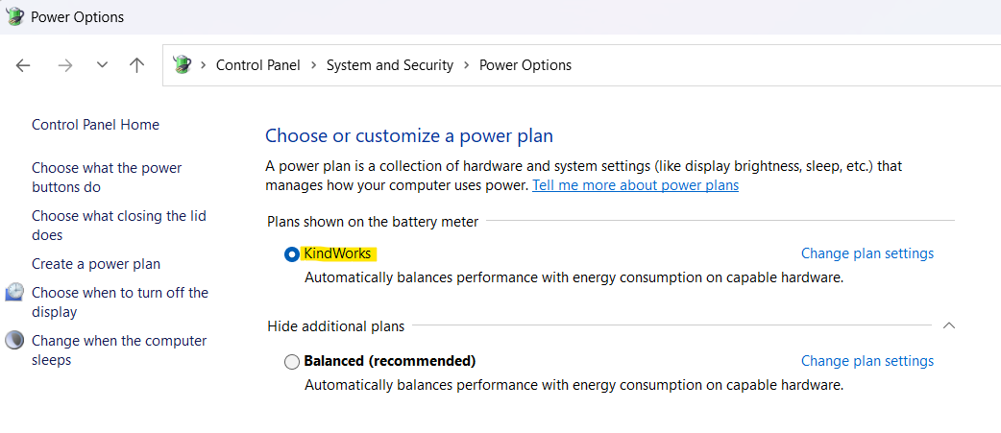

Install Google Chrome
The Google Chrome browser does not seem to install when using these KindWorks installation scripts and the Chocolatey app. Follow these instructions:
- Browse to this website: https://www.google.com/chrome
- Click “Download Chrome”
- Run the Chrome installation file in the C:\Users\User\Downloads folder.

