KindWorks

PowerShell and Command Prompt Scripts to Help Get Windows Computers Setup

Refurbisher’s Instruction Guide

Originally Written December 2025 by Adam and Brayden
Updated September 2026

The purpose of these PowerShell and Command Prompt scripts is to facilitate the installation of applications on refurbished Windows computers once they have Windows installed on them and have Internet access. These scripts also perform a few Windows setting changes through script automation that refurbishers would normally have to perform manually.

Instructions
These instructions tell refurbishers how to download and use custom PowerShell scripts for downloading, installing and configuring all of the Windows applications that refurbishers are expected to install on a Kindworks computer.

The following instructions should be followed after installing a fresh copy of Windows onto a KindWorks computer. Internet connectivity is required to proceed.

Installing Applications for the First Time on a Refurbished Windows Computer

- Open PowerShell
- Run the following command (all on one line – be sure to type it in exactly right!)

curl.exe -L “https://github.com/shimashi/kw-windows/archive/refs/heads/main.zip” -o “$env:USERPROFILE\Desktop\InstallScripts.zip”

- If the command is successful, you should see a file called InstallScripts.Zip appear on the Desktop.
- Double click the on the InstallScripts.Zip file to open it up.
- Double click on the folder called kw-windows-main to open it up
- Copy the folder called PowerShellScriptsAdam to the Desktop. You can close Windows explorer now if you’d like.
- Double click on the PowerShellScriptsAdam folder on the Desktop to open it up
- Double click the Bootup Bypass Script.cmd file to run it.

  - This script copies the script files to the C:\KindworksScripts folder
    - Note that the reason we’re copying files directly to the C: drive is because doing so will avoid Windows permissions issues later on if the user decides to add another user to the computer in the future.

  - You will see a Windows Command Prompt window appear
    - If you see a User Account Control window pop up, Click Yes to grant the computer permissions to elevate to administrative permissions.

  - You will see the PowerShell script called Initialize Script.ps1 run in a new PowerShell terminal.

  - The script will proceed with installing all of the standard apps that KindWorks typically installs on Windows machines.

  - While the script is running, you may see a Windows Explorer window pop up. That is done on purpose, and you can safely close that file explorer window.

  - The script will pause twice for your actions while running
    - Once to ask if you would like to adjust the LibreOffice default file save formats
      - If you enter “Y” then please wait two minutes and be patient while LibreOffice boots up for the first time
      - Instructions are printed on the PowerShell terminal for what to do in LibreOffice

    - Once to pause to give you a chance to follow the instructions to clean up the arrangement of Desktop icons.
      - Instructions are printed on the PowerShell terminal for what to do in Windows Desktop settings

- When the Command Prompt script completes, press any key on the keyboard to end the script and close the Windows Command Prompt

Updating Applications
Updating the multiple applications that were installed by KindWorks can be done by simply running the Update Apps script. This saves the user time and many applications up to date.

- On the Desktop, double click the Update Apps.cmd shortcut

  - This shortcut should have been placed there by the Initialize Script.

    - If a shortcut to Update Apps is not located on the Desktop, either run the Bootup Bypass Script.cmd again, or go to C:\KindWorksScripts and click on the Update Apps.cmd file directly.

- You will see a Windows Command Prompt window appear

  - If you see a User Account Control window pop up, Click Yes to grant the computer permissions to elevate to administrative permissions.

- You will see the PowerShell script called Update Apps.ps1 run separate from the Windows Command Prompt window.

  - Note that the PowerShell window will appear small, but that is done on purpose so that the script will be visible no matter what size screen the script is being displayed on.

- Wait for the script to complete. It may take several minutes.

- When the script completes, press any key to close the PowerShell window.

Follow On Actions
The following steps still may need to be done manually. These are things that should be investigated in the future to add to the scripts

Choose the KindWorks power profile
The purpose of these steps it to improve the power consumption settings of the laptop, and adjust the times that the laptop goes to sleep or turns off the display when left idle.
- Open Control Panel. In Windows 11, go to the search bar and search for “control panel”
- In control panel, select “System and Security”
- In the System and Security Menu, click “Power Options”
- In the Power Options screen, under “Choose or customize a power plan” you should see one plan option selected, and that plan should be named “KindWorks”
  - If the KindWorks plan is not selected, then click the radial button to select it now.
- If you see a section called “Plans shown on the battery meter”, and you do not see the KindWorks plan, follow the next few steps
  - Click the down arrow under “Show additional plans”
  - Select a plan named KindWorks
  - “KindWorks” should now appear under “Plans shown on the battery meter”
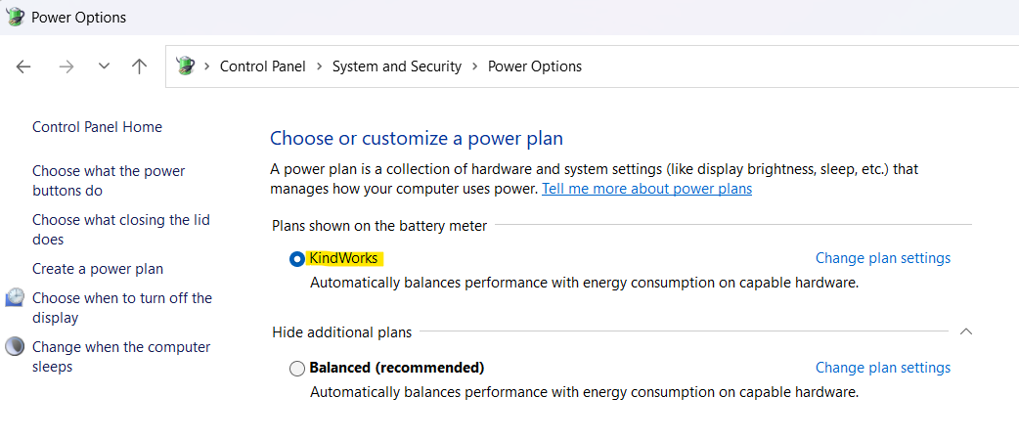

At this point, you can run the NovaBench application to get your benchmark test values.

Brief Script Descriptions
Below are quick descriptions of each script.

Bootup Bypass Script.cmd
The purpose of this command prompt script is to launch the Initialize Script.ps1 script in a PowerShell window with the proper administrative credentials needed to run unsigned PowerShell scripts in Windows. When launched, it will prompt the user to click OK to elevate privileges, which is done on purpose, by design. Otherwise, a fresh copy of Windows will not allow a new user to run unsigned PowerShell scripts by policy. This script also copies the necessary files over to the C:\KindworksScripts folder in order to facilitate future use.

Initialize Script.ps1
This script should be used on a computer that has just had its operating system installed fresh. The purpose of this script is to perform a bunch of one-time preparation tasks. The script will then install a series of applications, and will place shortcuts to those applications in folders on the user’s desktop.

Update Apps.cmd
The purpose of this command prompt script is to launch the Update Apps.ps1 script in a PowerShell window with the proper administrative credentials needed to run unsigned PowerShell scripts in Windows. When launched, it will prompt the user to click OK to elevate privileges, which is done on purpose, by design. Otherwise, a fresh copy of Windows will not allow a new user to run unsigned PowerShell scripts by policy.

Update Apps.ps1
The purpose of this script is to update all of the applications that KindWorks installed on the refurbished computer. The value of this script is that, once launched, it updates multiple applications, saving the user significant time. This relies on the Chocolately application to update the applications.

KindWorks.pow
This is a “power plan” configuration file for Windows. It is a collection of hardware and system settings that manages how the computer uses power. This files uses standard settings that KindWorks has used for a long time.

