Bluetooth Pairing barcode for Serial Port Profile (Central)
www.zebra.com
Serial Port Profile (Central) - Select this host type for Bluetooth Technology Profile Support.
The scanner connects to the PC/host via Bluetooth and behaves like there’s a serial connection.
The scanner initiates the connection to the remote device and is the Central. Enter the bluetooth
address for your bluetooth device in the “Pairing value” input box on the 123Scan screen and
hit 'Generate bar code'. Then scan Serial Port Profile (Central),followed by the PAIR bar code
for the remote device.

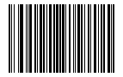

Bluetooth Serial Port Profile (Central)

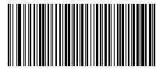

48A493D11C53 (Bluetooth Address of the remote device)

