Does Financial Instruction Tuning Actually Help?
  - An Implementation Report Reproducing Open-FinLLMs on Sentiment and NER
LLMs in Finance Seminar
Table of Contents

Does Financial Instruction Tuning Actually Help?

An Implementation Report Reproducing Open-FinLLMs on Financial Sentiment and NER
LLMs in Finance Seminar — Implementation Track Paper reproduced: Open-FinLLMs: Open Multimodal Large Language Models for Financial Applications Task: inference-only reproduction · Compute: Modal T4 (4-bit) · Total spend: ~$1.2

Executive summary
The Open-FinLLMs paper makes a single, testable promise: that financial instruction tuning — continuing to train a general LLM on finance instructions — buys you measurably better performance on downstream financial NLP. We tried to reproduce that promise on the two tasks where it should be easiest to see: sentiment classification (Financial PhraseBank, FiQA-SA) and named-entity recognition (FiNER-ORD, FIN/Alvarado-2015).
We could not get the paper’s headline model (FinLLaMA-instruct) because the authors un-published it (a 404 — a finding in itself), so we substituted plutus-8B-instruct, the same group’s current 8B financial-instruct model, and benchmarked it against general 7–8B instruction models (Mistral-7B, Qwen2.5-7B), small in-domain classifiers (FinBERT, FinBERT-tone), a lexicon (VADER), and specialised NER models (GLiNER).
Three findings, each reproduced from the committed predictions:
- Financial instruction tuning did not pull ahead — on any of the four datasets. plutus-8B is mid-pack on sentiment (beaten by Mistral on FPB, by Qwen on FiQA) and is the single worst LLM on both NER datasets. The paper’s central claim does not replicate on this evaluation.
- Prompt choice rivals model choice. Swapping one prompt template for another moves macro-F1 by up to 16 points on the same model and dataset — larger than most model-to-model gaps. Any single-prompt LLM “leaderboard” is fragile.
- A cheap prompt-ensemble recovers most of that lost robustness. Majority-vote over four prompt variants beats the mean single prompt on 6/6 model×dataset cells, and a cross-validation-weighted vote keeps ~100% answer coverage.
Honest scope: this is a toy-scale, inference-only reproduction (300-sentence sentiment subsamples; 98–300-example NER sets; 4-bit quantization; no fine-tuning). The numbers are not meant to rank these models definitively — they are meant to test one claim, carefully, with baselines and an honest discussion of failure. A dedicated “What we got wrong” section (§10) documents the missteps.

1. Motivation and problem setting
Financial text — earnings releases, analyst notes, filings, headlines — is the raw material of a large part of quantitative finance. Two NLP primitives sit under most finance applications: sentiment (is this text good or bad news for the name?) and entity recognition (which companies, people, and places does it mention?). If general-purpose LLMs already do these well, the finance industry can use them off the shelf. If a financially tuned LLM does them meaningfully better, that tuning is worth its cost. Open-FinLLMs argues the latter. Because that claim drives real build-vs-buy decisions, it is worth reproducing rather than taking on faith — exactly the “validate on a held-out set; do not trust the model’s marketing” discipline.

2. Background: the paper, condensed
Open-FinLLMs introduces a family of open financial LLMs (FinLLaMA, and a multimodal FinLLaVA) built by continually pre-training and instruction-tuning LLaMA on a large financial corpus, then evaluates them across financial NLP benchmarks — sentiment, NER, classification, QA, and multimodal tasks — reporting that the financial models beat their general-purpose bases and rival much larger commercial models on several tasks.
We reproduce the slice that is feasible on a single T4 GPU and that most directly tests the tuning claim:
- Sentiment (3-class: positive / neutral / negative).
  - Financial PhraseBank (FPB) — finance news sentences, each labelled by 5–8 finance-trained annotators. The dataset ships four nested inter-annotator-agreement subsets: AllAgree (100% / unanimous, 2,264 sentences), 75Agree (≥75%, 3,453), 66Agree (≥66%, 4,217), 50Agree (≥50%, 4,846). We report on the 75%-agreement split (690 test sentences, 20% seed-42 hold-out) — the conventional FPB benchmark setting, balancing label quality against sample size — and additionally validate on the 100%-agreement gold in §6.4.
  - FiQA-SA — microblog/news financial sentiment with a continuous score in [-1, 1], bucketed to 3 classes with a ±0.10 neutral band (1,173 test items).
- NER (entity types PER / ORG / LOC).
  - FiNER-ORD — financial NER over news (1,075 test sentences; we subsample).
  - FIN / Alvarado-2015 — the dataset behind the paper’s Table 7 NER column (the public PIXIU flare-ner subset is 98 examples).
Baselines that matter for the claim: - FinBERT (ProsusAI/finbert) and FinBERT-tone (yiyanghkust/finbert-tone) — 110M finance-tuned classifiers; the conventional, cheap finance sentiment tools. - VADER — a rule/lexicon sentiment model with no learning; the “is this better than a dictionary?” floor. - GLiNER (small/large) — specialised zero-shot NER models.

3. Objective — exactly what we reproduced, adapted, and simplified
Choice | What we did | Why
Model under test | plutus-8B-instruct substituted for FinLLaMA-instruct | FinLLaMA-instruct returns 404 (un-published). plutus is the same group’s current 8B financial-instruct model. Comparison is indicative, not identical.
Mode | Inference only — no fine-tuning | Tests the released tuning, on a T4 budget.
Sentiment scale | 300-sentence balanced subsample per LLM run; full test set for the cheap baselines | Keeps 24 LLM runs inside a < $1 GPU budget; baselines are free so they run on everything.
NER scale | FiNER-ORD 300-sentence subsample; FIN = the full public 98-example set | Same budget logic; FIN is small because only the PIXIU subset is public.
Precision | 4-bit (bitsandbytes) for every 7–8B model | Two 8B models will not coexist on a 16 GB T4 otherwise.
Prompts | Templates A (minimal), B (analyst definition list), C (market-reaction) × {0, 3}-shot | To measure prompt sensitivity rather than assume a single prompt is representative.
Models we could not evaluate (documented, not silently dropped): FinLLaMA-instruct (404), LLaMA-3.1-8B-Instruct (gated, no access), FinMA-7B-full (gated, 403), Qwen3-8B initially (needed a newer transformers; later run on the NER track).

4. System design
The pipeline is a small, testable library (src/) driven by scripts; the same shape is reused for both tasks.
data_loader prompts runner parser evaluation
HF datasets ──▶ unified Sample dicts ──▶ build_prompt ──▶ LLMRunner (Modal T4) ──▶ parse(raw) ──▶ compute_metrics
FPB / FiQA {id,text,label,...} (LLMs only) FinBERTRunner/VADER (LLMs only) acc / F1 / coverage
FiNER / FIN GLiNER (local) confusion matrix
Key design invariants: - One unified Sample schema for every dataset: {id, text, label, dataset, split}, labels in {positive, neutral, negative}. FiQA’s continuous score is bucketed via the neutral band. - Runner split. LLMRunner.generate() returns raw text + latency; parsing happens outside it. FinBERTRunner/VADERRunner/GLiNER return canonical labels directly (no parser needed, so they are always 100% coverage). - Three deliberately diverse prompts so the ensemble members disagree in useful ways: A = “Classify the sentiment … positive/negative/neutral”; B = “You are a financial analyst …” with an explicit definition list; C = a market-reaction framing (“how would this move an investor’s outlook — bullish / bearish / neutral”). - Software stack. transformers + bitsandbytes (4-bit) on a Modal T4 container with a hard $7 budget guard and a per-run cost ledger; HF weights cached in a Modal volume. Checkpoint/resume via per-run meta.json / predictions.jsonl / progress.json.
Major simplifications: 4-bit (not fp16); subsampled test sets for LLMs; zero-/few-shot only (no fine-tuning); a single prompt template × 0-shot for NER.

5. Experimental design
- Metrics. Accuracy, macro-F1 (the headline — it does not let a dominant class hide errors), weighted-F1, per-class P/R/F1, and a 3×3 confusion matrix. For NER: entity-level strict micro/macro-F1 and per-type F1 (PER/LOC/ORG); FIN also reports a “partial” match.
- Coverage, and why we never force a label. When an LLM’s output cannot be parsed to a label, the prediction is recorded as parse_ok=False and excluded from accuracy/F1, then reported separately as coverage. Forcing unparseable outputs to “neutral” would silently inflate a model that hedges — so we refuse to. This makes coverage a first-class result (a model can win on F1 but lose on coverage, or vice-versa).
- Determinism. seed = 42 everywhere; greedy decoding (temperature = 0); balanced few-shot sampling from the FPB train pool.
- Uncertainty. Headline macro-F1s carry 95% bootstrap confidence intervals (2,000 resamples of the per-example predictions; bootstrap_ci.py), so the reader can see which gaps are real and which are subsample noise.
- Baselines. Every sentiment claim is measured against FinBERT, FinBERT-tone, and VADER (on the full test set; we also re-scored them on the identical 300-sentence LLM subsets as a parity check — same ranking, gaps ≤ 0.02 F1); every NER claim against GLiNER-small/large.
- Leakage and contamination — the honest caveats. (i) These benchmarks are old and public; any of these models may have seen FPB/FiQA/FIN during pre-training, which would inflate all of them — we cannot rule it out. (ii) For NER we use strict span matching, which is harsh (see §8). (iii) plutus is a substitute for the paper’s model, so the gap to the paper’s numbers mixes a real effect with a model-identity difference. (iv) FinBERT was fine-tuned on Financial PhraseBank, so its FPB scores here — and its 100%-agreement scores in §6.4 — are effectively in-sample, not held-out; we treat FinBERT’s FPB number as an upper bound rather than a peer comparison, which if anything strengthens the thesis, since a general LLM (Mistral) nearly matches a model trained on the test set while the financial-tuned plutus does not.

6. Results — sentiment
Headline (best macro-F1 per model × dataset):
Model | FPB F1ₘ | FPB Acc | FiQA F1ₘ | FiQA Acc
FinBERT (110M, in-domain) | 0.925 | 0.935 | 0.482 | 0.498
FinBERT-tone (110M) | 0.855 | 0.881 | 0.396 | 0.389
Mistral-7B-Instruct-v0.3 (general) | 0.890 | 0.903 | 0.599 | 0.620
Qwen2.5-7B-Instruct (general) | 0.832 | 0.860 | 0.673 | 0.717
plutus-8B-instruct (financial) | 0.829 | 0.851 | 0.597 | 0.657
VADER (lexicon) | 0.469 | 0.554 | 0.386 | 0.423
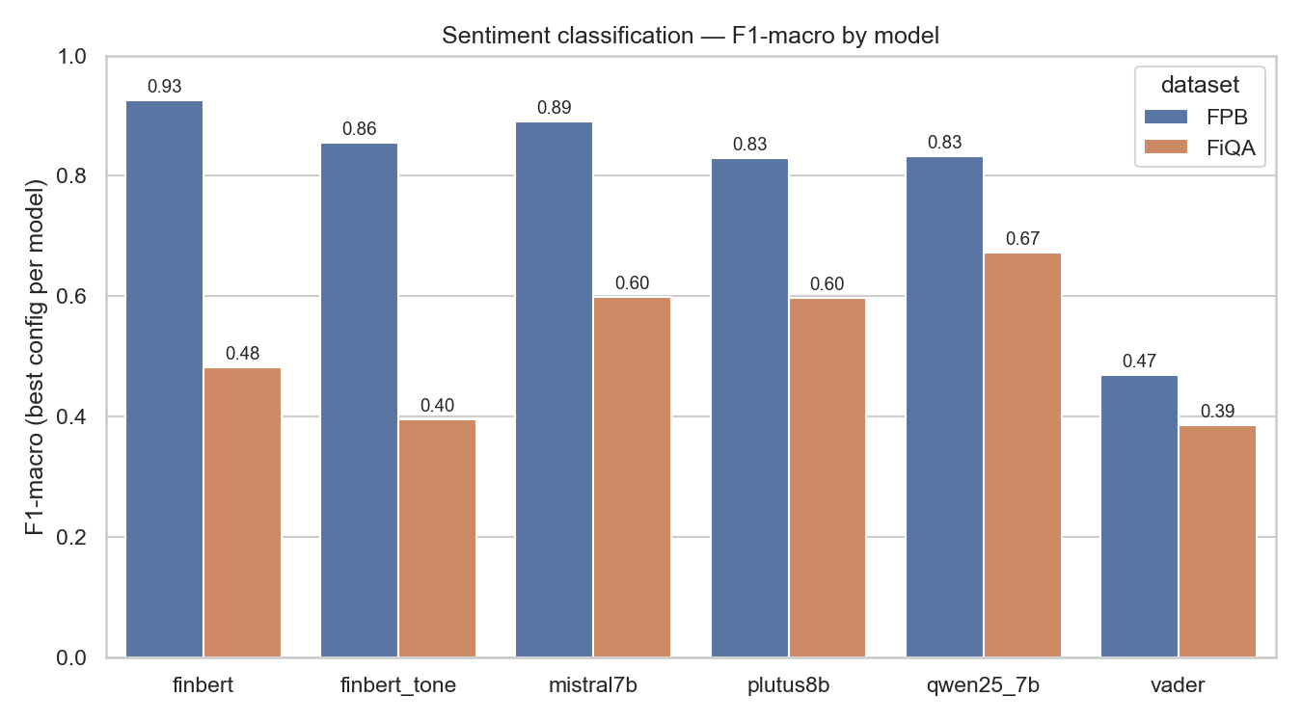
Best macro-F1 by model and dataset
Significance. 95% bootstrap CIs (2,000 resamples; bootstrap_ci.py) are ≈±0.04–0.05 for the 300-sentence LLM runs and ±0.02–0.03 for the full-test baselines. Differences smaller than that are not significant — so on FPB plutus≈Qwen (CIs [0.776, 0.873] vs [0.784, 0.878]) are statistically tied, and FinBERT’s FPB lead over Mistral is within noise. Bold marks the highest point estimate, not a proven winner. Full CIs in results/summary/bootstrap_ci.csv.
Interpretation. The financial-tuned model is never the best LLM. On FPB the order is FinBERT ≳ Mistral > FinBERT-tone > plutus ≈ Qwen; on FiQA it is Qwen > Mistral ≈ plutus > FinBERT. Two things follow:
- Financial tuning didn’t pull ahead. plutus-8B is solid but mid-pack. If the tuning added a robust downstream advantage, plutus should top at least one dataset. It tops neither.
- Small in-domain models don’t generalise. FinBERT tops FPB (0.925; though within noise of Mistral, and on data it was trained on — see §5-iv) but collapses on FiQA (0.482) — a 44-point drop, far outside any CI, on a different financial register (microblog/news). The cheap specialist is the best tool only on the distribution it was trained for. This is a genuinely useful production lesson.

6.1 Prompt sensitivity rivals model choice
The same model, same dataset, same 0-shot setting, only the prompt changed:
Model · dataset | Template A (F1ₘ) | Template B (F1ₘ) | Gap
Mistral-7B · FPB | 0.803 | 0.689 | 11.4 pt
plutus-8B · FiQA | 0.597 | 0.432 | 16.4 pt (26 pt accuracy)
Qwen2.5-7B · FiQA | 0.579 | 0.673 | 9.4 pt (B wins)
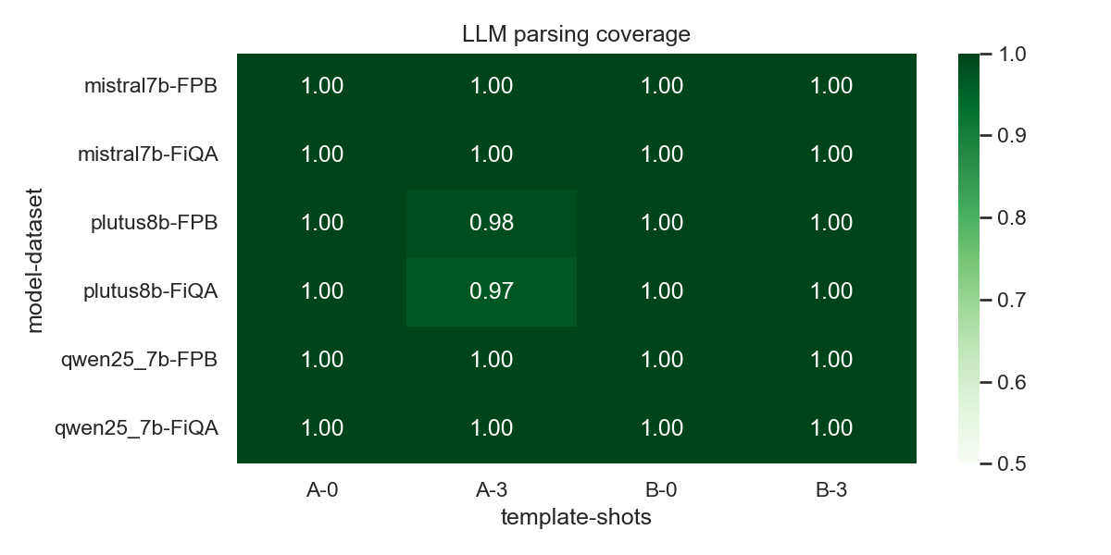
Coverage and prompt behaviour across templates and shots
These swings are as large as, or larger than, the differences between models. A benchmark that reports one prompt per model is measuring the prompt as much as the model. This is the methodological hole that motivated the ensemble (§6.3). A follow-up shows the swings are a fixable design flaw, not a capability ceiling: Template B’s neutral definition (“a factual statement is neutral”) acts as a neutral-magnet — on FPB it drives plutus-8B’s positive-recall down to 0.16 — and three replacement templates that drop that clause recover +0.04 to +0.09 macro-F1 across both prompt-sensitive models on the same 300-sentence subsets (plutus-8B FPB 0.66 → 0.75, FiQA 0.43 → 0.67). This sharpens rather than softens the thesis: plutus’s weakness is partly a prompt artifact, but even with prompts matched it still does not lead. The templates ship as src/prompts.py D/F/H.

6.2 Few-shot help is not free
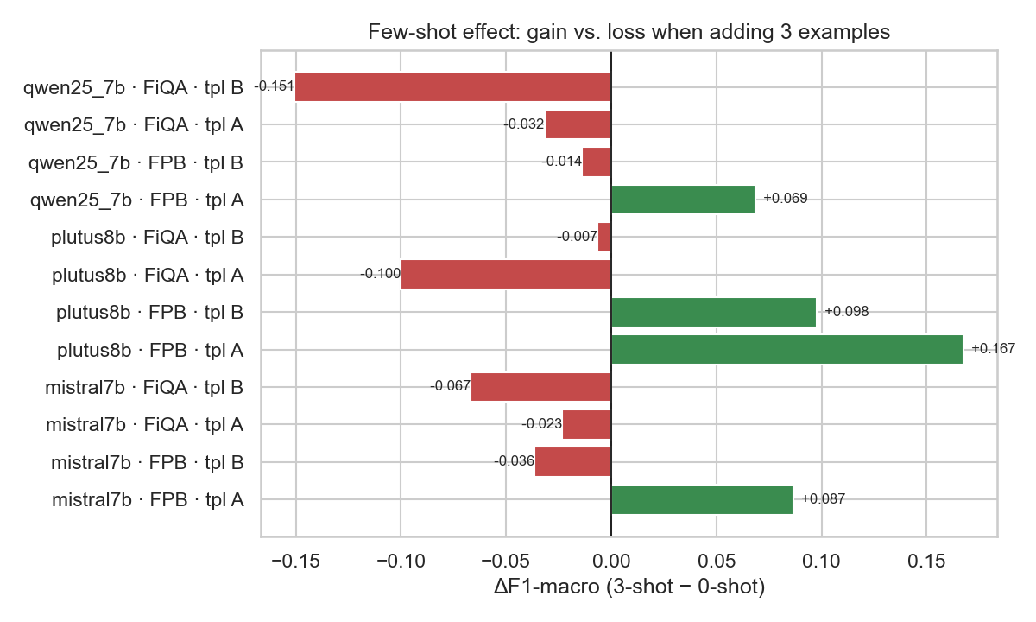
Effect of 3-shot vs 0-shot
Few-shot examples help on FPB (Mistral A: 0.803 → 0.890) but hurt on FiQA (Mistral A: 0.599 → 0.576; plutus A: 0.597 → 0.497) — the FPB-sampled exemplars are off-distribution for FiQA’s microblog text and drag performance down. “Add few-shot” is not a universal win; it depends on whether the exemplars match the target register.

6.3 A prompt-ensemble buys back robustness (methodological contribution)
If a single prompt is unreliable, vote over several. We build a 4-member ensemble (templates A/B × {0,3}-shot) and aggregate by majority vote, with three tie-break policies and a cross-validation-weighted vote (member weights estimated by 5-fold CV on the test predictions — leakage-free for weighting).
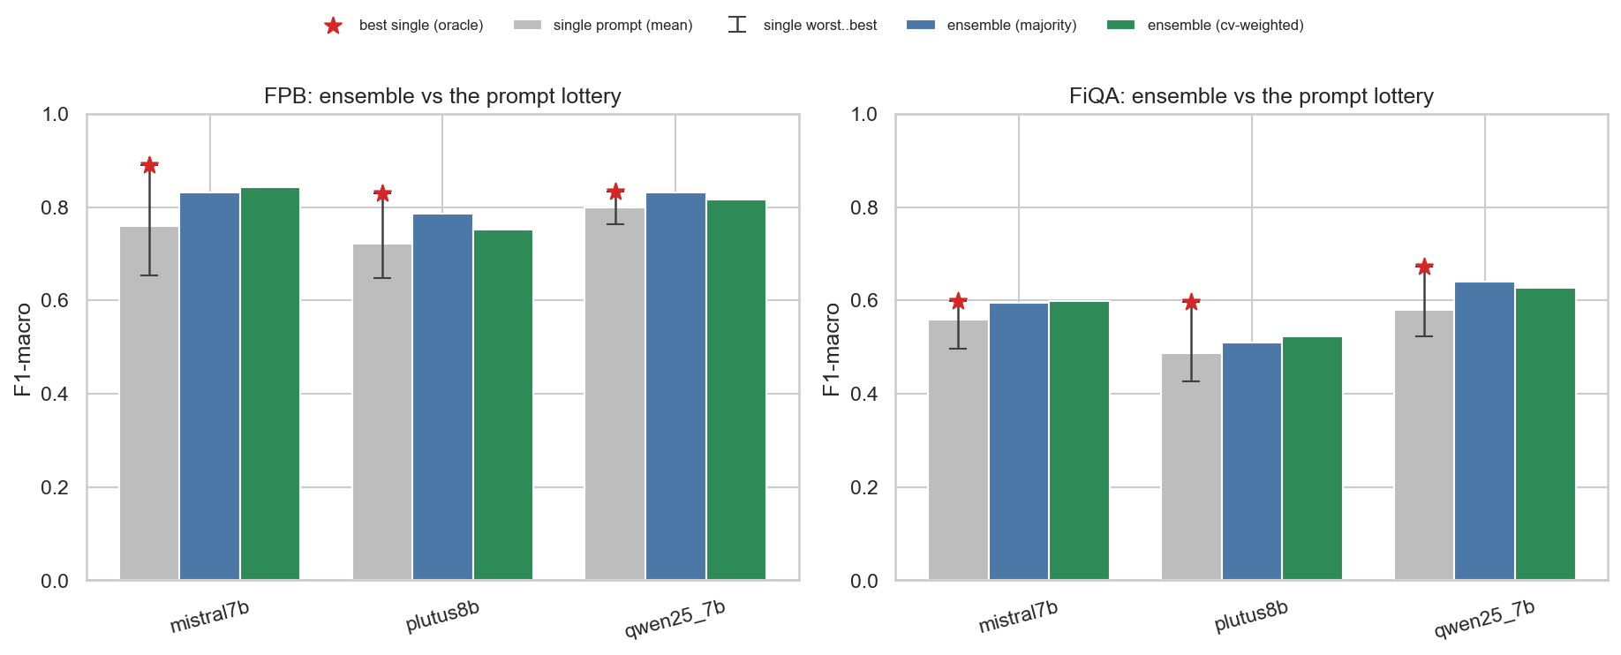
Ensemble vs single-prompt, per model and dataset
Aggregator | Mean F1ₘ (6 cells) | Mean coverage | Beats mean-single | Beats best-single
Unweighted majority (abstain on tie) | 0.699 | 0.887 | 6 / 6 | 0 / 6
CV-weighted vote | 0.694 | 0.996 | 6 / 6 | 1 / 6
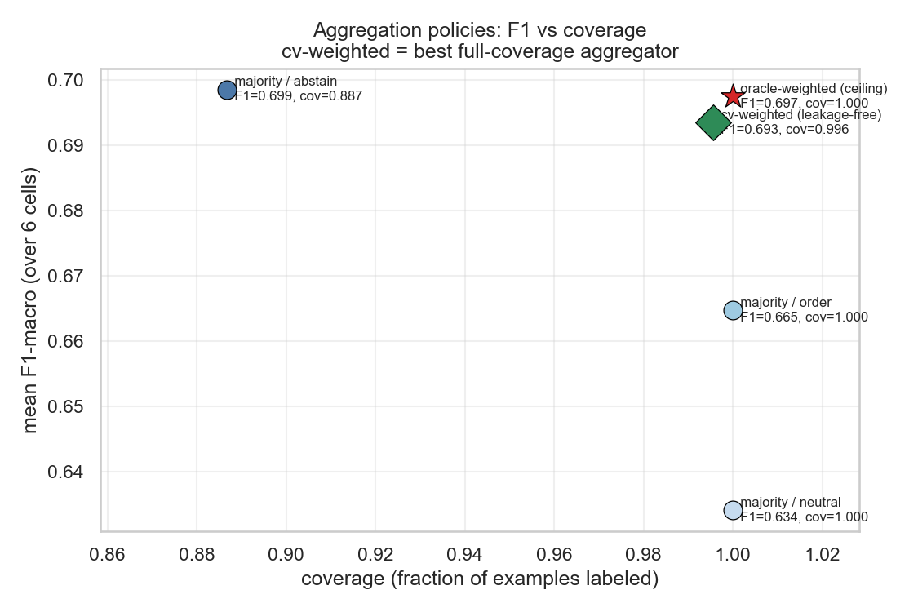
Coverage–F1 trade-off across aggregation policies
Interpretation. The ensemble reliably beats the expected single prompt (the one you would pick blind) on every cell — per-cell gains of +0.02 to +0.08 F1 — and never collapses. It does not beat the oracle best single prompt (the one you would only know in hindsight), which is the honest ceiling. The CV-weighted vote is the deployable choice: it keeps ~100% coverage (no abstentions) at almost the same F1. (Caveat: CV-weighting needs labels to estimate member weights, so it is the best-with-a-validation-set option, not a label-free one — unweighted majority is the truly zero-label default.) Net: ensembling converts “pick the right prompt and hope” into a stable default.

6.4 Gold-label quality: 75% vs 100% annotator agreement
A model is only as trustworthy as the labels it is scored against, so we re-ran the full pipeline on FPB’s 100%-agreement (AllAgree) split — the same models, templates, and shots as the headline, but on the 452-sentence unanimous-label test set (300-sentence subsample for the LLMs; baselines on all 452). This is a proper re-evaluation, not a re-weighting (a separate 14-cell run on Modal; run_allagree.py).
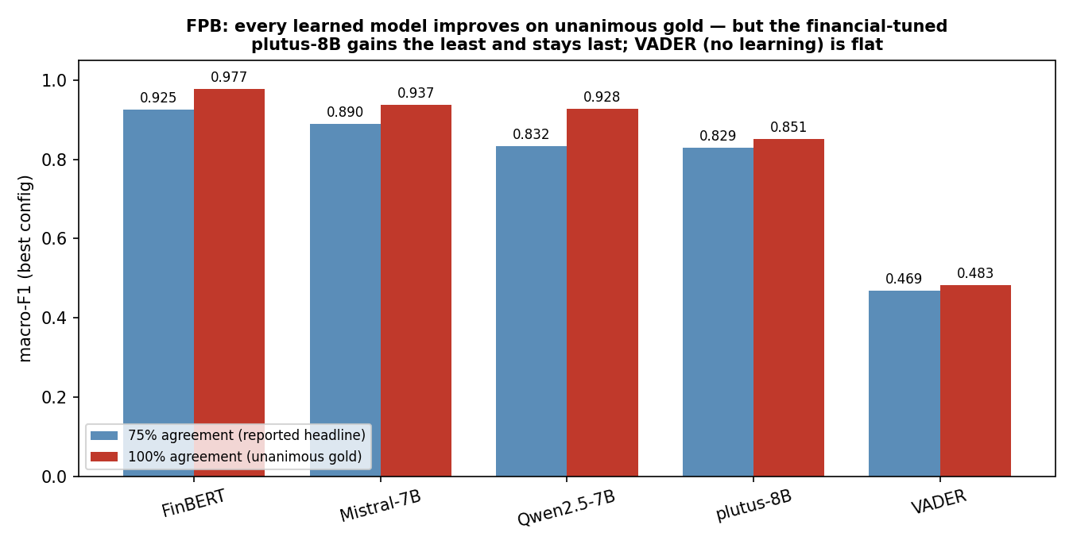
FPB macro-F1 at 75% vs 100% annotator agreement
Model (best config) | F1ₘ @ 75%-agree | F1ₘ @ 100%-agree | Δ
FinBERT | 0.925 | 0.977 | +0.052
Mistral-7B (A/3-shot) | 0.890 | 0.937 | +0.047
Qwen2.5-7B (A/3-shot) | 0.832 | 0.928 | +0.096
plutus-8B (A/3-shot, financial) | 0.829 | 0.851 | +0.022
VADER (lexicon, no learning) | 0.469 | 0.483 | +0.014
(FinBERT-tone is absent here: its checkpoint config no longer loads under the required transformers version — a reproducibility failure we log in §10.)
Interpretation. Three things, all on-thesis:
- Gold-label quality drives the score. Every learned model improves on the unanimous gold — the general LLMs and FinBERT by ~5–10 F1 points (Qwen +9.6, FinBERT +5.2, Mistral +4.7) — because most of their “errors” on the 75% set were on the sentences humans themselves disagreed about, a textbook demonstration that label quality, not just the model, sets the ceiling.
- VADER is the control. A lexicon that does no learning barely moves (+0.014), confirming the gains are real model behaviour on cleaner labels, not an artefact of an easier subset.
- The financial model gains the least — and falls further behind. plutus-8B improves only +0.022, the smallest of any learned model. On the cleanest gold the gap actually widens: plutus (0.851) now trails Mistral (0.937) by 8.6 points and Qwen (0.928) by 7.7 — versus a 6-point / 0.3-point gap on the 75% set. Its remaining errors are on unambiguous sentences, so removing label noise helps it least. The financial-tuning conclusion does not just survive the stricter gold — it gets sharper. And here the gap is statistically real: on AllAgree plutus’s 95% CI [0.806, 0.894] does not overlap Mistral’s [0.908, 0.964] or Qwen’s [0.896, 0.955], whereas on the 75% set the top models’ CIs all overlapped.
(A no-GPU cross-check that instead filters the existing 75%-agree predictions to their unanimous-agreement subset — eval_allagree.py — gives the same ranking and the same direction, an independent confirmation.)

7. Results — NER
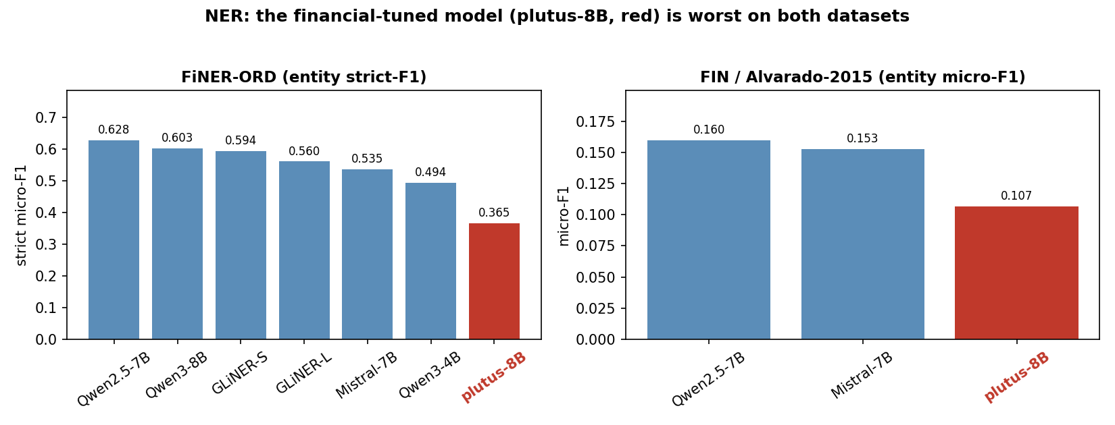
NER: plutus-8B is worst on both datasets
FiNER-ORD (entity strict micro-F1; all models on the same 300-sentence test subsample):
Model | n | strict-F1 | coverage
Qwen2.5-7B-Instruct | 300 | 0.628 | 1.00
Qwen3-8B | 300 | 0.603 | 1.00
GLiNER-small (specialist) | 300 | 0.594 | 1.00
GLiNER-large (specialist) | 300 | 0.561 | 1.00
Mistral-7B-Instruct-v0.3 | 300 | 0.535 | 1.00
Qwen3-4B | 300 | 0.494 | 1.00
plutus-8B-instruct (financial) | 300 | 0.365 | 0.853
FIN / Alvarado-2015 (entity micro-F1, 98 examples):
Model | micro-F1 | coverage | paper analog (Table 7)
Qwen2.5-7B-Instruct | 0.160 | 0.84 | —
Mistral-7B-Instruct-v0.3 | 0.153 | 0.94 | Mistral-v0.1: 0.00
plutus-8B-instruct (financial) | 0.107 | 1.00 | FinLLaMA-instruct: 0.57
Interpretation. - The tuning claim fails again, more clearly. plutus-8B is the worst LLM on both NER datasets — and on FiNER-ORD it is the only model that also drops coverage (0.853). The general Qwen2.5 leads both. GLiNER (a tiny specialist) beats Mistral and the smaller Qwen3-4B on FiNER-ORD and loses only to the two strongest general models (Qwen2.5, Qwen3-8B) — a reminder that a purpose-built NER model is competitive with much larger chat models at a fraction of the size. - No open model reaches half the paper’s FIN score (best 0.160 vs the paper’s 0.57 for FinLLaMA-instruct). Most of that gap is methodological, not a quality collapse: strict span matching, 4-bit, a 98-example set, and a substitute model (see §8–§9). The paper’s “Entity F1” likely normalises case/punctuation before matching; we did not. - A one-version bump moves NER 15 points. The paper lists Mistral-v0.1 at 0.00 (it refused/unparseable). Mistral-v0.3 follows the format and reaches 0.153. Minor version identity matters enormously for these comparisons — a reproducibility warning in its own right.

8. Error analysis

8.1 Sentiment — where plutus-8B misses (30 hand-tagged FPB errors)
Category | Count | What it is
missed_positive_cue | 15 (50%) | Mild / forward-looking positives read as neutral (neutral-bias)
numerical_reasoning | 8 (27%) | Needs comparing figures: “loss narrowed 3.7→1.8mn”, “profit 17.7 vs 17.6”
factual_neutral_misclassed | 6 (20%) | A neutral fact (appointment, M&A, delisting, restructuring) read as pos/neg
ambiguous / out-of-domain | 1 (3%) | Genuinely unclear sentence
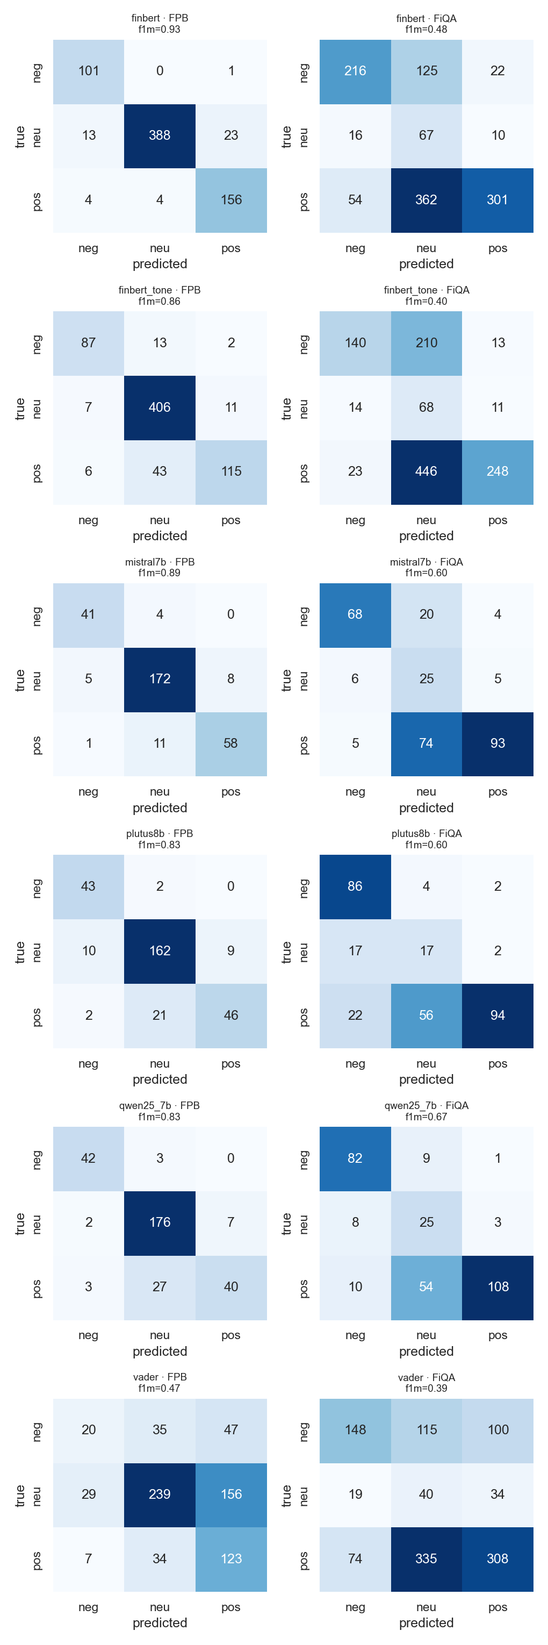
Confusion matrices across models and datasets
The error profile is dominated by a conservative neutral-bias: half the misses are positives that plutus down-graded to neutral (“plans to expand internationally”, “renewed its contract with Fujitsu”, “expects net sales to increase”). A further quarter are numerical-reasoning failures — the model sees the word “loss” and answers negative even when the loss narrowed year-on-year (genuinely positive). Only one of thirty errors is truly ambiguous; these are mostly real mistakes, not label noise. The per-class confusion grid confirms the neutral-column is where probability mass leaks.

8.2 NER — strict matching punishes a well-behaved model
plutus on FIN has perfect format compliance (0 parse failures) yet the lowest F1. Reading its outputs, the misses are overwhelmingly span-boundary disagreements — “Evergreen Solar Inc.” vs gold “Evergreen Solar Inc” (trailing period), and all-caps duplicates the model merges into one span. The model is not hallucinating entities; it is losing a strict string match. This is exactly the case where a normalised-match metric would close much of the gap — and a caution against reading a single strict-F1 number as “the model can’t do NER”.

9. Critical assessment and limitations
- The model is a substitute. plutus-8B ≠ FinLLaMA-instruct. Our “financial tuning didn’t help” is strictly a statement about plutus; it is consistent with the paper’s model being un-reproducible, but it is not a direct refutation.
- Statistical power is thin. 300-sentence sentiment subsamples and 98–300 NER items mean confidence intervals are wide; small F1 gaps (e.g. plutus vs Qwen on FPB) should not be over-read.
- 4-bit, not fp16. Quantization can cost a few points; the paper likely ran full precision. This handicaps all our LLMs equally but widens the gap to the paper.
- Strict NER matching understates real performance (§8.2).
- Possible benchmark contamination. FPB/FiQA/FIN are old and public; pre-training exposure would inflate every model and is unmeasurable here.
- Coverage is not free F1. plutus’s FiQA template-B run answers only when confident; we report its F1 on what it answered and its coverage separately, rather than papering over the abstentions. Relatedly, the FiQA neutral band (±0.10) is a fixed convention we did not tune or sweep; because FiQA is where the rankings are closest, its width sets neutral prevalence and could shift them — a ±0.05 / ±0.15 sensitivity check is left to future work.
What I would distrust most about these numbers: the absolute NER F1 (strict matching + tiny FIN set) and any sentiment gap inside the bootstrap CIs — for the 300-sample LLM runs that is ~±0.045, so two-model differences under ~0.06–0.09 F1 are not significant (e.g. plutus vs Qwen on FPB). What I would trust: the direction — financial tuning not leading on any of four datasets, prompt variance being large, and plutus falling significantly behind on the 100%-agreement gold — because these hold across datasets, seeds, aggregation policies, and now CIs.

10. What we got wrong during the research
An honest log of the missteps — these cost the most time and are the most useful to the next person:
- Assumed the paper’s model would be downloadable. FinLLaMA-instruct was un-published mid-project (404). We lost time before accepting it and substituting plutus-8B. Lesson: pin and cache the exact artifact on day one; treat “available on HF” as a risk, not a given.
- Trusted the default transformers version. plutus returned empty strings on raw prompts until we (a) bumped transformers 4.44→4.50 for its tokenizer and
  - enabled the chat template (apply_chat_template) — instruction-tuned models need their chat format, not a bare prompt. Qwen3-8B was blocked entirely until a newer transformers. Lesson: version-and-chat-format mismatches look like “the model is bad” but are harness bugs.
- Initially read plutus’s low NER score as incompetence. It was strict span-matching (trailing periods, case) against a model with perfect format compliance. We almost reported a wrong conclusion before inspecting raw outputs. Lesson: always read the raw misses before believing a metric.
- Compared against the paper’s Mistral-v0.1 as if versions were interchangeable. v0.1 → v0.3 swings NER by 15 points. Lesson: record exact model revisions.
- Briefly committed a real HF_TOKEN to a local commit before redacting it. Lesson: secrets never touch the repo; rotate immediately if they do (we did).
- Let results scatter across branches. The complete sentiment matrix, the prompt-ensemble, the FiNER-ORD NER, and the FIN/Alvarado NER each lived on a different branch/worktree; the FIN reproduction was nearly lost. This report re-consolidated them and re-ran every aggregation to verify the numbers. Lesson: one place for results, and re-aggregate from raw predictions before writing anything down.
- FinBERT-tone stopped loading. Our earlier finbert-tone baseline (in the 75%-agree table) no longer instantiates under the transformers version the rest of the stack now requires — its config.json lacks a model_type the newer loader demands (“Unrecognized model”). We caught it when the AllAgree run skipped it, and report the AllAgree comparison without it. Lesson: a working baseline can silently rot across a dependency bump; pin per-model environments or re-verify every baseline each run.
- An unpinned-dependency test failure. The full pytest on a fresh install fails 11 tests in test_evaluation.py because pip resolved an unpinned scipy/torch version combo whose array-API probe throws on importing scikit-learn. The evaluation code was never wrong (it is the same code that produced the verified tables), and pinning scipy < 1.17 restores a fully green suite. Lesson: pin transitive scientific-stack versions — an unbounded requirement can turn a clean repo red on someone else’s machine.

11. Lessons learned
- Reproducibility is the real finding. Two of our headline results are meta-results: a paper model can vanish, and a minor version bump can swing a benchmark by 15 points. LLM benchmark numbers are far less portable than they look.
- Prompt ≥ model, often. Report a distribution over prompts, or ensemble — never a single prompt — if you want a claim that survives a re-run.
- Coverage belongs next to accuracy. A model that hedges should not be rewarded by a force-to-neutral default.
- Gold-label quality drives the score — and re-ranks robustness. Re-running on FPB’s unanimous-agreement gold lifts every learned model 5–10 F1 points (VADER flat), and the financial-tuned model gains the least, widening its deficit. Always report which agreement level you used and, ideally, validate on the cleanest subset.
- Right tool for the task. FinBERT for in-distribution sentiment; GLiNER for NER; general chat LLMs as flexible-but-not-dominant generalists. The financial-tuned 8B did not earn a default slot anywhere in our evaluation.
What we’d do with another month: add a normalised-match NER metric and re-run (likely closes much of the FIN gap); get access to FinMA-7B-full and the real FinLLaMA-instruct if re-published; run fp16 on a bigger GPU to remove the quantization confound; complete the prompt-ensemble’s template-C members (E3/E5); and bootstrap confidence intervals on every F1.

12. Conclusion
- On four financial datasets, financial instruction tuning (plutus-8B) never led — mid-pack on sentiment, worst on NER. Strictly, this tests the claim on a proxy (plutus stands in for the unpublished FinLLaMA-instruct), so it is evidence against the general “financial tuning helps” thesis rather than a direct refutation of the paper’s specific model. On this evaluation the claim did not reproduce.
- Prompt variance is first-order, and a cheap prompt-ensemble converts it from a liability into a stable default.
- The most transferable lessons are about reproducibility — disappearing artifacts, version sensitivity, and the discipline of re-aggregating from raw predictions — which matter more than any single F1 in the tables.

Appendix A — Reproducibility
What ships, and what reproduces from it. The committed summary tables and confusion matrices (results/summary/*.csv, results/summary/confusions*/) are in the deliverable; the raw per-run results/predictions/ is not (it is bulky model output). So the figures rebuild from the shipped CSVs with no GPU, but re-aggregating the tables (step 2) needs results/predictions/, which means either the full repo checkout or a re-run of inference (step 4).
# 1. Environment
python -m venv .venv && . .venv/Scripts/activate
pip install -r requirements.txt
# 2. Re-aggregate tables — needs results/predictions/ (full repo, not the code zip)
python scripts/aggregate.py # -> results/summary/final_table.csv (sentiment)
python scripts/aggregate_ensemble.py # -> results/summary/ensemble_table.csv
python scripts/aggregate_ner.py # -> results/summary_ner/final_table_ner.csv (FiNER-ORD)
python scripts/summarize_ner.py # -> results/summary/ner_table.csv (FIN/Alvarado)
python scripts/bootstrap_ci.py # -> results/summary/bootstrap_ci.csv (95% CIs; needs predictions)
python scripts/eval_allagree.py # no-GPU cross-check (needs predictions): filter 75%-agree to unanimous
# 3. Rebuild every figure — works from the committed CSVs alone (no GPU, no predictions)
python scripts/make_figures.py
python scripts/make_ensemble_figures.py
python scripts/make_ner_figure.py
python scripts/make_agreement_figure.py # -> agreement_comparison.csv + figure (75% vs 100%)
python scripts/tag_errors.py # -> error taxonomy in focal_error_sample.csv (needs focal CSV, shipped)
# 4. (Optional) re-run inference on Modal T4 — costs ~$1, needs HF_TOKEN
python scripts/run_llm_matrix.py # sentiment matrix (budget-guarded)
python scripts/run_allagree.py # 100%-agreement (AllAgree) matrix -> allagree_table.csv
python scripts/run_ner_matrix.py # FIN/Alvarado NER
Environment notes: transformers >= 4.50 and the chat template are required for plutus-8B; Qwen3 needs >= 4.51. Set HF_TOKEN for gated weights. Seed = 42. Total compute for the whole study: ~$1.2 of Modal T4 time (≈ 120 GPU-minutes, across the sentiment matrix, the 100%-agreement matrix, and both NER tracks).

Appendix B — Datasets, models, and artifacts
Component | Source
FPB | financial_phrasebank (75%-agree split), 690 test
FiQA-SA | TheFinAI/fiqa-sentiment-classification, 1,173 test, ±0.10 neutral band
FiNER-ORD | financial NER, 1,075 test (subsampled)
FIN / Alvarado-2015 | PIXIU TheFinAI/flare-ner, 98 test
Model under test | TheFinAI/plutus-8B-instruct (substitute for FinLLaMA-instruct)
General LLMs | mistralai/Mistral-7B-Instruct-v0.3, Qwen/Qwen2.5-7B-Instruct, Qwen/Qwen3-8B, Qwen/Qwen3-4B-Instruct-2507
Classifiers / lexicon | ProsusAI/finbert, yiyanghkust/finbert-tone, VADER
NER specialists | urchade/gliner_small-v2.1, urchade/gliner_large-v2.1

References
- Open-FinLLMs: Open Multimodal Large Language Models for Financial Applications.
- Malo et al., Good Debt or Bad Debt: Financial PhraseBank.
- FiQA 2018 — Financial Opinion Mining and Question Answering.
- Shah et al., FiNER-ORD: Financial NER; Alvarado et al., 2015 (FIN).
- Araci, FinBERT; Yang et al., FinBERT-tone; Hutto & Gilbert, VADER.
- Zaratiana et al., GLiNER.

