COVID-19 Lung Atlas
  - Detailed Project Summary | Single-Nucleus RNA-seq Analysis of GSE171524
Project report • 3 November 2026
Scope: 26 donors (19 fatal COVID-19, 7 controls); 96,915 nuclei and 31,969 genes. Primary analyses: donor-level cell composition, macrophage and AT2 pseudobulk differential expression, and MSigDB Hallmark gene-set enrichment.
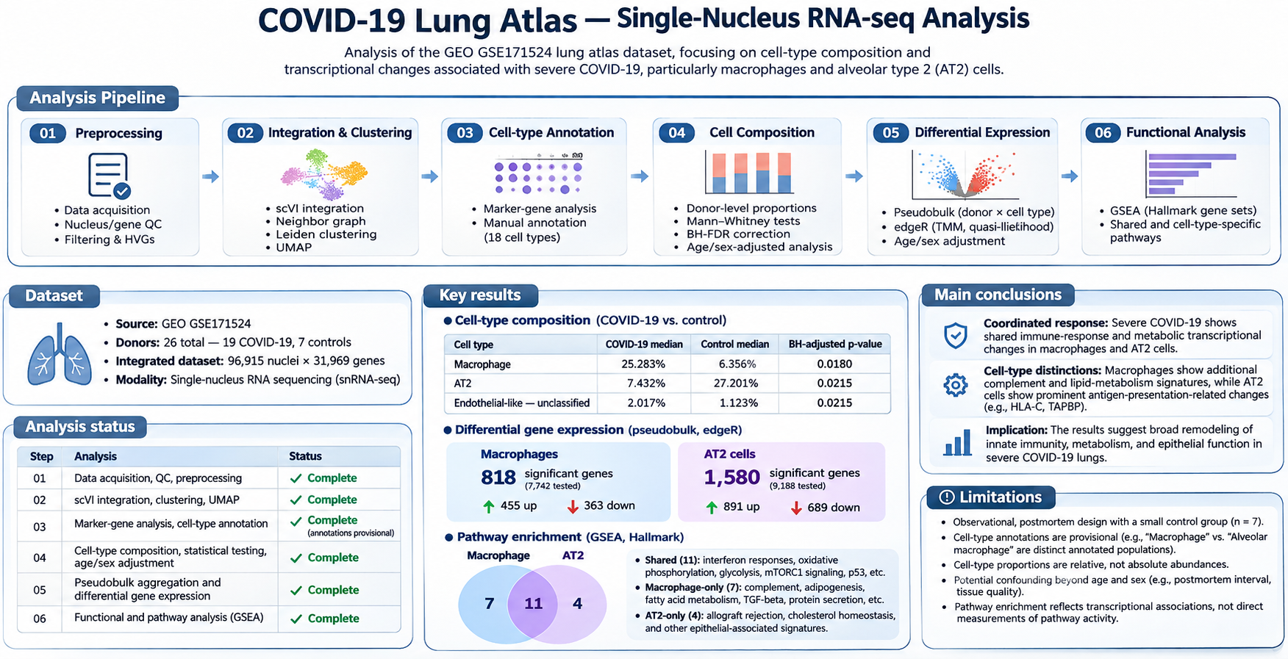
Figure 1. Schematic pipeline infographic; illustrative graphics are not computed UMAPs, volcano plots, or enrichment plots.

Executive summary
This project reanalyzes publicly available postmortem lung snRNA-seq data to investigate changes associated with fatal COVID-19. Nuclei were filtered and integrated using scVI, clustered with Leiden, and annotated using established marker genes. Analyses treated donors—not nuclei—as biological replicates. Macrophage and alveolar type 2 (AT2) epithelial populations were prioritized for pseudobulk differential expression and pathway enrichment.
The COVID-19 group showed a higher median fraction of recovered nuclei annotated as Macrophage (25.283% vs 6.356%) and a lower AT2 fraction (7.432% vs 27.201%). edgeR identified 818 macrophage and 1,580 AT2 genes meeting FDR < 0.05 and |log2FC| > 1. Of 50 Hallmark gene sets, 22 were significant in at least one cell type: 11 shared, 7 macrophage-only and 4 AT2-only. These results suggest shared interferon, stress and metabolic transcriptional programs, with additional population-associated signatures. They do not establish causality or absolute tissue cell abundances.

1. Research questions and design
Primary questions: (i) How does the distribution of recovered cell types differ between COVID-19 and control lungs? (ii) Which transcriptional changes are associated with disease in macrophages and AT2 cells? (iii) Which Hallmark signatures are shared or distinct across these two annotated populations?
Attribute | Study detail
Source | NCBI GEO GSE171524
Modality | Single-nucleus RNA sequencing (snRNA-seq)
Cohort | 19 fatal COVID-19; 7 controls
Integrated dataset | 96,915 nuclei × 31,969 genes
Replicate | Individual donor
Primary adjusted DGE | 18 COVID-19 + 7 controls (one COVID donor lacks age)
Cell types analyzed by DGE | Macrophage and AT2; separate Alveolar macrophage annotation not included

2. Computational pipeline

2.1 Data ingestion and quality control
Raw gene-by-nucleus matrices were imported into Scanpy/AnnData and converted to sparse matrices. Metadata were matched to nucleus barcodes, with checks for unique identifiers and donor/group assignment. scVI and SOLO were trained on a temporary copy for doublet identification; high-confidence doublets were removed from the original raw-count object. QC included minimum 200 detected genes, upper 98th percentile for detected genes, mitochondrial fraction <20%, and ribosomal fraction <2%, as configured. Filtering removes nuclei without normalizing the retained raw UMI count matrix.

2.2 Integration and annotation
scVI was trained on 2,000 highly variable genes, using biosample_id as a batch covariate. A 10-dimensional latent representation supported 15-neighbor graph construction, UMAP embedding, and Leiden clustering (resolution 0.5). Cell types were assigned by examining cluster marker genes, known lung markers, dot plots and donor representation. Marker identification used a separately normalized log-transformed AnnData copy, leaving the pseudobulk count object untransformed. Annotation labels remain provisional; 18 labeled clusters were defined in the annotation mapping.

2.3 Composition statistics
For each donor, nuclei were counted by annotated cell type and converted into percentages of all recovered nuclei for that donor. Two-sided Mann–Whitney U tests compared disease groups and p-values were corrected across cell types using Benjamini–Hochberg FDR. Selected macrophage and AT2 fractions were additionally evaluated using OLS with HC3 robust errors on logit-transformed proportions, adjusting for age and sex. These percentages describe the recovered sample and are not direct measurements of absolute lung cell abundance.

2.4 Pseudobulk differential expression
Raw UMI counts were summed across nuclei within each donor × annotated cell type, producing donor-by-gene matrices. Sample QC assessed nuclei per donor, total library size, detected genes, counts per nucleus and exploratory PCA. In R/edgeR, genes were filtered with filterByExpr, libraries normalized using TMM, dispersion estimated robustly, and quasi-likelihood generalized linear models fit using ~ age + sex + group. The COVID-19 group coefficient was tested relative to controls. BH-adjusted FDR <0.05 and |log2FC|>1 define the reported descriptive significant-gene set; this is not a formal test that the true fold change exceeds twofold.
Sensitivity checks included excluding an influential macrophage donor (L01cov), an unadjusted model retaining all 26 donors, and excluding two low-nucleus-count AT2 COVID donors (L05cov and L11cov, 23 nuclei each). These checks evaluate robustness; the report does not infer that every individual gene remained significant in each sensitivity run without the relevant comparison outputs.

2.5 Pathway analysis
Preranked GSEA used gseapy and the MSigDB Hallmark 2020 collection (50 gene sets; 1,000 permutations). The ranking metric was sign(logFC) × sqrt(edgeR quasi-likelihood F). Positive normalized enrichment score (NES) denotes enrichment toward COVID-higher-ranked genes; negative NES denotes enrichment toward the control-associated end. Pathway significance was assessed with GSEA FDR <0.05.

3. Results: donor-level composition
Annotated population | COVID median | Control median | BH-adjusted p
Macrophage | 25.283% | 6.356% | 0.0180
AT2 | 7.432% | 27.201% | 0.0215
Endothelial-like — unclassified | 2.017% | 1.123% | 0.0215
The macrophage fraction was higher and AT2 fraction lower in the COVID-19 group. These differences are compositional and could reflect changes in multiple populations, sample handling, differential recovery, or biological disease processes. The endothelial-like annotation is explicitly uncertain. Group summaries are donor medians, not pooled nucleus-level percentages.

4. Results: pseudobulk QC and DGE
Measure | Macrophage | AT2
COVID donors in QC | 19 | 19
Control donors in QC | 7 | 7
Median COVID nuclei/donor | 695 | 208
Median control nuclei/donor | 254 | 1,033
Genes tested | 7,742 | 9,188
Significant (FDR<0.05; |log2FC|>1) | 818 | 1580

4.1 Macrophage differential expression
818 genes met the descriptive significance threshold: 455 higher and 363 lower in COVID-19. The following are the five most statistically significant genes from the uploaded edgeR output, irrespective of direction.
Gene | log2FC | FDR
DPP6 | -7.75 | 3.9e-09
MED12L | -5.48 | 2e-06
CHIT1 | -3.55 | 2e-06
CADPS2 | -6.76 | 2e-06
GALNTL6 | -5.41 | 3.2e-06

4.2 AT2 differential expression
1,580 genes met the descriptive significance threshold: 891 higher and 689 lower in COVID-19. The following are the five most statistically significant genes from the uploaded edgeR output, irrespective of direction.
Gene | log2FC | FDR
IQCN | -4.20 | 4.6e-07
AP000857.2 | -2.91 | 4.6e-07
KCNK6 | +5.41 | 6.4e-07
AC003991.1 | -3.76 | 6.4e-07
HLA-C | +6.33 | 6.4e-07
Illustrative biologically interpretable genes noted in the project include CEBPB, PKM and JUND (macrophage, COVID-higher), CHIT1 and NLRP3 (macrophage, COVID-lower), and HLA-C, TAPBP, APOL6 and UNC93B1 (AT2, COVID-higher). Interpretation should emphasize coherent gene sets rather than treating single genes as causal proof.

5. Results: Hallmark GSEA
Of 50 pathways: 11 significant in both, 7 only in macrophages, 4 only in AT2, and 28 significant in neither. “Only” means passing the chosen FDR threshold in one analysis, not a formal difference between cell types.
Shared significant Hallmark set | Mac NES | AT2 NES
Oxidative Phosphorylation | +2.43 | +1.71
Myc Targets V1 | +2.35 | +2.06
mTORC1 Signaling | +2.33 | +2.09
Unfolded Protein Response | +2.17 | +1.59
Reactive Oxygen Species Pathway | +1.97 | +1.65
Interferon Alpha Response | +1.77 | +2.37
p53 Pathway | +1.73 | +2.02
Glycolysis | +1.73 | +1.71
PI3K/AKT/mTOR Signaling | +1.65 | +1.58
Interferon Gamma Response | +1.60 | +2.01
E2F Targets | +1.50 | +1.49

Macrophage-only significant
Hallmark pathway | Mac NES / FDR | AT2 NES / FDR
Adipogenesis | +2.16 / 0 | +0.93 / 0.719
Complement | +1.97 / 0.000973 | +1.17 / 0.36
Fatty Acid Metabolism | +1.73 / 0.00779 | -0.90 / 0.825
Protein Secretion | +2.12 / 0 | +1.14 / 0.369
TGF-beta Signaling | +1.60 / 0.0208 | -0.99 / 0.636
UV Response Up | +1.82 / 0.00405 | -1.07 / 0.603
Xenobiotic Metabolism | +2.11 / 0 | +1.12 / 0.386

AT2-only significant
Hallmark pathway | Mac NES / FDR | AT2 NES / FDR
Allograft Rejection | +1.02 / 0.59 | +1.77 / 0.00755
Apoptosis | +1.46 / 0.056 | +1.48 / 0.0499
Cholesterol Homeostasis | +0.93 / 0.651 | +1.58 / 0.026
TNF-alpha Signaling via NF-kB | +1.02 / 0.573 | -1.85 / 0.00846

6. Biological interpretation

6.1 Shared antiviral, metabolic and stress signatures
Both annotated populations show positive enrichment of interferon-alpha and interferon-gamma response gene sets. Shared oxidative phosphorylation, glycolysis, mTORC1, reactive oxygen species, p53 and MYC-associated programs point to broad metabolic and stress-related transcriptional remodeling. NES measures the relative location of genes in a ranked transcriptomic contrast; it is not a direct measure of mitochondrial respiration, glycolytic flux or protein signaling activity.

6.2 Macrophage-associated patterns
Complement, protein secretion, adipogenesis, fatty acid metabolism and TGF-beta-related Hallmark signatures were significant in the macrophage analysis but not the AT2 analysis. These results are compatible with changes in immune-effector, lipid-handling and tissue-remodeling gene programs. The separately annotated Alveolar macrophage cluster was not pooled into this macrophage DGE, and conclusions must retain that distinction.

6.3 AT2-associated patterns
AT2 cells showed interferon-related signatures and higher expression of antigen-processing/presentation genes such as HLA-C and TAPBP. Allograft rejection, cholesterol homeostasis and apoptosis-related Hallmark sets were among the AT2-only significant findings. TNF-alpha signaling via NF-κB had negative enrichment in AT2 (NES approximately −1.85), placing constituent genes toward the control-associated end of the ranked contrast; this does not demonstrate global suppression of NF-κB protein activity.

6.4 Interpretation across populations
The strongest cross-population conclusion is that severe COVID-19 lung tissue displays shared immune and metabolic transcriptional signatures with additional cell-type-associated patterns. Different significance status or different NES magnitude across separately analyzed cell types is not a statistical interaction test. Direct evidence for cell-type-specific effects would require a suitable interaction analysis or comparable formal contrasts.

7. Strengths, limitations and methodological cautions
- Strength: donor-level pseudobulk avoids treating thousands of nuclei from one person as independent biological replicates.
- Strength: preserved raw-count workflow and independent normalization for clustering versus DGE; robust edgeR quasi-likelihood framework and sensitivity analyses.
- Limitation: 7 controls, observational postmortem cohort, and potential confounding by clinical severity, tissue quality, collection conditions and postmortem interval.
- Limitation: one COVID donor missing age was excluded from adjusted DGE, and two COVID AT2 samples had only 23 nuclei each.
- Limitation: cell labels are marker-guided and provisional; macrophage and alveolar macrophage clusters are distinct annotations.
- Limitation: nucleus recovery fractions are compositional, not absolute cell abundance or direct measures of depletion/infiltration.
- Limitation: FDR<0.05 combined with |log2FC|>1 is a post hoc effect-size cutoff, not an interval-null hypothesis test.
- Limitation: pathway enrichment is transcript-level association and does not establish mechanism, cell-intrinsic viral infection, or measured pathway activity.
- Verification boundary: reviewed source functions preserve raw counts when used as intended; this does not independently audit the complete history of every saved intermediate file.

8. Reproducibility and repository organization
The repository organizes numbered analysis scripts (01 preprocessing through 09 pathway enrichment) and reusable src modules for configuration, preprocessing, integration, annotation, composition and pseudobulk aggregation. Data directories separate raw counts, processed AnnData objects and generated results; large raw data, .h5ad files and model checkpoints are excluded from version control. The project uses Python/Scanpy 1.12.4, scvi-tools 1.5.1, PyTorch 2.11 with CUDA 12.8, R/edgeR and gseapy 1.1.3. Exact package versions and seeds should be exported from the working environment to reproduce runs.
Relevant project outputs include macrophage_dge_edger.csv, at2_dge_edger.csv, macrophage_at2_gsea_comparison.csv and cell-type-specific GSEA ranking CSVs. Primary source: https://www.ncbi.nlm.nih.gov/geo/query/acc.cgi?acc=GSE171524

9. Final conclusion
This completed computational analysis provides an end-to-end, donor-aware snRNA-seq workflow from raw-count QC through scVI integration, cell-type annotation, compositional testing, pseudobulk differential expression and functional enrichment. The strongest observations are a higher recovered macrophage fraction, a lower recovered AT2 fraction, substantial disease-associated differential expression in both populations, and overlapping interferon/metabolic Hallmark signatures with additional population-associated patterns. These findings are appropriate for a portfolio demonstration of rigorous single-cell analysis and biological interpretation, while remaining descriptive and hypothesis-generating.

