CentOS7安装Jenkins

安装指令
wget -O /etc/yum.repos.d/jenkins.repo http://pkg.jenkins-ci.org/redhat/jenkins.repo2 rpm --import https://jenkins-ci.org/redhat/jenkins-ci.org.key3 yum install -y jenkins

配置文件
vi /etc/sysconfig/jenkins
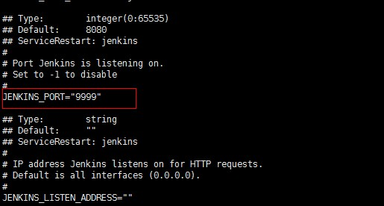
vim /etc/init.d/jenkins
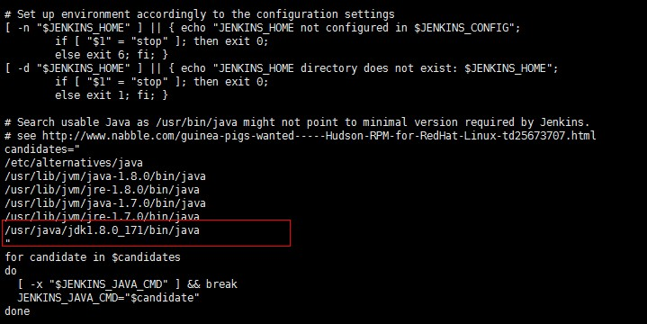

开启服务
service jenkins start
防火墙开放
firewall-cmd --zone=public --add-port=9999/tcp --permanent
重启防火墙
firewall-cmd --reload

查看自己的服务器ip

Linux:ifconfig
Window:ipconfig

访问：http://IP:9999/

查看密码
/var/lib/jenkins/secrets/initialAdminPassword 