安装SVN

安装指令
yum -y install subversion

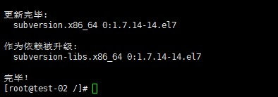
svnadmin create /usr/svn/project

#检测是否创建成功
cd/usr/svn/project/conf

