RabbitMQ--客户端
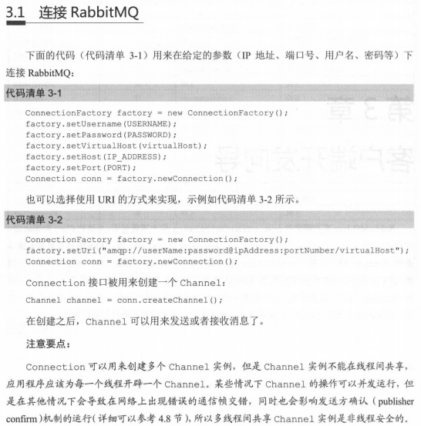
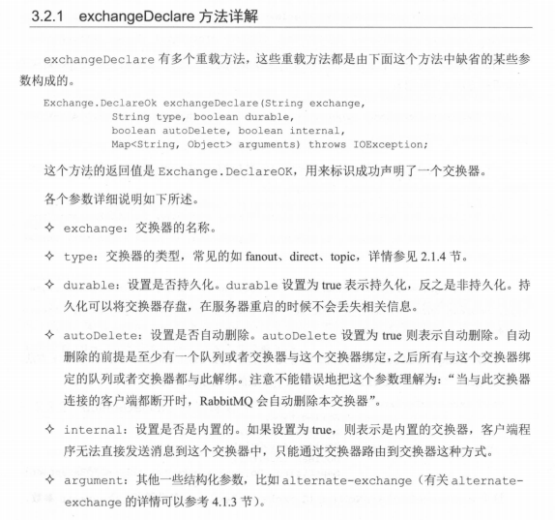
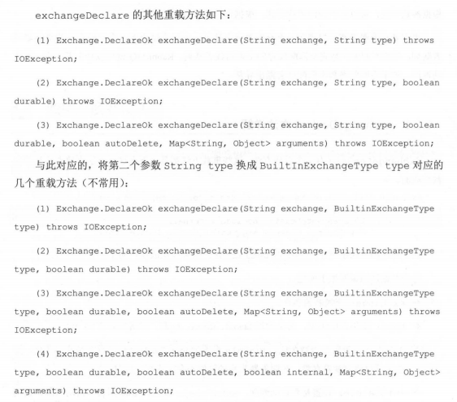
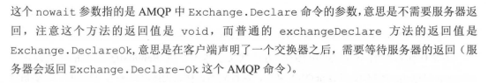
queueDeclare相对于exchangeDeclare方法而言，重载方法的个数就少很多
它只有两个重载方法:
(1) Queue . DeclareOk queueDec1are() throws IOException;
(2) Queue. DeclareOk queueDeclare (String queue , boolean durable , boolean exclusive ,boolean autoDelete , Map<Strng，Object> arguments) throws IOException;
