Shipping System SDLC Document

(Agile Method)

**Linan Zhang**

**Ming Zhao Shi**

Contents

1. System Planning 4

1.1. Purpose / Business case 4

1.2. SWOT Analysis (Team/Project) 4

1.2.1. Strengths 4

1.2.2. Weaknesses 4

1.2.3. Opportunities 4

1.2.4. Threats 5

1.3. Preliminary Investigation 5

1.3.1. Understand problem 5

1.3.2. Project scope/constraints 5

1.3.3. Perform fact-finding from end-user 5

1.3.4. Analyze fact, data 6

1.3.5. Project feasibility 6

1.3.6. Present result/recommendations 6

1.4. Project feasibility 6

1.4.1. Operational feasibility 6

1.4.2. Technical feasibility 6

1.4.3. Economic feasibility 6

1.4.4. Schedule feasibility 6

1.5. Project management 7

1.5.1. Project planning/Split project into tasks 7

1.5.2. Project scheduling (MS Project) 7

1.6. Project triangle (Scope, time, cost) 8

1.7. Project risk/Probability (Matrix – high risk with high probability) 8

2. System Analysis 9

2.1. Client questionnaires 9

2.2. Requirement modeling 9

2.2.1. Inputs 9

2.2.2. Outputs 9

2.2.3. Processes 9

2.2.4. Performance 9

2.2.5. Security 10

2.3.1. Function decomposition diagram – FDD 10

2.3.2. Data flow diagram – DFD 10

2.4.1. Use case diagram (actor) 11

2.4.2. Class diagram 11

2.4.3. Sequence diagram 12

2.4.4. Transition diagram 12

2.4.5. Activity diagram 13

3. System Design 13

3.1. Development strategies/impacts 13

3.1.1. Desktop app 13

~~3.1.2.~~ ~~Mobile app~~ 13

3.1.3. Web app/C/S app 13

~~3.1.4.~~ ~~Cloud-based app~~ 13

~~3.1.5.~~ ~~SOA-based app~~ 13

3.2. Project prototype 13

3.2.1. User interface (intuitiveness /user friendly) 13

3.2.2. Data structure issues (array of objects) 14

3.2.3. Reports consideration/Output design 14

3.3.1. 1NF (1 big table) 14

~~3.3.2.~~ ~~2NF (Partial dependency)~~ 15

~~3.3.3.~~ ~~3NF (Trans dependency)~~ 15

4. System Implementation 15

4.2. Back-end system 15

4.3. Structure chart 16

4.4. Prototype 16

5. System Testing/Security 16

5.1. Unit testing 16

~~5.2.~~ ~~System testing~~ 19

~~5.3.~~ ~~Integration testing~~ 19

# System Planning

## Purpose / Business case

The main purpose of this project is to provide admin of the shipping, post and express company the easiest way to retrieve customer’s information, calculate the delivery charges, track the package information, provide better service for the customer, and generate a detailed post/express report for both the customer and shipping company. This project is carried out to solve the problem face by the shipping company, such as low efficiency in package management, waste a lot of time in calculation, miscalculation of shipping charge since the rate of different kind of package category are different. The shipping charge is also determined by the destination and which kind of shipping method the customer choose. With this project, the shipping company can calculate the shipping charge more easily and more accurately, it is also convenient for the customer or the shipping company to retrieve package’s information.

## SWOT Analysis (Team/Project)

### Strengths

By using a computerized system, the shipping company can manage the package information more efficiently, do calculation activity more accurately, faster and reduce paper work and the chance of miscalculation. In addition, the client and the shipping company can also retrieve the package information. Therefore, this system will benefit both the customer and shipping company.

### Weaknesses

In the past, the shipping company is using paper to record and stored in file. This is impossible to get the updated package information. And there is also a lot of miscalculation for the shipping charge.

### Opportunities

With more and more online shopping made, and massive personal and business package delivered, it is necessary to have such a system to manage the shipping information and calculate the shipping charge accurately and efficiently, which can reduce the miscalculation and a lot of paper work. The system is also user friendly, which means the company does not need to spend a lot of time to learn how to use it.

### Threats

Since the development of this system, many shipping company need to change their way of manage customer information, especially it is hard to accept the new things for some elderly employees, it will hinder the use of the new system.

In addition, the new system involves many business and personal information, the system's security and stability is very important.

## Preliminary Investigation

### Understand problem

First of all, the shipping company is using a traditional way to manage customer and package information, which is not easy to keep (need space to keep all the files).

Secondly, the traditional manual calculation will cause lots of mistake.

Furthermore, there will be so difficult for the shipping company to retrieve customer and package information if they are still using the traditional paper way.

Finally, the way to keep client and customer’s information has to be safe and secure, so the old paper way should be abandoned.

### Project scope/constraints

The system should be capable of performing following functions:

* Create, save, and modify the basic information of the customer.
* Get the information of the employee who is responsible for the according customer, and employee management is also needed.
* Calculate the shipping charge accurately on basis of the basic charge, package category, shipping category and location.
* Retrieve the package information timely.
* System should generate the report for each sub system.

### Perform fact-finding from end-user

The shipping company side want all the information be managed in an efficient, accurate and secure way. With all matters into consideration, we decide that a “Shipping management System” is necessary.

### Analyze fact, data

At the beginning of the use of this system, it really do need time to input a lot of information. But during the stable operation period, we can be confident that the new system will significantly improve efficiency and reduce the cost.

### Project feasibility

Both the requirement and the objectives are clear, the basic environment of the project development and technical environment to meet the requirement.

### Present result/recommendations

It is recommended to develop a project based on JAVA / Oracle C / S architecture based on existing basic data and working methods.

## Project feasibility

### Operational feasibility

The project has a complete data base and network infrastructure, the project design based on the actual work process to simplify the work as the ultimate goal.

### Technical feasibility

The project is planned to use JAVA + Oracle C / S structure design, its advantages are:

JAVA features and advantages: ……

Oracle features and advantages: ……

C / S structural design features and advantages:

### Economic feasibility

The implementation of this project will greatly reduce the existing workload of the employee who work at shipping company while improving the efficiency and accuracy of the shipping charge, reducing time wasted on finding customer and package information.

### Schedule feasibility

The project implementation plan adopts the agile method, its purpose is to complete step by step. At each stage, a separate test will be conducted and the project user will be invited to participate in the test and then adjusted based on feedback.

## Project management

### Project planning/Split project into tasks

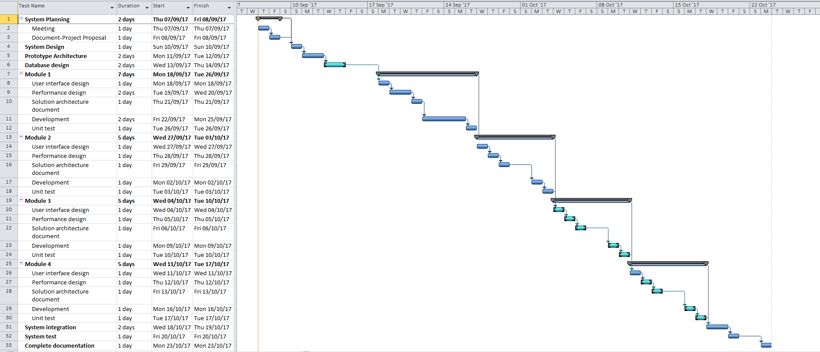

### Project scheduling (MS Project)

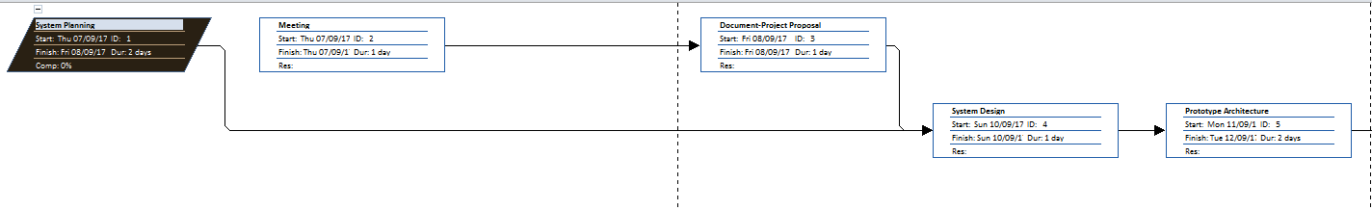

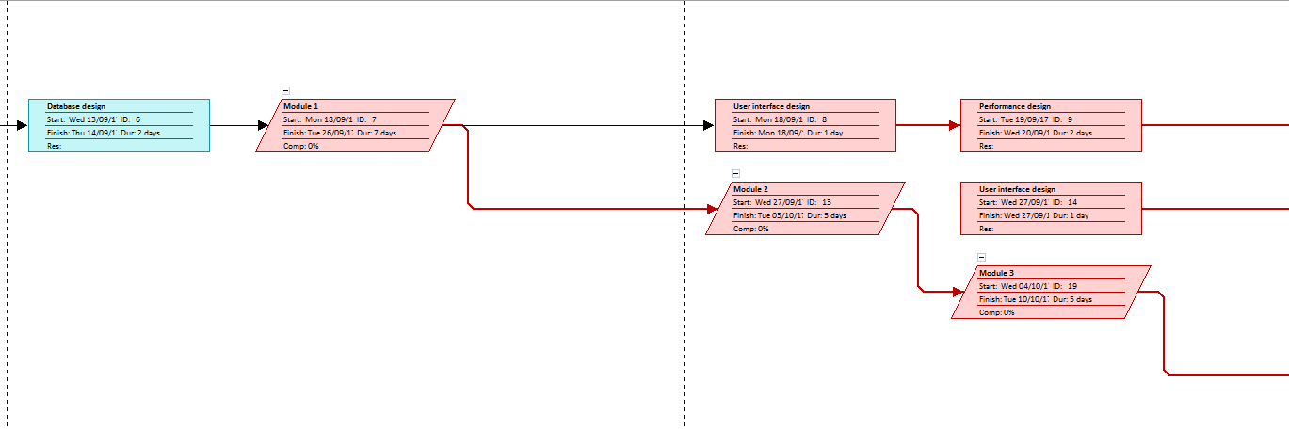

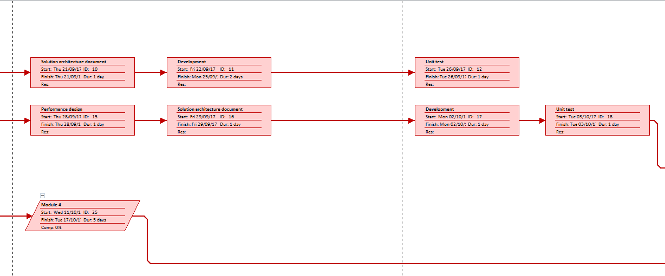

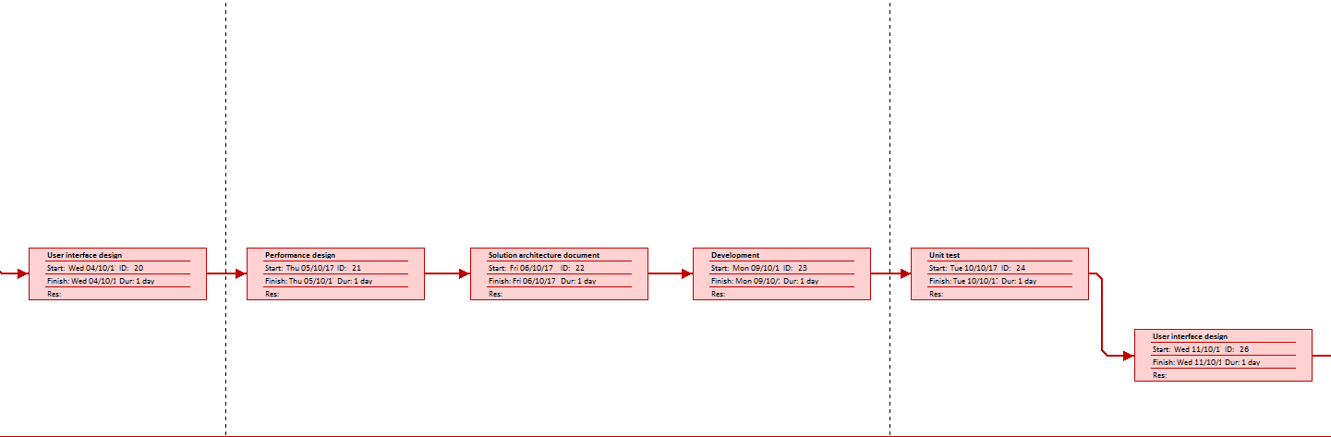

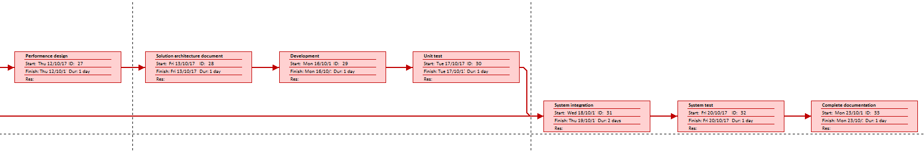

## Project triangle (Scope, time, cost)

## Project risk/Probability (Matrix – high risk with high probability)

# System Analysis

## Client questionnaires

Q: How many people will use this system?

A: Staffs who work for the shipping company, manager at the shipping company will also have access to the system to manage the staff, customer, package and price.

Q: Why need this system?

A: By using a computerized system, the shipping company can manage the package information more efficiently, do calculation activity more accurately, faster and reduce paper work and the chance of miscalculation. In addition, the client and the shipping company can also retrieve the package information. Therefore, this system will benefit both the customer and shipping company.

Q: The hardware can meet the requirement of system or not?

A: The project is planned to use JAVA + Oracle C / S structure design, so for these software, it does not require very high end hardware to run it.

## Requirement modeling

### Inputs

* Employee table: EmployeeId(pk), Employee_Lname, Employee_Fname, Telephone, Email, ClientId, PackageId
* Client table: ClientId(pk), Customer_Lname, Customer_Fname, telephone, Email , Address, EmployeeId , PackageId
* Package table: PackageId(pk), Name, PackageCategoryId, weight, ReceiverName, Destination, LocationId, ShippingMethod, ShippingCategoryId, Telephone, ClientId(fk), employee_id(fk)

### Outputs

* Package table: shipping_charge
* Every sub system report accordingly.

### Processes

Shipping_charge = (package_category_rate + location_rate) *weight + shipping_category_rate;

### Performance

* For Employee system, new employee can be added, employee’s information can also be updated, printed and deleted, the employee system will also display employee’s according responsible customers id.
* Within Customer system, we can create, modify, print and delete customer’s information.
* The Package system, the shipping charge should be calculated accurately, which is calculated on basis of the package’s weight, package category rate, shipping category rate, location rate.

### Security

* 1. Data and process modeling

### Function decomposition diagram – FDD

Location rate

Package category rate

Shipping category rate

Package shipping charge

Total Charge

Weight

### Data flow diagram – DFD

Employee info

Shipping charge

Get according rate from package category, shipping category, location table

Package info (weight,package category id,shipping category id,location id)

Customer info

Final Report

* 1. UML diagram

### Use case diagram (actor)

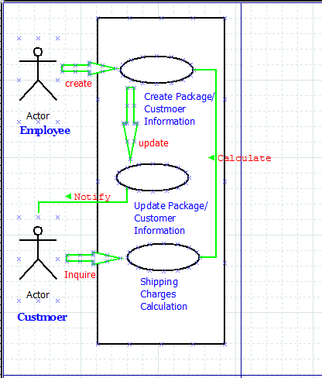

### Class diagram

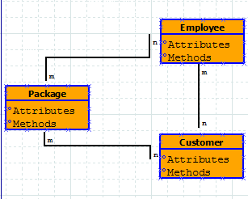

### Sequence diagram

### Transition diagram

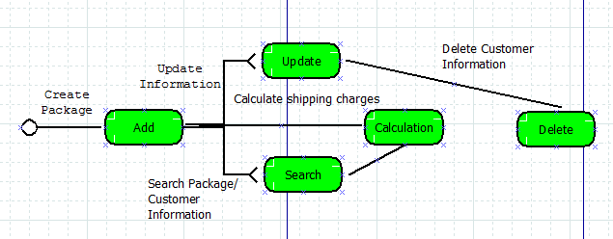

### Activity diagram

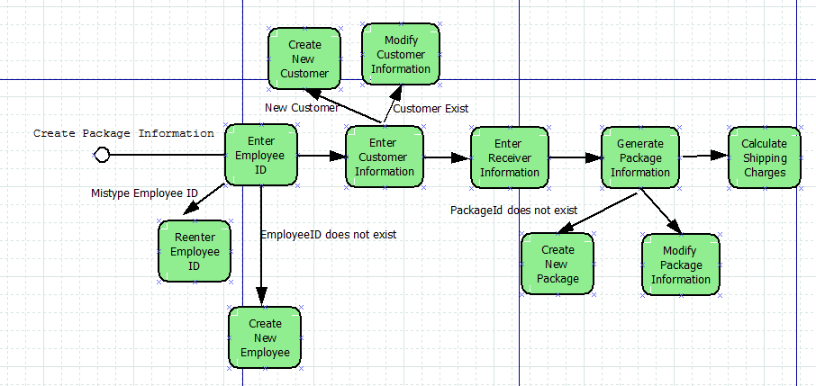

* 1. Data dictionary(name of field, type of the field, size of the field)

# System Design

## Development strategies/impacts

### Desktop app

### ~~Mobile app~~

### Web app/C/S app

### ~~Cloud-based app~~

### ~~SOA-based app~~

## Project prototype

### User interface (intuitiveness /user friendly)

Intuitiveness/use friendly

Graphical Employee interface (GUI)

Graphical Customer interface (GUI)

Graphical Package interface (GUI)

Graphical Package Category interface (GUI)

Graphical Shipping Category interface (GUI)

Graphical Location interface (GUI)

### Data structure issues (array of objects)

class: employee, GUIEmployee, OracleInsertConnection, OracleDeleteConnection, OracleUpdateConnection

### Reports consideration/Output design

* Employee Information Report
* Customer Information Report
* Package Information Report
* Package Category Information Report
* Shipping Category Information Report
* Location Information Report
  1. Database normalization

### 1NF (1 big table)

TABLE employeeT

|  |  |  |
| --- | --- | --- |
| Field Name | Field Type | Length |
| EmployeeId (PK) | NUMBER | 3 |
| Lname | VARCHAR2 | 15 |
| Fname | VARCHAR2 | 15 |
| Telephone | VARCHAR2 | 15 |
| Email | VARCHAR2 | 50 |
| ClientId | NUMBER | 6 |
| PackageId | NUMBER | 10 |

TABLE clientT

|  |  |  |
| --- | --- | --- |
| Field Name | Field Type | Length |
| ClientId (PK) | NUMBER | 3 |
| Lname | VARCHAR2 | 15 |
| Fname | VARCHAR2 | 15 |
| Telephone | VARCHAR2 | 15 |
| Email | VARCHAR2 | 30 |
| Address | VARCHAR2 | 30 |
| EmployeeId | NUMBER | 3 |
| PackageId | NUMBER | 10 |

TABLE PackageCategory

|  |  |  |
| --- | --- | --- |
| Field Name | Field Type | Length |
| PackageCategoryId (PK) | NUMBER | 3 |
| PackageDesc | VARCHAR2 | 50 |
| PackagePrice | NUMBER | 8 |

TABLE ShippingCategory

|  |  |  |
| --- | --- | --- |
| Field Name | Field Type | Length |
| ShippingCategoryId (PK) | NUMBER | 3 |
| ShippingDesc | VARCHAR2 | 30 |
| ShippingPrice | NUMBER | 8 |

TABLE Location

|  |  |  |
| --- | --- | --- |
| Field Name | Field Type | Length |
| LocationId (PK) | NUMBER | 3 |
| LocationDesc | VARCHAR2 | 30 |
| LocationPrice | NUMBER | 8 |

TABLE PackageT

|  |  |  |
| --- | --- | --- |
| Field Name | Field Type | Length |
| PackageId (PK) | NUMBER | 10 |
| Name | VARCHAR2 | 15 |
| PackageCategoryId | NUMBER | 3 |
| Weight | NUMBER | 8 |
| ReceiverName | VARCHAR2 | 15 |
| Destination | VARCHAR2 | 30 |
| LocationID | NUMBER | 3 |
| ShippingMethod | VARCHAR2 | 15 |
| ShippingCategoryId | NUMBER | 3 |
| Telephone | VARCHAR2 | 15 |
| ClientId | NUMBER | 6 |
| EmployeeId | NUMBER | 3 |

### ~~2NF (Partial dependency)~~

### ~~3NF (Trans dependency)~~

* + 1. ~~Dependency diagram~~
  1. Entity relationship diagram (Access/SQL developer)

Manages

1

Employee

M

Serves

Package Category

M

N M

Places

Shipping Category

Package

Customer

Location

* 1. System architecture

Class database

Object ---------- record

Attributes ----- field

# System Implementation

* 1. Front-end system

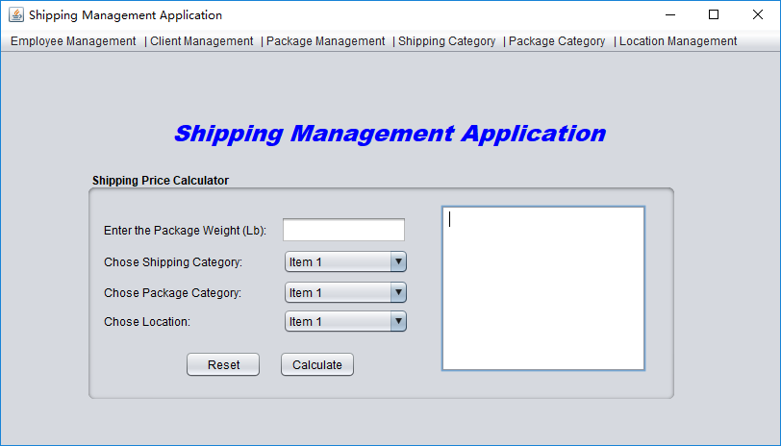

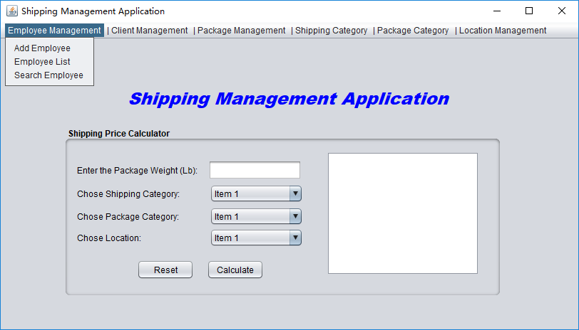

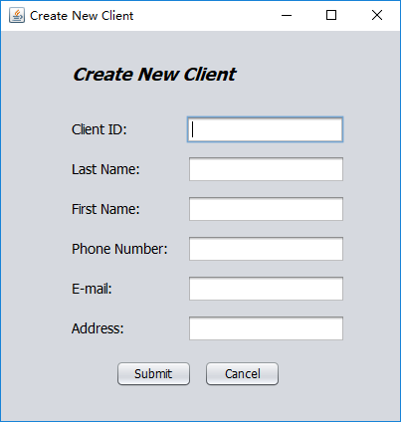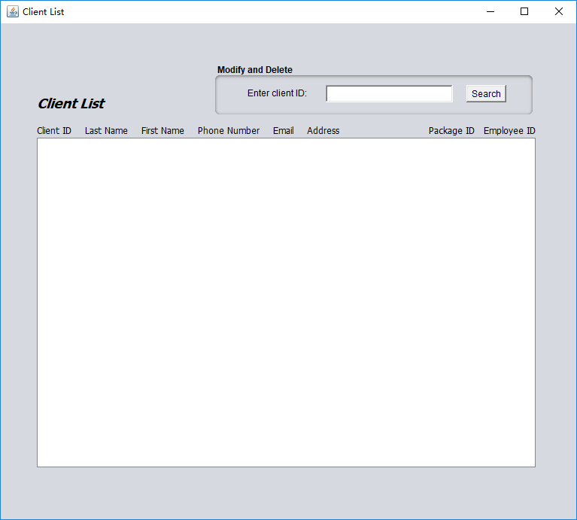

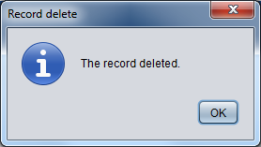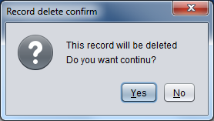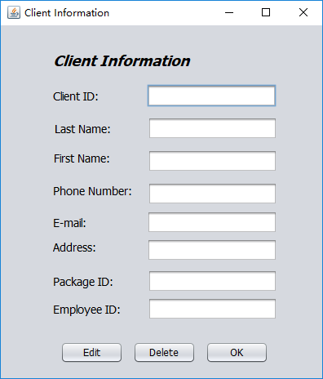

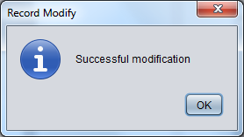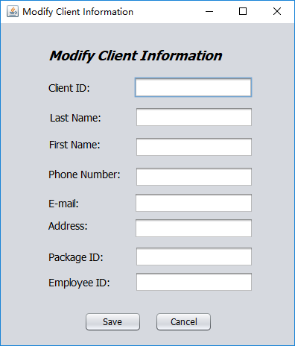

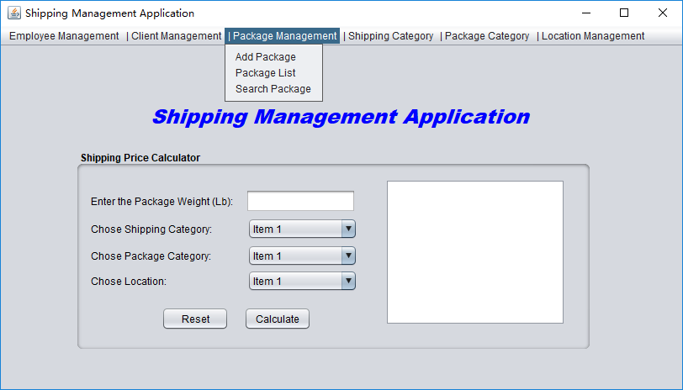

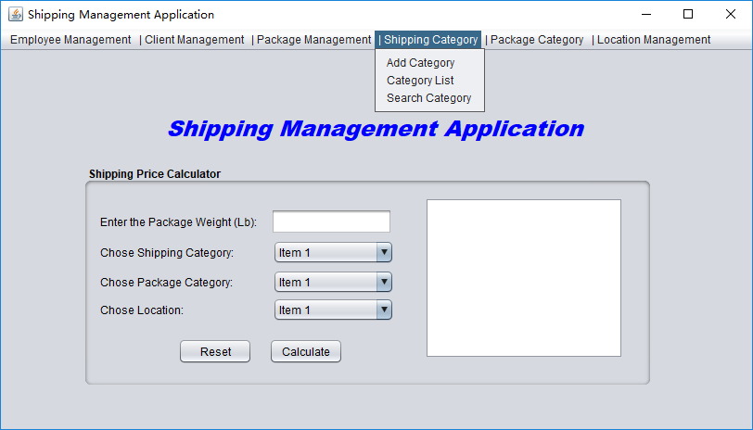

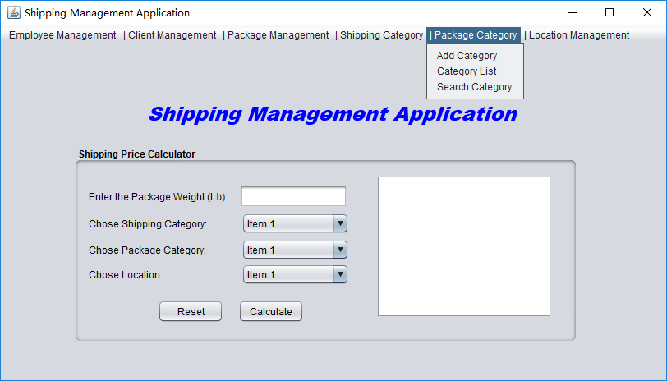

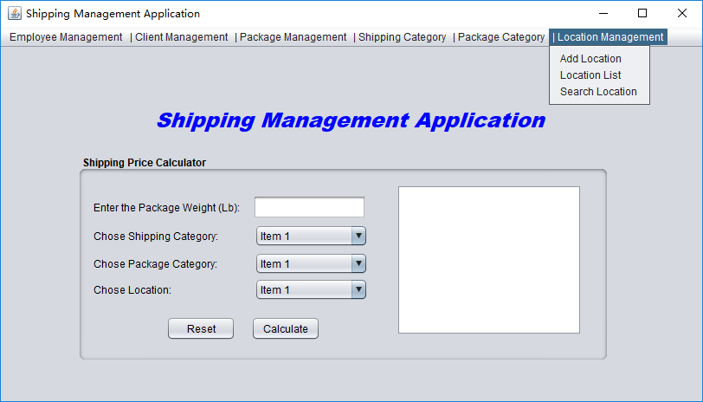

## Back-end system

Database Server

Database server is used in this project to handle database operations. The client does not directly interact with database, rather it goes through web server in order to keep the database secure from an unauthorized access. It is also called a third tier in the three tier architecture as implemented in this project.

## Structure chart

## Prototype

This system will use the Netbeans to develop. The system will calculate payroll amount, store it to database and display in UI. Database use Oracle to develop

# System Testing/Security

## Unit testing

Employee Management UT

1. Add new Employee
   1. EmployeeId should be integer only, no other characters.
   2. EmployeeId can not be blank
   3. The EmployeeId entered should not exist in table
   4. Telephone must be integer
   5. When click “Submit”, the information entered should be inserted into database
   6. When click “Cancel”, the information entered should not be inserted into database

## ~~System testing~~

## ~~Integration testing~~