Shipping System SDLC Document

(Agile Method)

**Linan Zhang**

**Ming Zhao Shi**

Contents

1. System Planning 4

1.1. Purpose / Business case 4

1.2. SWOT Analysis (Team/Project) 4

1.2.1. Strengths 4

1.2.2. Weaknesses 4

1.2.3. Opportunities 4

1.2.4. Threats 5

1.3. Preliminary Investigation 5

1.3.1. Understand problem 5

1.3.2. Project scope/constraints 5

1.3.3. Perform fact-finding from end-user 5

1.3.4. Analyze fact, data 6

1.3.5. Project feasibility 6

1.3.6. Present result/recommendations 6

1.4. Project feasibility 6

1.4.1. Operational feasibility 6

1.4.2. Technical feasibility 6

1.4.3. Economic feasibility 6

1.4.4. Schedule feasibility 7

1.5. Project management 7

1.5.1. Project planning/Split project into tasks 7

1.5.2. Project scheduling (MS Project) 7

1.6. Project triangle (Scope, time, cost) 8

1.7. Project risk/Probability (Matrix – high risk with high probability) 9

2. System Analysis 9

2.1. Client questionnaires 9

2.2. Requirement modeling 10

2.2.1. Inputs 10

2.2.2. Outputs 10

2.2.3. Processes 10

2.2.4. Performance 10

2.2.5. Security 10

2.3. Data and process modeling 10

2.3.1. Function decomposition diagram – FDD 10

2.3.2. Data flow diagram – DFD 11

2.4. UML diagram 12

2.4.1. Use case diagram (actor) 12

2.4.2. Class diagram 13

2.4.3. Sequence diagram 13

2.4.4. Transition diagram 13

2.4.5. Activity diagram 14

3. System Design 14

3.1. Project prototype 14

3.1.1. User interface (intuitiveness /user friendly) 14

3.1.2. Data structure issues (array of objects) 15

3.1.3. Reports consideration/Output design 15

3.2. Database normalization 15

3.3. Entity relationship diagram (Access/SQL developer) 17

3.4. System architecture 17

4. System Implementation 17

4.1. Front-end system 17

4.2. Back-end system 18

4.3. Structure chart 22

4.4. Prototype 22

5. System Testing/Security 22

5.1. Unit testing 22

5.2. System & Integration testing 77

# System Planning

## Purpose / Business case

The main purpose of this project is to provide admin of the shipping, post and express company the easiest way to retrieve customer’s information, calculate the delivery charges, track the package information, provide better service for the customer, and generate a detailed post/express report for both the customer and shipping company. This project is carried out to solve the problem face by the shipping company, such as low efficiency in package management, waste a lot of time in calculation, miscalculation of shipping charge since the rate of different kind of package category are different. The shipping charge is also determined by the destination and which kind of shipping method the customer choose. With this project, the shipping company can calculate the shipping charge more easily and more accurately, it is also convenient for the customer or the shipping company to retrieve package’s information.

## SWOT Analysis (Team/Project)

### Strengths

By using a computerized system, the shipping company can manage the package information more efficiently, do calculation activity more accurately, faster and reduce paper work and the chance of miscalculation. In addition, the client and the shipping company can also retrieve the package information. Therefore, this system will benefit both the customer and shipping company.

### Weaknesses

In the past, the shipping company is using paper to record and stored in file. This is impossible to get the updated package information. And there is also a lot of miscalculation for the shipping charge.

### Opportunities

With more and more online shopping made, and massive personal and business package delivered, it is necessary to have such a system to manage the shipping information and calculate the shipping charge accurately and efficiently, which can reduce the miscalculation and a lot of paper work. The system is also user friendly, which means the company does not need to spend a lot of time to learn how to use it.

### Threats

Since the development of this system, many shipping company need to change their way of manage customer information, especially it is hard to accept the new things for some elderly employees, it will hinder the use of the new system.

In addition, the new system involves many business and personal information, the system's security and stability is very important.

## Preliminary Investigation

### Understand problem

First of all, the shipping company is using a traditional way to manage customer and package information, which is not easy to keep (need space to keep all the files).

Secondly, the traditional manual calculation will cause lots of mistake.

Furthermore, there will be so difficult for the shipping company to retrieve customer and package information if they are still using the traditional paper way.

Finally, the way to keep client and customer’s information has to be safe and secure, so the old paper way should be abandoned.

### Project scope/constraints

The system should be capable of performing following functions:

* Create, save, and modify the basic information of the customer.
* Get the information of the employee who is responsible for the according customer, and employee management is also needed.
* Calculate the shipping charge accurately on basis of the basic charge, package category, shipping category and location.
* Retrieve the package information timely.
* System should generate the report for each sub system.

### Perform fact-finding from end-user

The shipping company side want all the information be managed in an efficient, accurate and secure way. With all matters into consideration, we decide that a “Shipping management System” is necessary.

### Analyze fact, data

At the beginning of the use of this system, it really do need time to input a lot of information. But during the stable operation period, we can be confident that the new system will significantly improve efficiency and reduce the cost.

### Project feasibility

Both the requirement and the objectives are clear, the basic environment of the project development and technical environment to meet the requirement.

### Present result/recommendations

It is recommended to develop a project based on JAVA / Oracle C / S architecture based on existing basic data and working methods.

## Project feasibility

### Operational feasibility

The project has a complete data base and network infrastructure, the project design based on the actual work process to simplify the work as the ultimate goal.

### Technical feasibility

The project is planned to use JAVA + Oracle C / S structure design, its advantages are:

JAVA features and advantages: ……

Oracle features and advantages: ……

C / S structural design features and advantages:

### Economic feasibility

The implementation of this project will greatly reduce the existing workload of the employee who work at shipping company while improving the efficiency and accuracy of the shipping charge, reducing time wasted on finding customer and package information.

### Schedule feasibility

The project implementation plan adopts the agile method, its purpose is to complete step by step. At each stage, a separate test will be conducted and the project user will be invited to participate in the test and then adjusted based on feedback.

## Project management

### Project planning/Split project into tasks

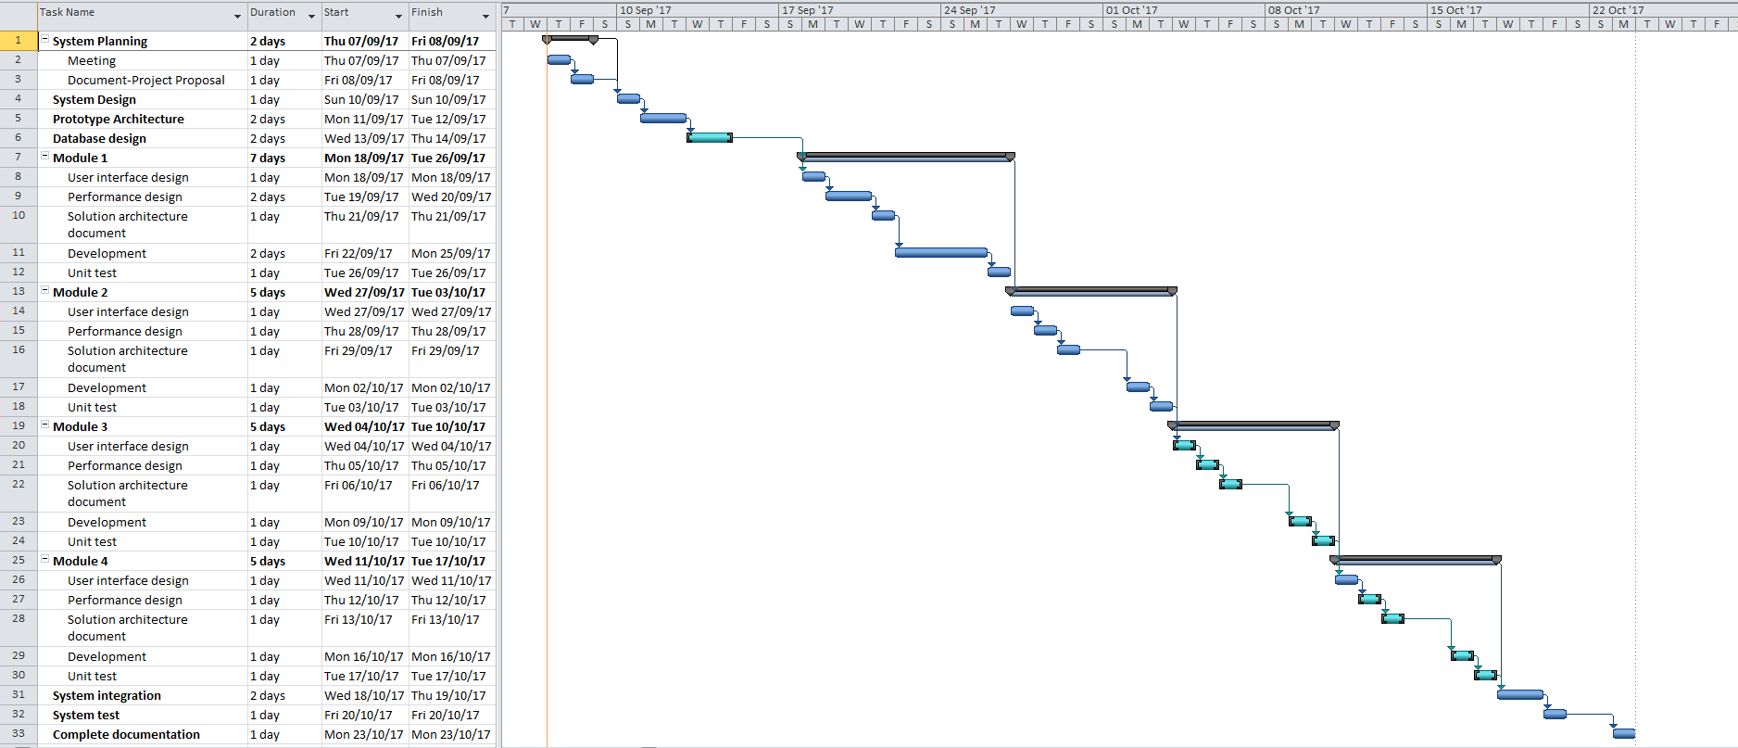

### Project scheduling (MS Project)

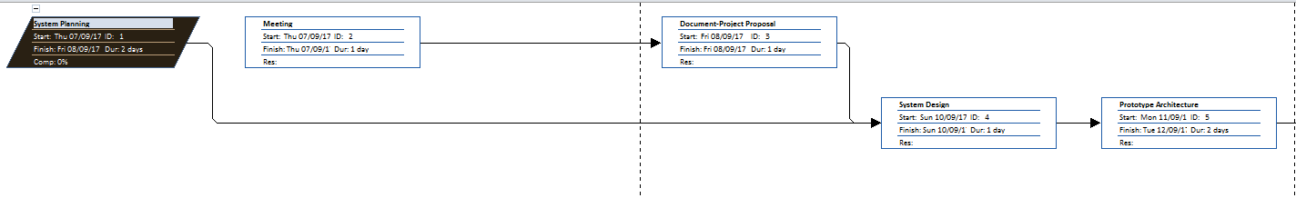

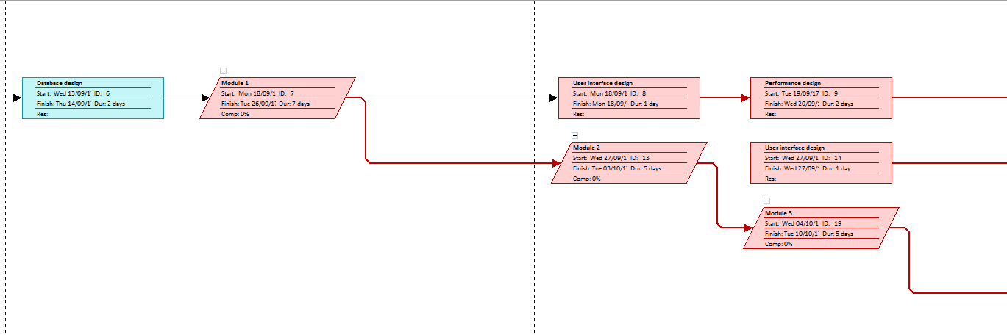

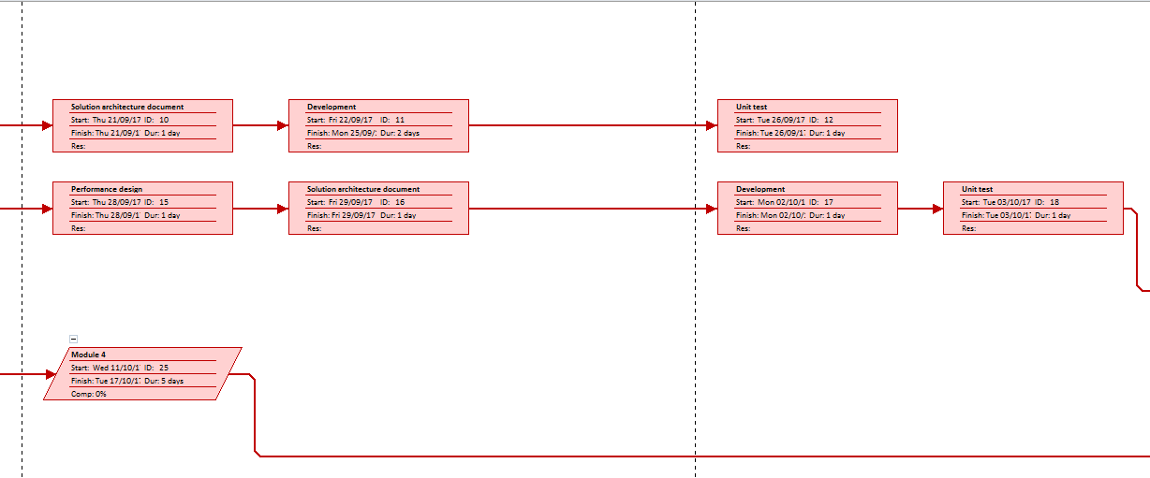

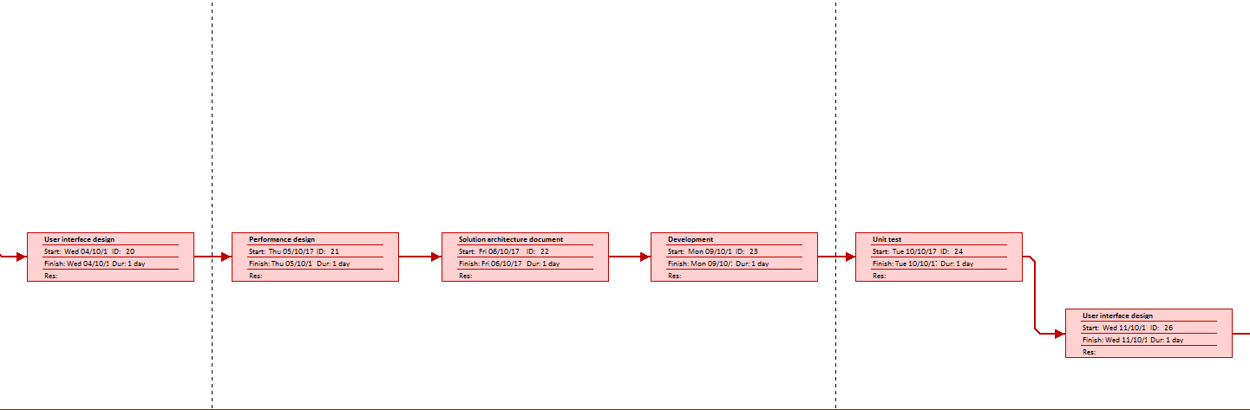

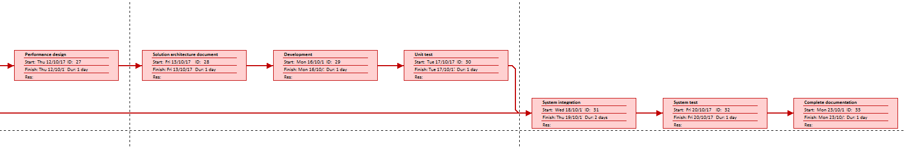

## Project triangle (Scope, time, cost)

## Project risk/Probability (Matrix – high risk with high probability)

# System Analysis

## Client questionnaires

Q: How many people will use this system?

A: Staffs who work for the shipping company, manager at the shipping company will also have access to the system to manage the staff, customer, package and price.

Q: Why need this system?

A: By using a computerized system, the shipping company can manage the package information more efficiently, do calculation activity more accurately, faster and reduce paper work and the chance of miscalculation. In addition, the client and the shipping company can also retrieve the package information. Therefore, this system will benefit both the customer and shipping company.

Q: The hardware can meet the requirement of system or not?

A: The project is planned to use JAVA + Oracle C / S structure design, so for these software, it does not require very high end hardware to run it.

## Requirement modeling

### Inputs

* Employee table: EmployeeId(pk), Employee_Lname, Employee_Fname, Telephone, Email
* Client table: ClientId(pk), Customer_Lname, Customer_Fname, telephone, Email , Address, EmployeeId , PackageId
* Package table: PackageId(pk), Name, PackageCategoryId, weight, ReceiverName, Destination, LocationId, ShippingCategoryId, Telephone, ClientId(fk), employee_id(fk)

### Outputs

* Package table: shipping_charge
* Every sub system report accordingly.

### Processes

Shipping_charge = (package_category_rate + location_rate) *weight + shipping_category_rate;

### Performance

* For Employee system, new employee can be added, employee’s information can also be updated, printed and deleted, the employee system will also display employee’s according responsible customers id.
* Within Customer system, we can create, modify, print and delete customer’s information.
* The Package system, the shipping charge should be calculated accurately, which is calculated on basis of the package’s weight, package category rate, shipping category rate, location rate.

### Security

## Data and process modeling

### Function decomposition diagram – FDD

Location rate

Package category rate

Shipping category rate

Package shipping charge

Total Charge

Weight

### Data flow diagram – DFD

Customer info

Employee info

Package info (weight,package category id,shipping category id,location id)

Get according rate from package category, shipping category, location table

Shipping charge

Final Report

## UML diagram

### Use case diagram (actor)

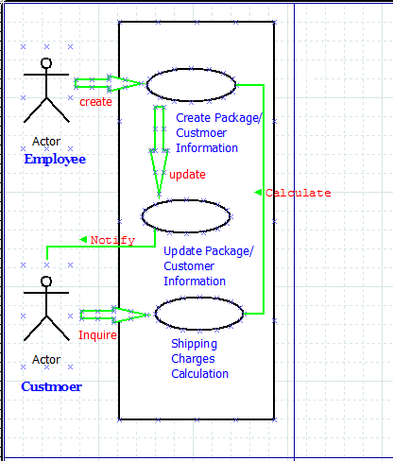

### Class diagram

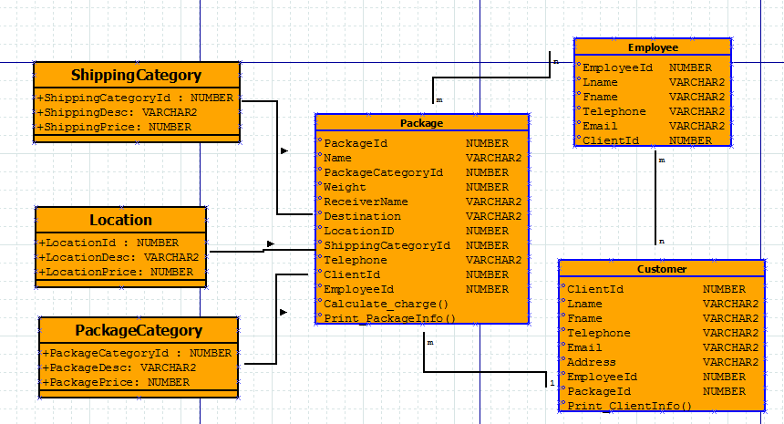

### Sequence diagram

### Transition diagram

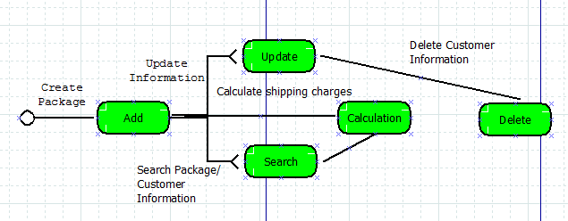

### Activity diagram

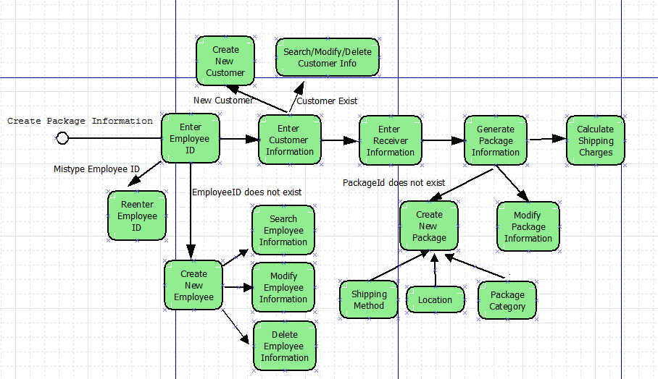

* 1. Data dictionary(name of field, type of the field, size of the field)

# System Design

## Project prototype

### User interface (intuitiveness /user friendly)

Intuitiveness/use friendly

Graphical Employee interface (GUI)

Graphical Customer interface (GUI)

Graphical Package interface (GUI)

Graphical Package Category interface (GUI)

Graphical Shipping Category interface (GUI)

Graphical Location interface (GUI)

### Data structure issues (array of objects)

class: employee, GUIEmployee, OracleInsertConnection, OracleDeleteConnection, OracleUpdateConnection

### Reports consideration/Output design

* Employee Information Report
* Customer Information Report
* Package Information Report
* Package Category Information Report
* Shipping Category Information Report
* Location Information Report

## Database normalization

TABLE employeeT

|  |  |  |
| --- | --- | --- |
| Field Name | Field Type | Length |
| EmployeeId (PK) | NUMBER | 3 |
| Lname | VARCHAR2 | 15 |
| Fname | VARCHAR2 | 15 |
| Telephone | VARCHAR2 | 15 |
| Email | VARCHAR2 | 50 |

TABLE clientT

|  |  |  |
| --- | --- | --- |
| Field Name | Field Type | Length |
| ClientId (PK) | NUMBER | 3 |
| Lname | VARCHAR2 | 15 |
| Fname | VARCHAR2 | 15 |
| Telephone | VARCHAR2 | 15 |
| Email | VARCHAR2 | 30 |
| Address | VARCHAR2 | 30 |
| EmployeeId | NUMBER | 3 |
| PackageId | NUMBER | 10 |

TABLE PackageCategory

|  |  |  |
| --- | --- | --- |
| Field Name | Field Type | Length |
| PackageCategoryId (PK) | NUMBER | 3 |
| PackageDesc | VARCHAR2 | 50 |
| PackagePrice | NUMBER | 8 |

TABLE ShippingCategory

|  |  |  |
| --- | --- | --- |
| Field Name | Field Type | Length |
| ShippingCategoryId (PK) | NUMBER | 3 |
| ShippingDesc | VARCHAR2 | 30 |
| ShippingPrice | NUMBER | 8 |

TABLE Location

|  |  |  |
| --- | --- | --- |
| Field Name | Field Type | Length |
| LocationId (PK) | NUMBER | 3 |
| LocationDesc | VARCHAR2 | 30 |
| LocationPrice | NUMBER | 8 |

TABLE PackageT

|  |  |  |
| --- | --- | --- |
| Field Name | Field Type | Length |
| PackageId (PK) | NUMBER | 10 |
| Name | VARCHAR2 | 15 |
| PackageCategoryId | NUMBER | 3 |
| Weight | NUMBER | 8 |
| ReceiverName | VARCHAR2 | 15 |
| Destination | VARCHAR2 | 30 |
| LocationID | NUMBER | 3 |
| ShippingCategoryId | NUMBER | 3 |
| Telephone | VARCHAR2 | 15 |
| ClientId | NUMBER | 6 |
| EmployeeId | NUMBER | 3 |

## Entity relationship diagram (Access/SQL developer)

Manages

1

Employee

M

Serves

Package Category

M

N M

Places

Shipping Category

Package

Customer

Location

## System architecture

Class database

Object ---------- record

Attributes ----- field

# System Implementation

## Front-end system

Main menu

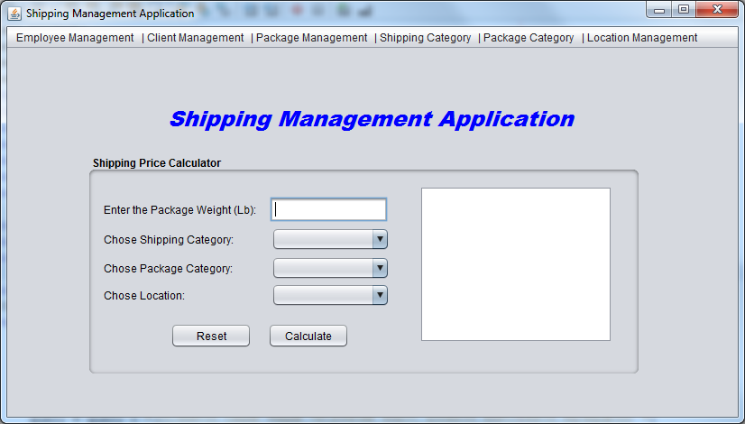

## Back-end system

Database Server

Database server is used in this project to handle database operations. The client does not directly interact with database, rather it goes through web server in order to keep the database secure from an unauthorized access. It is also called a third tier in the three tier architecture as implemented in this project.

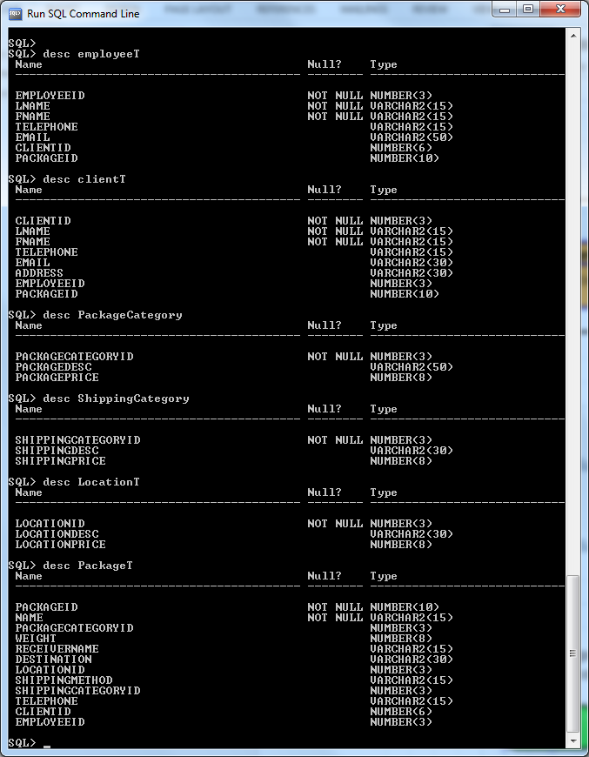

Table employeeT

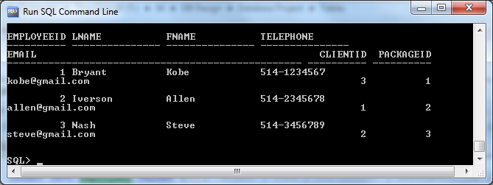

Table clientT

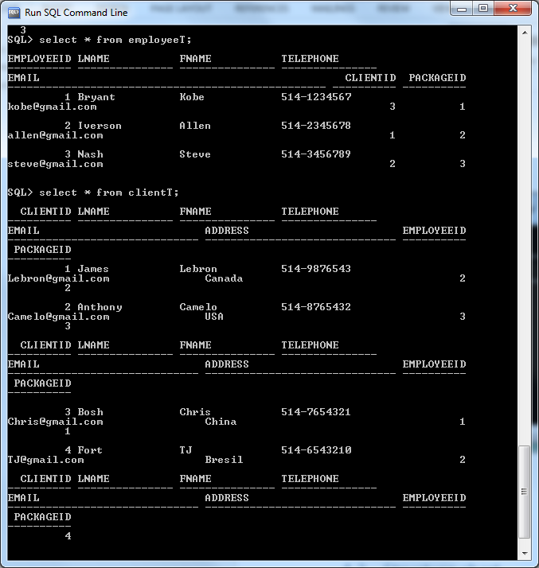

Table PackageCategory

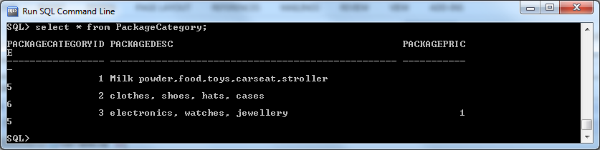

Table LocationT

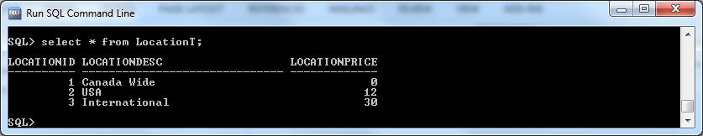

Table ShippingCategory

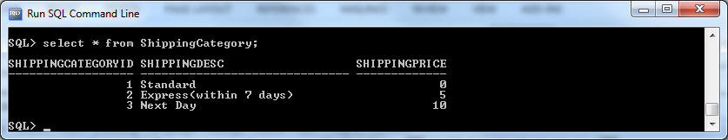

Table PackageT

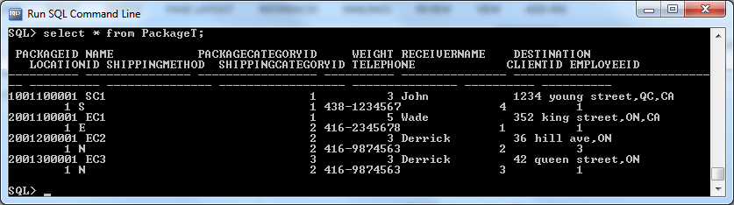

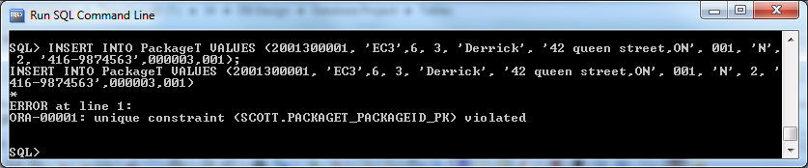

Add New

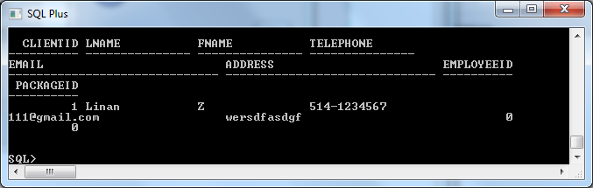

## Structure chart

## Prototype

This system will use the Netbeans to develop. The system will calculate payroll amount, store it to database and display in UI. Database use Oracle to develop

# System Testing/Security

## Unit testing

**Employee Management UT**

1. Add new Employee
   1. When click menu “Add New Employee”, the window “Add New Employee” should pop up.

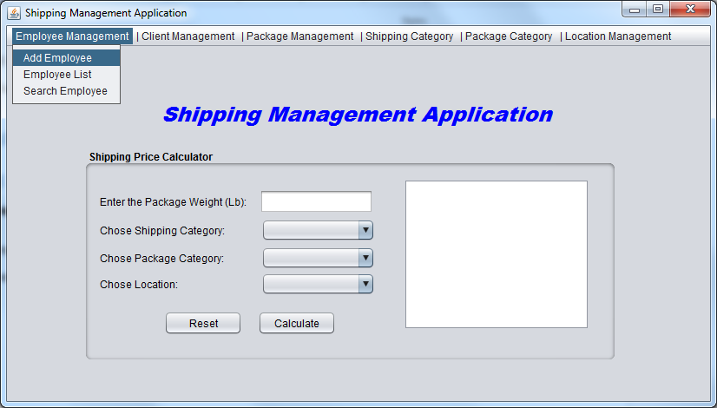

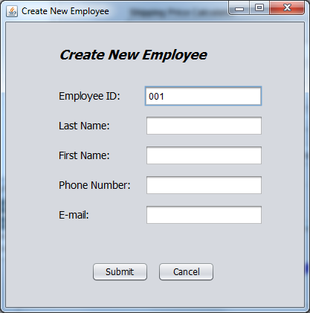

* 1. After finishing input the information in the window “Add New Employee”, click “Submit”, the information entered should be saved and inserted into database.

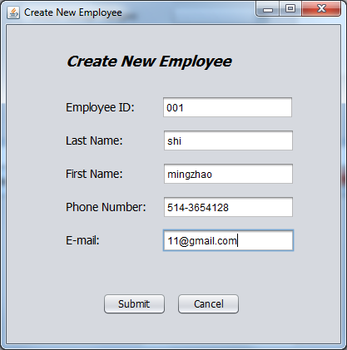

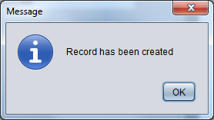

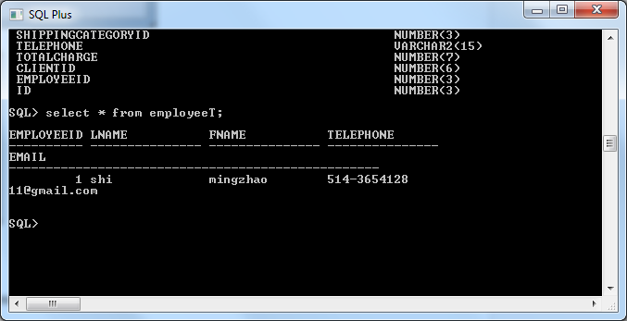

* 1. When click “Cancel”, the information entered should not be inserted into database.

1. Employee List
   1. When click menu “Employee List”, all the employees’ information or records exist in database should be displayed accordingly.

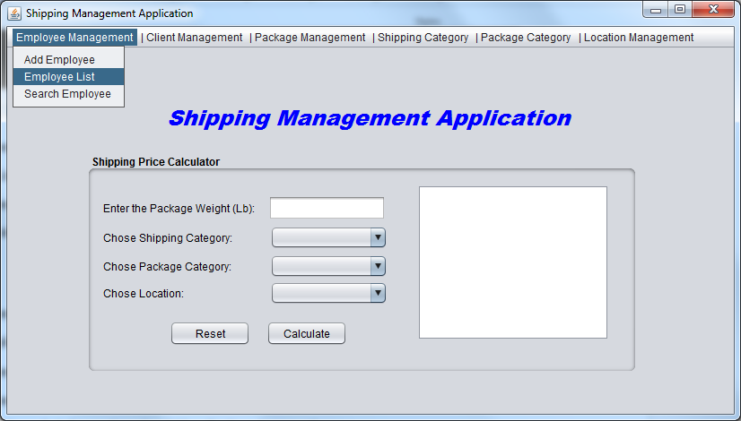

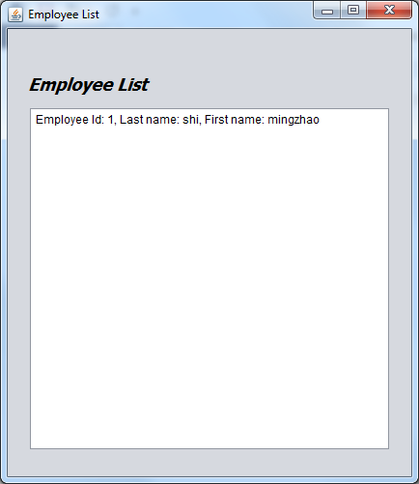

* 1. When click certain record, the corresponding details window will pop up.

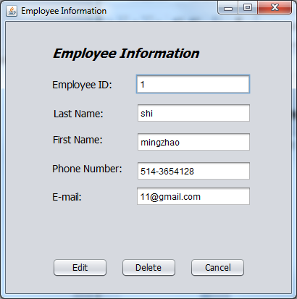

1. Search Employee
   1. When click menu “Search Employee”, the “Search Employee” window will show up.

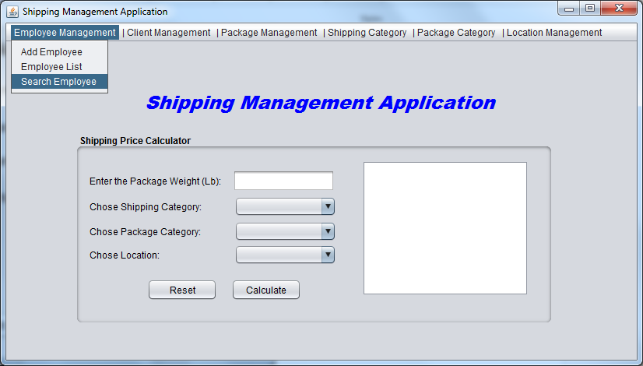

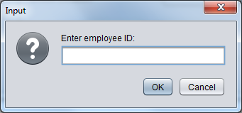

* 1. When input the employee id in “Search Employee” window, the corresponding employee’s information should be displayed correctly.

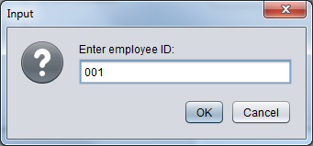

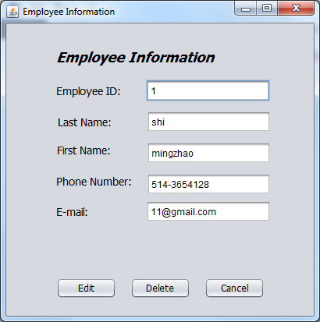

1. Modify Information
   1. When click “Edit”, the edit window will pop up, and the content in the textbox should be editable (except the employee ID).

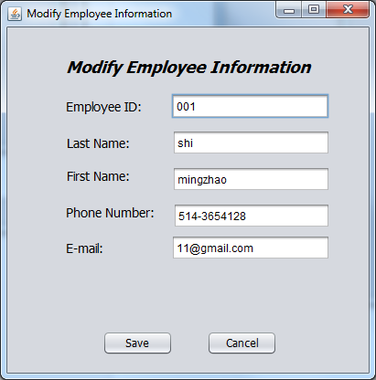

* 1. When finish editing, click “save”, the modified information should be saved both in database and the system.

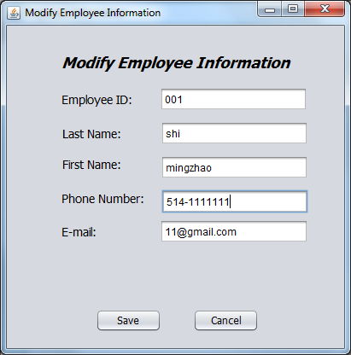

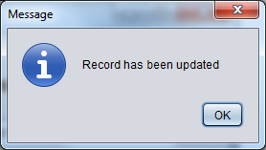

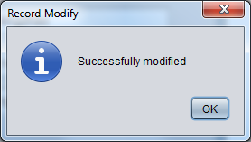

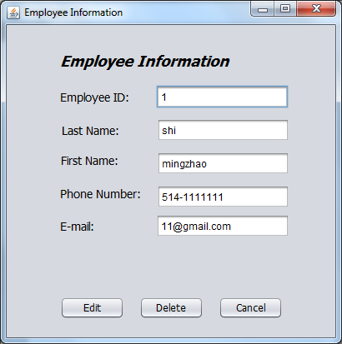

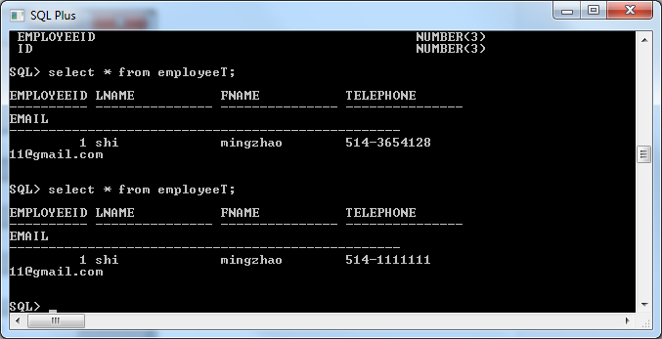

1. Delete Information
   1. Select one employee, then click “Delete”, then confirm the deletion, that record will be deleted from database.

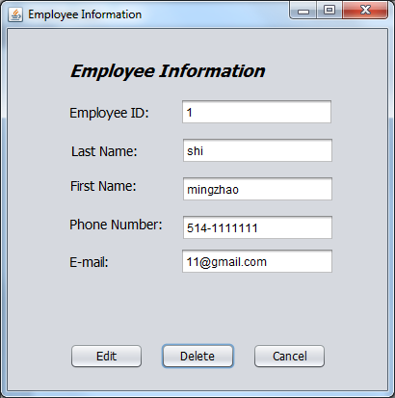

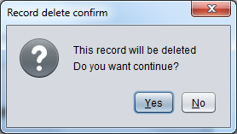

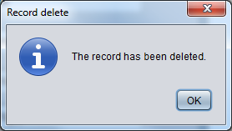

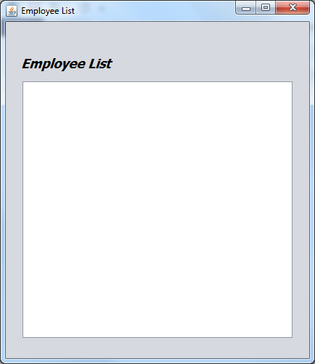

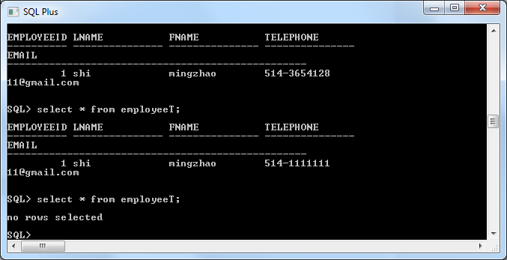

**Client Management UT**

1. Add new Client
   1. When click menu “Add New Client”, the window “Add New Client” should pop up.

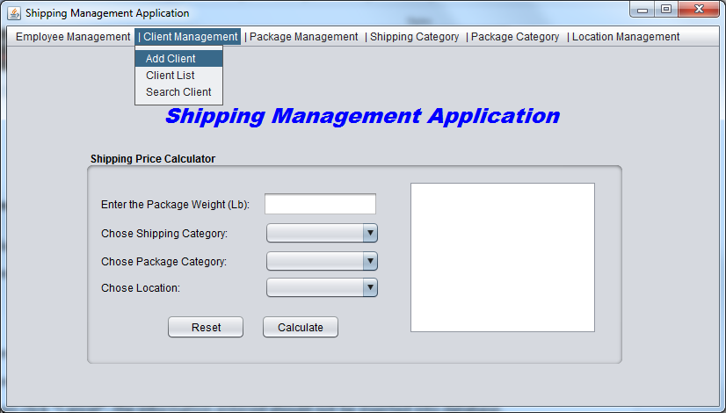

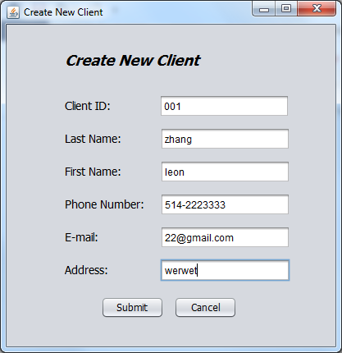

* 1. After finishing input the information in the window “Add New Client”, click “Submit”, the information entered should be saved and inserted into database.

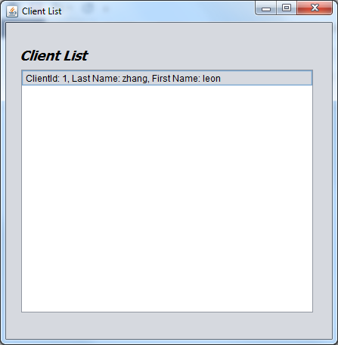

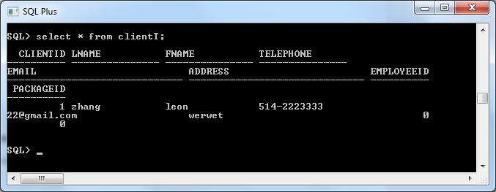

* 1. When click “Cancel”, the information entered should not be inserted into database.

1. Client List
   1. When click menu “Client List”, all the Clients’ information or records exist in database should be displayed accordingly.

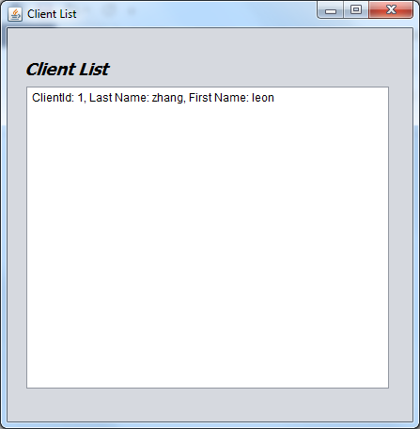

* 1. When click certain record, the corresponding details window will pop up.

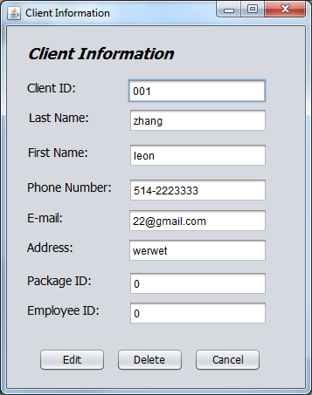

1. Search Client
   1. When click menu “Search Client”, the “Search Client” window will show up.

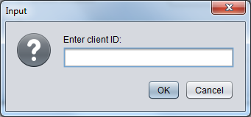

* 1. When input the Client id in “Search Client” window, the corresponding Client’s information should be displayed correctly.

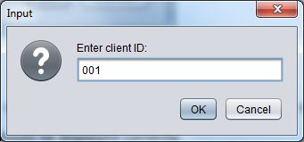

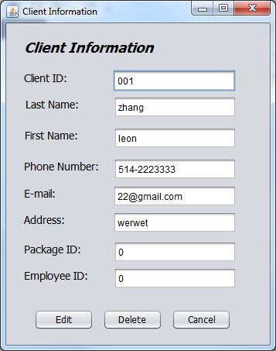

1. Modify Information
   1. When click “Edit”, the edit window will pop up, and the content in the textbox should be editable (except the Client ID).

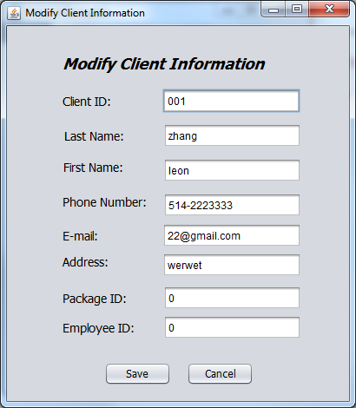

* 1. When finish editing, click “save”, the modified information should be saved both in database and the system.

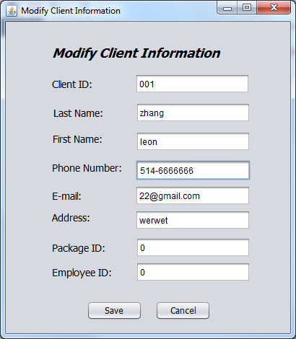

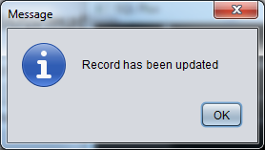

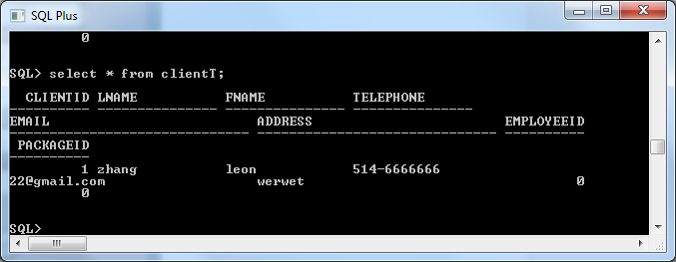

1. Delete Information
   1. Select one client, then click “Delete”, then confirm the deletion, that record will be deleted from database.

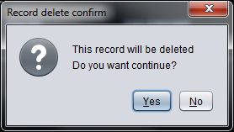

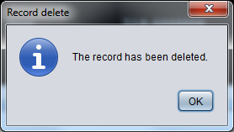

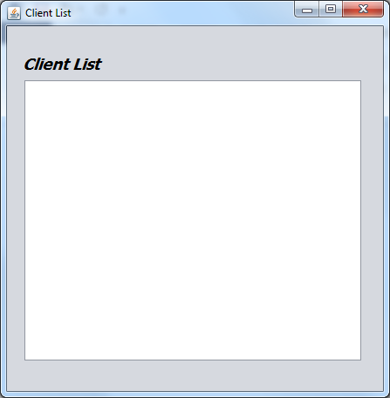

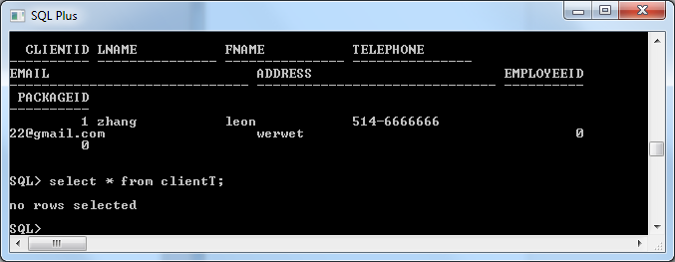

**Package Category Management UT**

1. Add new Package Category
   1. When click menu “Add New Package Category”, the window “Add New Package Category” should pop up.

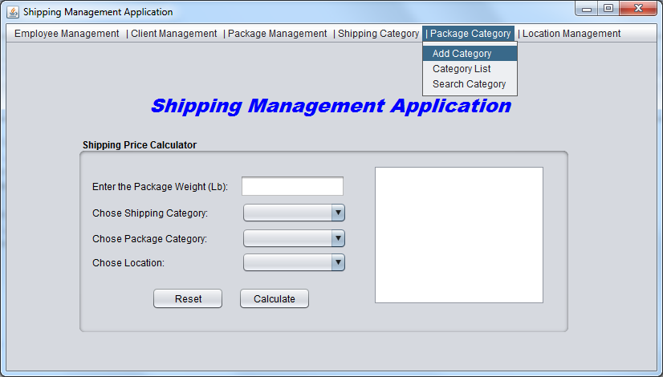

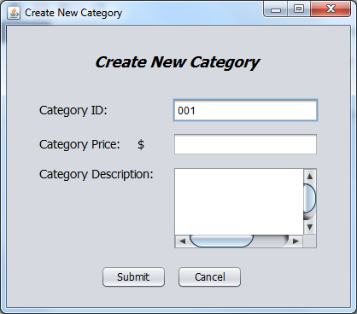

* 1. After finishing input the information in the window “Add New Package Category”, click “Submit”, the information entered should be saved and inserted into database.

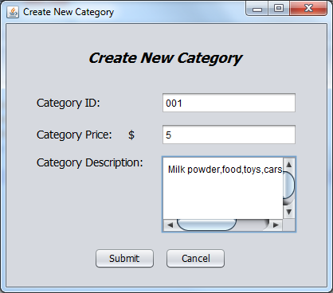

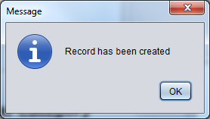

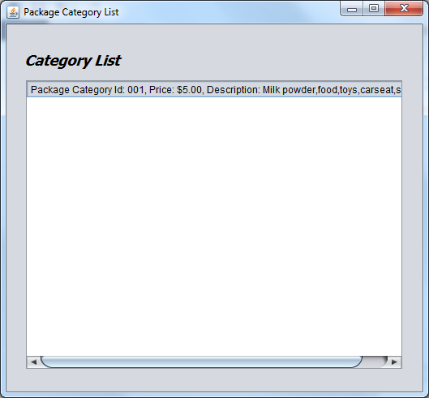

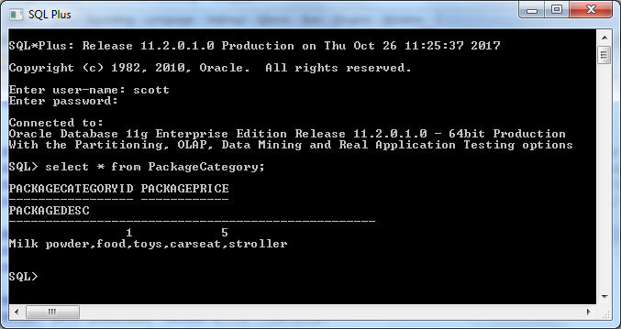

* 1. When click “Cancel”, the information entered should not be inserted into database.

1. Package Category List
   1. When click menu “Package Category List”, all the Package Categories’ information or records exist in database should be displayed accordingly.



* 1. When click certain record, the corresponding details window will pop up.

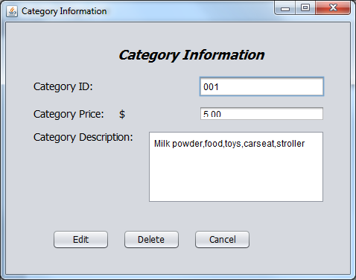

1. Search Package Category
   1. When click menu “Search Package Category”, the “Search Package Category” window will show up.

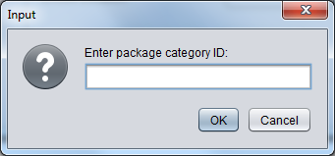

* 1. When input the Package Category id in “Search Package Category” window, the corresponding Package Category’s information should be displayed correctly.

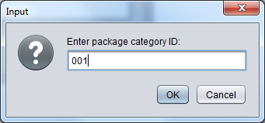

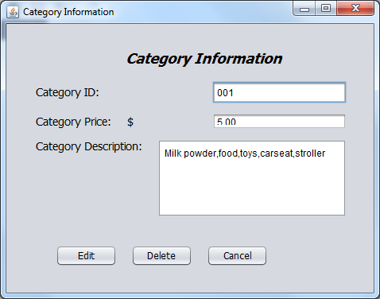

1. Modify Information
   1. When click “Edit”, the edit window will pop up, and the content in the textbox should be editable (except the PackageCategory ID).

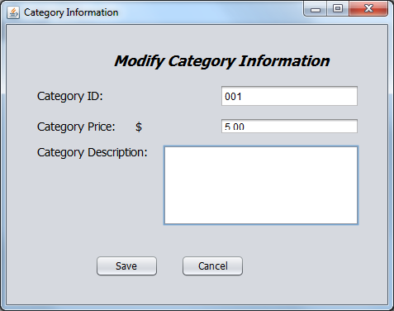

* 1. When finish editing, click “save”, the modified information should be saved both in database and the system.

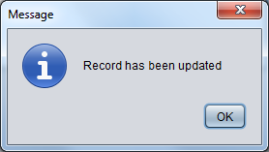

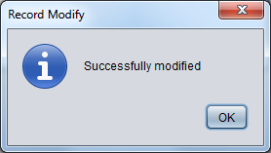

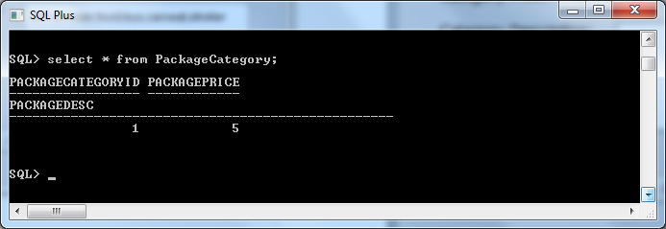

1. Delete Information
   1. Select one package category, then click “Delete”, then confirm the deletion, that record will be deleted from database.

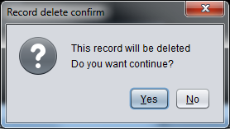

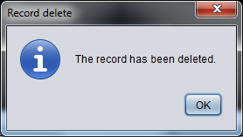

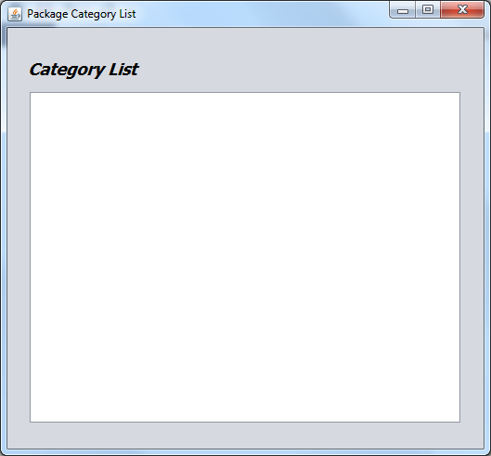

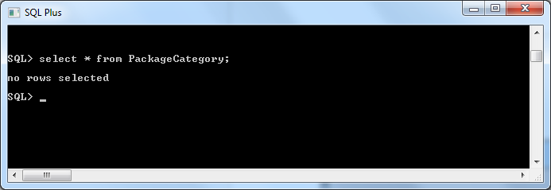

**Shipping Category Management UT**

1. Add new Shipping Category
   1. When click menu “Add New Shipping Category”, the window “Add New Shipping Category” should pop up.

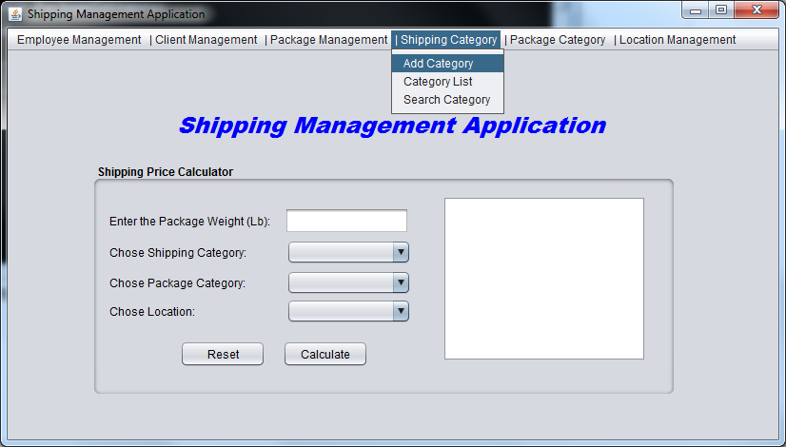

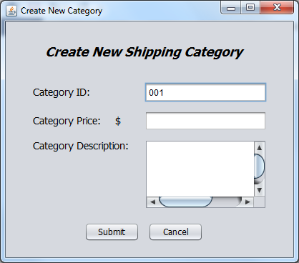

* 1. After finishing input the information in the window “Add New Shipping Category”, click “Submit”, the information entered should be saved and inserted into database.

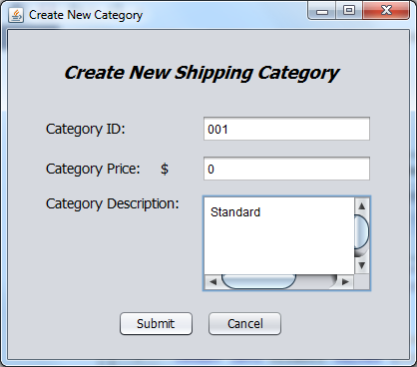

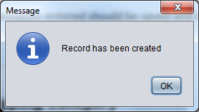

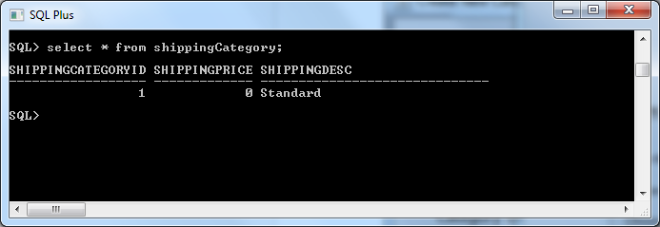

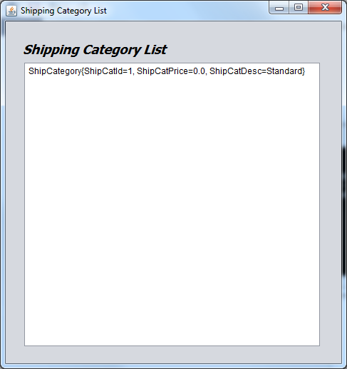

* 1. When click “Cancel”, the information entered should not be inserted into database.

1. Shipping Category List
   1. When click menu “Shipping Category List”, all the Shipping Categories’ information or records exist in database should be displayed accordingly.



* 1. When click certain record, the corresponding details window will pop up.

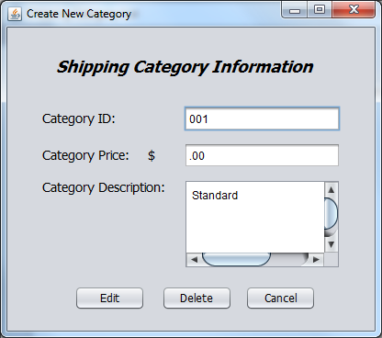

1. Search Shipping Category
   1. When click menu “Search Shipping Category”, the “Search Shipping Category” window will show up.
   2. When input the Shipping Category id in “Search Shipping Category” window, the corresponding Shipping Category’s information should be displayed correctly.
2. Modify Information
   1. When click “Edit”, the edit window will pop up, and the content in the textbox should be editable (except the shipping category ID).

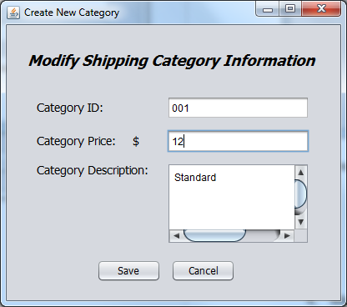

* 1. When finish editing, click “save”, the modified information should be saved both in database and the system.

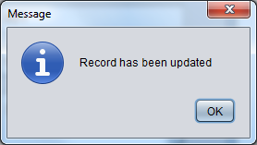

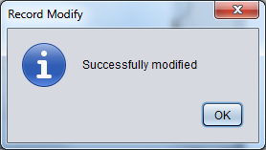

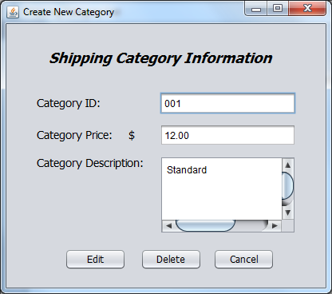

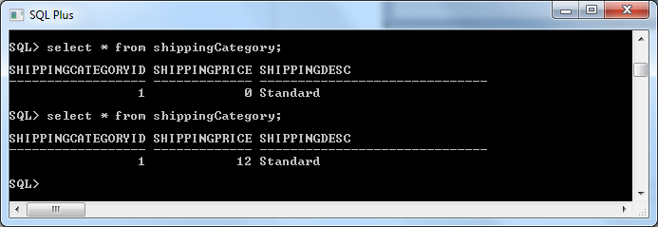

1. Delete Information
   1. Select one shipping category, then click “Delete”, then confirm the deletion, that record will be deleted from database.

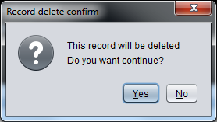

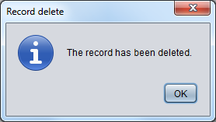

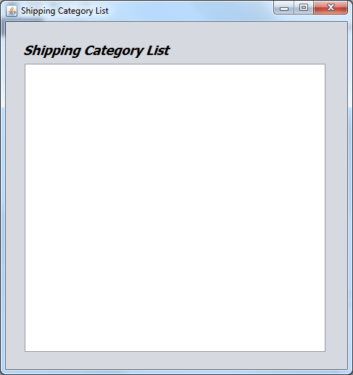

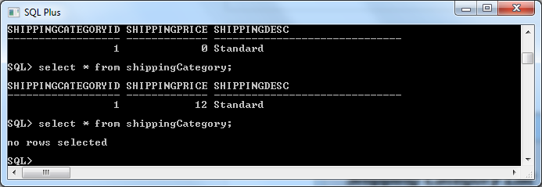

**Location Management UT**

1. Add new Location Category
   1. When click menu “Add New Category”, the window “Add New Location Category” should pop up.

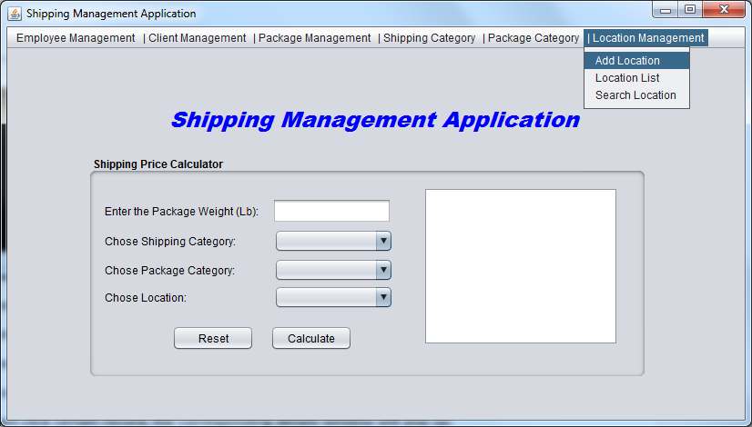

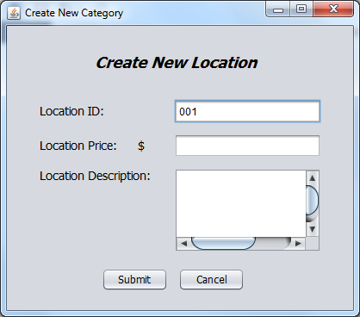

* 1. After finishing input the information in the window “Add New Location Category”, click “Submit”, the information entered should be saved and inserted into database.

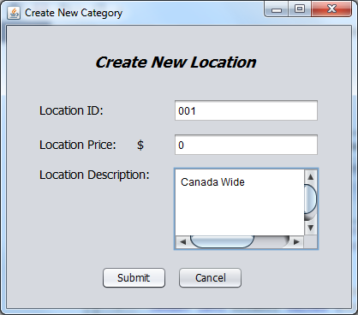

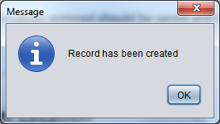

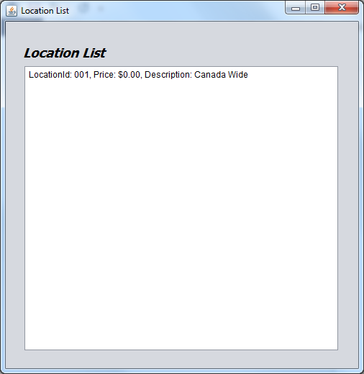

* 1. When click “Cancel”, the information entered should not be inserted into database.

1. Location Category List
   1. When click menu “Location Category List”, all the Location Categories’ information or records exist in database should be displayed accordingly.



* 1. When click certain record, the corresponding details window will pop up.

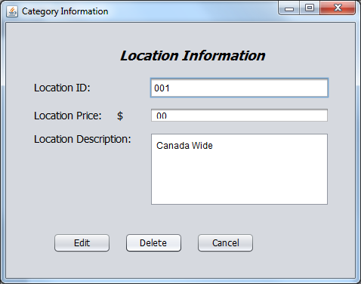

1. Search Location Category
   1. When click menu “Search Location Category”, the “Search Location Category” window will show up.

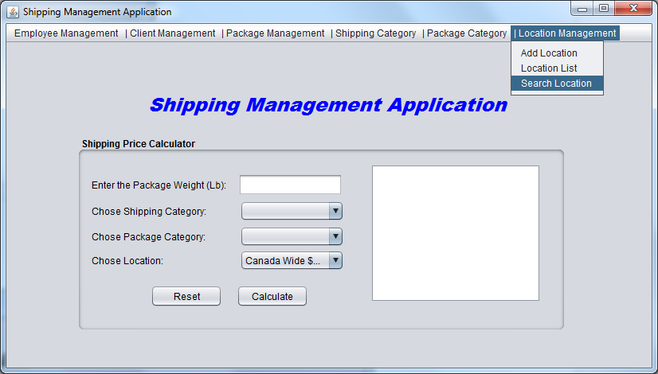

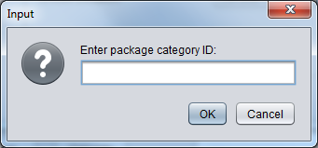

* 1. When input the Location Category id in “Search Location Category” window, the corresponding Location Category’s information should be displayed correctly.

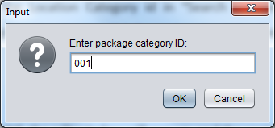

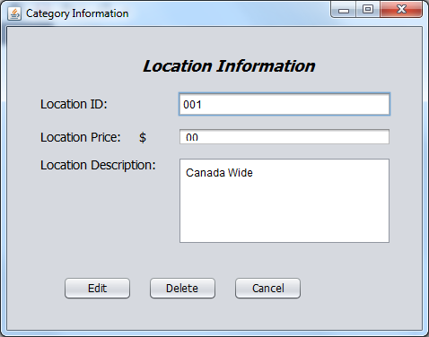

1. Modify Information
   1. When click “Edit”, the edit window will pop up, and the content in the textbox should be editable (except the location ID).

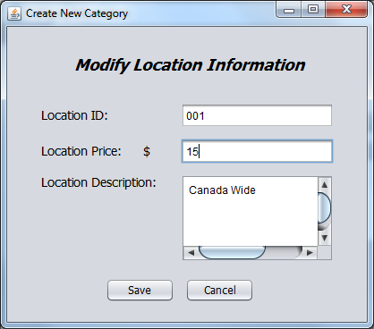

* 1. When finish editing, click “save”, the modified information should be saved both in database and the system.

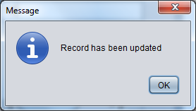

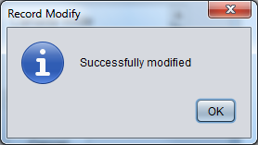

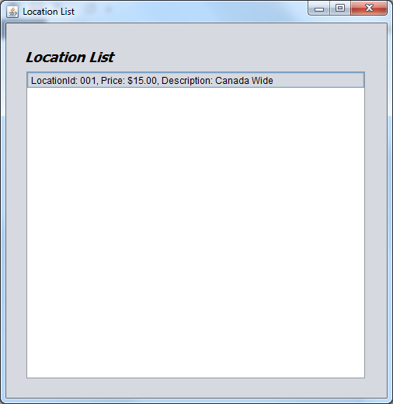

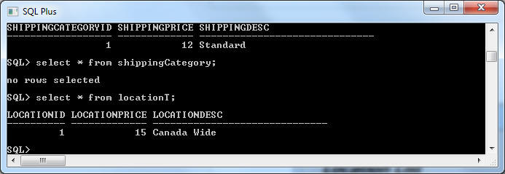

1. Delete Information
   1. Select one employee, then click “Delete”, then confirm the deletion, that record will be deleted from database.

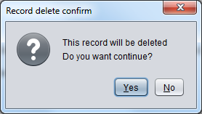

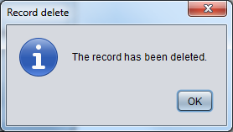

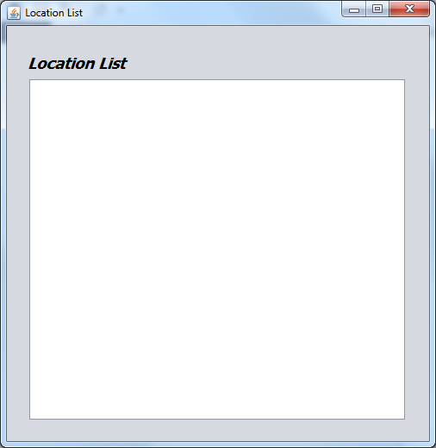

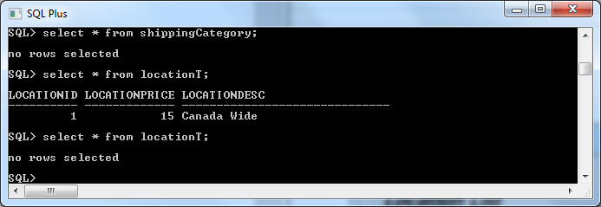

**Package Management UT**

1. Add new Package information
   1. When click menu “Add New Package”, the window “Add New Package” should pop up.

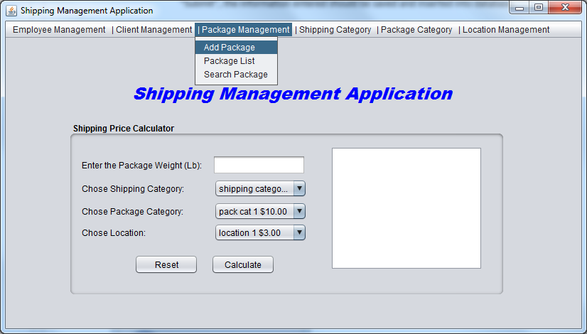

* 1. After finishing input the information in the window “Add New Package”, click “Submit”, the information entered should be saved and inserted into database.

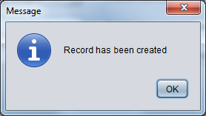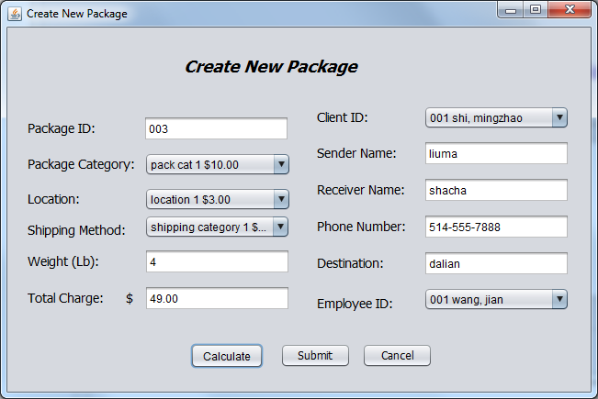

* 1. When click “Cancel”, the information entered should not be inserted into database.

1. Package List
   1. When click menu “Package List”, all the Package’s information or records exist in database should be displayed accordingly.

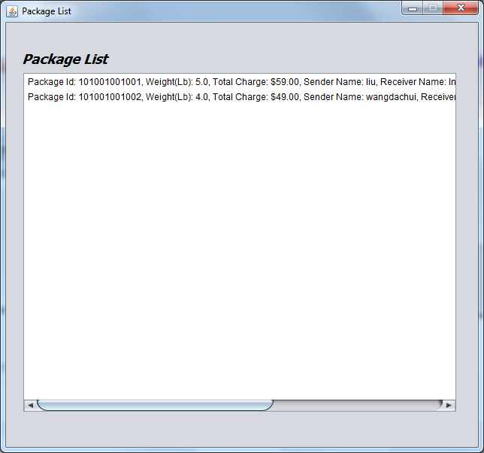

* 1. When click certain record, the corresponding details window will pop up.

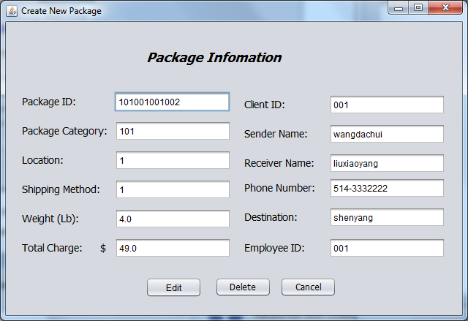

1. Search Package
   1. When click menu “Search Package”, the “Search Package” window will show up.
   2. When input the package id in “Search Package” window, the corresponding Package information should be displayed correctly.

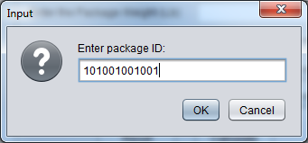

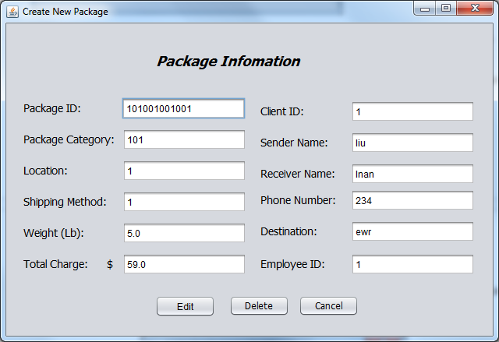

1. Modify Information
   1. When click “Edit”, the edit window will pop up, and the content in the textbox should be editable (except the package ID).

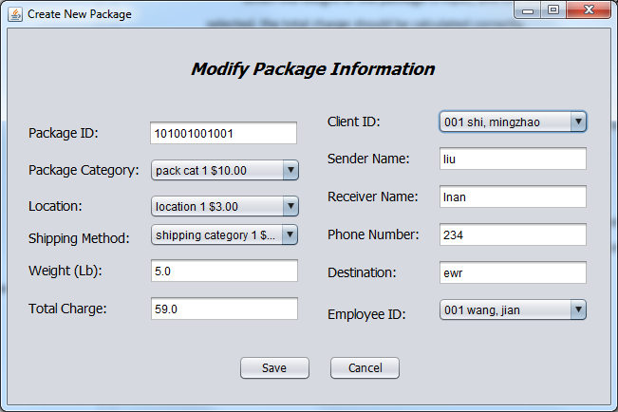

* 1. When finish editing, click “save”, the modified information should be saved both in database and the system.

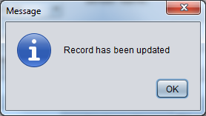

1. Delete Information
   1. Select one package, then click “Delete”, then confirm the deletion, that record will be deleted from database.

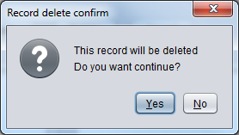

**Package Management UT**

When the weight of the package is input, and the shipping method, package category, location are selected, the total charge should be calculated correctly.

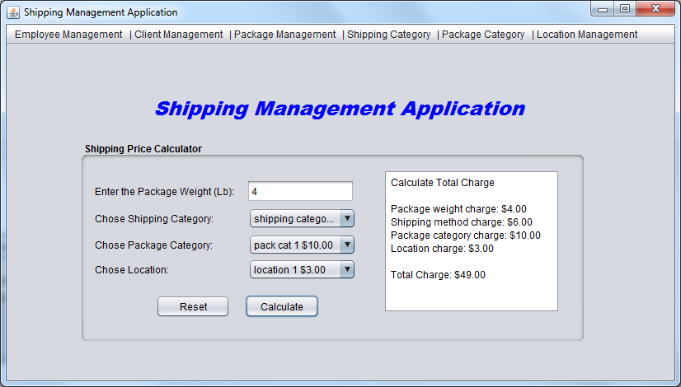

## System & Integration testing

1. For the package Management menu, the package id will be generated by the format of package category id & shipping category id & location id & package id.

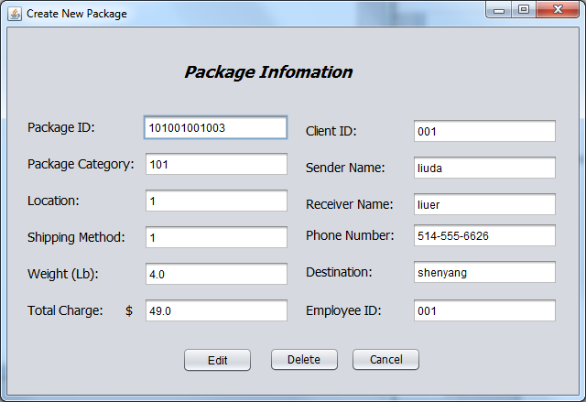

1. When the client information, shipping method, location and package category are entered or selected, the total shipping charge will be calculated and a report should be generated.

