PRODUCT LINE PROFITABILITY
& MARGIN PERFORMANCE ANALYSIS
Nassau Candy Distributor | Exploratory Data Analysis and Recommendations
Prepared from the supplied distributor dataset. Figures are calculated from the uploaded file and should be validated against the source system before operational decisions.

Executive overview
The dataset contains 10,194 transaction rows and 15 distinct products. Total recorded sales are $141,783.63, total cost is $48,340.83, and gross profit is $93,442.80, for a weighted gross margin of 65.91%. These metrics describe gross profitability only; they do not include operating expenses, taxes, or other overhead unless already reflected in the supplied cost field.

1. Business questions
- Which products and divisions contribute the most gross profit and strongest gross margins?
- Do high-sales products also produce strong gross profit?
- How concentrated are revenue and gross profit across products?
- Which products warrant pricing, supplier-cost, or portfolio reviews?

2. Dataset and analytical method
The analysis uses 10,194 rows and 18 columns. Product-level results aggregate transaction rows by product identifier and name; division results aggregate by Division. Gross margin is calculated as gross profit divided by sales. Revenue and profit concentration are evaluated by ranking products from highest to lowest and calculating cumulative shares. A 20% gross-margin cutoff is used only as an illustrative screening threshold, not as a company-approved target.

3. Headline KPIs
Metric | Result
Total sales | $141,783.63
Total cost | $48,340.83
Gross profit | $93,442.80
Weighted gross margin | 65.91%
Transaction rows | 10,194
Distinct products | 15

4. Division-level performance
Division | Sales | Gross profit | Gross margin | Revenue share
Chocolate | $131,693 | $88,825 | 67.45% | 92.9%
Other | $9,663 | $4,333 | 44.84% | 6.8%
Sugar | $427 | $285 | 66.61% | 0.3%
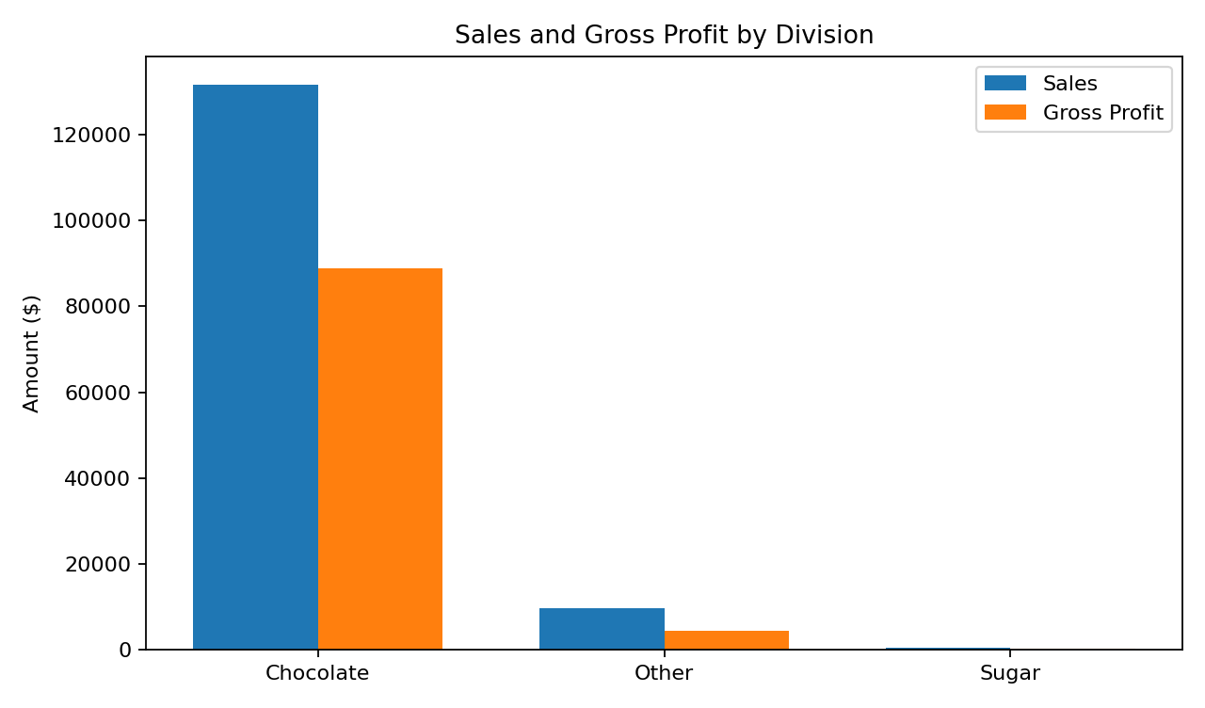
Chocolate is the largest division by gross profit in this dataset ($88,825; margin 67.45%). Chocolate has the highest overall division gross margin at 67.45%. A division can lead in gross profit because of its scale even when another division has a higher margin percentage.

5. Product profitability and margin risk
The top product by gross profit is Wonka Bar -Scrumdiddlyumptious (gross profit $19,357.50; sales $27,874.80; margin 69.44%). The lowest-margin product in the aggregated product table is Kazookles at 7.69%. There are 0 products with negative aggregate gross profit and 1 products below the illustrative 20% margin threshold.
Top products by gross profit | Sales | Gross profit | Margin
Wonka Bar -Scrumdiddlyumptious | $27,875 | $19,358 | 69.44%
Wonka Bar - Triple Dazzle Caramel | $28,485 | $18,610 | 65.33%
Wonka Bar - Milk Chocolate | $26,868 | $17,443 | 64.92%
Wonka Bar - Nutty Crunch Surprise | $23,575 | $16,820 | 71.35%
Wonka Bar - Fudge Mallows | $24,890 | $16,594 | 66.67%

6. Revenue and profit concentration (Pareto)
The top five products by sales contribute 92.9% of total sales. The top five products by gross profit contribute 95.1% of total gross profit. By cumulative ranking, approximately 5 products are needed to reach at least 80% of revenue and 5 products to reach at least 80% of gross profit. This is a concentration indicator: a small number of products may be critical to performance, so availability, supplier terms, and pricing should be monitored.
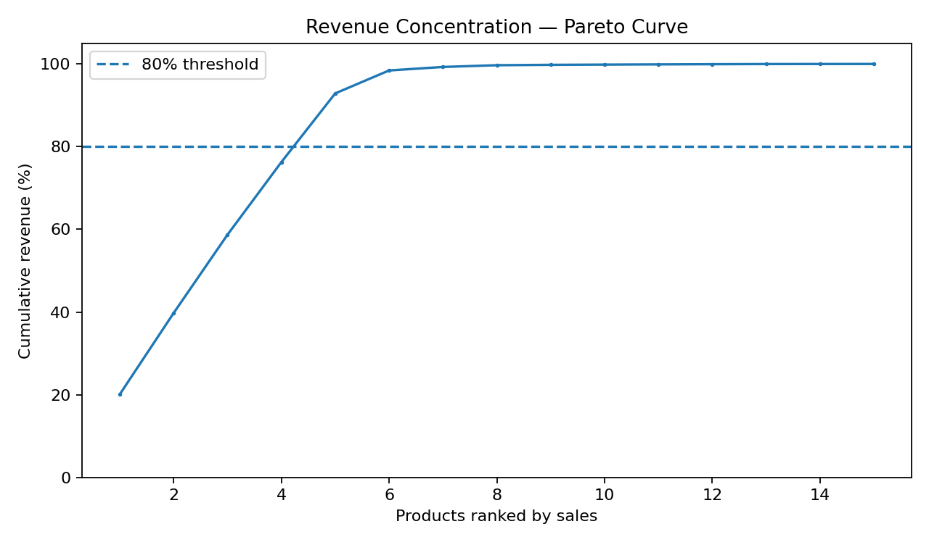

7. Cost structure diagnostics
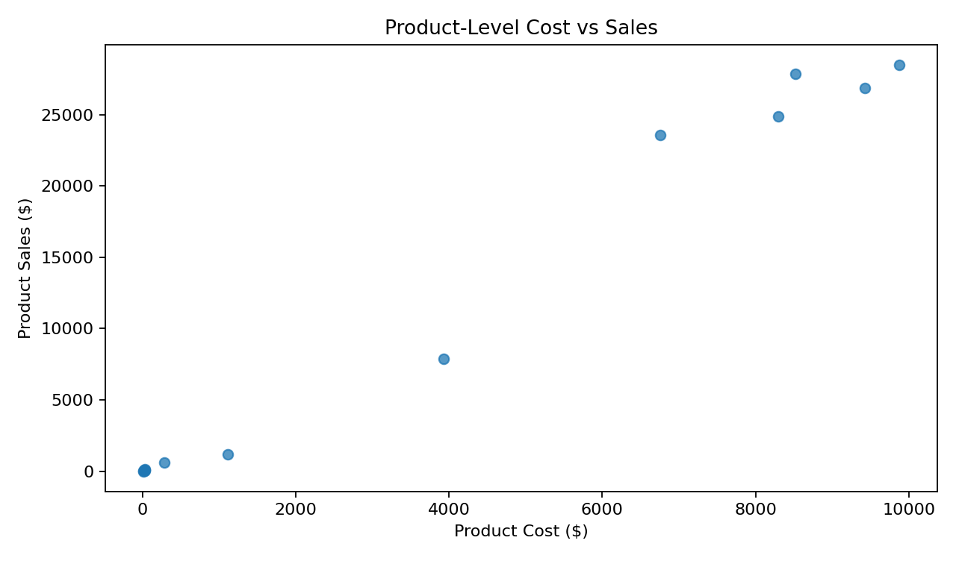
The cost-versus-sales scatter plot helps locate products with high costs relative to sales. Products in the high-cost/low-margin group should be reviewed for supplier terms, freight or handling costs if available, discounts, pack sizes, and selling prices. A low gross margin alone does not prove pricing is wrong; demand, competition, contract terms, and product role are needed before making a price decision.

8. Data quality and limitations
Exact duplicate rows detected: 0. Rows where recorded gross profit differs from Sales minus Cost by more than $0.02: 0. These are validation checks; no records were automatically deleted from the analysis.
Order Date range: 2024-01-02 to 2025-12-31.
Ship Date range: 2026-06-30 to 2030-06-28.
The dataset supports gross-margin analysis, not net profitability. No claim about seasonality should be made until dates are validated. The 20% threshold is an example and should be replaced with a management-approved target. Profit contribution percentages can behave unexpectedly when total gross profit is near zero or negative.

9. Recommendations
- Protect core profit contributors: monitor stock availability, supplier reliability, and margin changes for products with high gross-profit contribution.
- Review low-margin, high-sales products first: compare realized selling price, discounting, and total cost components before changing prices.
- Run targeted supplier negotiations for products with high cost-to-sales ratios and repeat volume.
- Use a documented margin threshold in Power BI and make it adjustable for scenario analysis.
- Review persistently low-sales/low-profit products for assortment simplification, but check strategic importance and customer bundles before discontinuation.
- Validate the date fields and reconcile sales/cost totals with the source system before presenting final findings to decision-makers.

10. Power BI dashboard design
Recommended visuals: KPI cards for Sales, Cost, Gross Profit and Gross Margin; clustered columns for sales versus gross profit by division; a product gross-margin bar chart; a cost-versus-sales scatter plot; a Pareto curve; a detailed product matrix; and slicers for Order Date, Division, Product Name, and a what-if margin threshold. See the accompanying Power BI implementation guide and DAX measures.

Conclusion
The analysis creates a practical starting point for improving gross-margin visibility. The next step is to validate date quality, confirm business-approved margin targets, and use the Power BI report to review the products and divisions with the greatest combination of financial impact and margin risk.

