Robot Ostrich (Robostrich) Requirements
CC-BY-SA
Michael Shimniok - Bot Thoughts LLC

High Level Requirements

- Balance on two legs
- Sit down from standing position
- Recover from fall
  - Recover to sitting position
  - Stand up from sitting position
- Recover to standing or walking from external push
  - How much force?
- Walking
  - Learn to walk (self teaching/training)
  - Walk on two legs like ostrich
    - https://www.youtube.com/watch?v=G3cTSlzyzic
    - Note steadiness of body
  - Walk over uneven terrain
    - Define “uneven terrain” – How uneven? Slope? Amount of variation? Examples?
  - Walk on surfaces with varying traction
    - Ice, Cement, Dirt, Gravel, hardwood floor, carpet, loose rocks, stairs, etc.
  - How fast?
- Running?
  - How fast?
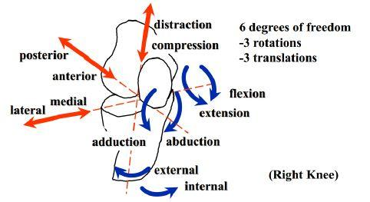
- Legs
  - 3 joints like Ostrich: hip, knee, ankle
  - Hip joint
    - At least 4DOF: extension, flexion; adduction, abduction
  - Feet
    - Toes??
    - 6DOF: extension, flexion; adduction, abduction; internal, external
  - Knee joint
    - bends in the same direction as an ostrich (ie, kneecap would be at the back)
    - At least 2DOF: flexion, extension

- How much force required per actuator? Derived requirement. depends on total weight of robot body. Also, requirement for walking means less force than requirement to stand up from sitting.
- Size of robot?

Early Research / Design Evaluation

BNO055 – Mag 3, Acc 3, Gy 3, Quat 4, Temp 1, Grav 3, LIA 3 = 20 words (2 bytes) for read plus ?? bytes to query, say it's 10 bytes. So figure 50 bytes for each poll. Poll at 100Hz = 5000 bytes/sec. I2C fast is 400kHz

