EeZeeAmp User Guide

Quick Start
  - Install pin headers (See the document, How To Assemble)
  - Speaker: speaker + terminal to SP+, speaker negative terminal to GND
  - Audio In: analog + audio signal to IN+, analog negative signal to GND
  - Power: 4-12V positive to V+, negative to GND
  - Volume: connect potentiometer to VOL, with wiper on middle pin labeled >

About the LM386

Datasheet

Description

Basic characteristics

Setting Gain

By default, with no external components, gain factor is set to 20 (26 dB).

For a gain of 200, connect a 10uF capacitor between pins 1 and 8.
To select a gain between 20 (26 dB) and 200 (46 dB), place a resistor in series with the capacitor between pins 1 and 8. Use the table below to select the appropriate resistor value to achieve the desired gain.

For adjustable gain use a 10K potentiometer instead of a fixed resistor. Connect the middle potentiometer pin to pin 1 and one of the other two potentiometer pins to pin 8.

Desired Gain Factor | Closest Resistor (Ω) | Actual Gain Factor | Actual Gain (dB)
200 | No Resistor | 200.0 | 46.0
100 | 160 | 102.4 | 40.2
80 | 270 | 80.0 | 38.1
70 | 330 | 37.2 | 37.2
60 | 470 | 60.2 | 35.6
50 | 680 | 49.8 | 33.9
40 | 1000 | 41.4 | 32.3
30 | 2200 | 30.4 | 29.7
20 | 100k | 20.2 | 26.1

What's going on?

Bass Boost

RIAA??

Example Projects

Circuit Diagram

Assembly is easy. And, you can learn how to solder at the same time. Review Sparkfun's Soldering Tutorial if you need to. Here's a helpful info-graphic from the tutorial:

Illustration 1: https://learn.sparkfun.com/tutorials/how-to-solder---through-hole-soldering

You'll need
- Soldering iron, 40W
- Sponge to clean the iron (I recommend a brass sponge)
- Workbench with plenty of light
- Ventilation since breathing flux fumes is irritating
- Soldering surface (e.g., marble tile sample)
- Rosin core solder 0.022” or 0.032” diameter
- Kester #2331-ZX flux pen (optional)

Pin Headers

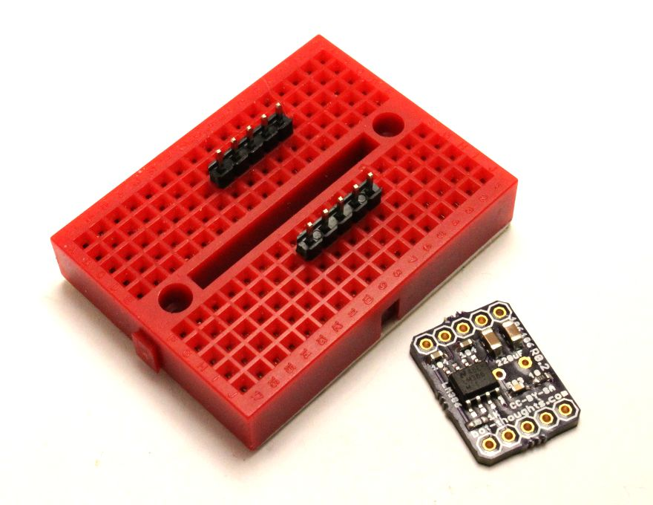
Apply flux to the outer pin header pads on the board.

Insert the two 5-pin headers into a breadboard 0.7” apart (6 rows between).

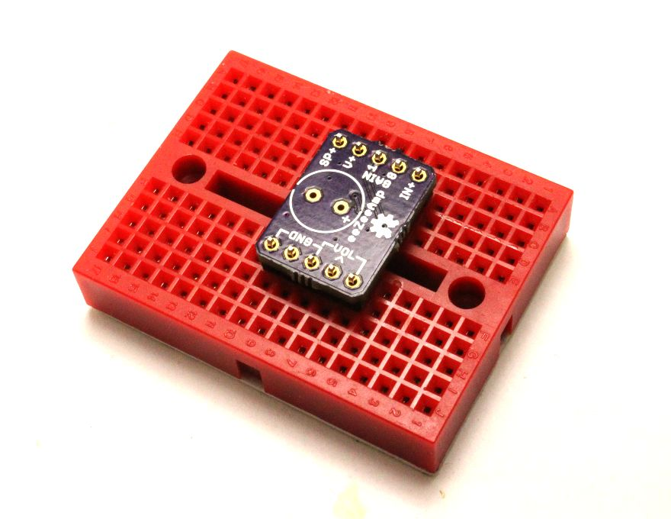
Install the eeZeeAmp board on the pin headers.

Solder one pin on each side, then continue soldering the remaining pins.

220uF Capacitor

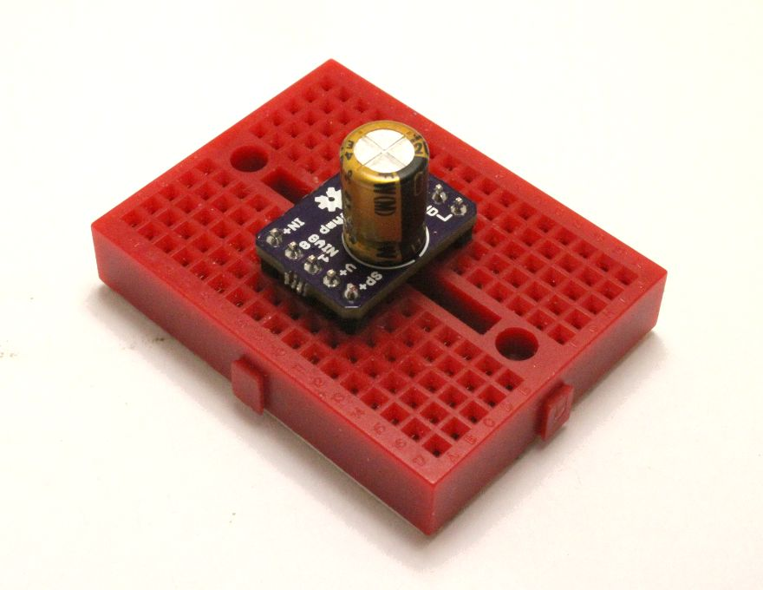
Note that the footprint for the 220uF capacitor is on the top of the board and the positive terminal is labeled with a “+” symbol. The black stripe on the capacitor indicates the negative terminal (see right)

Insert the 220uF output capacitor into the board with the black stripe (negative terminal) closest to the board edge.

While holding the capacitor and board together, solder the positive terminal.
Then, solder the negative terminal. Because it is connected to a large ground plane, it may take longer to heat up the pad and melt the solder.

Cleanup

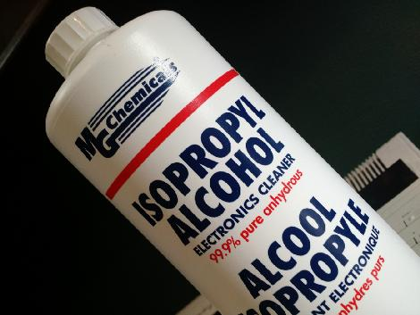
You'll want to remove the rosin and flux

I usually just use isopropyl alcohol and an old toothbrush

You can also buy chemicals specifically for removing flux and rosin

