Assembly Instructions for eeZee Big Tiny
Assembly is easy. And, you can learn how to solder at the same time. Review Sparkfun's Soldering Tutorial if you need to. Here's a helpful info-graphic from the tutorial:

Illustration 1: https://learn.sparkfun.com/tutorials/how-to-solder---through-hole-soldering

You'll need
- Soldering iron, 40W
- Sponge to clean the iron (I recommend a brass sponge)
- Workbench with plenty of light
- Ventilation since breathing flux fumes is irritating
- Soldering surface (e.g., marble tile sample)
- Rosin core solder 0.022” or 0.032” diameter
- Kester #2331-ZX flux pen (optional)

IC Socket

Apply flux pen or flux paste to the pin pads, top and bottom.

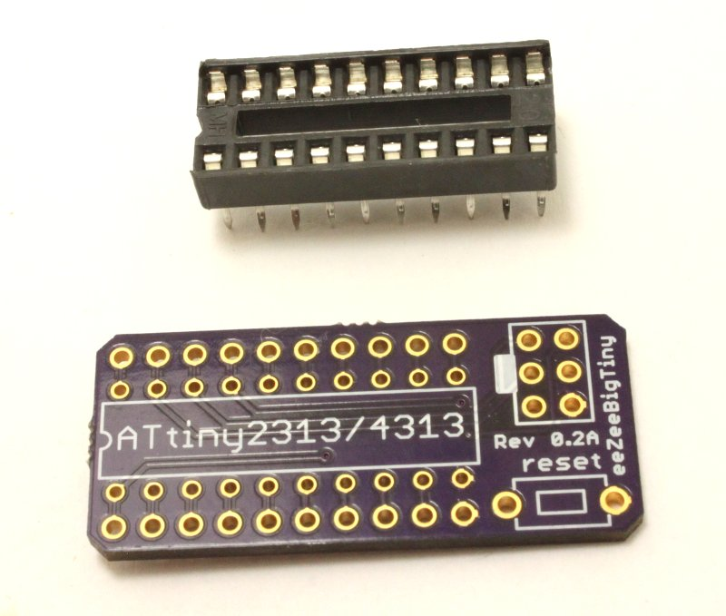
Match the notch on the socket with the silkscreen on the board

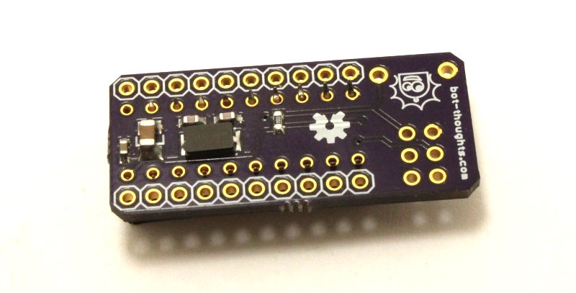
Insert the socket and flip the board and socket upside down

Bend the socket pins outward to help hold the socket and board together

Solder a pin in one corner, then a pin in the opposite corner

Solder the remaining pins

Pin Headers

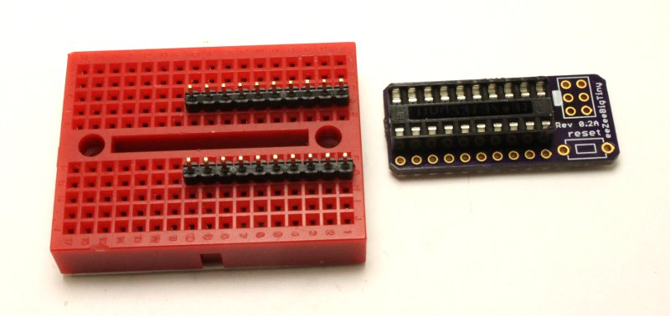
Stick the two 10-pin headers into your breadboard, long side down, with 4 rows between

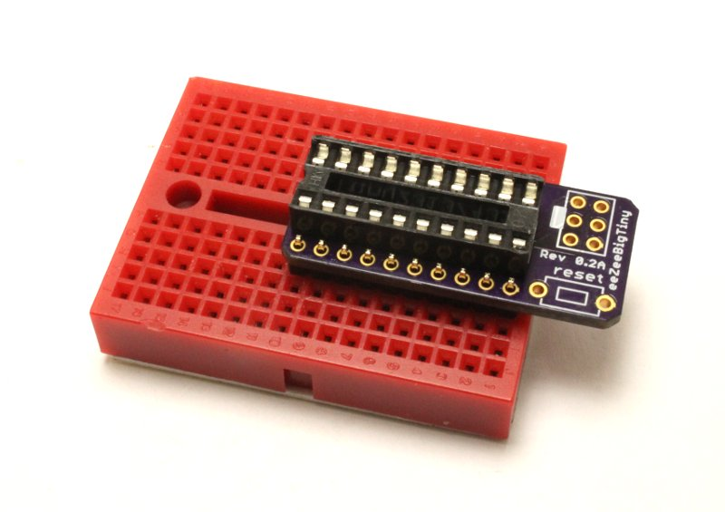

Place eeZeeBigTiny onto to pin headers

Holding the board in place, solder one of the pins on each pin header

Now solder the rest of the pins

ISP Header

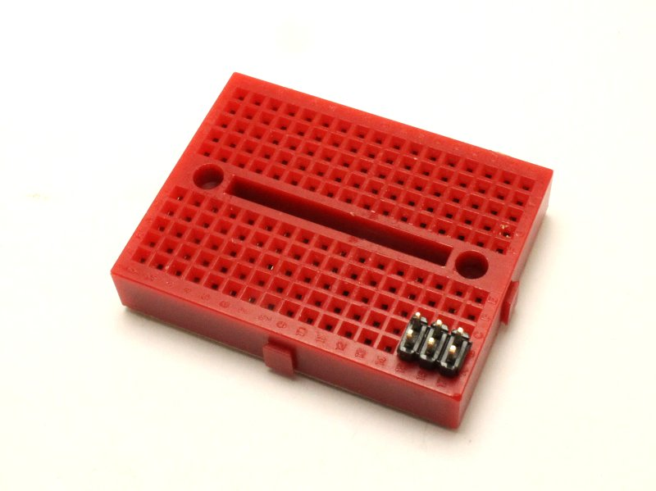
Install the 2x3 ISP header into the breadboard, long side down

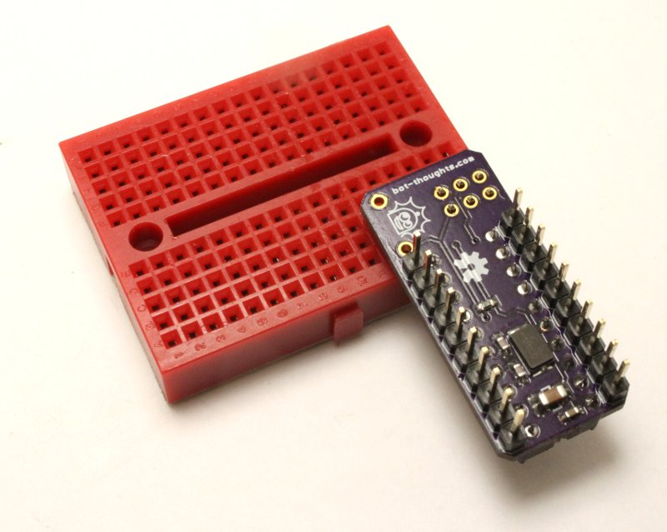
Flip the board upside down and place the board onto the pin header

Hold down the board and solder one pin

Solder the remaining pins.

Reset Switch

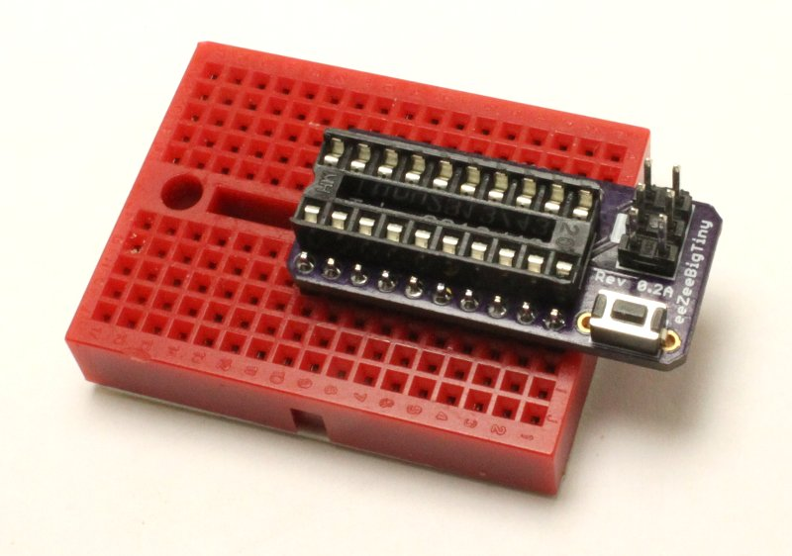
Insert the board back into the breadboard, right side up

Install the reset switch

Solder the reset switch pins on the top side

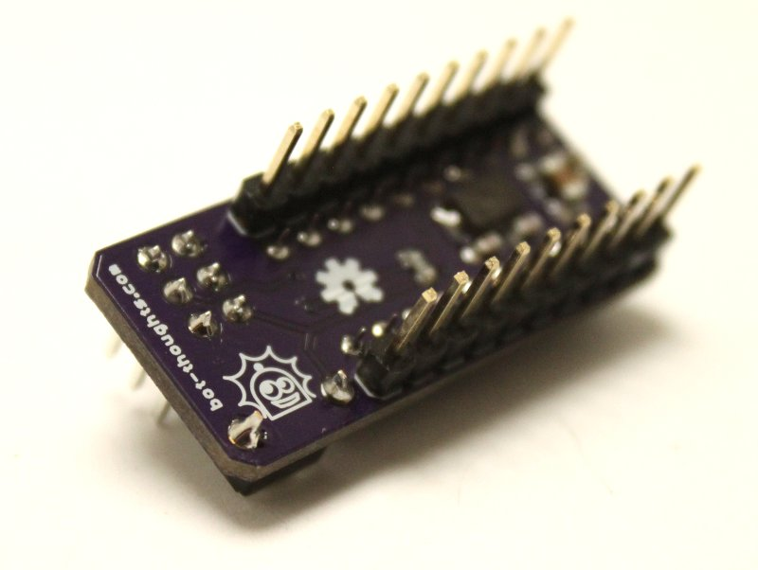

Flip the board upside down and solder the reset switch on the bottom side

Cleanup

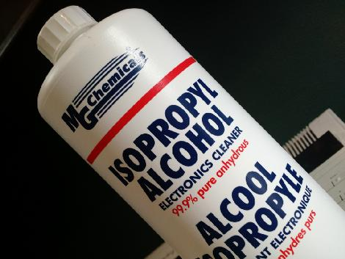
You'll want to remove the rosin and flux

I usually just use isopropyl alcohol and an old toothbrush

You can also buy chemicals specifically for removing flux and rosin

