clear();

clc();

s=%s;

P=(s+0.1)/(s+1);

P1=1/s+1;

P2=s+0.1;

w = logspace(-2,2,400);

Pjw = horner(P,%i\*w);

[Phase,GaindB] = phasemag(Pjw,'c');

P1jw = horner(P1,%i\*w);

[Phase1,GaindB1] = phasemag(P1jw,'c');

P2jw = horner(P2,%i\*w);

[Phase2,GaindB2] = phasemag(P2jw,'c');

scf(0);

xset('window',0);

subplot(211);

plot2d(w,GaindB, logflag='ln', style=2);

xtitle('Bode Diagram','ω[rad/s]','Gain[dB]')

xgrid();

subplot(212);

plot2d(w,Phase, logflag='ln', style=2);

xtitle('', 'w[rad/s]','Phase[degree]')

xgrid();

scf(1);

xset('window',1);

subplot(211);

plot2d(w,GaindB1, logflag='ln', style=2);

xtitle('Bode Diagram','ω[rad/s]','Gain[dB]')

xgrid();

subplot(212);

plot2d(w,Phase1, logflag='ln', style=2);

xtitle('', 'w[rad/s]','Phase[degree]')

xgrid();

scf(2);

xset('window',2);

subplot(211);

plot2d(w,GaindB2, logflag='ln', style=2);

xtitle('Bode Diagram','ω[rad/s]','Gain[dB]')

xgrid();

subplot(212);

plot2d(w,Phase2, logflag='ln', style=2);

xtitle('', 'w[rad/s]','Phase[degree]')

xgrid();

scf(3);

xset('window',3);

subplot(211);

plot2d(w,GaindB, logflag='ln', style=2);

xtitle('Bode Diagram','ω[rad/s]','Gain[dB]')

xgrid();

subplot(212);

plot2d(w,Phase, logflag='ln', style=2);

xtitle('', 'w[rad/s]','Phase[degree]')

xgrid();

xset('window',3);

subplot(211);

plot2d(w,GaindB1, logflag='ln', style=2);

xtitle('Bode Diagram','ω[rad/s]','Gain[dB]')

xgrid();

subplot(212);

plot2d(w,Phase1, logflag='ln', style=2);

xtitle('', 'w[rad/s]','Phase[degree]')

xgrid();

xset('window',3);

subplot(211);

plot2d(w,GaindB2, logflag='ln', style=2);

xtitle('Bode Diagram','ω[rad/s]','Gain[dB]')

xgrid();

subplot(212);

plot2d(w,Phase2, logflag='ln', style=2);

xtitle('', 'w[rad/s]','Phase[degree]')

xgrid();

xs2png(0, 'kadai7-1.png')

xs2png(1, 'kadai7-2.png')

xs2png(2, 'kadai7-3.png')

xs2png(3, 'kadai7-4.png')

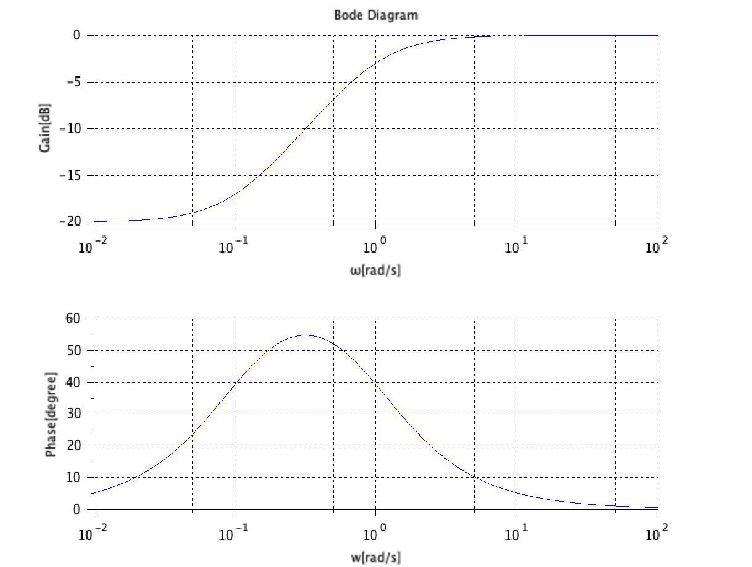

Figure 1P(s)のボード線図

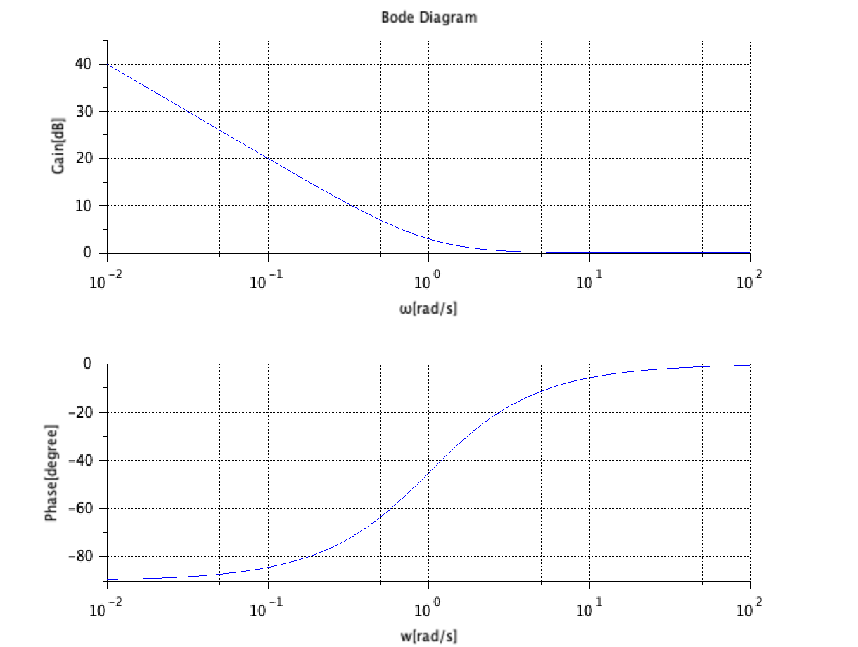

Figure 2 $P_{1}(s)$ のボード線図

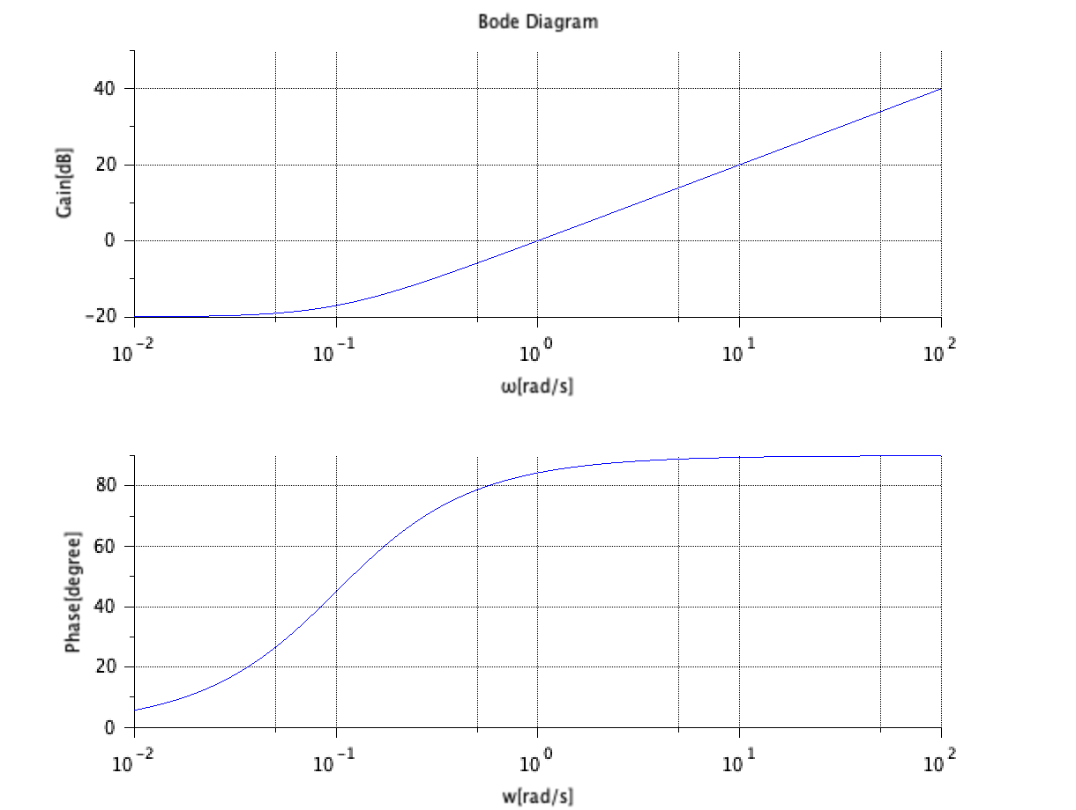

Figure 3 $P_{2}$ (s)のボード線図

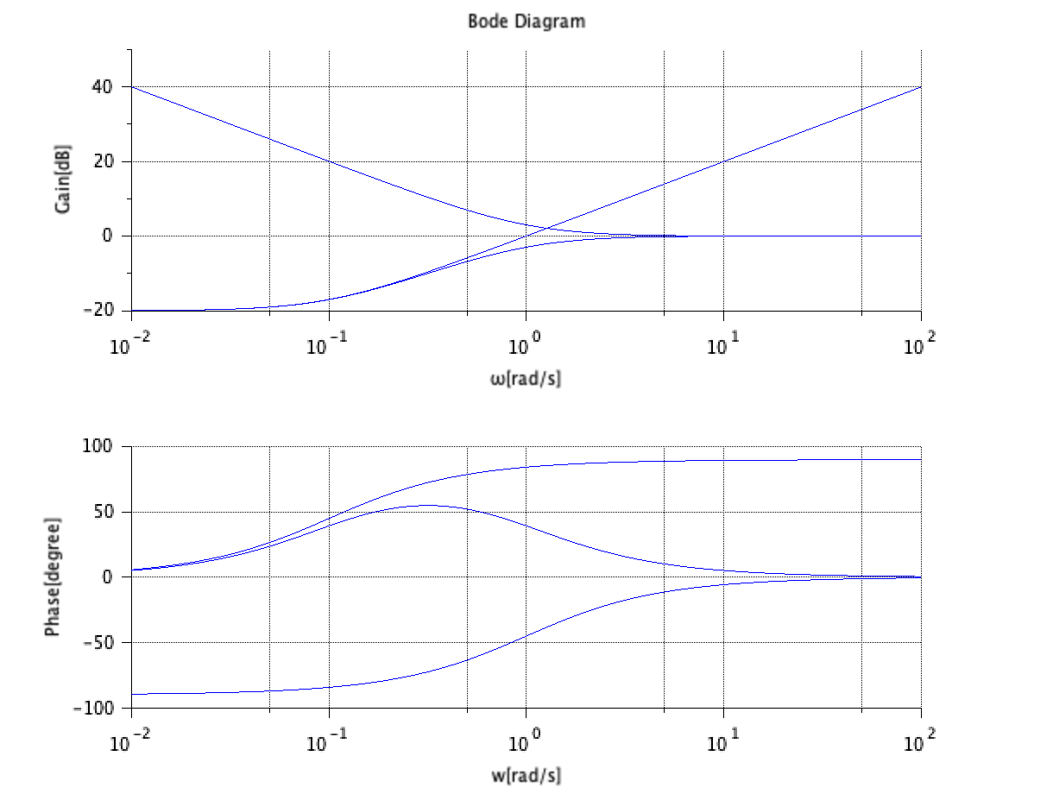

Figure 4 $P\left(s\right), P_{1}\left(s\right), P_{2}\left(s\right)を合わせたボード線図$