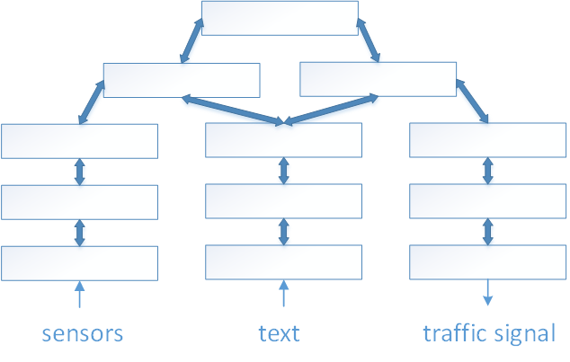

traffic network and social media



episodes

phrases

words

low

patterns

high patterns