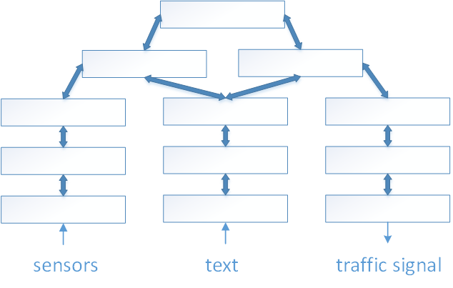

--------- Sensory inputs ---------- Action

Environment



episodes

phrases

words

low

patterns

high patterns