**Artificial General Intelligence Course**

Review:

The course presents a large set of ideas in the field of artificial general intelligence. It combines ideas from many scientific fields, such as neuroscience, computer science, psychology, and more. The course is not technical/practical, yet occasionally presents the mathematics behind different methods.

Takeaways:

1. The student will be able to expand his/her horizons in a new, exciting, and uncharted field of AGI.
2. This knowledge might be relevant in research labs around the world e.g. AI Initiative at [KAUST](https://cemse.kaust.edu.sa/ai), [CSAIL](https://www.csail.mit.edu/) (MIT AI Lab) and more. Also, in different companies around the world that do R&D in this topic: [Meta AI](https://ai.facebook.com/) (Yann LeCun) or FAIR (Facebook AI research), [Google AI](https://www.ai.google/), [DeepMind](https://www.deepmind.com/), [Open AI](https://openai.com/), [Decodea](https://decodea.ai/), [AI21 Labs](https://www.ai21.com/) (Amnon Shashua), [Numenta](https://numenta.com/) (Jeff Hawkins), [SingularityNET](https://singularitynet.io/) (Ben Goertzel), [ABRAINA](https://www.abraina.com/), Keen Technologies ([John Carmack](https://twitter.com/ID_AA_Carmack)) and more.

Teaching:

Via regular presentations or via “flipped classroom”:

1. Watch lecture video for that week.

Suggestion: if you come up with misunderstandings during the playback, please replay and watch it more than once.

1. Feedback: fill up form of review, ideas, suggestions, etc.
2. At class: discussion (recap, then Q&A, additional information about the subject, and then dive deeper to the/more ideas/techniques).

Grade:

* 10%: attendance.
* 30%: feedback after home-watching lectures.
* 60%: final summary paper/presentation about some subject in more depth, e.g., some Cognitive Architecture.

A list of papers will be supplied to choose from, or there will be an option for the student to find other AGI-related papers in the literature.

Syllabus:

1. Historical overview of AGI
   * AGI relation with physics and computer sciences
   * AGI relation with scientific philosophy
   * AGI in culture and in popular literature
   * Optional: AGI in Judaism
2. Neuro-science
   * Pathom Brain theory
   * Other Brain theories
   * System 1 & 2
   * Jeff Hawkins’ Neocortex models
   * Selected studies
3. Deep Learning (DL)
   * Hierarchical classification
   * Generative models
   * Other Neural Network types
   * Network Architecture Search
4. Unsupervised Learning
5. Other Learning approaches and types
6. Natural language processing (NLP)
   * Embeddings
   * Model of computation (Chomsky Hierarchy)
   * Syntax and Semantics
   * John Ball’s NLU
7. Understanding DL (Black-box issue)
8. Bayesian theory (Brain Hypothesis, optimization, BNN, GP, PML)
9. Classical AI
   * Knowledge Representations
   * Logic
   * Programming Paradigms
10. Cognitive Architectures
11. State space (RL, control theory, Markov)
12. Neuro-Symbolic AI
13. Other topics:
    * Visual perception
    * AGI motivated by engineering (as in optimization and control)
    * Human growth (psychology)
    * Serial verse Parallel thinking (Eduard De Bono)
    * Memory (types, limitations, theories)
    * Consciousness
    * Time series
    * Cognitive Bias

Sources:

|  |  |  |
| --- | --- | --- |
|  | Text | Presentation |
| Historical overview of AGI |  | ‏‏AI_presentation12.pptx |
| Cognitive architectures | Ben Goertzel in AIsummary16.docx, Ricardo R. Gudwin in AIpapers15.docx | AI_presentation12.pptx |
| AGI relation with physics and computer sciences |  | ‏‏AI_presentation12.pptx |
| AGI relation with scientific philosophy |  | ‏‏AI_presentation12.pptx |
| AGI in culture and in literature |  | ‏‏AI_presentation12.pptx |
| Visual perception | Visual perception in AIsummary16.docx | ‏‏AI_presentation12.pptx |
| Neuroscience and sleep | Neuroscience in AIsummary16.docx | AI_presentation12.pptx |
| Neural models (especially of cognition) | Jeff Hawkins in AIsummary16.docx, After "skymind articles" in AIpapers15.docx | ‏‏AI_presentation12.pptx |
| AGI motivated by engineering (especially in optimization and control) |  | ‏‏AI_presentation12.pptx |
| Black-box deep learning (DL) | Information theory in AIpapers15.docx | AI_presentation12.pptx |
| Human growth (psychology) | Psychology in AIsummary16.docx | ‏‏AI_presentation12.pptx |
| Optional: AGI in Judaism | AIsummary16.docx | ‏‏AI_presentation12.pptx |
| Serial verse Parallel thinking (Eduard De Bono) | Eduard De Bono in AIsummary16.docx | ‏‏AI_presentation12.pptx |
| Memory (types, limitations, theories) | "Course 8" and "DL for sequential pattern.." in AICourses01.docx, "ANNs finally yield.." in AIsummary16.docx | ‏‏AI_presentation12.pptx, NLP+DL.pptx, Framework AI 05.pptx |
| DL | RL, GNN, scene graphs in AIpapers15.docx, DL.docx, Intro to NLP.docx | NLP+DL.pptx, AI_presentation12.pptx, Graph NNs.pptx |
| Natural language processing (NLP) | Intro to NLP.docx | NLP+DL.pptx, Framework AI 05.pptx |
| Bayesian verse frequentist perspectives | Bayesian Brain Hypothesis in AIsummary16.docx |  |
| Meta-learning and domain adaptation | "Course 13, 14" in AICourse01.docx | NLP+DL.pptx |
| Hypernetworks and NAS | "Structural priors.." , "Hypernetworks.." in AICourse01.docx | MyDNN.pptx, NLP+DL.pptx |
| ML | Courses in AICourse01.docx | AI_presentation12.pptx |
| Rule-based AI | "Course 10" in AICourse01.docx, "Course of AI" in AIsummary16.doc | "From course of AI" Transportation AGI 05.pptx |
| Computer Vision | "Course 12" in AICourse01.docx, More stuff in DL.docx, CNN_images.docx | Transportation AGI 05.pptx |
| Causality | "Course 15", "Towards cau.." in AICourse01.docx |  |
| Left/right brain | Psychology in AIsummary16.docx |  |
| Fast/slow or System 1/2 | "Towards caus.." in AICourse01.docx, Ben Goertzel in AIsummary16.docx | AI_presentation12.pptx |
| Unsupervised Learning | "Deep clustering" in AICourse01.docx | Unsupervised Learners.pptx |
| Communication and senses |  | AI_presentation12.pptx, Framework AI 05.pptx |
|  |  |  |
|  |  |  |
|  |  |  |
|  |  |  |

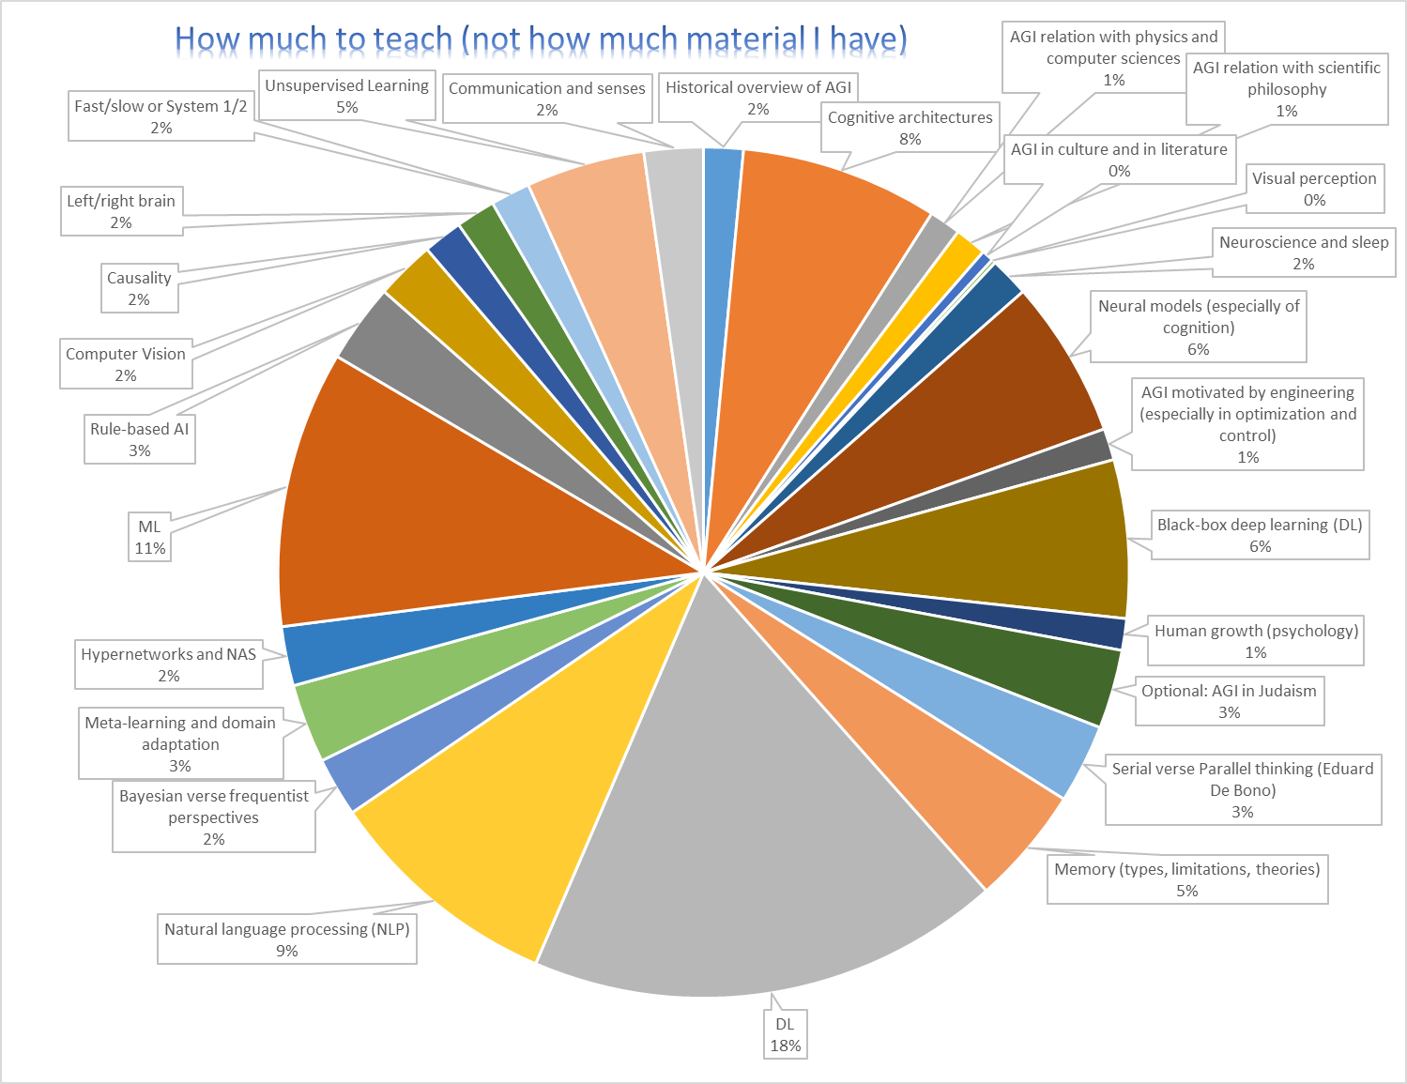

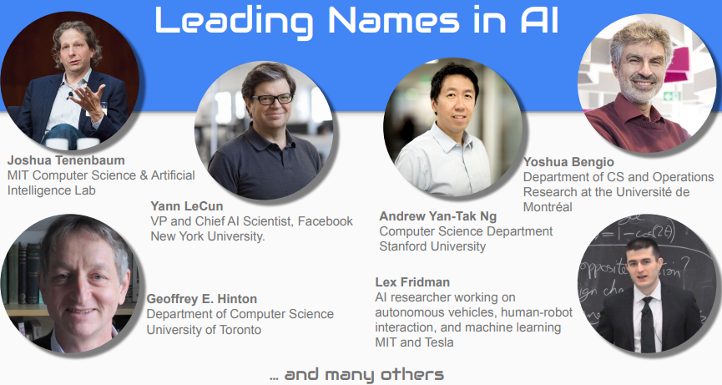taken from [here](https://blogs.embarcadero.com/machine-learning-and-artificial-intelligence-webinar/)…



Ian Goodfellow

AGI:

   Ben Goertzel Sam Adams John Carmack

Psychology:

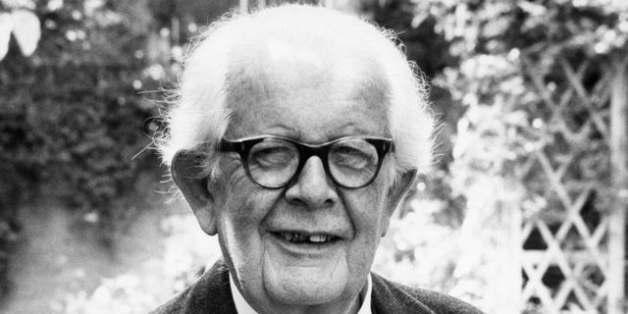 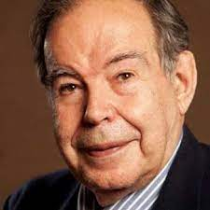 Jean Piaget Edward de Bono Daniel Kahneman

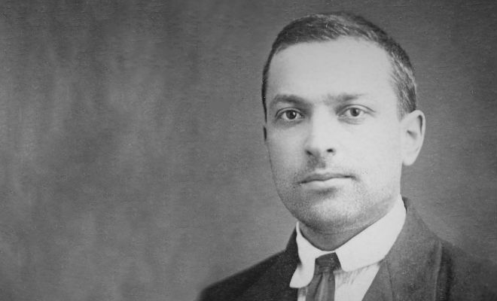  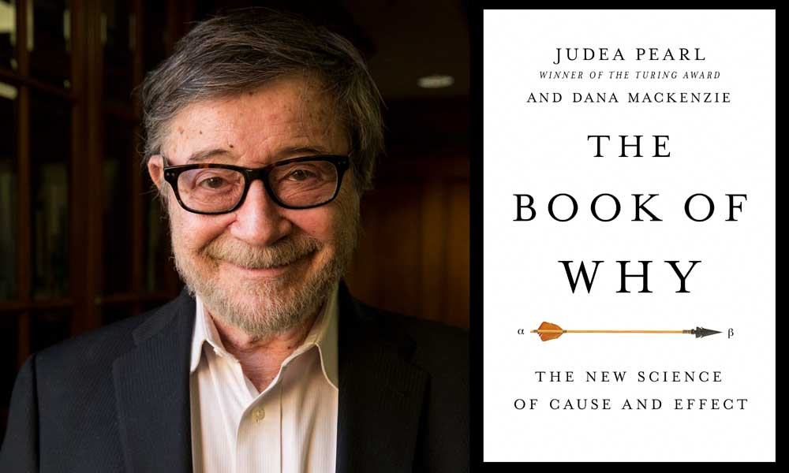Lev Vygotsky Gary Marcus Judea Pearl

My favorite:

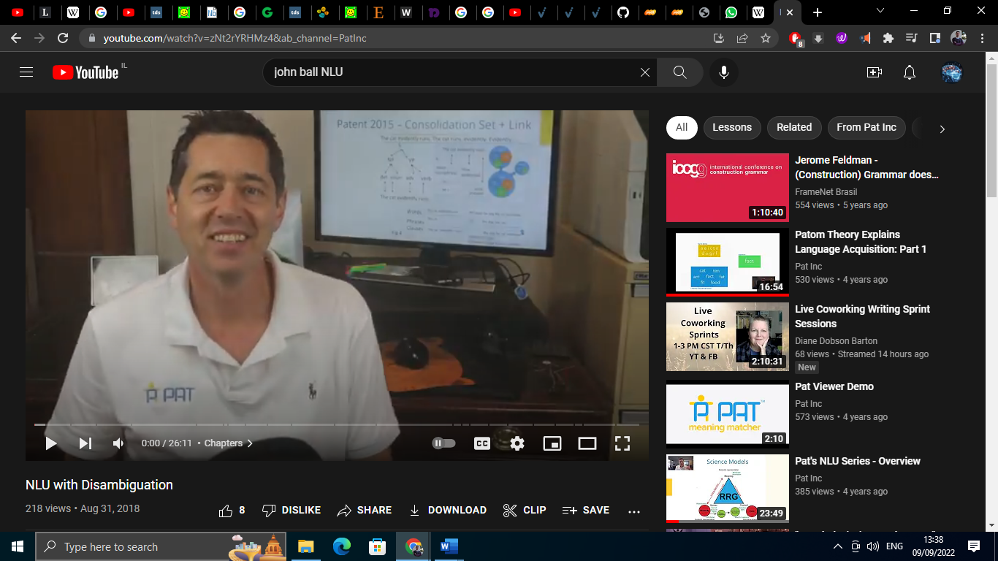 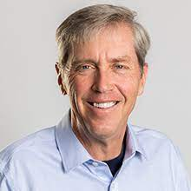

[John S. Ball](https://en.wikipedia.org/wiki/John_Ball_%28cognitive_scientist%29) [Jeff Hawkins](https://en.wikipedia.org/wiki/Jeff_Hawkins)

Cognitive Language scientist Neuro-scientist