**2.2.1**

**Q5**

5)a)

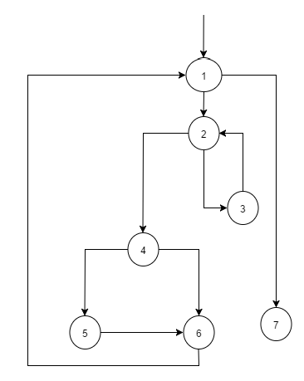

b)

|  |  |
| --- | --- |
|  | Test Requirement (TR) |
| A | [1,2,3] |
| B | [1,2,4] |
| C | [2,3,2] |
| D | [2,4,5] |
| E | [2,4,6] |
| F | [3,2,3] |
| G | [3,2,4] |
| H | [4,5,6] |
| I | [4,6,1] |
| J | [5,6,1] |
| K | [6,1,2] |
| L | [6,1,7] |

c)

t0 = [1,2,4,5,6,1,7] covers B, D, H, J, L

t1 = [1,2,3,2,4,6,1,7] covers A,C, G, E, I, L

Edge pair TRs’ F[3,2,3] and K[6,1,2] are not toured by any of the test paths.

d)

The test path does not tour the simple path [3, 2, 4, 5, 6] directly. It tours with a sidetrip [4, 6, 1, 2, 4].

e)

Node Coverage test requirements = {1, 2, 3, 4, 5, 6, 7}

Edge coverage requirements = {(1, 2,), (1, 7), (2, 3), (2, 4), (3, 2), (4, 5), (4, 6), (5, 6), (6, 1)} .

Prime path coverage requirements =

1. [1,2,4,6,1] ,
2. [1,2,4,5,6,1] ,
3. [2,3,2],
4. [2,4,6,1,2],
5. [2,4,5,6,1,2] ,
6. [3,2,3],
7. [3,2,4,6,1,7],
8. [3,2,4,5,6,1,7],
9. [4,5,6,1,2,4] ,
10. [4,5,6,1,2,3] ,
11. [4,6,1,2,4] ,
12. [4,6,1,2,3] ,
13. [5,6,1,2,4,5],
14. [6,1,2,4,5,6] ,
15. [6,1,2,4,6] ,

f)

Test path [1,2,3,2,4,5,6,1,7] fulfills node coverage , but does not cover (4,6) .

g)

[1,2,3,2,4,5,6,1,7] , [1,2,4,6,1,7]

**2.3**

**Q7**

**a)**

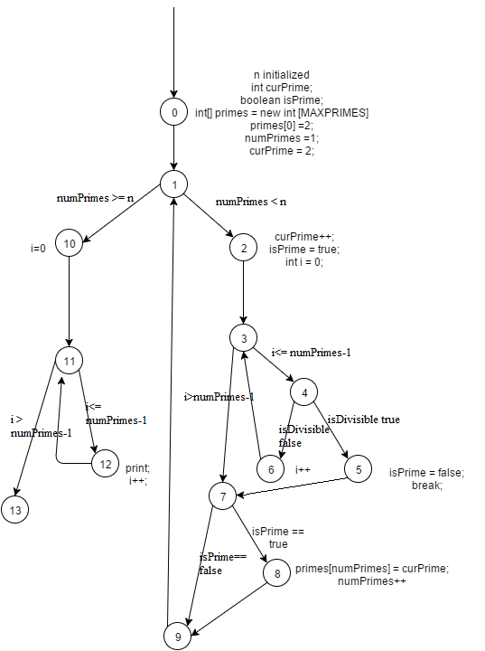

b)

line 16, while(numPrimes < 3) . This would be detected by n = 3 but not by n = 5.

c)

// is the **for statement**  the for statement at line 36? My answer assumes so.

For test case n = 1, the body of the while loop is skipped.

d)

Node coverage TR = {0,1,2,3,4,5,6,7,8,9,10,11}

Edge coverage TR = {(0,1), (1,2), (2,3) , (3,4), (4,5), (4,6), (6,3), (3,7), (5,7), (7,8), (7,9) , (8,9), (9,1), (1,10), (10,11), (11,12), (12,11), (11,13)}

Prime Path coverage TR ={

[0,1,10,11,13],

[0,1,10,11,12],

[0,1,2,3,7,9],

[0,1,2,3,7,8,9],

[0,1,2,3,4,6],

[0,1,2,3,4,5,7,9],

[0,1,2,3,4,5,7,8,9],

[1,2,3,7,9,1],

[2,3,7,9,1,2],

[3,7,9,1,2,3],

[7,9,1,2,3,7],

[9,1,2,3,7,9],

[1,2,3,4,5,7,9,1],

[2,3,4,5,7,9,1,2],

[3,4,5,7,9,1,2,3],

[4,5,7,9,1,2,3,4],

[5,7,9,1,2,3,4,5],

[7,9,1,2,3,4,5,7],

[9,1,2,3,4,5,7,9],

[1,2,3,4,5,7,8,9,1],

[2,3,4,5,7,8,9,1,2],

[3,4,5,7,8,9,1,2,3],

[4,5,7,8,9,1,2,3,4],

[5,7,8,9,1,2,3,4,5],

[7,8,9,1,2,3,4,5,7],

[8,9,1,2,3,4,5,7,8],

[9,1,2,3,4,5,7,8,9],

[2,3,7,9,1,10,11,12],

[2,3,7,9,1,10,11,13],

[2,3,7,8,9,1,10,11,12],

[2,3,7,8,9,1,10,11,13],

[2,3,4,5,7,9,1,10,11,12],

[2,3,4,5,7,9,1,10,11,13],

[2,3,4,5,7,8,9,1,10,11,12],

[2,3,4,5,7,8,9,1,10,11,13],

[3,4,6,3],

[4,6,3,4],

[6,3,4,6],

[4,6,3,7,9,1,10,11,12],

[4,6,3,7,8,9,1,10,11,12],

[4,6,3,7,9,1,10,11,13],

[4,6,3,7,8,9,1,10,11,13],

[5,7,9,1,2,3,4,6]

[5,7,8,9,1,2,3,4,6]

[7,9,1,2,3,4,5]

[11,12,11]

[12,11,12]

[12,11,13]

[6,3,4,5,7,9,1,2],

[6,3,4,5,7,8,9,1,2],

[4,6,3,7,9,1,2]

[4,6,3,7,8,9,1,2]

[6,3,4,5,7,9,1,10,11,13],

[6,3,4,5,7,8,9,1,10,11,13],

[4,6,3,7,9,1,2,10,11,13]

[4,6,3,7,8,9,1,2,,10,11,13]

[6,3,4,5,7,9,1,10,11,12],

[6,3,4,5,7,8,9,1,10,11,12],

[4,6,3,7,9,1,2,10,11,12]

[4,6,3,7,8,9,1,2,,10,11,12]

}

e)

[0,1,2,3,4,6,3,4,5,7,8,9,1,10,11,12,11,14] does not achieve edge coverage but achieves node coverage.

f)

test path [0,1,2,3,7,9,1,2,3,4,6,3,4,5,7,8,9,1,10,11,12,11,13] tours all the edges, but does not cover prime path [0,1,10,11,14] .

3)

