1. a. 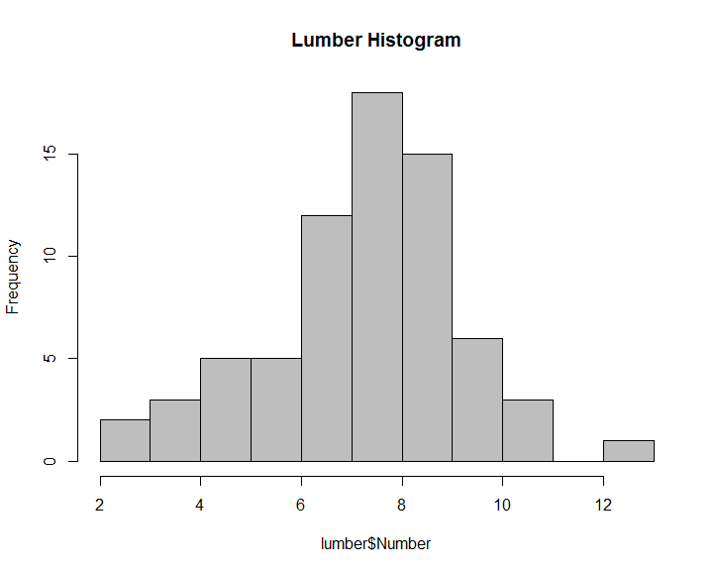

b. Mean = 7.728571

Median = 8

c. The data appears to be **normal.**

A normal curve is symmetric, single-peaked and bell-shaped. From the histogram, we can see that it is nearly symmetric around the mean (at 7.728571), single-peaked (at 7.728571), and nearly bell shaped.

Observation distribution of lumber data:  
Standard Deviation = 1.984881

From the histogram, 50 out of the 70 observations (71%) are located within 1sd of mean (5.74369 to 9.713452)

From the histogram, 64 out of the 70 observations (91.4%) are located within 2sd of mean (3.758809 to 11.69833)

From the histogram, 70 out of the 70 observations (100%) are located within 3sd of mean (1.773928 to 13.68321)

This distribution of data nearly follows the normal distribution where 68% , 95% and 99.7% observations are within 1, 2 and 3 sd of mean respectively.

Based on these patterns observed in the sample data, the data appear to be normally distributed.

* 1. Sample Mean for StandardTherapy = 15.67857

Sample Mean for NewTherapy = 20.71429

Sample Standard Deviation for StandardTherapy = 9.630405

Sample Standard Deviation for NewTherapy = 9.808753

b) 