1)A)

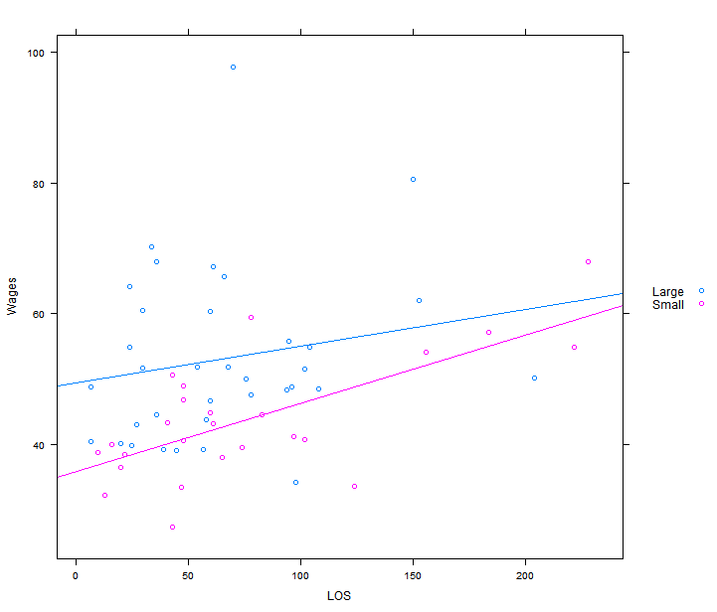

**B) ${For Large bank, }_{y}^{^}$** = 49.54532 + 0.05595x

${For Small bank, }_{y}^{^}$ = 35.87192 + 0.10416x

**C)** **For Large Bank**, estimates of the intercept, $β_{0} =$ 49.54532

95% Confidence interval of intercept $β_{0}$

fit lwr upr

$\hat{β_{0}}$ 49.54532 41.38071 57.70992

**For Small Bank**, estimates of the intercept, $β_{0} =$ 35.87192

95% Confidence interval of intercept $β_{0}$

|  |
| --- |
| fit lwr upr $\hat{β_{0}}$ 35.87192 31.15136 40.59248 |

Based on the confidence interval for the intercepts of both large and small banks, a brand new employee be better off at a large bank.

**D)**

Estimate of the slope for large bank $\hat{β_{1}}$ = 0.05595

Estimate of the slope for small bank $\hat{β_{1}}$ = 0.10416

From the figure of the slopes, we can interpret that although the starting salary of the large bank for a brand new employee is better, an employee will have a larger increase in salary in a small bank over time.

**E)**

**For large bank,**

H0 :

H1 :

p-value = 0.282 > 0.05

Conclusion: The null hypothesis cannot be rejected with 95% confidence.

**For small bank,**

H0 :

H1 :

p-value = 0.000171 < 0.05

Conclusion: The null hypothesis can be rejected with 95% confidence, meaning we can be 95% confident that the slope of the true regression line is zero.

For the lack of Fit test, we make the following hypothesis:

H0 : The linear regression model is appropriate

H1 : The linear regression model is not appropriate

p-value for large bank = 0.2442 > 0.05, which means there is no evidence of lack of fit for the linear regression for the large bank.

p-value for small bank = 0.9095 > 0.05, which means there is no evidence of lack of fit for the linear regression for the small bank.

This means that we have evidence that LOS is (linearly) related to wages.

**F)**

For large bank, the prediction and the confidence interval are the following:

fit lwr upr

1 54.91688 49.43465 60.39911

For small bank, the prediction and the confidence interval are the following:

fit lwr upr

1 45.87139 42.83057 48.91221

Based on salary, an employee with 8 years of experience be better off at a Large bank.

**G)**Prediction intervals will be wider than confidence interval.

**H)**

Outlier from the large bank has the following: LOS = 70, Wages = 97.6801

Rstudent residual for the outlier = 4.242492

Bonferoni adjusted p-value = 0.006173458 < 0.05

**I)**

**Large Banks:**

Estimated correlation for large banks , r = 0.1870392

p-value = 0.282 > 0.05

Null hypothesis that the population correlation is zero for large banks can not be rejected with 95% certainty.

**Small Banks:**

Estimated correlation for small banks, r = 0.682432

p-value = 0.001712

Null hypothesis that the population correlation is zero for small banks can not be rejected with 95% certainty.

Compared to part E, we see that we obtain the same p-values for large and small banks.

**J)**

By testing variance of LOS of large bank and small bank, we get F-test p-value = 0.06389 > 0.05, which means we can not reject with 95% certainty that the null hypothesis that true ratio of variances in LOS of large and small bank is equal to 1.

This means we operate assuming equal variances of LOS data for large and small banks.

Assuming equal variances, we run the two-sample t-test and get the p-value = 0.3915 > 0.05.

From this , we can conclude that we can not reject the assumption of equal means of LOS in larger and smaller bank with 95% certainty.

**2)A)**  
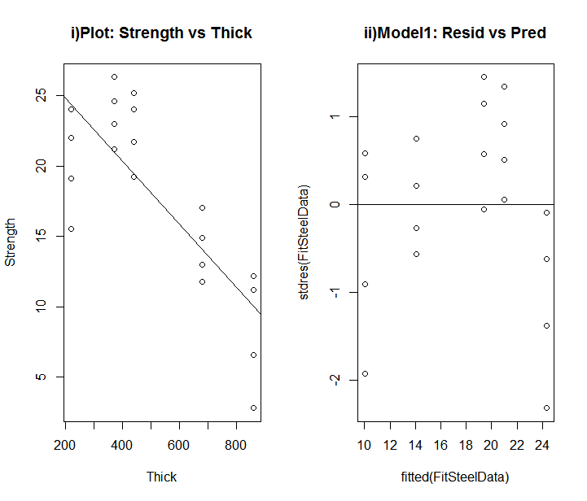

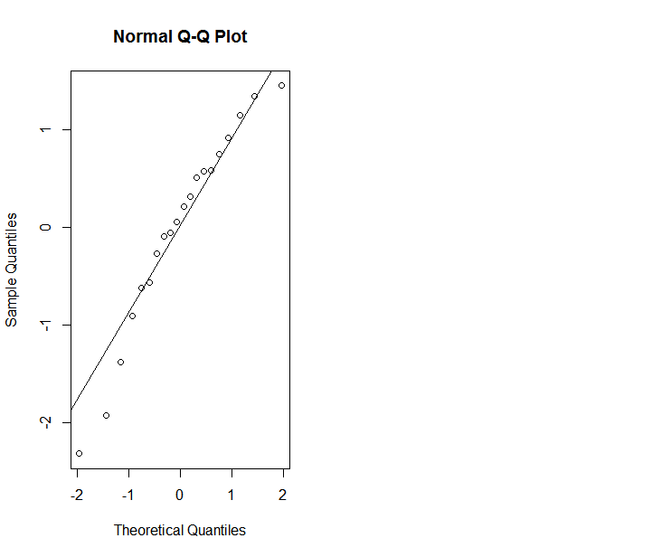

The regression assumption of equal scatter in the plt of residuals vs fitted value does not seem to be met.

**B)**

Performing the F-test for lack of fit, we get the following:

Analysis of Variance Table

Model 1: Strength ~ Thick

Model 2: Strength ~ as.factor(Thick)

Res.Df RSS Df Sum of Sq F Pr(>F)

1 18 301.90

2 15 148.57 3 153.33 5.16 0.01195 *

---

Signif. codes: 0 ‘***’ 0.001 ‘**’ 0.01 ‘*’ 0.05 ‘.’ 0.1 ‘ ’ 1

p-value = 0.01195 < 0.05 , which means we can reject the null hypothesis that the linear regression model is appropriate.

**C)**

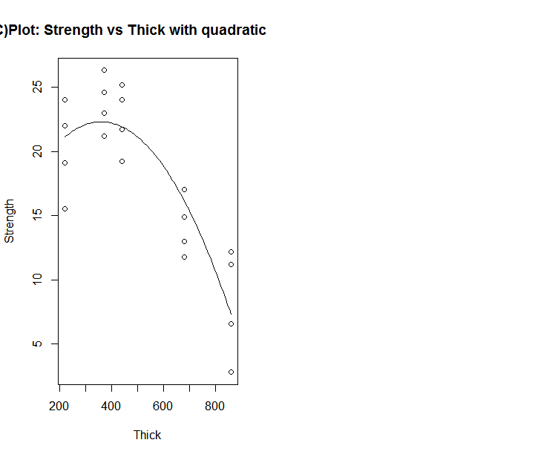

**Summary Table:**

Call:

lm(formula = Strength ~ Thick + I(Thick^2), data = steelData)

Residuals:

Min 1Q Median 3Q Max

-5.6222 -2.1960 0.2443 2.4491 4.8763

Coefficients:

Estimate Std. Error t value Pr(>|t|)

(Intercept) 1.452e+01 4.752e+00 3.057 0.00713 **

Thick 4.318e-02 1.980e-02 2.181 0.04354 *

I(Thick^2) -5.994e-05 1.786e-05 -3.357 0.00374 **

---

Signif. codes: 0 ‘***’ 0.001 ‘**’ 0.01 ‘*’ 0.05 ‘.’ 0.1 ‘ ’ 1

Residual standard error: 3.268 on 17 degrees of freedom

Multiple R-squared: 0.7796, Adjusted R-squared: 0.7537

F-statistic: 30.07 on 2 and 17 DF, p-value: 2.609e-06

|  |
| --- |
| > #Question1  > bankSalary <- read.csv(file.choose())  > str(bankSalary)  'data.frame': 60 obs. of 3 variables:  $ Wages: num 48.3 49 40.9 36.6 46.8 ...  $ LOS : int 94 48 102 20 60 78 45 39 20 65 ...  $ Size : Factor w/ 2 levels "Large","Small": 1 2 2 2 1 2 1 1 1 2 ...  > head(bankSalary)  Wages LOS Size  1 48.3355 94 Large  2 49.0279 48 Small  3 40.8817 102 Small  4 36.5854 20 Small  5 46.7596 60 Large  6 59.5238 78 Small  > large <- subset(bankSalary, Size=="Large")  > small <- subset(bankSalary, Size=="Small")  > head(large)  Wages LOS Size  1 48.3355 94 Large  5 46.7596 60 Large  7 39.1304 45 Large  8 39.2465 39 Large  9 40.2037 20 Large  11 50.0905 76 Large  > head(small)  Wages LOS Size  2 49.0279 48 Small  3 40.8817 102 Small  4 36.5854 20 Small  6 59.5238 78 Small  10 38.1563 65 Small  12 46.9043 48 Small  > #1A: Create a scatterplot  > library(lattice)  > xyplot(Wages ~ LOS , data = bankSalary , groups = Size, type = c("p","r"), auto.key = list(space="right"))  > #1B: Regressions  > FitLarge <- lm(Wages ~ LOS, data = large)  > summary(FitLarge)  Call:  lm(formula = Wages ~ LOS, data = large)  Residuals:  Min 1Q Median 3Q Max  -20.688 -8.472 -3.691 5.767 44.218  Coefficients:  Estimate Std. Error t value Pr(>|t|)  (Intercept) 49.54532 4.01305 12.346 6.46e-14 ***  LOS 0.05595 0.05116 1.094 0.282  ---  Signif. codes: 0 ‘***’ 0.001 ‘**’ 0.01 ‘*’ 0.05 ‘.’ 0.1 ‘ ’ 1  Residual standard error: 13.02 on 33 degrees of freedom  Multiple R-squared: 0.03498, Adjusted R-squared: 0.005741  F-statistic: 1.196 on 1 and 33 DF, p-value: 0.282  > FitSmall <- lm(Wages ~ LOS, data = small)  > summary(FitSmall)  Call:  lm(formula = Wages ~ LOS, data = small)  Residuals:  Min 1Q Median 3Q Max  -15.0716 -4.4861 0.3944 2.8101 15.5273  Coefficients:  Estimate Std. Error t value Pr(>|t|)  (Intercept) 35.87192 2.28194 15.720 8.53e-14 ***  LOS 0.10416 0.02326 4.478 0.000171 ***  ---  Signif. codes: 0 ‘***’ 0.001 ‘**’ 0.01 ‘*’ 0.05 ‘.’ 0.1 ‘ ’ 1  Residual standard error: 7.021 on 23 degrees of freedom  Multiple R-squared: 0.4657, Adjusted R-squared: 0.4425  F-statistic: 20.05 on 1 and 23 DF, p-value: 0.0001712  > confint(FitLarge, level = 0.95)  2.5 % 97.5 %  (Intercept) 41.38071287 57.7099183  LOS -0.04812646 0.1600341  > confint(FitSmall, level = 0.95)  2.5 % 97.5 %  (Intercept) 31.15135828 40.5924796  LOS 0.05603753 0.1522847  > anova(FitLarge)  Analysis of Variance Table  Response: Wages  Df Sum Sq Mean Sq F value Pr(>F)  LOS 1 202.8 202.75 1.1963 0.282  Residuals 33 5592.9 169.48  > anova(FitSmall)  Analysis of Variance Table  Response: Wages  Df Sum Sq Mean Sq F value Pr(>F)  LOS 1 988.32 988.32 20.048 0.0001712 ***  Residuals 23 1133.85 49.30  ---  Signif. codes: 0 ‘***’ 0.001 ‘**’ 0.01 ‘*’ 0.05 ‘.’ 0.1 ‘ ’ 1  > newdata <- data.frame(LOS = 0.0)  > predict(FitLarge, newdata, interval = "confidence", level = 0.95)  fit lwr upr  1 49.54532 41.38071 57.70992  > predict(FitSmall, newdata, interval = "confidence", level = 0.95)  fit lwr upr  1 35.87192 31.15136 40.59248  > ANOVAFitLarge <- lm(Wages ~ as.factor(LOS), data = large)  > ANOVAFitSmall <- lm(Wages ~ as.factor(LOS), data = small)  > #Lack of fit test for Large bank  > anova(FitLarge,ANOVAFitLarge)  Analysis of Variance Table  Model 1: Wages ~ LOS  Model 2: Wages ~ as.factor(LOS)  Res.Df RSS Df Sum of Sq F Pr(>F)  1 33 5592.9  2 5 478.8 28 5114.1 1.9074 0.2442  > anova(FitSmall,ANOVAFitSmall)  Analysis of Variance Table  Model 1: Wages ~ LOS  Model 2: Wages ~ as.factor(LOS)  Res.Df RSS Df Sum of Sq F Pr(>F)  1 23 1133.85  2 3 307.54 20 826.3 0.403 0.9095  > #F LOS 96 months  > NewLOS <- data.frame(LOS = 96.0)  > predict(FitLarge, NewLOS, interval = "confidence", level = 0.95)  fit lwr upr  1 54.91688 49.43465 60.39911  > predict(FitSmall, NewLOS, interval = "confidence", level = 0.95)  fit lwr upr  1 45.87139 42.83057 48.91221  > #xyplot(Wages ~ LOS , data = bankSalary , groups = Size, type = c("p","r"), auto.key = list(space="right"))  > plot(Wages ~ LOS, data =bankSalary)  > identify(bankSalary$Wages ~ bankSalary$LOS , labels = bankSalary$Wages)  warning: nearest point already identified  warning: nearest point already identified  [1] 15  > plot(Wages ~ LOS, data =bankSalary)  > identify(bankSalary$Wages ~ bankSalary$LOS , labels = bankSalary$LOS)  warning: nearest point already identified  warning: nearest point already identified  warning: nearest point already identified  warning: nearest point already identified  warning: nearest point already identified  [1] 15  > #H residual and RStudent  > bankSalary  Wages LOS Size  1 48.33550 94 Large  2 49.02790 48 Small  3 40.88170 102 Small  4 36.58540 20 Small  5 46.75960 60 Large  6 59.52380 78 Small  7 39.13040 45 Large  8 39.24650 39 Large  9 40.20370 20 Large  10 38.15630 65 Small  11 50.09050 76 Large  12 46.90430 48 Small  13 43.18940 61 Small  14 60.56370 30 Large  15 97.68010 70 Large  16 48.57950 108 Large  17 67.15510 61 Large  18 38.78470 10 Small  19 51.89260 68 Large  20 51.83260 54 Large  21 64.10260 24 Large  22 54.94510 222 Small  23 43.80950 58 Large  24 43.34550 41 Small  25 61.98930 153 Large  26 40.01830 16 Small  27 50.71430 43 Small  28 48.84000 96 Large  29 34.34070 98 Large  30 80.58610 150 Large  31 33.71630 124 Small  32 60.37920 60 Large  33 48.84000 7 Large  34 38.55790 22 Small  35 39.27600 57 Large  36 47.65640 78 Large  37 44.68640 36 Large  38 44.57875 83 Small  39 65.62880 66 Large  40 33.57750 47 Small  41 41.20880 97 Small  42 67.90960 228 Small  43 43.09420 27 Large  44 40.70000 48 Small  45 40.57480 7 Large  46 39.68250 74 Small  47 50.17420 204 Large  48 54.94510 24 Large  49 32.38220 13 Small  50 51.71300 30 Large  51 55.83790 95 Large  52 54.94510 104 Large  53 70.27860 34 Large  54 57.23440 184 Small  55 54.11260 156 Small  56 39.86870 25 Large  57 27.47250 43 Small  58 67.95840 36 Large  59 44.93170 60 Small  60 51.56120 102 Large  > large_Subdata <- data.frame(large, Resid = resid(FitLarge), student = stdres(FitLarge) , RStudent = rstudent(FitLarge))  > large_Subdata[large_Subdata$LOS == 70,]  Wages LOS Size Resid student RStudent  15 97.6801 70 Large 44.21802 3.44666 4.242492  > #Bonferoni Adjusted 2-sided p-value  > 2*35*(1-pt(4.242492,32))  [1] 0.006173458  > #I  > #Estimated Correlation  > large  Wages LOS Size  1 48.3355 94 Large  5 46.7596 60 Large  7 39.1304 45 Large  8 39.2465 39 Large  9 40.2037 20 Large  11 50.0905 76 Large  14 60.5637 30 Large  15 97.6801 70 Large  16 48.5795 108 Large  17 67.1551 61 Large  19 51.8926 68 Large  20 51.8326 54 Large  21 64.1026 24 Large  23 43.8095 58 Large  25 61.9893 153 Large  28 48.8400 96 Large  29 34.3407 98 Large  30 80.5861 150 Large  32 60.3792 60 Large  33 48.8400 7 Large  35 39.2760 57 Large  36 47.6564 78 Large  37 44.6864 36 Large  39 65.6288 66 Large  43 43.0942 27 Large  45 40.5748 7 Large  47 50.1742 204 Large  48 54.9451 24 Large  50 51.7130 30 Large  51 55.8379 95 Large  52 54.9451 104 Large  53 70.2786 34 Large  56 39.8687 25 Large  58 67.9584 36 Large  60 51.5612 102 Large  > cor.test(large$Wages, large$LOS)  Pearson's product-moment correlation  data: large$Wages and large$LOS  t = 1.0938, df = 33, p-value = 0.282  alternative hypothesis: true correlation is not equal to 0  95 percent confidence interval:  -0.1559263 0.4897590  sample estimates:  cor  0.1870392  > small  Wages LOS Size  2 49.02790 48 Small  3 40.88170 102 Small  4 36.58540 20 Small  6 59.52380 78 Small  10 38.15630 65 Small  12 46.90430 48 Small  13 43.18940 61 Small  18 38.78470 10 Small  22 54.94510 222 Small  24 43.34550 41 Small  26 40.01830 16 Small  27 50.71430 43 Small  31 33.71630 124 Small  34 38.55790 22 Small  38 44.57875 83 Small  40 33.57750 47 Small  41 41.20880 97 Small  42 67.90960 228 Small  44 40.70000 48 Small  46 39.68250 74 Small  49 32.38220 13 Small  54 57.23440 184 Small  55 54.11260 156 Small  57 27.47250 43 Small  59 44.93170 60 Small  > cor.test(small$Wages, small$LOS)  Pearson's product-moment correlation  data: small$Wages and small$LOS  t = 4.4775, df = 23, p-value = 0.0001712  alternative hypothesis: true correlation is not equal to 0  95 percent confidence interval:  0.3933745 0.8487086  sample estimates:  cor  0.682432  > #J  > var.test(large$LOS,small$LOS)  F test to compare two variances  data: large$LOS and small$LOS  F = 0.50183, num df = 34, denom df = 24, p-value = 0.06389  alternative hypothesis: true ratio of variances is not equal to 1  95 percent confidence interval:  0.230228 1.041119  sample estimates:  ratio of variances  0.5018278  > t.test(large$LOS,small$LOS, var.equal = TRUE)  Two Sample t-test  data: large$LOS and small$LOS  t = -0.8634, df = 58, p-value = 0.3915  alternative hypothesis: true difference in means is not equal to 0  95 percent confidence interval:  -38.89185 15.45185  sample estimates:  mean of x mean of y  65.60 77.32  > #2  > #i)  > library(MASS)  > steelData <- read.csv(file.choose())  > head(steelData)  Thick Strength  1 220 24.0  2 220 22.0  3 220 19.1  4 220 15.5  5 370 26.3  6 370 24.6  > plot(Strength ~ Thick , data = steelData, main = "i)Plot: Strength vs Thick")  > FitSteelData <- lm(Strength ~ Thick , data = steelData)  > abline(coef(FitSteelData))  > #ii)  > plot(stdres(FitSteelData) ~ fitted(FitSteelData), main = "ii)Model1: Resid vs Pred")  > abline(h=0)  > #iii)  > qqnorm(stdres(FitSteelData))  > qqline(stdres(FitSteelData))  > ANOVAFitSteelData <- lm(Strength ~ as.factor(Thick), data = steelData)  > anova(FitSteelData)  Analysis of Variance Table  Response: Strength  Df Sum Sq Mean Sq F value Pr(>F)  Thick 1 522.04 522.04 31.125 2.699e-05 ***  Residuals 18 301.90 16.77  ---  Signif. codes: 0 ‘***’ 0.001 ‘**’ 0.01 ‘*’ 0.05 ‘.’ 0.1 ‘ ’ 1  > anova(ANOVAFitSteelData)  Analysis of Variance Table  Response: Strength  Df Sum Sq Mean Sq F value Pr(>F)  as.factor(Thick) 4 675.37 168.843 17.047 1.881e-05 ***  Residuals 15 148.57 9.905  ---  Signif. codes: 0 ‘***’ 0.001 ‘**’ 0.01 ‘*’ 0.05 ‘.’ 0.1 ‘ ’ 1  > anova(FitSteelData,ANOVAFitSteelData)  Analysis of Variance Table  Model 1: Strength ~ Thick  Model 2: Strength ~ as.factor(Thick)  Res.Df RSS Df Sum of Sq F Pr(>F)  1 18 301.90  2 15 148.57 3 153.33 5.16 0.01195 *  ---  Signif. codes: 0 ‘***’ 0.001 ‘**’ 0.01 ‘*’ 0.05 ‘.’ 0.1 ‘ ’ 1  > #C) Quadratic term adding  > FitSteelData2 <- lm(Strength ~ Thick +I(Thick^2) , data = steelData)  > plot(Strength ~ Thick , data = steelData, main = "C)Plot: Strength vs Thick with quadratic term")  > FitSteelData2$coefficients  (Intercept) Thick I(Thick^2)  1.452457e+01 4.317629e-02 -5.994113e-05  > curve((1.452457e+01) + (4.317629e-02)*x + (-5.994113e-05)*x^2 , add = TRUE)  > summary(FitSteelData2)  Call:  lm(formula = Strength ~ Thick + I(Thick^2), data = steelData)  Residuals:  Min 1Q Median 3Q Max  -5.6222 -2.1960 0.2443 2.4491 4.8763  Coefficients:  Estimate Std. Error t value Pr(>|t|)  (Intercept) 1.452e+01 4.752e+00 3.057 0.00713 **  Thick 4.318e-02 1.980e-02 2.181 0.04354 *  I(Thick^2) -5.994e-05 1.786e-05 -3.357 0.00374 **  ---  Signif. codes: 0 ‘***’ 0.001 ‘**’ 0.01 ‘*’ 0.05 ‘.’ 0.1 ‘ ’ 1  Residual standard error: 3.268 on 17 degrees of freedom  Multiple R-squared: 0.7796, Adjusted R-squared: 0.7537  F-statistic: 30.07 on 2 and 17 DF, p-value: 2.609e-06  >  >  >  > |
|  |
| |  | | --- | |  | |