1. a.   
    P(Z ≤ 0.57) = 0.7157  
   b.  
    P(Z ≤ -0.32) = 0.3745

c.   
 P(Z > 2.10) = 1-P(Z ≤ 2.10) = 1 - .9821 = 0.0179  
d.  
 P(-0.32 ≤ Z ≤ 1.55) = P(Z ≤ 1.55) – P(Z ≤ -0.32) = 0.9394-0.3745 = 0.5649

e.   
 P(Z ≤ z) = 0.3300; z = -0.44

f.  
 P(Z > z) = 0.3987, so P(Z ≤ z) = 1 – 0.3987 = 0.6013 ; z = 0.2567

2)   
 Y ~ N ( µ = 6, = 0.8)   
 a.  
 P(Y ≤ 7 ) = ?

Converting normal distribution Y to standard normal distribution Z, we get

P(Y ≤ 7 ) = P($\frac{Y-µ}{σ}≤\frac{7-µ}{σ}$) = P($Z≤\frac{7-6}{0.8}$) = P(Z $≤1.25)$ =0.8944

b.   
 P(Y > 5.4) = ?

Converting normal distribution Y to standard normal distribution Z, we get

P(Y > 5.4) = P($\frac{Y-µ}{σ}>\frac{5.4-µ}{σ}$) = P($Z≤\frac{5.4-6}{0.8}$) = P(Z $>-0.75)$ = 1 – P(Z ≤ -0.75) = 1 – 0.2266 = 0.7734

c.

P(6 ≤ Y ≤ 7.2) = ?

Converting normal distribution Y to standard normal distribution Z, we get

P(6 ≤ Y ≤ 7.2) = P ($\frac{6.0-µ}{σ}≤\frac{Y-µ}{σ}≤\frac{7.2-µ}{σ}$) = P ($\frac{6.0-6.0}{0.8}≤\frac{Y-µ}{σ}≤\frac{7.2-6.0}{0.8}$) = P ($0≤Z≤\frac{1.2}{0.8}$)

= P ($0≤Z≤1.5$) = P($Z≤1.5$) – P( $Z≤0.0)$ = 0.9332 – 0.5 = 0.4332

d.

P(Y ≤ y) = 0.85

Converting normal distribution Y to standard normal distribution Z, we get

P(Y ≤ y) = P($\frac{Y-µ}{σ}≤\frac{y-µ}{σ}$) = P(Z $≤z$) = 0.85, where z = $\frac{y-µ}{σ}$

From Table 1, z=1.035.

So, 1.035 = $\frac{y-6}{0.8}$, making y = 6.828

3)

a.

df=25, P(T>1.708) = 0.05

b.

df=9, P(-t<T<t) = 0.95.

Two-tailed probability, α = 0.05.

So, right tailed probability, α/2 =0.025

t0.025,9  = 2.262

c.

df=50, P(T>t) = 0.90.

t0.9,50 = -1.299

4)

a.

As the distribution of Y is skewed, empirical rule for normal distribution can’t be applied. In this case, Chebyshev’s rule should be applied for determining 75% interval for population distribution.

From Chebyshev’s rule, for population mean at least 75% of the data lie within (µ±2 $σ$) range, or (90±20) = (70,110) range.

So, the interval is (70,110)

b.

According to the Central Limit Theorem, the distribution of sample mean, $\overline{y}$ is close to normal as n is large (n=100). So the shape of the distribution will follow normal distribution (bell shaped curve) [ $\overline{y}$ ~ (µ, $\frac{σ}{√n} )$]

Mean = µ = 90

Standard deviation s = $\frac{σ}{√n}$ = $\frac{10}{√100} =1$

5)

a.

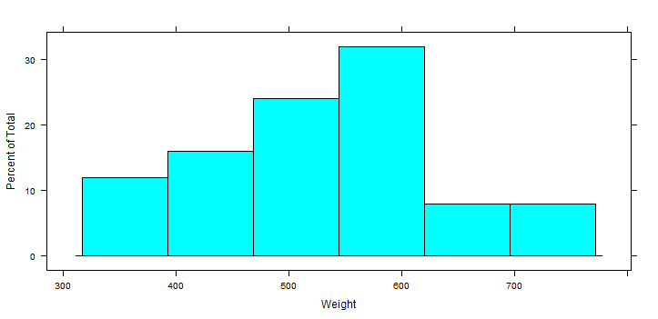

Sample mean $\overline{y}$ = 526.12

Sample sd , s= 113.7279

b.

From the histogram, the sample data looks like a normal distribution. So from the empirical rule, 95% (α = 0.05) confidence interval for µ is = ( $\overline{y}$ ± tα/2 [Two tailed distribution]

Now, tα/2 = t0.05/2 = t0.025 , and df = n-1 = 25-1 = 24.

From Student’s t-distribution, t0.025 for df , tα/2, n-1 = t0.025, 24 = 2.064.

So, confidence interval = (y̅ ± tα/2 = (526.12 ± (2.064) $\frac{113.7279}{√25}$ = (526.12 ± 46.95) = (479.17 , 573.07)

c.  
 We can be 95% confident that population mean seed weight is contained in the 95% confidence interval (479.17 , 573.07).

d.

For H0 : µ = 500

HA : µ ≠ 500

Test Statistic TS, t = $\frac{\overline{y}-500}{s/\sqrt{n}}$ = $\frac{526.12-500}{113.7279/\sqrt{25}}=1.148$.

Now , |t| ≯ tα/2, n-1 as 1.148 < 2.064.

So the test statistics does not fall into the rejection region.   
  
This means, we fail to reject the null hypothesis H0 with 95% certainty, or we fail to reject that the bean population mean is 500 with 95% certainty.