1)A)

Sample Mean Oxygen Level $\overline{y}$ = 8.9

Sample Standard Deviation s = 1.1

Sample Size n = 10 , α = 0.05 (95% confidence level)

t-table value tα/2 , n-1= t0.025,9 = 2.262

95% confidence interval for $µ= \overline{y}± \frac{s}{\sqrt{n}}$ t0.025,9 = 8.9 $±$ (2.262)( $\frac{1.1}{\sqrt{9}})$ = 8.9 $±$ 0.8294

**= (8.071 , 9.729)**

B)

H0 :

HA :

Sample Size n = 10 , α = 0.05 (95% confidence level)

This is a two-tailed distribution. For α=0.05 and two-tailed distribution, t-table value is tα/2 , n-1= t0.025,9= 2.262.

Now, Test statistics (TS) t = $\frac{\overline{y}- 8.5}{\frac{s}{\sqrt{n}}}$ = $\frac{8.9- 8.5}{\frac{1.1}{\sqrt{9}}}=1.091$

Rejection Region: We can reject null hypothesis H0 if |t| > tα/2 , n-1 ; or |t|>2.262 .

Now, 1.091 ≯ 2.262, which means the null hypothesis H0 **can’t be rejected**.

Conclusion: Based on the given data, there is not enough evidence to suggest that the true population mean oxygen level is not 8.5 at the 95% confidence level.

C) In order for the confidence interval and hypothesis test to be “valid”, the distribution is assumed to be normal. It can be assumed normal if the sample data is not too skewed and / or the sample size n is large.

D) H0 :

HA :

Sample size n = 100, α = 0.05 (95% confidence level)

This is a two-tailed distribution. For α=0.05 and two-tailed distribution, t-table value is tα/2 , n-1= t0.025,99= 1.984217.

Now, Test statistics (TS) t = $\frac{\overline{y}- 8.5}{\frac{s}{\sqrt{n}}}$ = $\frac{8.9- 8.5}{\frac{1.1}{\sqrt{100}}}=3.636$

Rejection Region: We can reject null hypothesis H0 if |t| > tα/2 , n-1 ; or |t|>1.984217.

Now, 3.636 > 1.984217, which means the null hypothesis H0 **can be rejected**.

Conclusion: Based on the given data, there is enough evidence to suggest with 95% confidence level that the true population mean oxygen level is not 8.5.

2)A.

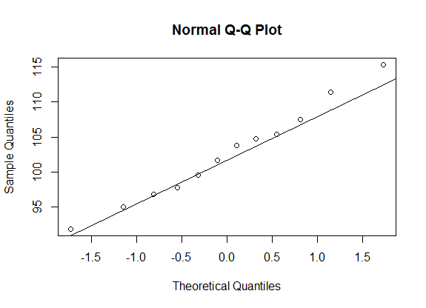

Shapiro-Wilk normality test

data: HomeRadonDetectData

W = 0.9841, p-value = 0.9951

The QQplot appears to be a straight line. From the Shapiro-Wilk Normality test, we see that p-value is larger than α (0.9951>0.05). So from this we can say that null hypothesis H0 = data is normally distributed cannot be rejected.   
  
From the QQplot and Shapiro-Wilk test, the data appears to be normally distributed.

2)B)

Sample mean $\overline{y}$ = 102.5833

Sample Standard Deviation s = 6.846344

Sample size n = 12 , α = 0.05 (95% confidence level)

t-table value tα/2 , n-1= t0.025,11 = 2.201

95% confidence interval for population mean $µ=(\overline{y}± \frac{s}{\sqrt{n}}$ t0.025,11 ) = 102.5833 ±(2.201)($\frac{6.846344}{\sqrt{12}}$) = 102.5833 ± 4.3499 = (98.2334 , 106.9332)

C)

H0 :

HA :

Sample size n = 12, α = 0.05 (95% confidence level)

This is a two-tailed distribution. For α=0.05 and two-tailed distribution, t-table value is tα/2 , n-1= t0.025,11= 2.201.

Now, Test statistics (TS) t = $\frac{\overline{y}- 105}{\frac{s}{\sqrt{n}}}$ = $\frac{102.5833- 105}{\frac{6.846344}{\sqrt{12}}}=-1.223$

Corresponding P-value = 0.247

Rejection Region: We can reject null hypothesis H0 if p-value < α.

Now, 0.247 > α = 0.05, which means the null hypothesis H0 **cannot be rejected**.

Conclusion: Based on the given data, there is not enough evidence to suggest with 95% confidence level that the true population mean oxygen level is not 105.

3)A)   
H0 :

HA :

Sample size n = 300, Sample mean $\overline{y}$ = 14.6, Standard Deviation s = 3.8.

t-table value , tα , n-1 = t0.01 , 299 =2.339

Rejection region: Reject H0 if test statistic t > tα , n-1,

Test statistic t = $=\frac{\overline{y}- 14}{\frac{s}{\sqrt{n}}}$ = $\frac{14.6- 14}{\frac{3.8}{\sqrt{300}}}=2.735$

As 2.735 > 2.339, H0 can be rejected.

Conclusion: Tobacco company’s claim of ciggerate nicotine content population mean is 14 mg is not supported by significant evidence and can be rejected with 99% confidence. The agency should take action.

4)A)  
Conjectured population standard deviation σ = 2.9

α = 0.05 (95% confidence level)

ME <= 2

Sample size = 11

B)

Conjectured population standard deviation σ = 2.9

α = 0.05 (95% confidence level)

ME <= 1

Sample size = 35

**APPENDIX:**

R code for Ex. 4:

n <- seq(5,50,1)

sd <- 2.9

alpha <- 0.05

ME <- qt(1 - alpha/2 , n-1)*sd/sqrt(n)

ME

out <- data.frame(n,ME)

out

Result:

n ME

1 5 3.6008256

2 6 3.0433634

3 7 2.6820527

4 8 2.4244607

5 9 2.2291373

6 10 2.0745350

7 11 1.9482465

8 12 1.8425721

9 13 1.7524525

10 14 1.6744101

11 15 1.6059665

12 16 1.5453009

13 17 1.4910424

14 18 1.4421361

15 19 1.3977553

16 20 1.3572418

17 21 1.3200642

18 22 1.2857880

19 23 1.2540540

20 24 1.2245626

21 25 1.1970612

22 26 1.1713353

23 27 1.1472018

24 28 1.1245026

25 29 1.1031010

26 30 1.0828778

27 31 1.0637286

28 32 1.0455615

29 33 1.0282953

30 34 1.0118578

31 35 0.9961849

32 36 0.9812188

33 37 0.9669081

34 38 0.9532063

35 39 0.9400713

36 40 0.9274650

37 41 0.9153529

38 42 0.9037036

39 43 0.8924883

40 44 0.8816806

41 45 0.8712565

42 46 0.8611937

43 47 0.8514719

44 48 0.8420722

45 49 0.8329773

46 50 0.8241709