1. a) Although there are some deviations present in the distribution of data, most data points fall near the normal line in QQplot. Hence, **it can be assumed that the data is normally distributed.**

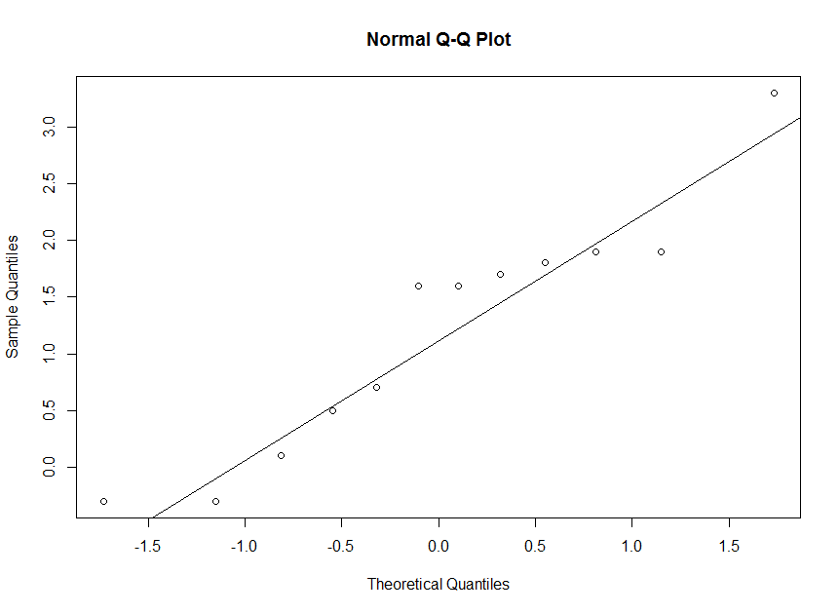

b) Hypothesis:

H0 : µD ≤ 0 ; where µD = µAfter - µBefore

HA : µD > 0

Test statistic, t = 3.885, df = 11, p-value = 0.001271

As p-value < α=0.05, null hypothesis can be rejected with 95% confidence. So, we can say with 95% confidence that ozone exposure increases lung capacity.

c) 95% confidence interval for the increase in lung capacity = (0.5237735, 1.8928932)

d) For H0 : µD ≤ 0 ; where µD = µAfter - µBefore

HA : µD > 0

p-value = 0.002441 < 0.05

As p-value < α=0.05, null hypothesis can be rejected with 95% confidence. So, we can say with 95% confidence that ozone exposure increases lung capacity.

2) s = 11.35, df = 99 , n = 100

A) 95% CI = (9.965,13.185)

B) H0 : σ <=10

HA : σ >10 ; Rejection Region: *X2 > X2α,n-1*

TS: *X2* = = 127.5343 ; *X2α,n-1* = 123.2252 ; *X2 > X2α,n-1*

So, H0 can be rejected. We can conclude with 95% confidence that true standard deviation of the speed of vehicle is not less than 10 miles per hour.

C) For the CI and the Test to be valid, normal distributional assumption is required.

D) CI from part A is a two-sided confidence interval, and part B is a one-sided test. As a result of which for part B CI, the CI will be $≥ \frac{s√(n-1)}{{√X}_{0.05,n-1}^{2}}$, or $σ≥ \frac{11.35*√99}{√123.2252 }$, or $σ≥10.17334$, which is larger than 10.

So for one sided CI, 10 is not included in the CI for the one-sided test. And that is why we reject H0 .

R Code:

|  |  |  |  |  |
| --- | --- | --- | --- | --- |
| |  | | --- | | > #Ans 1  > rats<-read.csv(file.choose())  > rats  X.Rat. X.Before. X.After.  1 1 8.7 9.4  2 2 7.9 9.8  3 3 8.3 9.9  4 4 8.4 10.3  5 5 9.2 8.9  6 6 9.1 8.8  7 7 8.2 9.8  8 8 8.1 8.2  9 9 8.9 9.4  10 10 8.2 9.9  11 11 8.9 12.2  12 12 7.5 9.3  > Diff_After_Before <-rats$X.After.-rats$X.Before.  > Diff_After_Before  [1] 0.7 1.9 1.6 1.9 -0.3 -0.3 1.6 0.1 0.5 1.7 3.3 1.8  > mean(Diff_After_Before)  [1] 1.208333  > sd(Diff_After_Before)  [1] 1.07742  >  >  > #A  > #Are the difference normally distributed?  > hist(Diff_After_Before)  > qqnorm(Diff_After_Before)  > qqline(Diff_After_Before)  > #NO, most data points are deviated from the straight line in the QQPlot  >  > #B  > t.test(Diff_After_Before,mu=0,alternative = "greater")  One Sample t-test  data: Diff_After_Before  t = 3.885, df = 11, p-value = 0.001271  alternative hypothesis: true mean is greater than 0  95 percent confidence interval:  0.6497695 Inf  sample estimates:  mean of x  1.208333  > #No, p value less than alpha  >  > #C Two sided CI  > t.test(Diff_After_Before,mu=0,alternative = "two.sided")  One Sample t-test  data: Diff_After_Before  t = 3.885, df = 11, p-value = 0.002541  alternative hypothesis: true mean is not equal to 0  95 percent confidence interval:  0.5237735 1.8928932  sample estimates:  mean of x  1.208333  >  >  > #D. Wilcoxon Paired test  > library(coin)  > wilcoxsign_test(X.After. ~ X.Before. , data = rats, distribution="exact", alternative = "greater")  Exact Wilcoxon-Pratt Signed-Rank Test  data: y by  x (pos, neg)  stratified by block  Z = 2.6692, p-value = 0.002441  alternative hypothesis: true mu is greater than 0  > #P value less than alpha | |  | | |  | | --- | | > | | |
|  |
|  |

|  |
| --- |
| > sigma0 <- 10  > df = 99  > s = 11.35  > Chi_Square <- df*s^2/sigma0^2  > qchisq(0.975,df=99,lower.tail = FALSE)  [1] 73.36108  > qchisq(0.025,df=99,lower.tail = FALSE)  [1] 128.422  >  > Lower <- sqrt((df*s^2)/(qchisq(0.025,df=99,lower.tail = FALSE)))  > Upper <- sqrt((df*s^2)/(qchisq(0.975,df=99, lower.tail = FALSE)))  > Lower  [1] 9.965378  > Upper  [1] 13.18501 |
|  |
| |  | | --- | | > | |