1.A)  
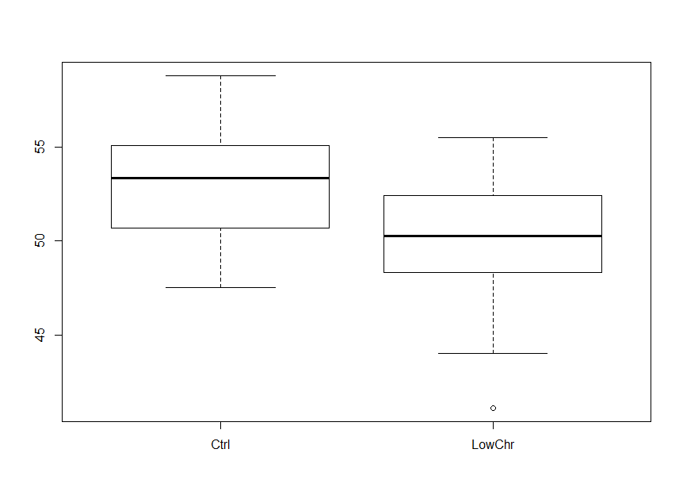

B) df1 = num df = dfcntrl = 9

df2 = denom df = dfLowChr = 13

H0: =

H1: =

Test Statistic, F = $\frac{s_{1}^{2}}{s_{2}^{2}}$ = 0.78978 ; Rejection Region, F>3.312032 or F<0.261056.

P-value = 0.7373 > α (=0.05), which means we fail to reject the null hypothesis that the true ratio of variances ($\frac{σ_{cntrl}}{σ_{LowChr}}$) is equal to 1 with 95% confidence.

C) Levene test P value = 0.6789 > α (=0.05), which means we fail to reject (with 95% confidence) the null hypothesis that the true ratio of variances ($\frac{σ_{cntrl}}{σ_{LowChr}}$) is equal to 1.

D) As we fail to reject that $\frac{σ_{cntrl}}{σ_{LowChr}}=1$, pooled variance t-test would be preferred.

E) H0:

H0:

Test statistic, t = 2.1709

p-value = 0.041 < α (=0.05), which means we can reject null hypothesis H0 with 95% confidence.

F)

|  |
| --- |
| Df Sum Sq Mean Sq F value Pr(>F)  Trt 1 66.25 66.25 4.713 0.041 *  Residuals 22 309.26 14.06  ---  Signif. codes: 0 ‘***’ 0.001 ‘**’ 0.01 ‘*’ 0.05 ‘.’ 0.1 ‘ ’ 1 |
|  |
| |  | | --- | |  | |

Comparing the results to E, we see that the p value of ANOVA test is 0.041 , which is the same as the p-value obtained from two-sample t-test. And F-value obtained from ANOVA is 4 =

2)A)

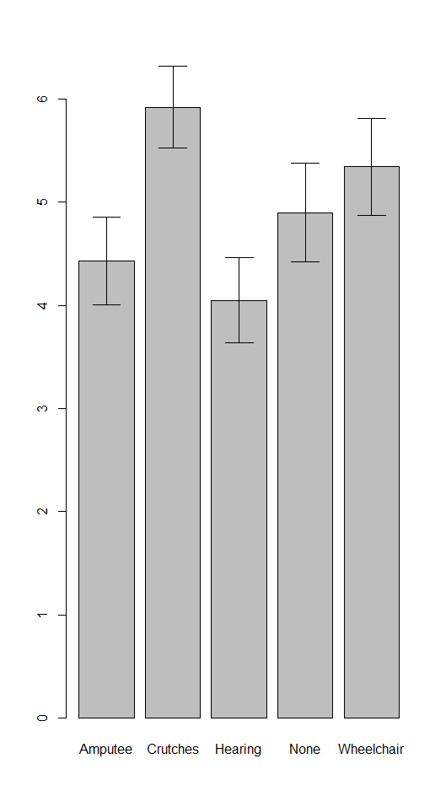

B) H0:

HA:

Test Statistic : F = 2.862

p-value = 0.0301 < α (=0.05) , which means we can reject (with 95% confidence) the null hypothesis that all Handicap Population mean scores are equal.

C)

Pairwise comparisons using t tests with pooled SD

data: case0601$Score and case0601$Handicap

Amputee Crutches Hearing None

Crutches 0.0184 - - -

Hearing 0.5418 0.0035 - -

None 0.4477 0.1028 0.1732 -

Wheelchair 0.1433 0.3520 0.0401 0.4756

P value adjustment method: none

D) LSD(0.05) = t0.05/2sw = (1.997)($\sqrt{2.666}$)*($\sqrt{\frac{2}{14}}$) = 1.232506

E)

Handicap

Hearing Amputee None Wheelchair Crutches

4.050 4.429 4.900 5.343 5.921

2) F)

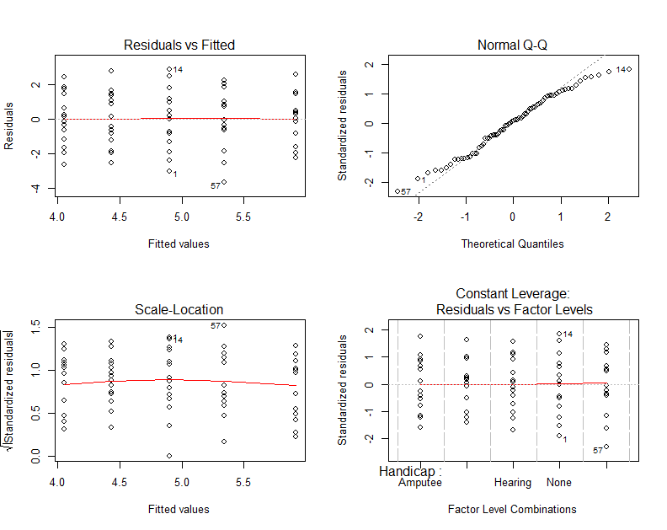

#APPENDIX:

|  |
| --- |
| > ratLiverData  Trt Enzyme  1 LowChr 44.0  2 LowChr 48.5  3 LowChr 50.7  4 LowChr 45.0  5 LowChr 53.0  6 LowChr 52.7  7 LowChr 51.8  8 LowChr 49.8  9 LowChr 48.3  10 LowChr 55.5  11 LowChr 52.4  12 LowChr 41.1  13 LowChr 51.1  14 LowChr 49.1  15 Ctrl 53.1  16 Ctrl 50.7  17 Ctrl 55.8  18 Ctrl 55.1  19 Ctrl 47.5  20 Ctrl 53.6  21 Ctrl 47.8  22 Ctrl 58.8  23 Ctrl 52.6  24 Ctrl 53.7  >  > #1A  > boxplot(Enzyme ~ Trt, data = ratLiverData)  >  > #1B  > var.test(Enzyme ~ Trt, data = ratLiverData)  F test to compare two variances  data: Enzyme by Trt  F = 0.78978, num df = 9, denom df = 13, p-value = 0.7373  alternative hypothesis: true ratio of variances is not equal to 1  95 percent confidence interval:  0.2384571 3.0253182  sample estimates:  ratio of variances  0.7897775  >  > fcritLower = qf(0.05/2,9,13)  > fcritUpper = qf(1-0.05/2,9,13)  > fcritLower  [1] 0.261056  > fcritUpper  [1] 3.312032  >  > #1C  > library(car)  > leveneTest(Enzyme ~ Trt, data = ratLiverData)  Levene's Test for Homogeneity of Variance (center = median)  Df F value Pr(>F)  group 1 0.176 0.6789  22  >  > #1E  > t.test(Enzyme ~ Trt, data = ratLiverData, var.equal = TRUE)  Two Sample t-test  data: Enzyme by Trt  t = 2.1709, df = 22, p-value = 0.041  alternative hypothesis: true difference in means is not equal to 0  95 percent confidence interval:  0.1505995 6.5894005  sample estimates:  mean in group Ctrl mean in group LowChr  52.87 49.50  >  > #1F  > AoV_Enzyme <- aov(Enzyme ~ Trt, data = ratLiverData)  > AoV_Enzyme  Call:  aov(formula = Enzyme ~ Trt, data = ratLiverData)  Terms:  Trt Residuals  Sum of Squares 66.24858 309.26100  Deg. of Freedom 1 22  Residual standard error: 3.749309  Estimated effects may be unbalanced  > summary(AoV_Enzyme)  Df Sum Sq Mean Sq F value Pr(>F)  Trt 1 66.25 66.25 4.713 0.041 *  Residuals 22 309.26 14.06  ---  Signif. codes: 0 ‘***’ 0.001 ‘**’ 0.01 ‘*’ 0.05 ‘.’ 0.1 ‘ ’ 1 |
|  |
| |  | | --- | | > | |