1)a.

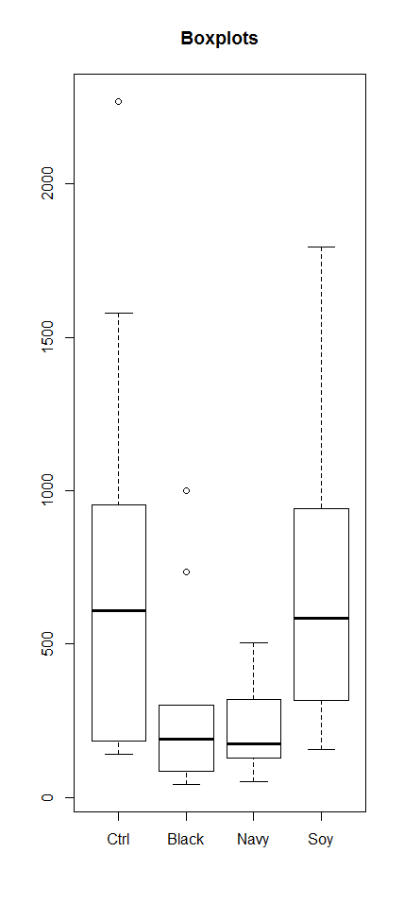

b)

|  |
| --- |
| Df Sum Sq Mean Sq F value Pr(>F)  Diet 3 2623607 874536 3.723 0.0198 *  Residuals 36 8457190 234922  ---  Signif. codes: 0 ‘***’ 0.001 ‘**’ 0.01 ‘*’ 0.05 ‘.’ 0.1 ‘ ’ 1 |
|  |
| |  | | --- | |  | |

c) Residual Vs. Fitted value plot looks like a megaphone. So assumption of equal variance does not hold. Also, Normal Q-Q plots for residuals show that there is significant deviation of data plots from normal line. So the assumption of normality does not hold.

d)

Levene's Test for Homogeneity of Variance (center = median)

Df F value Pr(>F)

group 3 2.8958 0.0484 *

36

---

Signif. codes: 0 ‘***’ 0.001 ‘**’ 0.01 ‘*’ 0.05 ‘.’ 0.1 ‘ ’ 1

P-Value = 0.0484 <α= 0.05 , so the assumption of equal variance does not hold.

e)

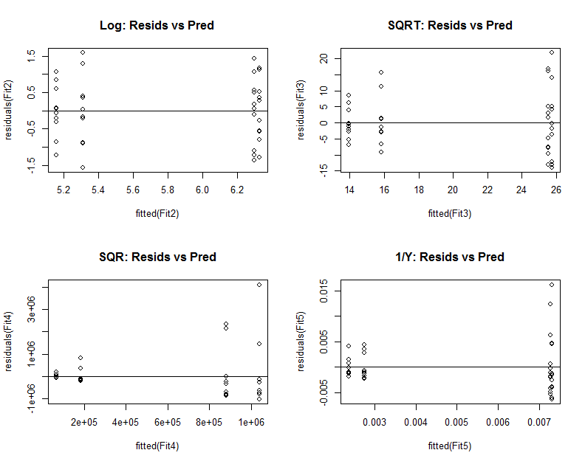

From the residual vs fitted plot of the transformed data – log transformation does not look like a megaphone shape. So I used log transformation.

f) One way anova results for the log transformed data:

Df Sum Sq Mean Sq F value Pr(>F)

Diet 3 11.80 3.934 5.137 **0.00464** **

Residuals 36 27.57 0.766

---

Signif. codes: 0 ‘***’ 0.001 ‘**’ 0.01 ‘*’ 0.05 ‘.’ 0.1 ‘ ’ 1

**p-value 0.00464** < α= 0.05, we can reject the null hypothesis that all means are equal with 95% confidence level.

g) Unadjusted p-values for pairwise comparisons of mean:

Pairwise comparisons using t tests with pooled SD

data: DiffDiets$logTrig and DiffDiets$Diet

Ctrl Black Navy

Black 0.0161 - -

Navy 0.0061 0.6981 -

Soy 0.9353 0.0132 0.0049

P value adjustment method: none

h)

Simultaneous Tests for General Linear Hypotheses

Multiple Comparisons of Means: Tukey Contrasts

Fit: aov(formula = logTrig ~ Diet, data = DiffDiets)

Linear Hypotheses:

Estimate Std. Error t value Pr(>|t|)

Black - Ctrl == 0 -0.98818 0.39133 -2.525 **0.0726** .

Navy - Ctrl == 0 -1.14118 0.39133 -2.916 **0.0297** *

Soy - Ctrl == 0 0.03198 0.39133 0.082 **0.9998**

Navy - Black == 0 -0.15300 0.39133 -0.391 **0.9794**

Soy - Black == 0 1.02016 0.39133 2.607 **0.0608** .

Soy - Navy == 0 1.17316 0.39133 2.998 **0.0243** *

---

Signif. codes: 0 ‘***’ 0.001 ‘**’ 0.01 ‘*’ 0.05 ‘.’ 0.1 ‘ ’ 1

(Adjusted p values reported -- single-step method)

i)

Tukey HSD value = 1.05415

j)  
Navy Black Ctrl Soy

5.156 5.309 6.297 6.329

K)

Dunnet Adjusted p-values are the following:

Simultaneous Tests for General Linear Hypotheses

Multiple Comparisons of Means: Dunnett Contrasts

Fit: aov(formula = logTrig ~ Diet, data = DiffDiets)

Linear Hypotheses:

Estimate Std. Error t value Pr(>|t|)

Black - Ctrl == 0 -0.98818 0.39133 -2.525 **0.0425** *

Navy - Ctrl == 0 -1.14118 0.39133 -2.916 **0.0165** *

Soy - Ctrl == 0 0.03198 0.39133 0.082 **0.9996**

---

Signif. codes: 0 ‘***’ 0.001 ‘**’ 0.01 ‘*’ 0.05 ‘.’ 0.1 ‘ ’ 1

(Adjusted p values reported -- single-step method)

L) null hypothesis: difference between the contrasts is 0.

1) Black Bean vs. Navy bean: Estimate = 0.153 , p-value = 0.69,

H0: µB - µN = 0

As p-value> α =0.05, H0 can not be rejected with 95% confidence.

2) H0: ( )- µC = 0

Mean of (Black and Navy beans) vs Control : Estimate = -1.0647, p-value = 0.003354 < α =0.05 , null hypothesis can be rejected with 95% confidence level.

3) H0: ( )- µS = 0

Mean of (Black and Navy beans) vs Soy bean: Estimate = -1.0967, p-value = 0.002602 < α =0.05 , null hypothesis can be rejected with 95% confidence level.

4) H0: ( )- ( )= 0

Mean of (Black and Navy beans) vs Mean of (Control and Soy bean): Estimate = -1.081, p-value = 0.000397 < α =0.05 , null hypothesis can be rejected with 95% confidence level.

**APPENDIX:**

|  |
| --- |
| > DiffDiets<- read.csv(file.choose())  > str(DiffDiets)  'data.frame': 40 obs. of 2 variables:  $ Diet: Factor w/ 4 levels "Black","Ctrl",..: 1 1 1 1 1 1 1 1 1 1 ...  $ Trig: num 165.7 83.2 998.2 42.6 172 ...  > DiffDiets  Diet Trig  1 Black 165.73  2 Black 83.24  3 Black 998.16  4 Black 42.62  5 Black 171.99  6 Black 734.01  7 Black 84.39  8 Black 208.76  9 Black 290.88  10 Black 298.90  11 Ctrl 139.95  12 Ctrl 953.96  13 Ctrl 648.98  14 Ctrl 486.39  15 Ctrl 2268.20  16 Ctrl 182.15  17 Ctrl 568.92  18 Ctrl 1578.87  19 Ctrl 159.43  20 Ctrl 890.76  21 Navy 182.16  22 Navy 73.52  23 Navy 126.44  24 Navy 187.91  25 Navy 406.58  26 Navy 142.34  27 Navy 503.59  28 Navy 163.19  29 Navy 50.91  30 Navy 318.96  31 Soy 316.56  32 Soy 1743.54  33 Soy 432.90  34 Soy 156.40  35 Soy 808.23  36 Soy 940.58  37 Soy 254.08  38 Soy 735.94  39 Soy 320.79  40 Soy 1794.59  > levels(DiffDiets$Diet)  [1] "Black" "Ctrl" "Navy" "Soy"  > DiffDiets$Diet <- factor(DiffDiets$Diet, levels(DiffDiets$Diet)[c(2,1,3,4)])  > levels(DiffDiets$Diet)  [1] "Ctrl" "Black" "Navy" "Soy"  > #1A  > par(mfrow=c(1,1))  > #Constructing the Boxplot  > boxplot(Trig~Diet,data=DiffDiets,main="Boxplots")  > library(plyr)  >  > #1B  > SumStats<-ddply(DiffDiets,c("Diet"),summarise,  + n = length(Trig),  + mean = mean(Trig),  + sd = sd(Trig),  + se = sd/sqrt(n) )  > SumStats  Diet n mean sd se  1 Ctrl 10 787.761 682.7220 215.89564  2 Black 10 307.868 312.2880 98.75414  3 Navy 10 215.560 147.3291 46.58954  4 Soy 10 750.361 595.2721 188.24155  > AovFit <- aov(Trig~Diet, data = DiffDiets)  > AovFit  Call:  aov(formula = Trig ~ Diet, data = DiffDiets)  Terms:  Diet Residuals  Sum of Squares 2623607 8457190  Deg. of Freedom 3 36  Residual standard error: 484.6875  Estimated effects may be unbalanced  > summary(AovFit)  Df Sum Sq Mean Sq F value Pr(>F)  Diet 3 2623607 874536 3.723 0.0198 *  Residuals 36 8457190 234922  ---  Signif. codes: 0 ‘***’ 0.001 ‘**’ 0.01 ‘*’ 0.05 ‘.’ 0.1 ‘ ’ 1  >  > #1C  > par(mfrow=c(2,2))  > plot(AovFit)  > #Megaphone Shape Found, Equal Variance not happening.  > shapiro.test(residuals(AovFit))  Shapiro-Wilk normality test  data: residuals(AovFit)  W = 0.88668, p-value = 0.000801  > #Shapiro-Wilks Test shows that probability of Null hypothesis of normal distribution of residuals are less than 0.05(alpha)  >  > #1D  > library(car)  > leveneTest(Trig~Diet, data = DiffDiets)  Levene's Test for Homogeneity of Variance (center = median)  Df F value Pr(>F)  group 3 2.8958 0.0484 *  36  ---  Signif. codes: 0 ‘***’ 0.001 ‘**’ 0.01 ‘*’ 0.05 ‘.’ 0.1 ‘ ’ 1  > #p value < 0.05 , the assumption of equal variance does not hold.  >  >  > #1E  > DiffDiets <- data.frame(DiffDiets, logTrig = log(DiffDiets$Trig))  > DiffDiets <- data.frame(DiffDiets, SqrtTrig = sqrt(DiffDiets$Trig))  > DiffDiets <- data.frame(DiffDiets, SqrTrig = (DiffDiets$Trig)*(DiffDiets$Trig))  > DiffDiets <- data.frame(DiffDiets, MinusOnePowTrig = 1/(DiffDiets$Trig))  >  > str(DiffDiets)  'data.frame': 40 obs. of 6 variables:  $ Diet : Factor w/ 4 levels "Ctrl","Black",..: 2 2 2 2 2 2 2 2 2 2 ...  $ Trig : num 165.7 83.2 998.2 42.6 172 ...  $ logTrig : num 5.11 4.42 6.91 3.75 5.15 ...  $ SqrtTrig : num 12.87 9.12 31.59 6.53 13.11 ...  $ SqrTrig : num 27466 6929 996323 1816 29581 ...  $ MinusOnePowTrig: num 0.00603 0.01201 0.001 0.02346 0.00581 ...  > DiffDiets  Diet Trig logTrig SqrtTrig SqrTrig MinusOnePowTrig  1 Black 165.73 5.110360 12.873616 27466.433 0.0060339106  2 Black 83.24 4.421728 9.123596 6928.898 0.0120134551  3 Black 998.16 6.905914 31.593670 996323.386 0.0010018434  4 Black 42.62 3.752324 6.528399 1816.464 0.0234631628  5 Black 171.99 5.147436 13.114496 29580.560 0.0058142915  6 Black 734.01 6.598523 27.092619 538770.680 0.0013623793  7 Black 84.39 4.435449 9.186403 7121.672 0.0118497452  8 Black 208.76 5.341185 14.448529 43580.738 0.0047901897  9 Black 290.88 5.672911 17.055204 84611.174 0.0034378438  10 Black 298.90 5.700109 17.288725 89341.210 0.0033456005  11 Ctrl 139.95 4.941285 11.830046 19586.002 0.0071454091  12 Ctrl 953.96 6.860622 30.886243 910039.682 0.0010482620  13 Ctrl 648.98 6.475402 25.475086 421175.040 0.0015408795  14 Ctrl 486.39 6.187011 22.054251 236575.232 0.0020559633  15 Ctrl 2268.20 7.726742 47.625623 5144731.240 0.0004408782  16 Ctrl 182.15 5.204831 13.496296 33178.623 0.0054899808  17 Ctrl 568.92 6.343740 23.852044 323669.966 0.0017577164  18 Ctrl 1578.87 7.364465 39.734997 2492830.477 0.0006333644  19 Ctrl 159.43 5.071605 12.626559 25417.925 0.0062723452  20 Ctrl 890.76 6.792075 29.845603 793453.378 0.0011226368  21 Navy 182.16 5.204885 13.496666 33182.266 0.0054896794  22 Navy 73.52 4.297557 8.574380 5405.190 0.0136017410  23 Navy 126.44 4.839768 11.244554 15987.074 0.0079088896  24 Navy 187.91 5.235963 13.708027 35310.168 0.0053216966  25 Navy 406.58 6.007781 20.163829 165307.296 0.0024595406  26 Navy 142.34 4.958219 11.930633 20260.676 0.0070254321  27 Navy 503.59 6.221762 22.440811 253602.888 0.0019857424  28 Navy 163.19 5.094915 12.774584 26630.976 0.0061278265  29 Navy 50.91 3.930059 7.135124 2591.828 0.0196425064  30 Navy 318.96 5.765066 17.859451 101735.482 0.0031351894  31 Soy 316.56 5.757513 17.792133 100210.234 0.0031589588  32 Soy 1743.54 7.463673 41.755718 3039931.732 0.0005735458  33 Soy 432.90 6.070507 20.806249 187402.410 0.0023100023  34 Soy 156.40 5.052417 12.505999 24460.960 0.0063938619  35 Soy 808.23 6.694847 28.429386 653235.733 0.0012372716  36 Soy 940.58 6.846497 30.668877 884690.736 0.0010631738  37 Soy 254.08 5.537649 15.939887 64556.646 0.0039357683  38 Soy 735.94 6.601149 27.128214 541607.684 0.0013588064  39 Soy 320.79 5.770787 17.910611 102906.224 0.0031173042  40 Soy 1794.59 7.492532 42.362601 3220553.268 0.0005572303  > par(mfrow=c(2,2))  > Fit2 <- aov(logTrig~Diet, data=DiffDiets)  > summary(Fit2)  Df Sum Sq Mean Sq F value Pr(>F)  Diet 3 11.80 3.934 5.137 0.00464 **  Residuals 36 27.57 0.766  ---  Signif. codes: 0 ‘***’ 0.001 ‘**’ 0.01 ‘*’ 0.05 ‘.’ 0.1 ‘ ’ 1  > #plot(residuals(AovFit)~fitted(AovFit),main="Original: Resids vs Pred");abline(h=0)  > plot(residuals(Fit2)~fitted(Fit2),main="Log: Resids vs Pred");abline(h=0)  >  > Fit3 <- aov(SqrtTrig~Diet, data=DiffDiets)  > summary(Fit3)  Df Sum Sq Mean Sq F value Pr(>F)  Diet 3 1175 391.6 4.663 0.00747 **  Residuals 36 3024 84.0  ---  Signif. codes: 0 ‘***’ 0.001 ‘**’ 0.01 ‘*’ 0.05 ‘.’ 0.1 ‘ ’ 1  > plot(residuals(Fit3)~fitted(Fit3),main="SQRT: Resids vs Pred");abline(h=0)  >  > Fit4 <- aov(SqrTrig~Diet, data=DiffDiets)  > summary(Fit4)  Df Sum Sq Mean Sq F value Pr(>F)  Diet 3 7.194e+12 2.398e+12 2.266 0.0974 .  Residuals 36 3.809e+13 1.058e+12  ---  Signif. codes: 0 ‘***’ 0.001 ‘**’ 0.01 ‘*’ 0.05 ‘.’ 0.1 ‘ ’ 1  > plot(residuals(Fit4)~fitted(Fit4),main="SQR: Resids vs Pred");abline(h=0)  >  > Fit5 <- aov(MinusOnePowTrig~Diet, data=DiffDiets)  > summary(Fit5)  Df Sum Sq Mean Sq F value Pr(>F)  Diet 3 0.0002244 7.482e-05 3.463 0.0261 *  Residuals 36 0.0007777 2.160e-05  ---  Signif. codes: 0 ‘***’ 0.001 ‘**’ 0.01 ‘*’ 0.05 ‘.’ 0.1 ‘ ’ 1  > plot(residuals(Fit5)~fitted(Fit5),main="1/Y: Resids vs Pred");abline(h=0)  >  > #From the graph, only log transformation does not look like a megaphone.  >  > #F  > Fit2  Call:  aov(formula = logTrig ~ Diet, data = DiffDiets)  Terms:  Diet Residuals  Sum of Squares 11.80066 27.56524  Deg. of Freedom 3 36  Residual standard error: 0.8750434  Estimated effects may be unbalanced  > summary(Fit2)  Df Sum Sq Mean Sq F value Pr(>F)  Diet 3 11.80 3.934 5.137 0.00464 **  Residuals 36 27.57 0.766  ---  Signif. codes: 0 ‘***’ 0.001 ‘**’ 0.01 ‘*’ 0.05 ‘.’ 0.1 ‘ ’ 1  > #G  > pairwise.t.test(DiffDiets$logTrig,DiffDiets$Diet,data=DiffDiets, p.adj="none")  Pairwise comparisons using t tests with pooled SD  data: DiffDiets$logTrig and DiffDiets$Diet  Ctrl Black Navy  Black 0.0161 - -  Navy 0.0061 0.6981 -  Soy 0.9353 0.0132 0.0049  P value adjustment method: none  > #H  > library(multcomp)  > PairComps <- glht(Fit2, linfct= mcp(Diet = "Tukey"))  > PairComps  General Linear Hypotheses  Multiple Comparisons of Means: Tukey Contrasts  Linear Hypotheses:  Estimate  Black - Ctrl == 0 -0.98818  Navy - Ctrl == 0 -1.14118  Soy - Ctrl == 0 0.03198  Navy - Black == 0 -0.15300  Soy - Black == 0 1.02016  Soy - Navy == 0 1.17316  > summary(PairComps)  Simultaneous Tests for General Linear Hypotheses  Multiple Comparisons of Means: Tukey Contrasts  Fit: aov(formula = logTrig ~ Diet, data = DiffDiets)  Linear Hypotheses:  Estimate Std. Error t value Pr(>|t|)  Black - Ctrl == 0 -0.98818 0.39133 -2.525 0.0730 .  Navy - Ctrl == 0 -1.14118 0.39133 -2.916 0.0295 *  Soy - Ctrl == 0 0.03198 0.39133 0.082 0.9998  Navy - Black == 0 -0.15300 0.39133 -0.391 0.9794  Soy - Black == 0 1.02016 0.39133 2.607 0.0611 .  Soy - Navy == 0 1.17316 0.39133 2.998 0.0244 *  ---  Signif. codes: 0 ‘***’ 0.001 ‘**’ 0.01 ‘*’ 0.05 ‘.’ 0.1 ‘ ’ 1  (Adjusted p values reported -- single-step method)  >  > #I  > Fit2  Call:  aov(formula = logTrig ~ Diet, data = DiffDiets)  Terms:  Diet Residuals  Sum of Squares 11.80066 27.56524  Deg. of Freedom 3 36  Residual standard error: 0.8750434  Estimated effects may be unbalanced  > summary(Fit2)  Df Sum Sq Mean Sq F value Pr(>F)  Diet 3 11.80 3.934 5.137 0.00464 **  Residuals 36 27.57 0.766  ---  Signif. codes: 0 ‘***’ 0.001 ‘**’ 0.01 ‘*’ 0.05 ‘.’ 0.1 ‘ ’ 1  > #Observations per treatment group = 10  > #SW = sqrt(MSResid), so SW^2 = MSResid  > HSD<- qtukey(1-0.05,4,36)*sqrt((0.766)/10)  > HSD  [1] 1.05415  >  > #J  > cld(PairComps)  Ctrl Black Navy Soy  "b" "ab" "a" "b"  > model.tables(Fit2,type="means", se=T)  Tables of means  Grand mean    5.772431  Diet  Diet  Ctrl Black Navy Soy  6.297 5.309 5.156 6.329  Standard errors for differences of means  Diet  0.3913  replic. 10  > Navy_Mean <-5.156  > Black_Mean <- 5.309  > Ctrl_Mean <- 6.297  > Soy_Mean <- 6.329  > Navy_Range <- Navy_Mean+HSD  > Navy_Range  [1] 6.21015  > Black_Range <- Black_Mean+HSD  > Black_Range  [1] 6.36315  >  > #I  > DunnetComparisons <- glht(Fit2, linfct = mcp(Diet = "Dunnett"))  > DunnetComparisons  General Linear Hypotheses  Multiple Comparisons of Means: Dunnett Contrasts  Linear Hypotheses:  Estimate  Black - Ctrl == 0 -0.98818  Navy - Ctrl == 0 -1.14118  Soy - Ctrl == 0 0.03198  > summary(DunnetComparisons)  Simultaneous Tests for General Linear Hypotheses  Multiple Comparisons of Means: Dunnett Contrasts  Fit: aov(formula = logTrig ~ Diet, data = DiffDiets)  Linear Hypotheses:  Estimate Std. Error t value Pr(>|t|)  Black - Ctrl == 0 -0.98818 0.39133 -2.525 0.0422 *  Navy - Ctrl == 0 -1.14118 0.39133 -2.916 0.0163 *  Soy - Ctrl == 0 0.03198 0.39133 0.082 0.9996  ---  Signif. codes: 0 ‘***’ 0.001 ‘**’ 0.01 ‘*’ 0.05 ‘.’ 0.1 ‘ ’ 1  (Adjusted p values reported -- single-step method)  > confint(DunnetComparisons)  Simultaneous Confidence Intervals  Multiple Comparisons of Means: Dunnett Contrasts  Fit: aov(formula = logTrig ~ Diet, data = DiffDiets)  Quantile = 2.4516  95% family-wise confidence level    Linear Hypotheses:  Estimate lwr upr  Black - Ctrl == 0 -0.98818 -1.94758 -0.02878  Navy - Ctrl == 0 -1.14118 -2.10058 -0.18178  Soy - Ctrl == 0 0.03198 -0.92742 0.99138  >  > #J  > contfit <-lm(logTrig~Diet-1,data=DiffDiets)  > contfit  Call:  lm(formula = logTrig ~ Diet - 1, data = DiffDiets)  Coefficients:  DietCtrl DietBlack DietNavy DietSoy  6.297 5.309 5.156 6.329  > BvN <- c(0,1,-1,0)  > BNvC <- c(-1,0.5,0.5,0)  > BNvS <- c(0,0.5,0.5,-1)  > BNvCS <- c(-0.5,0.5,0.5,-0.5)  >  > Cmat <-t(cbind(BvN,BNvC,BNvS,BNvCS))  > Cmat  [,1] [,2] [,3] [,4]  BvN 0.0 1.0 -1.0 0.0  BNvC -1.0 0.5 0.5 0.0  BNvS 0.0 0.5 0.5 -1.0  BNvCS -0.5 0.5 0.5 -0.5  > colnames(Cmat) <- c("A","B","C","D")  > Cmat  A B C D  BvN 0.0 1.0 -1.0 0.0  BNvC -1.0 0.5 0.5 0.0  BNvS 0.0 0.5 0.5 -1.0  BNvCS -0.5 0.5 0.5 -0.5  > contrast_Results <- glht(contfit, linfct=Cmat)  > contrast_Results #Gives The Estimate of the contrasts  General Linear Hypotheses  Linear Hypotheses:  Estimate  BvN == 0 0.153  BNvC == 0 -1.065  BNvS == 0 -1.097  BNvCS == 0 -1.081  > summary(contrast_Results,test=adjusted(type="none"))  Simultaneous Tests for General Linear Hypotheses  Fit: lm(formula = logTrig ~ Diet - 1, data = DiffDiets)  Linear Hypotheses:  Estimate Std. Error t value Pr(>|t|)  BvN == 0 0.1530 0.3913 0.391 0.698129  BNvC == 0 -1.0647 0.3389 -3.142 0.003354 **  BNvS == 0 -1.0967 0.3389 -3.236 0.002602 **  BNvCS == 0 -1.0807 0.2767 -3.905 0.000397 ***  ---  Signif. codes: 0 ‘***’ 0.001 ‘**’ 0.01 ‘*’ 0.05 ‘.’ 0.1 ‘ ’ 1  (Adjusted p values reported -- none method) |
|  |
|  |