OroraTech Data Analyst / Statistician Tech Challenge, May 2022 🔥

Description:
Africa is known for the wildfires and therefore to analyse this topic, I felt Africa is an apt example. Although the selected region is a medium wildfire zone but I was able to draw few insights which fulfil my hypothesis. The region selected is a small area of Madagascar country.
The selected region for analysis was referred on NASA Firms and the region specifications were drawn which are summed as below:

Latitude (degrees north) | -20.875° to -22.125°
Longitude (degrees east) | 45.125° to 47.125°

For the month of March 2018:
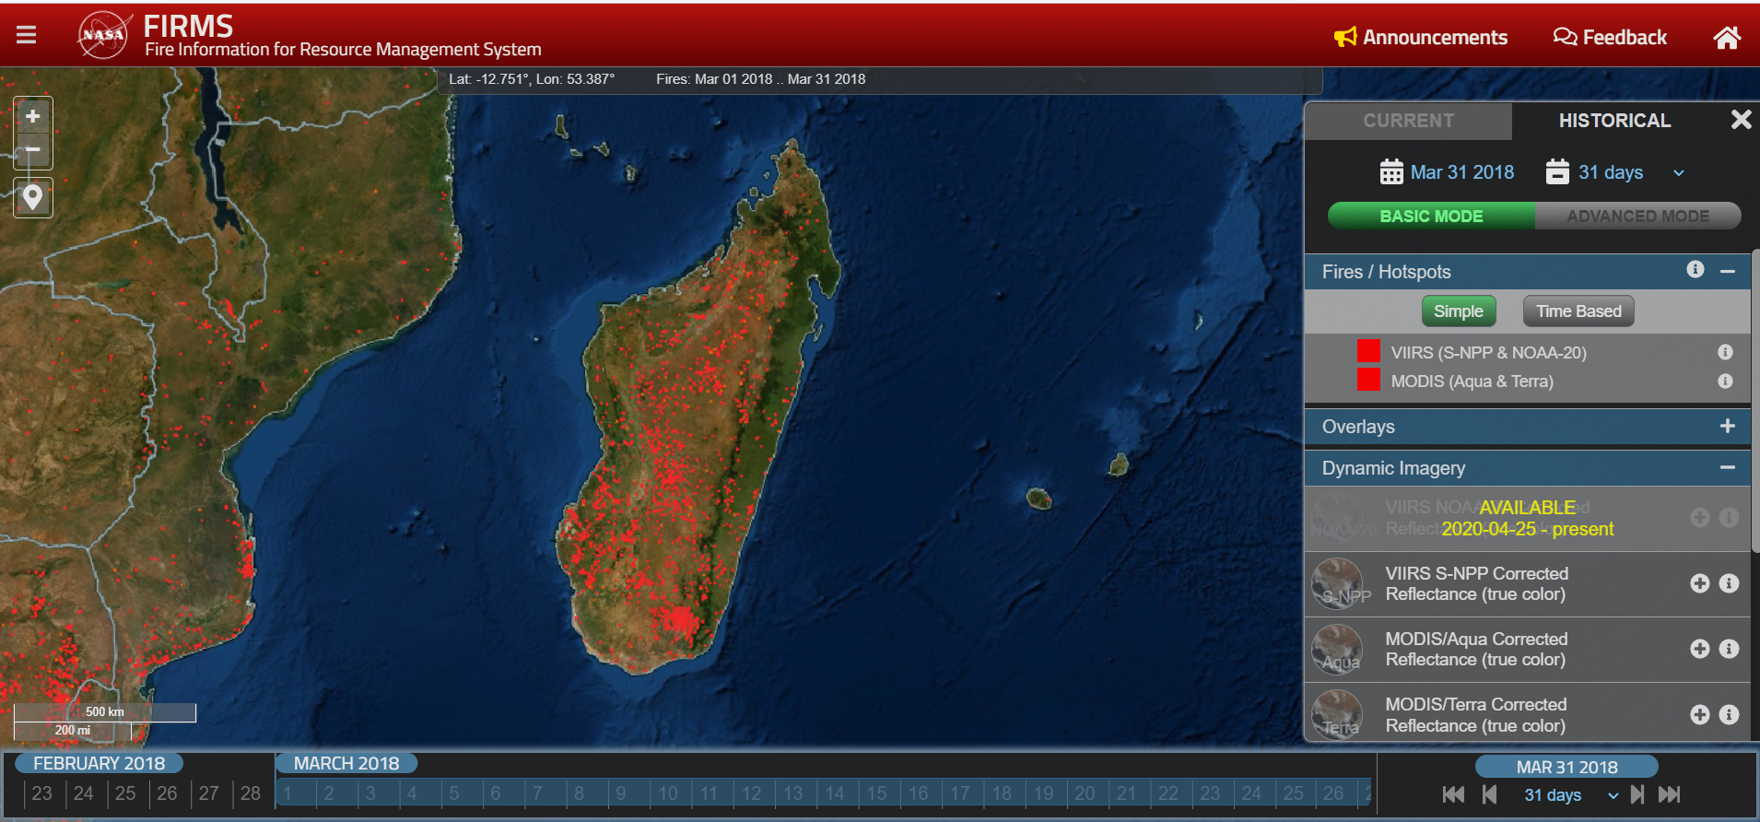
For the month of August 2018:
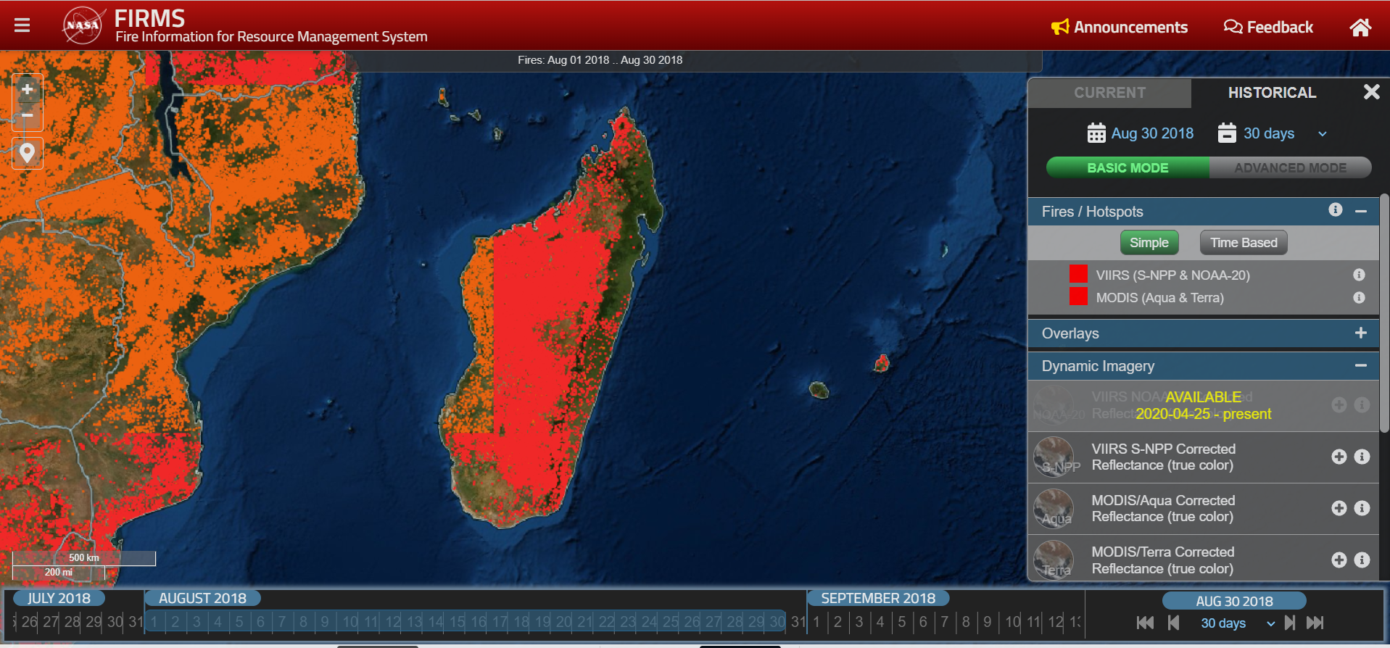

For the month of August 2019:

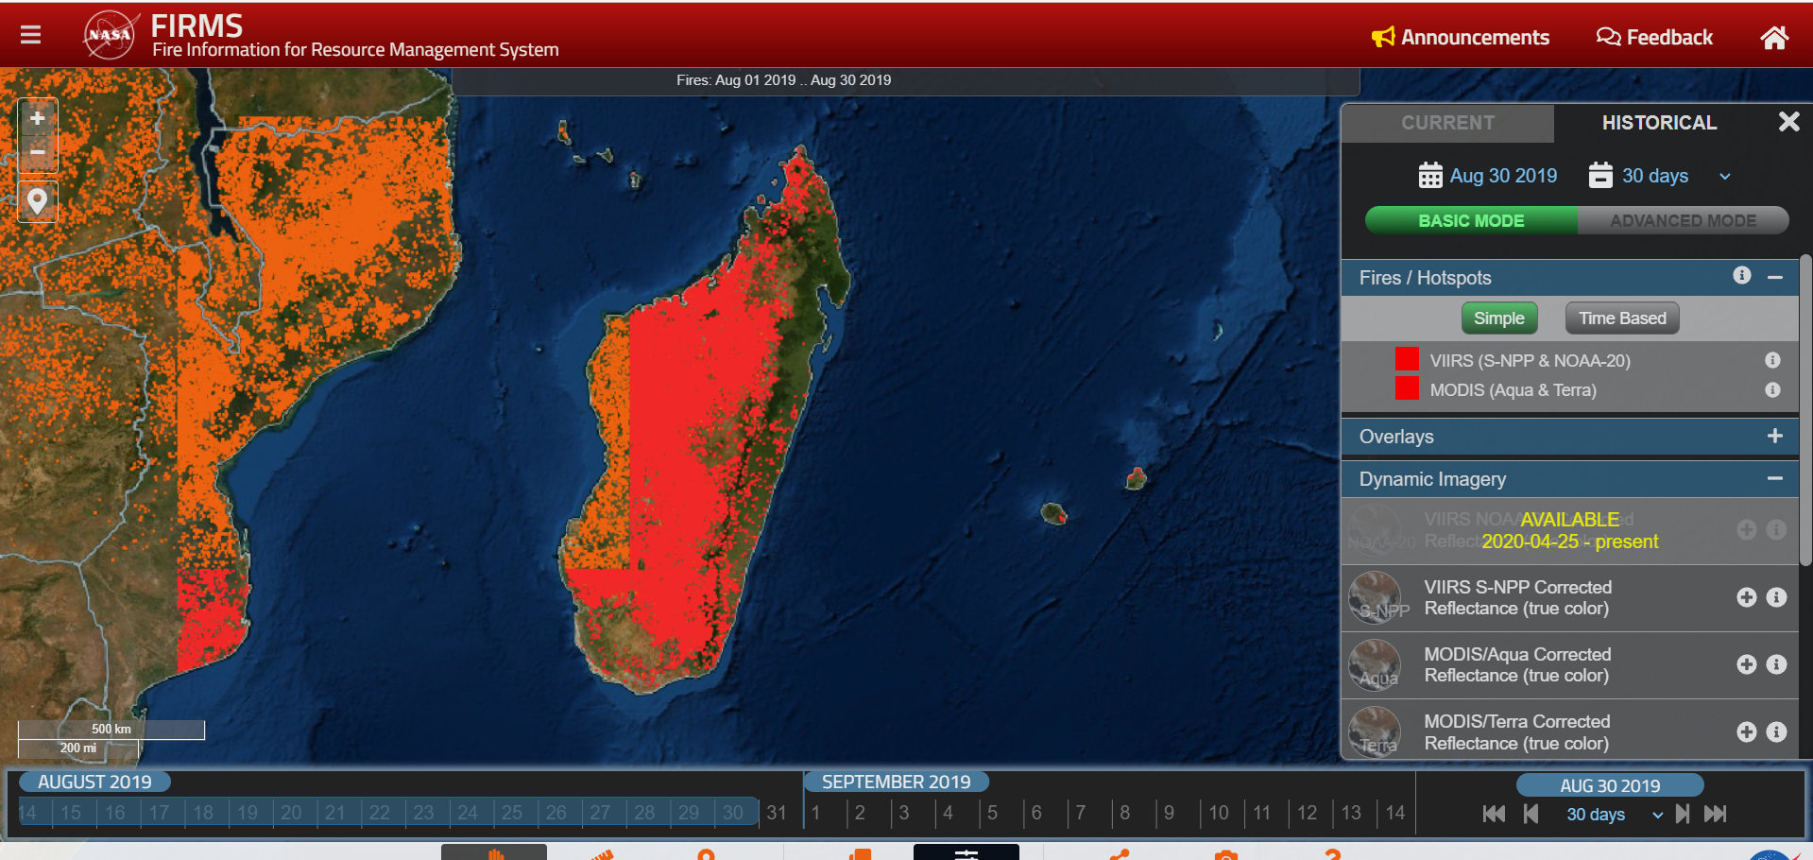

Input Data:
As per the task, the input data is downloaded from MODIS burned area datasets. The input data details are as below:
Origin | ESA-CCI (European Space Agency Climate Change Initiative)
Sensor | MODIS (Moderate Resolution Imaging Spectroradiometer)
Variable | Grid variables
Version | 5.1.1cds
Year | 2018, 2019
Month | March, August for both years
**No additional Input data was taken up for analysis as the file size was around 2 GB for land cover which was taking a lot of processing time.

Data Exploration:
To explore and understand netcdf data I used the Panoply NetCDF viewer.

Panoply region plot for month March 2018
The highlighted coordinates are the coordinates of the region taken into consideration

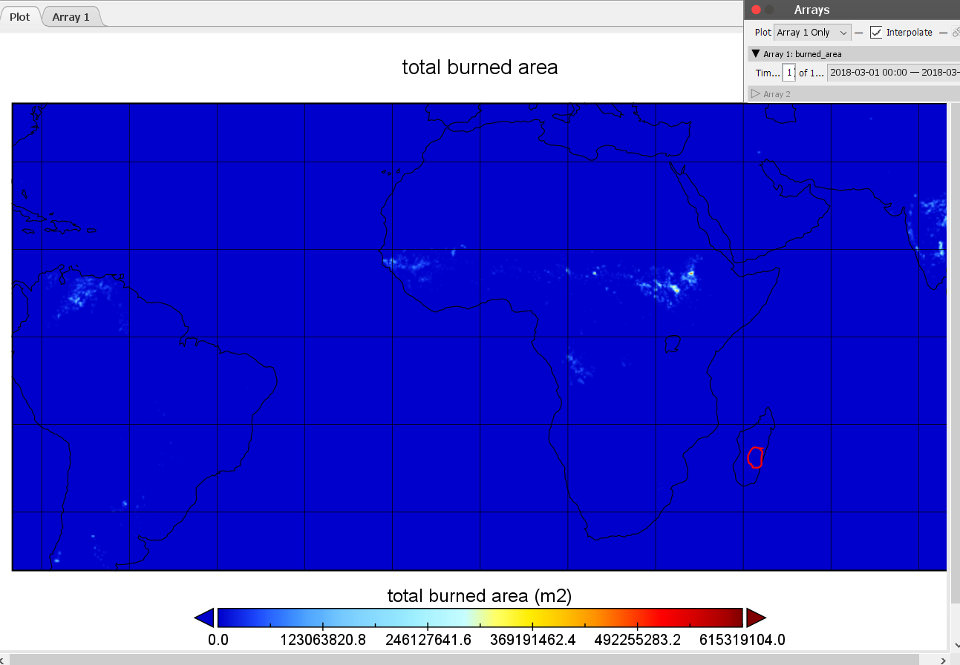
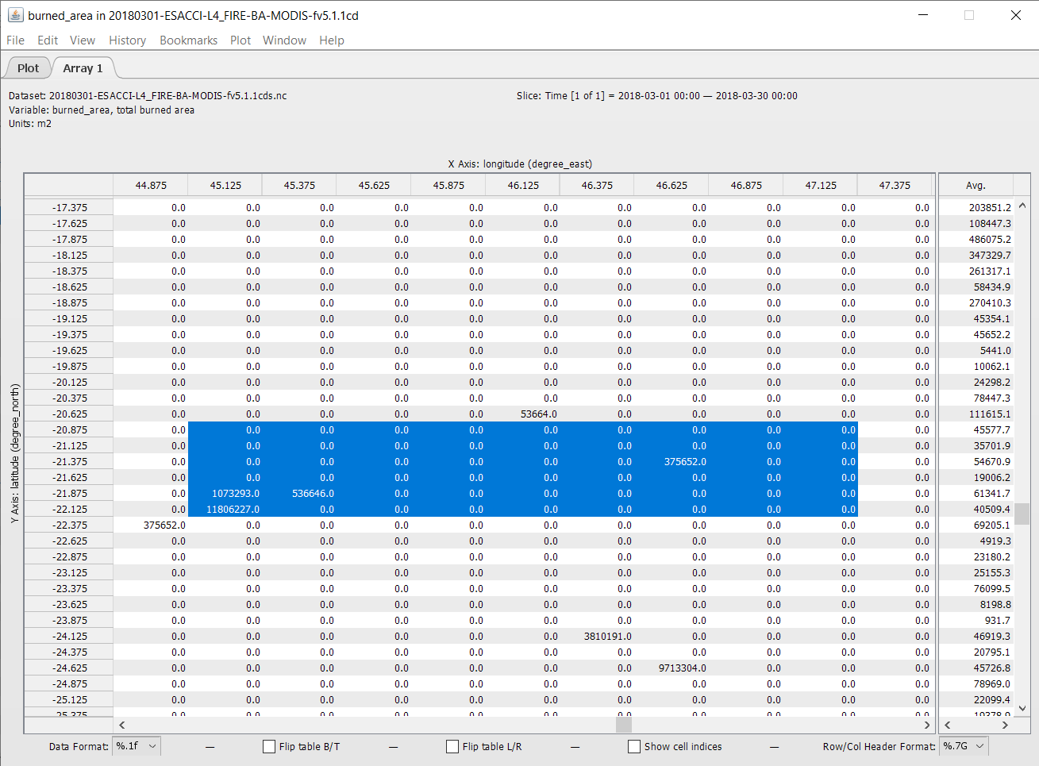

Panoply region plot for month August 2018
The highlighted coordinates are the coordinates of the region taken into consideration

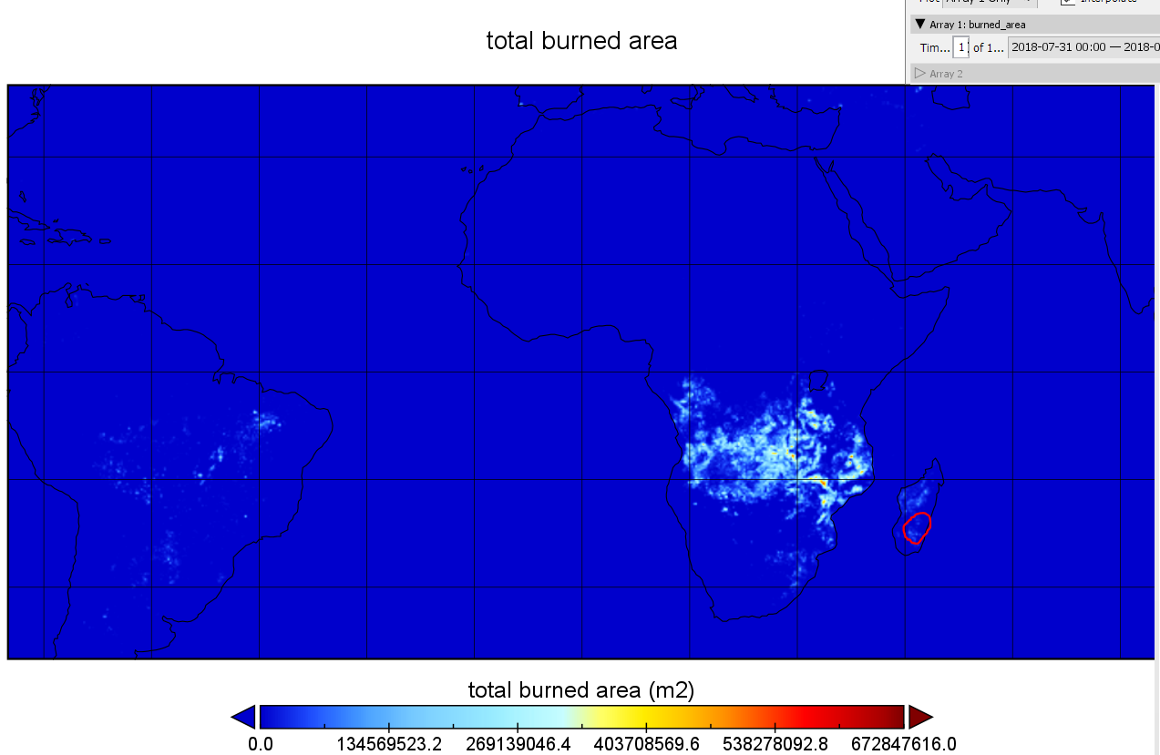

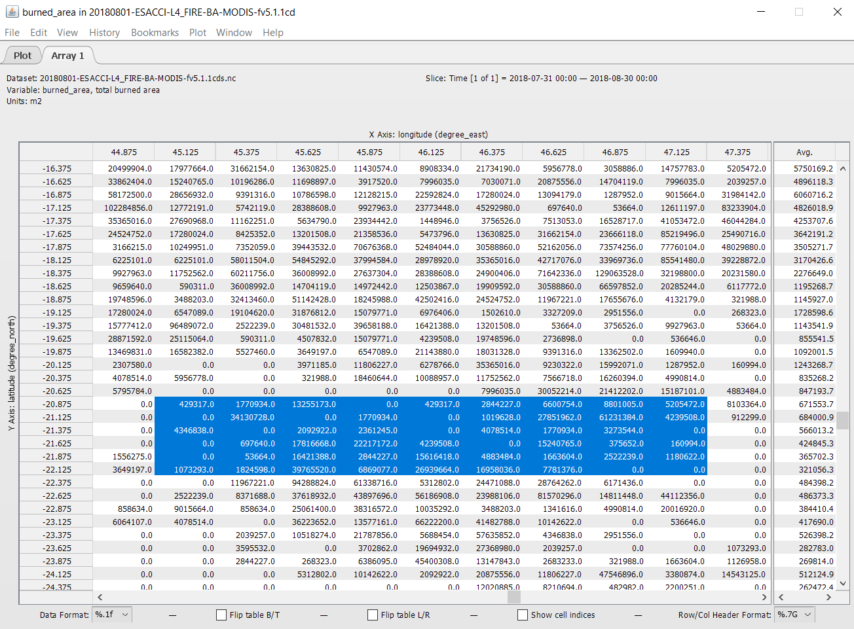

Hypotheses:
Below is the hypotheses to test based on the data.
- The wildfires are more evidently common in summers than in winters.
For this considering data for year 2018. For contrast August and March months are taken into inspection.
- The burned area comparison for both months
- Top 3 location points with highest Standard error in the region
- Number of patches of burned area comparison
- Distribution of fraction of burnable vegetated land area and observable area across the region

- The data replicates its behaviour analysed above in consecutive years.
For this considering data for year 2018 and 2019. For contrast August and March months are taken for each year into inspection

