Design Document

Owner: Mojgan Ghanbaran
Component Name: SchedulerWidget

Overview:
Scheduler widget provides the user interface equivalent of the command line scheduler of the DDRs for the purpose of scheduling automated tasks.

For 4.6, we will support two types of scheduling:

1) Scheduling for “filesys clean” operation. The “filesys clean” command supports the following format:

filesys clean set schedule {daily | monthly | day-name | never} {1,2,….,31 for monthly or mon,tue,…, fri or mon-wed for day-name} {time in military format for all options except “never”}

Example: filesys clean set schedule monthly 1,3 1300

The default filesys clean operation is set to Tuesday at 6:00 a.m.

2) Scheduling for “replication throttle” operation. The “replication throttle” command supports the following format:

replication throttle add {mon tue etc, | daily} {time in military format} {rate which can be: “unlimited” or “zero” which is the same as “disabled”/“disable” or in <none>/bps/b, Kibps/Kib/Ki, Bps/B or KiBps/KiB}

Example: replication throttle add mon tue 1300 30KB

The default “replication throttle” setting is unlimited.

Requirements:
“filesys clean” requirements:
- Provide the ability to modify default factory schedule setting.
- Provide the ability to reset the modified schedule to factory default setting.
- Scheduler should only allow the setting and resetting of the default schedule. There will not be multiple schedules associated with the “filesys clean” operation.
- Scheduler should allow scheduling:
1) Daily at a certain time
2) On specific day(s) of the week at a certain time (mon, tue, etc)
3) Monthly on specific day(s) (i.e. 1,2,…..,31) at a certain time
4) Never

“replication throttle” scheduling requirements:
- Provide the ability to view all throttle schedules.
- Provide the ability to save multiple throttle schedules by name.
- Provide the ability to edit or delete a throttle schedule.
- Provide the ability to reset a schedule to factory default setting.
- Provide the ability to specify effective start and end time for a schedule to run.
- Scheduler should allow scheduling:
1) Daily at a certain time for a specific duration.
2) On specific day(s) of the week at a certain time (mon, tue, etc) for a specific duration

Technical Requirements:
- CLI will add the capability to accept a name for a schedule.
- UI will have to add multiple schedules for “replication throttle” scheduling to accommodate specifying start and end time for a schedule duration (i.e. 4 schedules for each schedule specified with a duration).

Use Cases
For common use cases for scheduling for future releases after 4.6 refer to: https://iweb.datadomain.com/eweb/sm/docs/cli/scheduling_fs.php

4.6 Wireframes:

“filesys clean”
Monday
Tuesday
Wednesday
Thursday
Friday
Saturday
Sunday
Day of month
Daily
1,2
Save
Cancel
At:
18:00
Reset

“replication throttle”
Reset
Schedule Name:
Schedule0
Schedule1
Schedule2
Actions: <add, remove >
Rate
Monday
Tuesday
Wednesday
Thursday
Friday
Saturday
Sunday
From to
08:00
16:00
20
KiB
Cancel
Save
Daily

Wireframe Future Releases:
Schedule Name:
Default
Schedule1
Schedule2
Actions: <add, remove, reset, edit>
Every during and
Every starting at
15
10:10 (optional)
Minutes
15
10:10
15:10
Hour

Actions: <add, remove>
11:58
13:00
At:
Monday
Tuesday
Wednesday
Thursday
Friday
Saturday
Sunday
Day of Month
1,2 or 1-3
Last day of Month
Daily

Mockup:

Look and feel of the following mock ups are not finalized.

Replication Throttle:
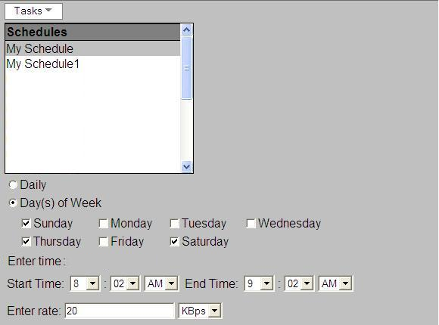

FileSys Clean:
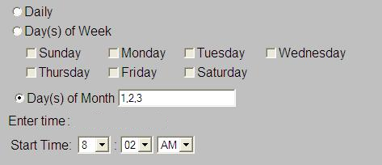

Module Design:
- Schedule & ScheduleImpl
Schedule interface represents a schedule object. It will contain methods that will allow setting and getting of schedule options. The mid-tier object providing scheduler functionality will have to create objects of subclass types of Schedule. The interface could be extended for subclasses of a schedule as needed (ex: ReplicationThrottleScheduler to add get/setRate).

- Abstract SchedulerPanel <Schedule> extends FlowPanel
Common base class for the scheduler UI. Its protected constructor will accept the schedule object.

- Abstract MultipleSchedulesSchedulerPanel extends SchedulerPanel
Common base class for tasks that can have multiple schedules. It displays schedules list and allows adding/removing schedules.

- FileSysCleanSchedulerPanel extends SchedulerPanel
Widget used to display scheduler settings for filesys clean.

- ReplicationThrottleSchedulerPanel extends MultipleSchedulesSchedulerPanel
Widget used to display scheduler settings for replication throttle.

Detailed Design:

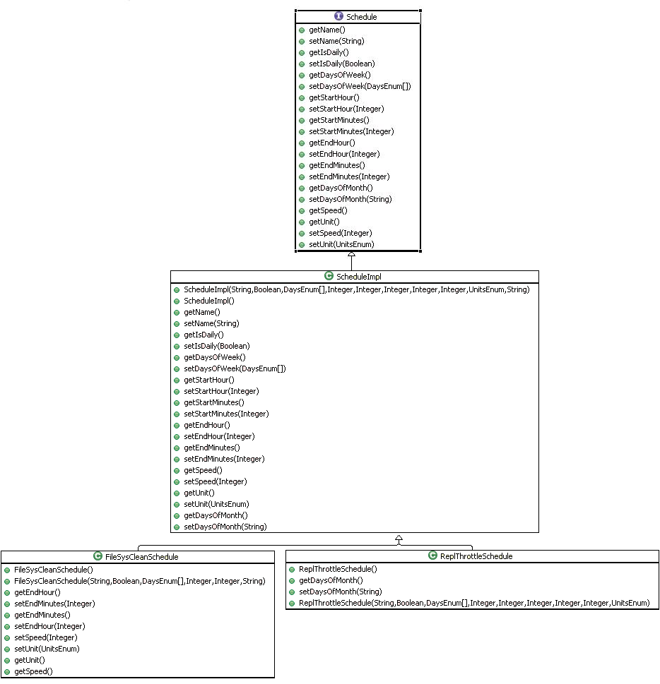

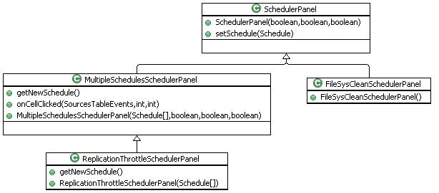

Revision History:
- Jan 24, 2008 Mojgan
Added Overview, requirements and Wireframe.

- Jan 28, 2008 Mojgan
Added module design.

- Feb 4, 2008 Mojgan
Added class diagrams and mockups.

