|  |  |
| --- | --- |
| NETWORK ID | PASSWORD |
| NedaLink | NedaLink99 |

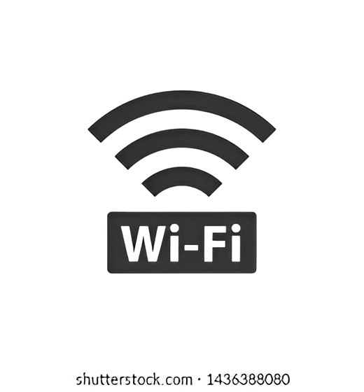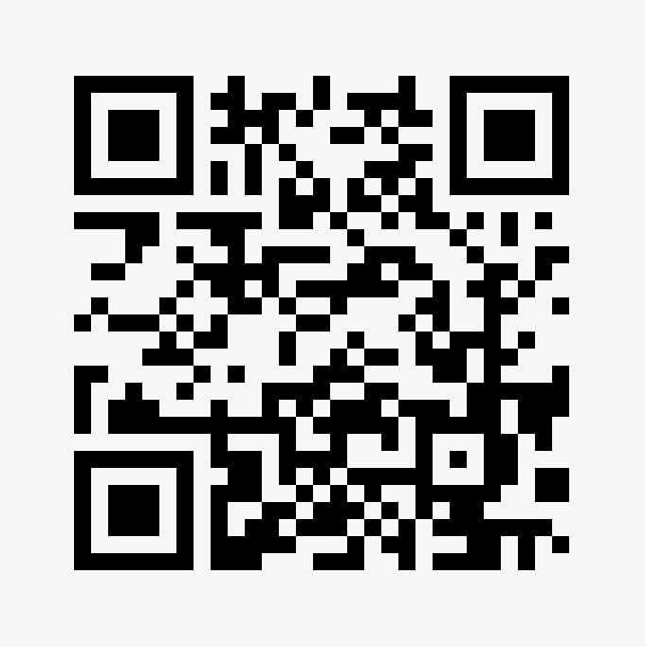

**SCAN TO CONNECT**