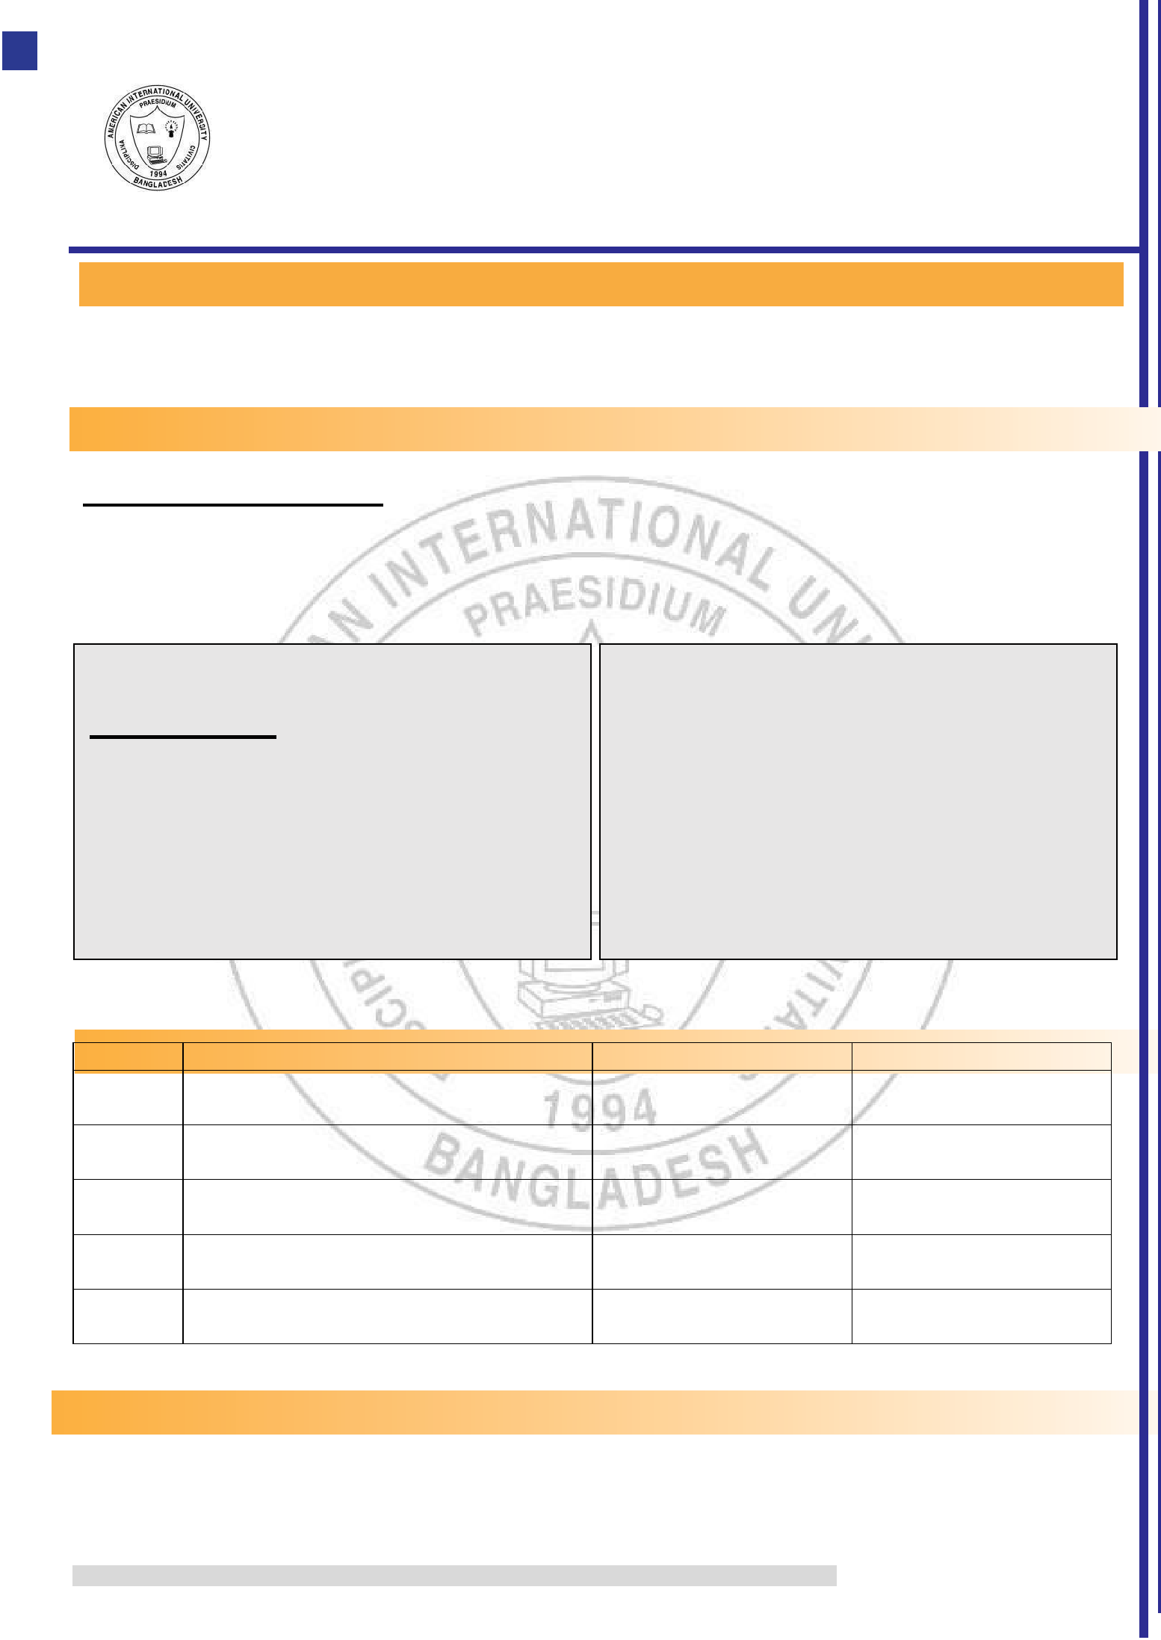
AMERICAN INTERNATIONAL UNIVERSITY-


BANGLADESH (AIUB)

Faculty of Engineering

Department of Electrical and Electronic Engineering


EXPERIMENT NO: 01 MID TERM

SEC: B



Engineering Shop Lab

EXPERIMENT TITLE: Cathode Ray Tube Technology and Appliances

Submitted to:
Semester: Summer 2021
Dr. Md. Kabiruzzaman

Date of Submission: 14-06-21



SUBMITTED BY: Sultana, Samima |  |  | GROUP NO:10
Serial no | Student’s Name | ID | Dept.
1 | Samima Sultana | 16-32012-2 | CSSE
2 | Kifaat Raskin | 17-35440-3 | CSE
3 | SK. Md .Kanijur Rahman Noor | 17-35444-3 | CSE
4 | Md.Tanjimul islam | 17-35381-2 | CSE
.


© Dept. of EEE & COE, FE, AMERICAN INTERNATIONAL UNIVERSITY-BANGLADESH (AIUB)

Experiment 1 Lab Manual


American International University- Bangladesh

Department of Electrical and Electronic Engineering

EEE3110: Engineering Shop Laboratory

Title: Cathode Ray Tube Technology and Appliances

Abstract:

The cathode ray tube (CRT) is a vacuum tube containing one or more electron guns (a source of electrons or electron emitter) and a fluorescent screen used to view images. It has a means to accelerate and deflect the electron beam(s) onto the screen to create the images. The images may

represent electrical waveforms (oscilloscope), pictures (television, computer monitor), radar targets or others. CRTs have also been used as memory devices, in which case the visible light emitted from the fluorescent material (if any) is not intended to have significant meaning to a visual observer.

Introduction:

The experimentation of cathode rays is largely accredited to J.J. Thomson, an English physicist who, in his three famous experiments, was able to deflect cathode rays, a fundamental function of the modern CRT. The earliest version of the CRT was invented by the German physicist Ferdinand Braun in 1897 and is also known as the Braun tube. It was a cold-cathode diode, a modification of the Crookes tube with a phosphor-coated screen. The first commercially made electronic television sets with cathode ray tubes were manufactured by Telefunken in Germany in 1934.

The CRT uses an evacuated glass envelope which is large, deep (i.e. long from front screen face to rear end), fairly heavy, and relatively fragile. As a matter of safety, the face is typically made of thick lead glass so as to be highly shatter-resistant and to block most X-ray emissions, particularly if the CRT is used in a consumer product.

CRTs have largely been superseded by newer display technologies such as LCD, plasma display, and OLED, which have lower manufacturing and distribution costs.

The vacuum level inside the tube is high vacuum on the order of 0.01 Pa to133 nPa.

In television sets and computer monitors, the entire front area of the tube is scanned repetitively and systematically in a fixed pattern called a raster. An image is produced by controlling the intensity of each of the three electron beams, one for each additive primary color (red, green, and blue) with a video signal as a reference. In all modern CRT monitors and televisions, the beams are bent by magnetic deflection, a varying magnetic field generated by coils and driven electronic circuits around the neck of the tube, although electrostatic deflection is commonly used in oscilloscopes, a type of diagnostic instrument.

Theory:

A cathode ray tube is a device of the form of a long-evacuated glass tube. A metal anode and a cathode are present in either ends of the glass tube. The anode and cathode are connected to the positive and negative sides of a battery respectively. When the key is pressed, the circuit is complete and current starts flowing. But the long gap between the cathode and anode prevent current to flow throughout the circuit. However, when the voltage of the current is increased, the electrons present in the cathode start getting emitted as fluorescent blue green colored cathode rays, and travel towards the anode. These rays are thus negatively charged as they are composed on negatively charged electrons. The discovery of these rays led to the discovery of electrons.

The electrons emitted by the cathode are accelerated by the use of anodes, because electrons are attracted toward anodes (which are positively charged) and thus get accelerated towards the anodes.

Electrical and magnetic fields are used to change the direction of the electron beam so that it does not strike the anode, but it goes towards the fluorescent screen.

The fluorescent screen glows when the electrons strike it. The fig. 1 is a labeled diagram of cathode ray tube.
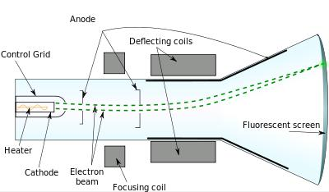

Fig. 1: Cathode Ray Tube Diagram

Experiment 1 Lab Manual

There are two types of CRT available depending on the deflection system. (i) The Electromagnetic deflection type; used in CRT TV, CRT monitor (ii) The Electrostatic deflection type used in Oscilloscope and other measurement and instrumentation equipment.

Oscilloscope and other measurement and instrumentation equipment.

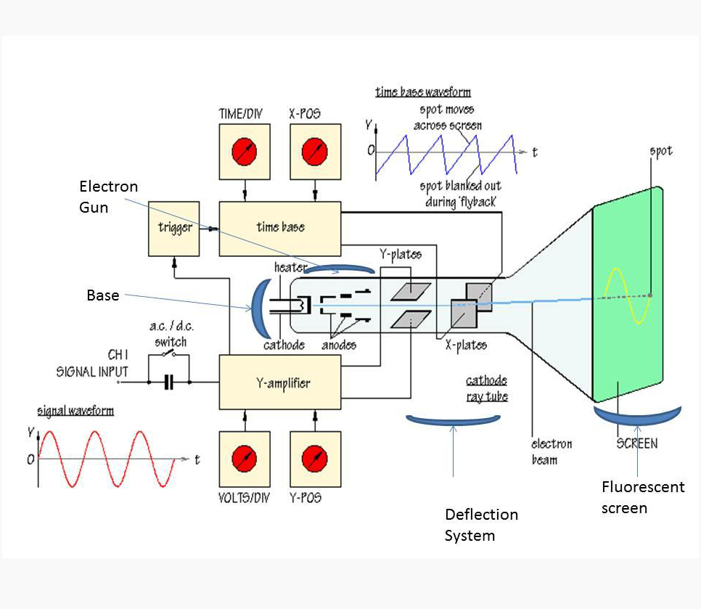
Oscilloscope and other measurement and instrumentation equipment.
Oscilloscope and other measurement and instrumentation equipment.

Advantages of CRT

- The contrast features of the cathode ray tube monitor are considered highly excellent
Fig. 2: Electrostatic deflection type CRT used in Oscilloscopes

- The cathode rayed tube can easily increase the monitor’s brightness by reflecting the light.

- They produce more colours

- The Cathode Ray Tube monitors have lower price rate than the LCD display or Plasma display.

- The quality of the image displayed on a Cathode Ray Tube is superior to the LCD and Plasma monitors.

- The contrast features of the cathode ray tube monitor are considered highly excellent

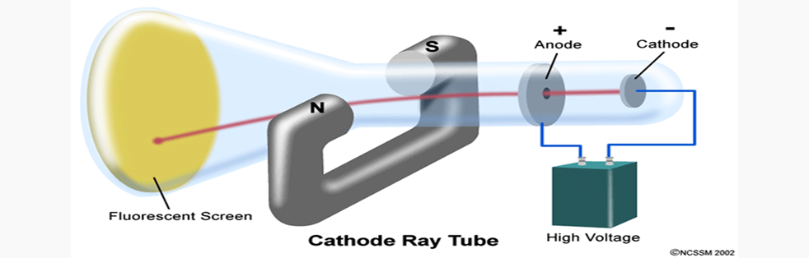

Fig. 3: Cathode Ray Tube Diagram

Disadvantages of CRT:

- They have a big back and take up space on desk.

- The electromagnetic fields emitted by CRT monitors constitute a health hazard to the functioning of living cells.

- CRTs emit a small amount of X-ray band radiation which can result in a health hazard.

- Constant refreshing of CRT monitors can result in headache.

- CRTs operate at very high voltage which can overheat system or result in an implosion

- Within a CRT a strong vacuum exists in it and can also result in a implosion

- They are heavy to pick up and carry around

Some Common Types of CRTs:
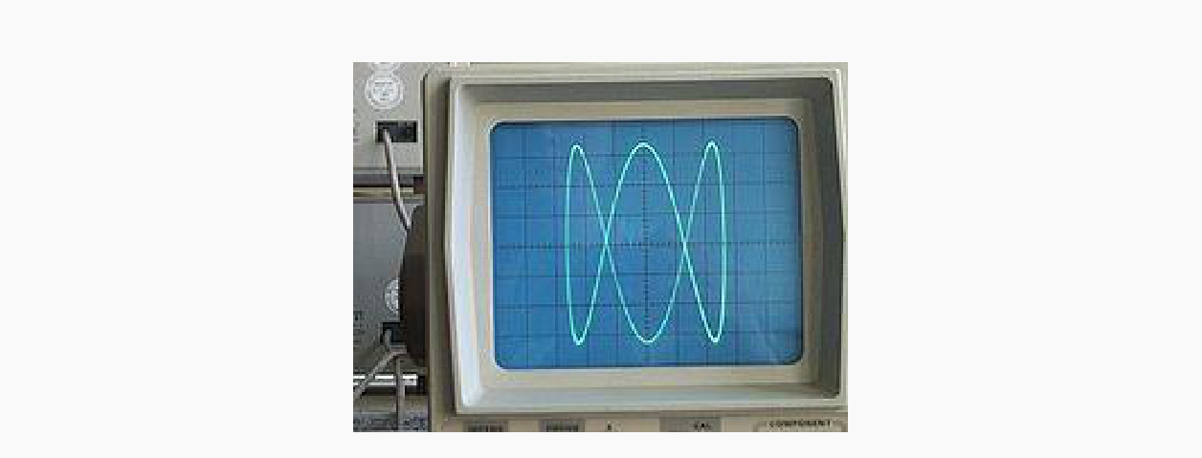

Oscilloscope CRTs

Experiment 1 Lab Manual

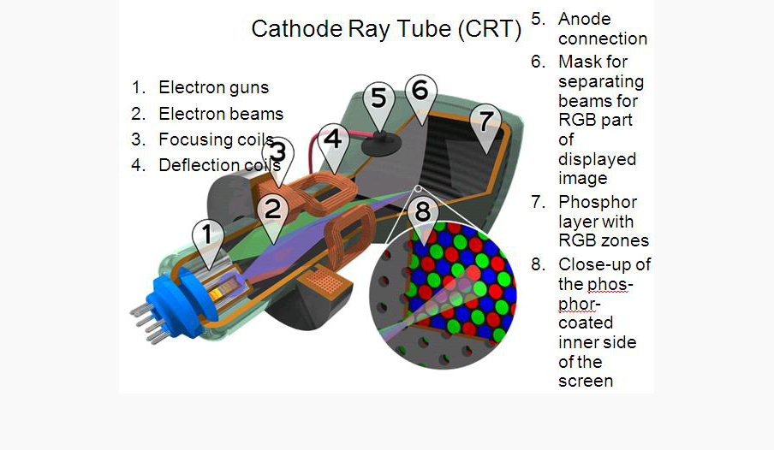

fFffiFig. 4: CRTs Architecture

In oscilloscope CRTs, electrostatic deflection is used, rather than the magnetic deflection commonly used with television and other large CRTs. The beam is deflected horizontally by applying an electric field between a pair of plates to its left and right, and vertically by applying an electric field to plates above and below. Oscilloscopes use electrostatic rather than magnetic deflection because the inductive reactance of the magnetic coils would limit the frequency response of the instrument.
Color CRTs:

Color CRTs:

Color tubes use three different phosphors which emit red, green, and blue light respectively. They are packed together in stripes (as in aperture grille designs) or clusters called "triads" (as in shadow mask CRTs). Color CRTs have three electron guns, one for each primary color, arranged either in a straight line or in an equilateral triangular configuration (the guns are usually constructed as a single unit). (The triangular configuration is often called "delta-gun", based on its relation to the shape of the Greek letter delta.) A grille or mask absorbs the electrons that would otherwise hit the wrong phosphor. A shadow mask tube uses a metal plate with tiny holes, placed so that the electron beam only illuminates the correct phosphors on the face of the tube; the holes are tapered so that the electrons that strike the inside of any hole will be reflected back, if they are not absorbed (e.g. due to local charge accumulation), instead of bouncing through the hole to strike a random (wrong) spot on the screen. Another type of color CRT uses an aperture grille of tensioned vertical wires to achieve the same result.

Experiment 1 Lab Manual


Fig. 5: Magnified view of a delta-gun shadow mask color CRT.

How Television Works:

Television is certainly one of the most influential forces of our time. Through the device called a television set or TV, you are able to receive news, sports, entertainment, information and commercials. The average American spends between two and five hours a day glued to "the tube"!

There are two amazing things about our brain that make television possible. By understanding these two facts, it is easy to gain a good bit of insight into why televisions are designed the way they are.

The first principle is this: If a still image is divided into a collection of small colored dots, the brain will reassemble the dots into a meaningful image. This is no small feat, as any researcher who has tried to program a computer to understand images will tell you.


Fig. 6: Pixels in a picture

Most people, sitting right up close to their computer screens, cannot tell what this is a picture of -

- the dots are too big for the brain to handle. If we stand 10 to 15 feet away from the monitor, however, the brain will be able to assemble the dots in the image and we will clearly see that it is the baby's face. By standing at a distance, the dots become small enough for the brain to integrate them into a recognizable image.

Both the televisions and computer screens (as well as newspaper and magazine photos) rely on this fusion-of-small-colored-dots capability in the human brain to chop pictures up into thousands of individual elements. On a TV or computer screen, the dots are called pixels. The resolution of our computer's screen might be 800x600 pixels, or maybe 1024x768 pixels.

Experiment 1 Lab Manual

The human brain's second amazing feature relating to television is this: If a moving scene is divided into a sequence of still pictures and show the still images in rapid succession, the brain will reassemble the still images into a single, moving scene.

The Cathode Ray Tube:

A few TVs in use today rely on a device known as the cathode ray tube, or CRT, to display their images. LCDs and plasma displays are other common technologies.
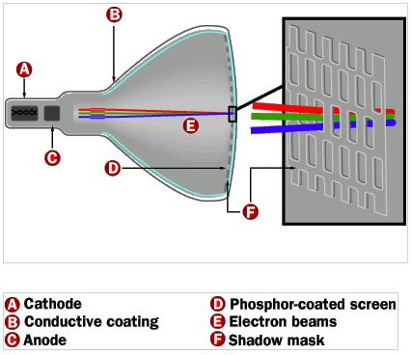

Fig. 7: CRT

The terms anode and cathode are used in electronics as synonyms for positive and negative terminals. In a cathode ray tube, the "cathode" is a heated filament (not unlike the filament in a normal light bulb). The heated filament is in a vacuum created inside a glass "tube." The "ray" is a stream of electrons that naturally pour off a heated cathode into the vacuum.

Electrons are negative. The anode is positive, so it attracts the electrons pouring off the cathode. In a TV's cathode ray tube, the stream of electrons is focused by a focusing anode into a tight beam and then accelerated by an accelerating anode. This tight, high-speed beam of electrons flies through the vacuum in the tube and hits the flat screen at the other end of the tube. This screen is coated with phosphor, which glows when struck by the beam.

There is a cathode and a pair (or more) of anodes. There is the phosphor-coated screen. There is a conductive coating inside the tube to soak up the electrons that pile up at the screen-end of the tube.

Experiment 1 Lab Manual

The following pictures give three different views of a typical set of steering coils:
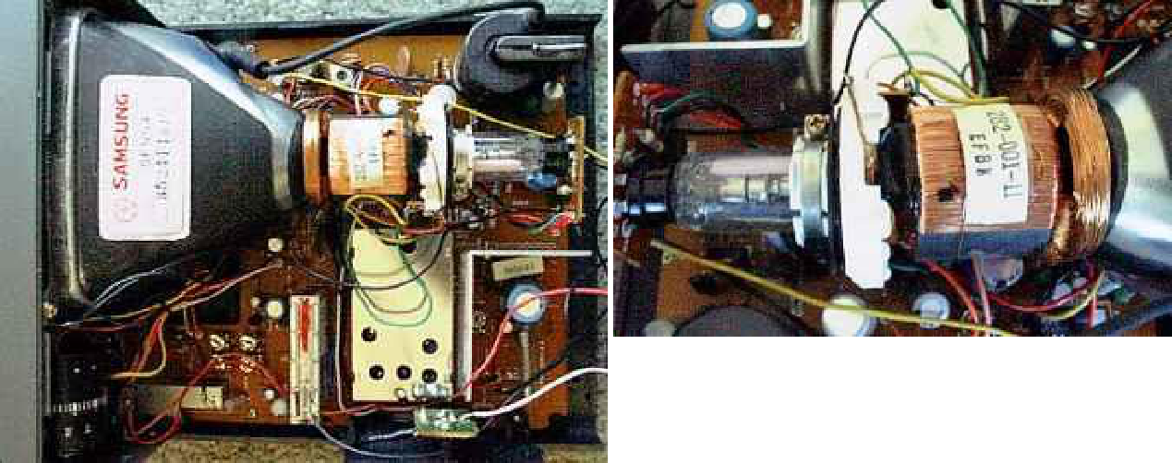

Fig. 8: Steering Coils of TV

The steering coils are simply copper windings. These coils are able to create magnetic fields inside the tube, and the electron beam responds to the fields. One set of coils creates a magnetic field that moves the electron beam vertically, while another set moves the beam horizontally. By controlling the voltages in the coils, you can position the electron beam at any point on the screen.

TV Phosphors:

A phosphor is any material that, when exposed to radiation, emits visible light. The radiation might be ultraviolet light or a beam of electrons. Any fluorescent color is really a phosphor -- fluorescent colors absorb invisible ultraviolet light and emit visible light at a characteristic color.

In a CRT, phosphor coats the inside of the screen. When the electron beam strikes the phosphor, it makes the screen glow. In a black-and-white screen, there is one phosphor that glows white when struck. In a color screen, there are three phosphors arranged as dots or stripes that emit red, green and blue light. There are also three electron beams to illuminate the three different colors together.

There are thousands of different phosphors that have been formulated. They are characterized by their emission color and the length of time emission lasts after they are excited.

The Black-and-White TV Signal:

In a black-and-white TV, the screen is coated with white phosphor and the electron beam "paints" an image onto the screen by moving the electron beam across the phosphor a line at a time. To "paint" the entire screen, electronic circuits inside the TV use the magnetic coils to move the electron beam in a "raster scan" pattern across and down the screen. The beam paints

Experiment 1 Lab Manual

one line across the screen from left to right. It then quickly flies back to the left side, moves down slightly and paints another horizontal line, and so on down the screen.

In this figure, the blue lines represent lines that the electron beam is "painting" on the screen from left to right, while the red dashed lines represent the beam flying back to the left. When the beam reaches the right side of the bottom line, it has to move back to the upper left corner of the screen, as represented by the green line in the figure. When the beam is "painting," it is on, and when it is flying back, it is off so that it does not leave a trail on the screen. The term horizontal retrace is used to refer to the beam moving back to the left at the end of each line, while the term vertical retrace refers to its movement from bottom to top.

As the beam paints each line from left to right, the intensity of the beam is changed to create different shades of black, gray and white across the screen. Because the lines are spaced very closely together, the brain integrates them into a single image. A TV screen normally has about 480 lines visible from top to bottom. In the next section, you'll find out how the TV "paints" these lines on the screen.
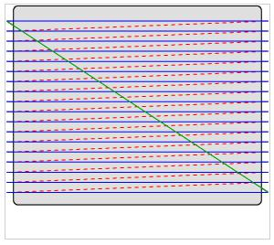

Fig. 9: Raster Scanning

Standard TVs use an interlacing technique when painting the screen. In this technique, the screen is painted 50 times per second but only half of the lines are painted per frame. The beam paints every other line as it moves down the screen -- for example, every odd-numbered line. Then, the next time it moves down the screen it paints the even-numbered lines, alternating back and forth between even-numbered and odd-numbered lines on each pass. Most computer monitors use interlaced scanning because it significantly reduces flicker.

In the 625-line monochrome system, for successful interlaced scanning, the 625 lines of each frame or picture are divided into sets of 312.5 lines and each set is scanned alternately to cover the entire 'picture area. To achieve this the horizontal sweep oscillator is made to work at a frequency of 15625 Hz (312.5 X 50 = 15625) to scan the same number of lines per frame

Experiment 1 Lab Manual

(15625/25 = 625 lines), but the vertical sweep circuit is run at a frequency of 50 instead of 25 Hz. Note that since the beam is now deflected from top to bottom in half the time and the horizontal oscillator is still operating at 15625 Hz, only half the total lines, i.e. 312.5 (625/2 = 312.5) get scanned during each vertical sweep. Since the first field ends in a half line and the second field commences at middle of the line on the top of the target plate or screen the beam is able to scan the remaining 312.5 alternate lines during its downward journey. In all then, the beam scans 625 lines (312.5 x 2 = 625) per frame at the same rate of is 625 lines (312.5 x 50 = 15625) per second. Therefore, with interlaced scanning the flicker effect is eliminated without increasing the speed of scanning, which in turn does not need any increase in the channel bandwidth. It may be noted that the frame repetition rate of 25 (rather than 24 as used in motion pictures) was chosen to make the field frequency equal to the power line frequency of 50 Hz. This helps in reducing the undesired effects of hum due to pickup from the mains, because then such effects in the picture stay still, instead of drifting up or down on the screen. In the American TV system, a field frequency of 60 was adopted because the supply frequency is 60 Hz in USA. This brings the total number of lines scanned per second (525/2) X 60 = 15750) lines to practically the same as in the 625-line system.

Scanning periods: The wave shapes of both horizontal and vertical sweep currents are shown in the following figure. As shown there the retrace times involved (both horizontal and vertical) are due to physical limitations of practical scanning systems and are not utilized for transmitting or receiving any video signal. The nominal duration of the horizontal line as shown in the figure is 64 µs (106/15625 = 64 µs), out of which the active line period is 52 µs and the remaining 12 µs is the line blanking period. The beam returns during this short interval to the extreme left side of the frame to start tracing the next line. Similarly, with the field frequency set at 50 Hz, the nominal duration of the vertical trace is 20 ms (1/50 = 20 ms). Out of this period of 20 ms, 18.72 ms are spent in bringing the beam from top to bottom and the remaining 1.28 ms is taken by the beam to return back to the top to commence the next cycle. Since the horizontal and vertical sweep oscillators operate continuously to achieve the fast sequence (If interlaced scanning, 20 horizontal lines ((1280 µs/64 µs) = 20 lines) get traced during each vertical retrace interval. Thus 40 scanning lines are lost per frame, as blanked lines during the retrace interval of two fields. This leaves the active number of lines, N, for scanning the picture details equal to 625 - 40 = 585, instead of the 625 lines actually scanned per frame.

Experiment 1 Lab Manual
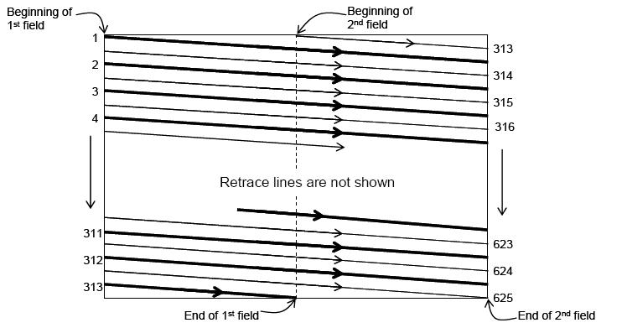

Fig. 10: Principle of Interlaced Scanning
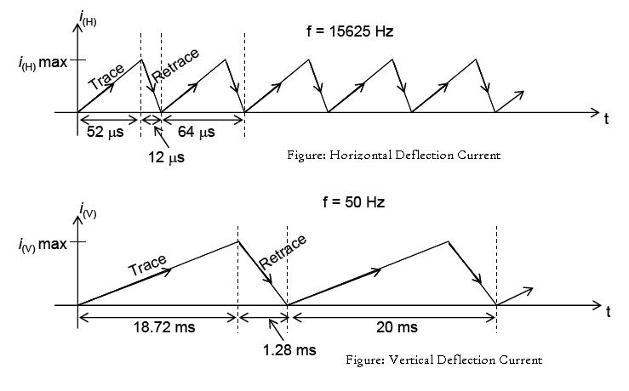

Fig. 11: Horizontal and Vertical Deflection Current

When a television station wants to broadcast a signal to the TV, the signal needs to mesh with the electronics controlling the beam so that the TV can accurately paint the picture that the TV

Experiment 1 Lab Manual

station sends. The TV station therefore sends a well-known signal to the TV that contains three different parts:

- Intensity information for the beam as it paints each line

- Horizontal-retrace signals to tell the TV when to move the beam back at the end of each line

- Vertical-retrace signals 50 times per second to move the beam from bottom-right to top-left.

Color TV Screen:

A color TV screen differs from a black-and-white screen in three ways:

- There are three electron beams that move simultaneously across the screen. They are named the red, green and blue beams.

- The screen is not coated with a single sheet of phosphor as in a black-and-white TV. Instead, the screen is coated with red, green and blue phosphors arranged in dots or stripes. If you turn on your TV or computer monitor and look closely at the screen with a magnifying glass, you will be able to see the dots or stripes.

- On the inside of the tube, very close to the phosphor coating, there is a thin metal screen called a shadow mask. This mask is perforated with very small holes that are aligned with the phosphor dots (or stripes) on the screen.

When a color TV needs to create a red dot, it fires the red beam at the red phosphor. Similarly for green and blue dots. To create a white dot, red, green and blue beams are fired simultaneously -- the three colors mix together to create white. To create a black dot, all three beams are turned off as they scan past the dot. All other colors on a TV screen are combinations of red, green and blue.
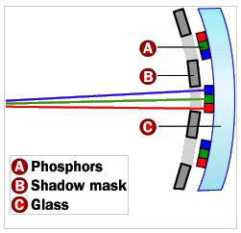

Fig. 12: Color TV Screen

Experiment 1 Lab Manual

A delta gun assembly consisting of three separate electron guns positioned 120 degree apart in the rear neck of the tube, generated three high velocity electron beams. The guns are slightly tilted towards the centre line of the tube to converge near the face plate as the apertures in the shadow mask and face on the respective color phosphors dots only. There is one aperture hole for each phosphors trio and the converged beam moves over the mask momentarily illuminating a phosphor trio as it passes, thus blanked or masked out while moving between the apertures. This is an essential function of shadow mask, in the absence of which the beams would excite all the dots in sequence mixing up the color reproduction. The shadow mask thus blocks an appreciable portion of the beam current dissipating several watts of power. The phosphor screen gets less than 20% of the beam current reducing the brightness capabilities of the color tube. That is why color picture tubes used higher anode voltages and need larger beam and cathode currents than the monochrome tubes of the same size.
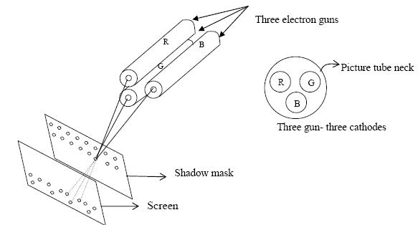

Fig. 13: Delta Gun Assemble of Color Picture Tube

In front of the delta gun assembly structure is located the convergence electrode assembly for the three guns. This includes a magnetic shield, which allows each beam to be shifted in position without affecting others, and the internal pole pieces as shown in the figure. They are so shaped that they concentrate the magnetic field produced by the external yoke coils across the beams to shift them radically in order to make them converge through the aperture of the mask.

Experiment 1 Lab Manual
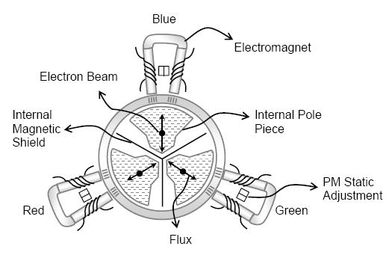

Fig. 14: Convergence System

Degaussing Coil:

Degaussing means demagnetizing. The name comes from the gauss unit, which measures flux density. The purpose of a degaussing is to remove the magnetic flux from metals that have become magnetized. In color TV, the steel chassis and its supports, the internal frame that holds the shadow mask and the mask itself, all are subject to introduced magnetism. These local magnetic fields can affect the path of electrons in the picture tube causing errors in beam landing that result in contamination of the color purity. For this reason, loudspeakers, toys and other devices containing magnets should be kept away from a color TV. However, one PM (permanent magnet) field is unavoidable – the earth’s magnetic field in which we are all immersed. Terrestrial magnetism is the main reason why degaussing is necessary for color picture tubes. For color tubes, the magnetization affects the color purity and the convergence of the three electron beams. But with a monochrome picture tube, magnetization is no problem. So, no degaussing coil is used in B/W picture tube.

Automatic Degaussing (ADG) circuit is designed to compensate for the earth’s magnetic field, no matter which way the set is facing. By this method, the picture tube is demagnetized automatically each time the TV set is turned on. A set of degaussing coils is built into the tube support harness, at the top, bottom and sides of the screen. A strong current from the ac input passes through these coils when the set is first turned on. Then the current decreases rapidly to a negligible value in a fraction of a second.

Experiment 1 Lab Manual

The future of CRT technology:

Although a mainstay of display technology for decades, CRT-based computer monitors, and televisions constitute a dead technology. The demand for CRT screens has dropped precipitously since 2000, and this falloff had accelerated in the latter half of that decade. The rapid advances and falling prices of LCD flat panel technology, first for computer monitors and then for televisions, has been the key factor in the demise of competing display technologies such as CRT, rear-projection, and plasma display. The end of most high-end CRT production by around 2010 (including high-end Sony and Mitsubishi product lines) means an erosion of the CRT's capability. In Canada and the United States, the sale and production of high-end CRT TVs (30-inch screens) in these markets had all but ended by 2007; just a couple of years later, inexpensive combo CRT TVs (20-inch screens with an integrated VHS or DVD player) have disappeared from discount stores. It has been common to replace CRT-based televisions and monitors in as little as 5–6 years, although they generally are capable of satisfactory performance for a much longer time.

CRTs, despite recent advances, have remained relatively heavy and bulky and take up a lot of space in comparison to other display technologies. CRT screens have much deeper cabinets compared to flat panels and rear-projection displays for a given screen size, and so it becomes impractical to have CRTs larger than 40 inches (102 cm). The CRT disadvantages became especially significant in light of rapid technological advancements in LCD and plasma flat-panels which allow them to easily surpass 40 inches (102 cm) as well as being thin and wall-mountable, two key features that were increasingly being demanded by consumers.

By 2006, although the price points of CRTs were generally much lower than LCD and plasma flat panels, large screen CRTs (30-inches or more) were as expensive as a similar-sized LCD.

Monochrome CRTs use less power than color CRTs (but they are not more efficient overall). This is because up to 2/3 of the backlight power of LCD and rear-projection CRT displays are lost to the RGB stripe filter. Older LCDs also have poorer color rendition and can change color with viewing angle, though modern PVA and IPS LCDs have greatly attenuated these problems.

Some CRT manufacturers, both LG Display and Samsung Display, have innovated CRT technology by creating a slimmer tube. Slimmer CRT has a trade name Superslim and Ultraslim. A 21-inch flat CRT has 447.2-millimeter depth. The depth of Superslim is 352 millimeters and Ultraslim is 295.7 millimeters.

Experiment 1 Lab Manual

Pre-lab Homework:

Get basic idea about television, oscilloscope and other CRT appliances from book or internet.

Apparatus:

- Black & White CRT TV

- Color TV

- Oscilloscope

- Measuring Meters (Multimeter)

- Toolbox

Precautions:

- Be careful of handling small equipments/instruments inside the apparatus.

- Be careful if power is supplied to the apparatus when the casing is kept open.

Experimental (Demonstration) Procedure:

- Follow the rules and regulation for opening an electronic device.

- Choose proper tools from the toolbox to open the casing of the device.

- Follow the way the Course Teacher or the Lab Instructor demonstrates the cathode ray tube appliance.

References:

1. HowStuffWorks, Available: www.electronics.howstuffworks.com

Name : Samima Sultana
ID: 16-32012-2

1. Explain the basic principles of CRT monitors with appropriate references.

Answer:

When the two metal plates are connected to a high voltage source, the
negatively charged plate called the cathode emits an invisible ray. The cathode ray
is drawn to the positively charged plate, called the anode, where it passes through a
hole and continues traveling to the other end of the tube. When the ray strikes the
specially coated surface, the cathode ray produces a bright light. When an electric
field is applied across the cathode ray tube, the cathode ray is attracted by the plate
bearing positive charges. Therefore a cathode ray must consist of negatively
charged particles. The electrons deflected by the magnetic field. And also when
the external magnetic field is reversed, the beam of electronics is deflected in the
opposite direction. In a cathode ray tube, the cathode is a heated filament and it
placed in a vacuum.. Electrons are negative. The anode is positive, so it attracts the
electrons pouring off the cathode. In a TV’s cathode ray tube, the stream of
electrons is focused by a focusing anode into a tight beam and then accelerated by
an accelerating anode. This tight, high-speed beam of electrons flies through the
vacuum in the tube and hits the flat screen at the other end of the tube. This screen
is coated with phosphor, which glows when struck by the beam.

2. We know that, CRT monitors are now replaced by the LCD and LED displays. Please explain the reasons behind the CRT monitors becoming obsolete and give some suggestions to improve the CRT monitors so that people do not discard the CRT technologies.

Answer:
The CRT monitors have some drawbacks and disadvantages . That’s why
they are being replaced by the LCD and LED displays. The basic drawbacks are ,
Big back and take up space on a desk, not suitable for very brightly environment
because less bright than LCD, they are large, heavy and bulky, consume a lot of
electricity and also produce a lot of heat, geometrical error at edges, flickering at
50-80 Hz , harmful DC and AC electric and magnetic fields.
I think CRT monitors should improve their technology by not changing their
Principles, like they can make slimmer tv and make them lighter. They also have to
improve the display technology. They need to make more energy efficient displays,
which will reduce heat energy.

Reference:
- https://www.elprocus.com/cathode-ray-tube/
- https://www.ecstuff4u.com/2018/04/advantages-and-disadvantages-of-crt.html?m=1

Noor, Sk. Md. Kanijur Rahman [17-35444-3]

Principal of CRT [1]:
- It consists of an electron gun.
- The electron gun produce an electron beam.
- The beam is narrow and is allowed to pass down the tube, and to fall on the screen.
- The screen is formed by the flat end of glass tube which is coated with the fluorescent material.
- The point at which the electron beam strikes the screen, a sport is formed.
- The electron beam passes through two pairs of electrostatic deflection plates, the horizontal and vertical deflecting plates. The voltages which are applied to these plates deflect the beam.

- Horizontal deflecting plates move the spot in horizontal direction and vertical deflecting plates move the spot on the screen in vertical and horizontal are independent of each other and thus the beam may be displayed anywhere on the screen.

Why Crt monitors get absolute by LCD and LED [2]

1. Sharpness
The CRT's Gaussian beam profile produces images with softer edges that are not as sharp as an LCD at its native resolution. Imperfect focus and color registration also reduce sharpness. Generally sharper than LCDs at other than native resolutions.
2. Interference
All color CRTs produce annoying Moiré patterns. Many monitors include Moiré reduction, which normally doesn't eliminate the Moiré interference patterns entirely.
3. Geometric Distortion
Subject to geometric distortion and screen regulation problems. Also affected by magnetic fields from other equipment including other CRTs.
4. Brightness
Relatively bright but not as bright as LCDs. Not suitable for very brightly lit environments.
5. Screen Shape
Some CRTs have a rounded spherical or cylindrical shape screen. Newer CRTs are flat.
6. Emissions
CRTs give off electric, magnetic and electromagnetic fields. There is considerable controversy as to whether any of these pose a health hazard, particularly magnetic fields. The most authoritative scientific studies conclude that they are not harmful but some people remain unconvinced.
7. Physical
They are large, heavy, and bulky. They consume a lot of electricity and produce a lot of heat.

Besides all the disadvantages and de-modernizations there’s still so many advantages why can still use crt’s with some corrections.
1. Resolution and Aspect Ratio
They operate at any resolution, geometry and aspect ratio without the need for rescaling the image.
2. Highest Resolutions
CRTs run at the highest pixel resolutions generally available.
3. Black-Level and Contrast
Produce a very dark black and the highest contrast levels normally available. Suitable for use even in dimly lit or dark environments.
4. Color and Gray-Scale Accuracy
CRTs produce the very best color and gray-scale and are the reference standard for all professional calibrations. They have a perfectly smooth gray-scale with an infinite number of intensity levels. Other display technologies are expected to reproduce the natural power-law Gamma curve of a CRT, but can only do so approximately.
5. Motion Artifacts
CRTs have fast response times and no motion artifacts. Best for rapidly moving or changing images.
6. Cost
CRTs are less expensive than comparable displays using other display technologies.

Reference:
[1] https://www.polytechnichub.com/principal-of-crt/
[2] https://www.displaymate.com/crts.html

Name : Raskin Kifaat ID: 17-35440-3

- 1. Explain the basic principles of CRT monitors with appropriate references.
ANS:
- CRT is used to display the output in a standard composite video signal.
- CRT monitors display occurs with an electron beam gun. It radiates the flow of electrons that pass through a specialized metal mask and are directed to the inner part of the glass surface of the display.
- Due to the passage through the modulator, the charged particles receive a lot of energy spent on the pixel backlight.
- A CRT has a fluorescent screen to display the output signal

Reference
https://karpsy.ru/en/printery/elt-monitor-princip-raboty-elt-monitory-osnovnye-harakteristiki.html
https://www.elprocus.com/cathode-ray-tube/

- 2. We know that, CRT monitors are now replaced by the LCD and LED displays. Please explain the reasons behind the CRT monitors becoming obsolete and give some suggestions to improve the CRT monitors so that people do not discard the CRT technologies.
ANS:
The display quality of LED is age and temperature dependent while CRT has no such kind of issue. Moreover, LED is expensive and inaccessible to everyone. Similarly, LCD monitor doesn’t support black and white feature and also has less response time. On the contrary, CRT gives true black color and has a high response time. CRT monitors are cheap and accessible to everyone. CRT Monitors are the conventional computers, large in size and have wide viewing angles. While An LCD monitor is the advanced form of CRT monitors. Unlike CRT monitors, LCD monitors are slim, occupy less space and consume less energy. The large screen area makes it perfect for playing games, watching movies while the size of the CRT monitor is always less than the specified size on the paper as its frame around the glass screen covers more than one-inch space. The flat Screen screen displays the perfect image while it’s harmless for the eyes as it emits very small part of the radiation. The feature of an auto button lets the user resize the screen size to make images sharp and flexible. Moreover, it’s free from the burn-in issue which is a major drawback of CRT and Plasma monitors. Unlike LED monitors, LCD monitors are affordable and accessible for everyone.

Reference
https://byte-notes.com/difference-between-crt-lcd-led-monitors/

Name: MD TANJIMUL ISLAM
ID: 17-35381-3
Sec: B

Explain the basic principles of CRT monitors with appropriate references.
Ans:
- CRT consists of an electron gun.
- The electron gun produces an electron beam.
- The beam is narrow and is allowed to pass down the tube, and to fall on the screen.
- The screen is formed by the flat end of glass tube which is coated with the fluorescent material.
- The point at which the electron beam strikes the screen, a sport is formed.
- The electron beam passes through two pairs of electrostatic deflection plates, the horizontal and vertical deflecting plates. The voltages which are applied to these plates deflect the beam.
- Horizontal deflecting plates move the spot in horizontal direction and vertical deflecting plates move the spot on the screen in vertical and horizontal are independent of each other and thus the beam may be displayed anywhere on the screen.

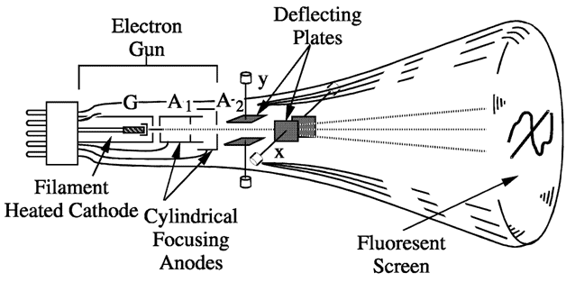
We know that, CRT monitors are now replaced by the LCD and LED displays. Please explain the reasons behind the CRT monitors becoming obsolete and give some suggestions to improve the CRT monitors so that people do not discard the CRT technologies.
Ans:
There was a time when all TVs contained a cathode ray tube (CRT) and, as a result, were bulky and heavy. CRT TV work by firing a stream of negatively charged particles, called electrons, at a phosphor screen. When an electron strikes a phosphor atom, the atom becomes excited and emits light of a certain color, hence creating one picture element, or “pixel”, of a TV picture.

LCD/LED displays are slim, occupy less space and consume less energy. The large screen area makes it perfect for playing games, watching movies while the size of the CRT monitor is always less than the specified size on the paper as its frame around the glass screen covers more than one-inch space. The flat Screen displays the perfect image while its harmless for the eyes as it emits very small part of the radiation. The feature of an auto button lets the user resize the screen size to make images sharp and flexible. Moreover, it’s free from the burn-in issue which is a major drawback of CRT monitor.

The display quality of LED is age and temperature dependent while CRT has no such kind of issue. Moreover, LED is expensive and inaccessible to everyone. Similarly, LCD monitor doesn’t support black and white feature and also has less response time. On the contrary, CRT gives true black color and has a high response time. CRT monitors are cheap and accessible to everyone.

Discussion:
In this experiment basic knowledge about CRT TV is learned by both practically and theoretically. Invention of CRT is an important phenomenon. In many electronic devices CRT is used. There are different techniques and designs for CRT. Practically a CRT TV circuit was observed for understanding the working principle of CRT. Finally the experiment was finished by summarizing all the learning of the experiment.

Reference:
- http://whatis.techtarget.com/definition/cathode-ray-tube-CRT
- https://www.crtsite.com/oscilloscope-crt.html

