

empowering farmers agriculture

mmgggggmrem

Maize farming 💐🌸🌻

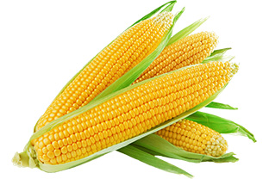h

November 17, 2023

agri- mechanisation

Kigali- Nyarugenge

**IMPOWERING FARMERS PROJECT**

COLLEGE OF SCIENCE AND TECHNOLOGY

SCHOOL OF ICT

DEPARTMENT OF COMPUTER ENGINEERING

COMPUTER ENGINEERING YEAR 1

Name; SHIMWAMUBYEYI Fortunee

Registration Number: 223013738

November 17, 2023

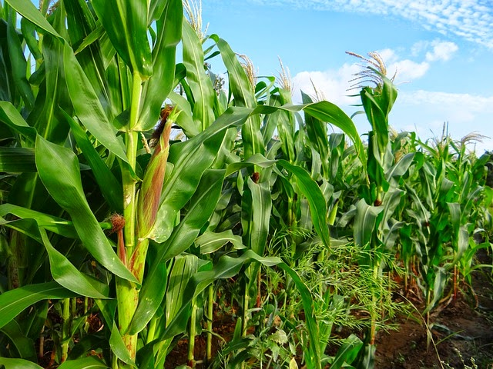

Table of Contents

Chapter 1: Introduction 2

Background of case study 3

Problem statement 4

Objectives of project 4

Project rationale 7

1.5 project limitation 9

1.6. implementation and plane 10

The table below show the implementation and plan of my project; 11

Chapter 2; SYSTEM ANLYSIS AND DESIGN 14

2.1 system analysis 14

2.1.2 internal and external user 16

Flow chart of each user 18

2.1.2 Functionality of project 19

# Chapter 1: Introduction

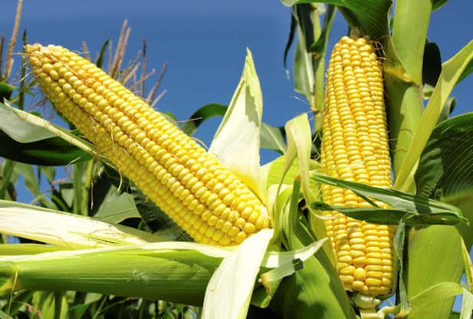

## Background of case study

In rural and agricultural communities worldwide, farmers encounter substantial challenges in optimizing crop yields, managing resources efficiently, and accessing vital market information. The absence of effective tools compounds these challenges, hindering informed decision-making and impeding overall agricultural progress. Recognizing this, the proposed solution involves the development of a tailored web application, strategically designed to meet the unique needs of farmers.

### Problem statement

in many rural and agricultural communities, farmers face challenges in managing their crops, resources, and market access. a significant problem is the lack of efficient tools to help them make informed decisions and improve their overall farming practices. this problem can be addressed through the development of a web application tailored to the needs of farmers. the application can provide features such as weather forecasts, crop management advice, market price information, and a platform for buying and selling agricultural products. this digital solution can help farmers enhance their productivity, reduce risks, and connect with broader markets, ultimately leading to improved livelihoods and food security.

### Objectives of project

#### General objective

The primary objective of this project is to empower maize farmers in Rwanda by developing and implementing a specialized agricultural management web application. this digital solution aims to address the unique challenges faced by maize farmers in the region, providing tailored features and insights to enhance their productivity, reduce risks, and improve overall agricultural practices.

#### Specific objective

1. **Provide decision-making for maize cultivation:**
   * Provide maize farmers with accurate and localized weather forecasts to aid in optimal planning for planting, harvesting, and other critical activities.
   * Offer crop management advice specific to maize cultivation, including planting schedules, fertilization practices, and pest control measures.
2. **Market access and price setting for maize products:**
   * Create a platform within the web application for maize farmers to access real-time market prices for their products.
   * Facilitate connections with local and regional marketplaces and agribusinesses to enable efficient buying and selling of maize products.
3. **Resource sharing among maize farmers:**
   * Enable maize farmers to organize and manage collective activities through the web application, fostering collaboration within the community.
   * Facilitate resource sharing among maize farmers, including equipment, seeds, and knowledge, to contribute to improved maize cultivation practices.
4. **Extension services and knowledge:**
   * Provide a channel for agricultural extension workers in Rwanda to reach maize farmers with timely advice, best practices, and relevant information.
   * Create a knowledge-sharing platform within the application where maize farmers can exchange experiences and learn from each other.
5. **Collaboration with local experts and research institutions:**
   * Establish partnerships with local agricultural experts and research institutions in Rwanda to incorporate region-specific insights into the application.
   * Ensure that the web application stays updated with the latest research findings and best practices related to maize cultivation in the Rwandan context.

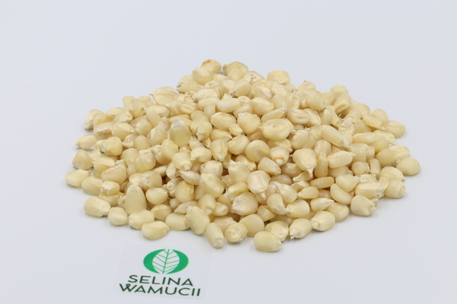

### Project rationale

Addressing unique challenges:

Maize farmers in Rwanda face distinct challenges related to weather variability, pest control, and market access.

1. Increasing productivity:

Limited access to accurate weather forecasts and crop management advice hinders optimal cultivation practices.

1. Market access and income improvement:

By creating a marketplace within the application, farmers can connect with buyers, access market prices, and optimize their income through direct and streamlined transactions.

1. Strengthening community collaboration:

The web application facilitates community building, enabling farmers to organize group activities, share resources, and collectively address challenges, leading to improved community-wide agricultural practices.

1. Empowering through knowledge dissemination:

The platform provides a space for agricultural extension workers to share timely advice, while also enabling farmers to exchange experiences and learn from one another, fostering a culture of continuous improvement.

1. Localized insights for maize cultivation:

Collaborating with local agricultural experts and research institutions.

1. Contributing to food security and economic growth:

By empowering maize farmers with the knowledge and tools needed for sustainable and productive cultivation, the project aligns with broader national goals of enhancing food security and driving economic growth in the agricultural sector.

8. Leveraging technology for agricultural transformation:

The web application leverages technology to bridge gaps, bringing about a digital transformation in the agricultural practices of maize farmers, fostering efficiency and innovation.

The project rationale underscores the need for a targeted and technology-driven intervention to address the specific challenges faced by maize farmers in Rwanda. By tailoring the web application to the unique requirements of maize cultivation, the project aims to bring about positive, sustainable, and community-wide impacts in the agricultural landscape of the region.

## 1.5 project limitation

1. **Limited technology access:**

Some maize farmers in rural areas may have limited access to smartphones or computers, hindering their ability to fully utilize the web application.

1. **Internet connectivity challenges:**

In remote rural areas, where maize farming is prevalent, internet connectivity can be inconsistent or unavailable.

1. **Language and literacy barriers:**

The application's content may need to be presented in multiple languages to cater to diverse linguistic groups in Rwanda. Additionally, literacy levels may vary among the target audience.

1. **Dependence on meteorological data accuracy:**

The accuracy of weather forecasts, a crucial component of the application, depends on the reliability of meteorological data sources.

1. **Marketplace adoption challenges:**

The success of the marketplace feature relies on the active participation of both buyers and sellers.

1. **Resource and infrastructure**

Limited resources and agricultural infrastructure in some regions may hinder the implementation and adoption of the web application.

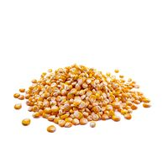

1. **Dependency on external partnerships:**

Collaborations with external partners, such as local experts and marketplaces, are crucial for the success of the project.

1. **Security and privacy concerns:**

Handling sensitive information, such as farmer data and marketplace transactions, raises security and privacy concerns.

1. **Resistance to technological change:**

Farmers may be resistant to adopting new technological tools due to unfamiliarity or traditional farming practices.

Acknowledging these limitations and addressing them in the project planning and implementation phases will be essential for ensuring a more effective and inclusive impact on maize farming in Rwanda.

Top of Form

## 1.6. implementation and plane

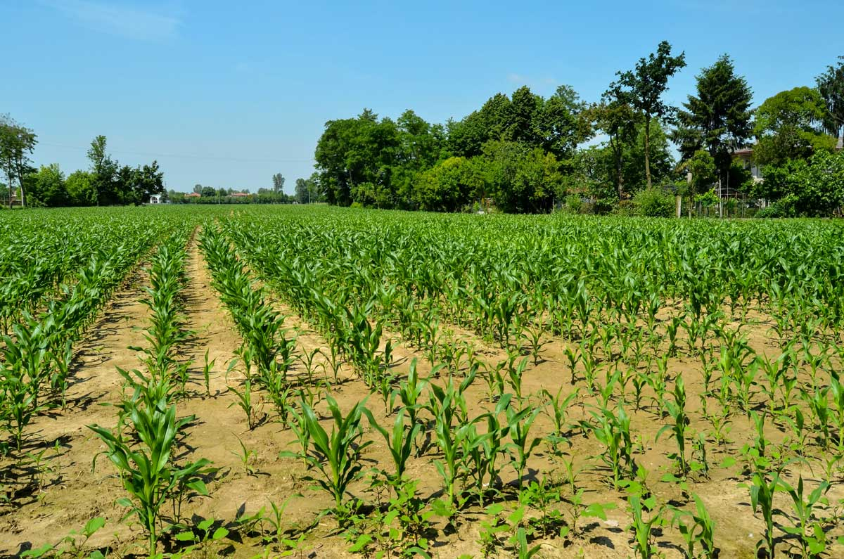

### The table below show the implementation and plan of my project;

|  |  |  |
| --- | --- | --- |
| Description | activity | Timeline |
| * 1. Need assessment | Conduct a thorough needs assessment to understand the specific challenges faced by maize farmers in different regions of Rwanda. | 2 months |
| * 1. Training to the farmer | Conduct training sessions for maize farmers, extension workers, and agricultural cooperatives on how to use the web application effectively | 3 months |
| * 1. Data security | Implement robust security measures to protect user data and ensure privacy. | Ongoing |
| * 1. testing | Conduct a small-scale test with a select group of maize farmers to gather feedback | 3 months |
| 5.infrastructure | Establish the necessary technological infrastructure | 1 month |

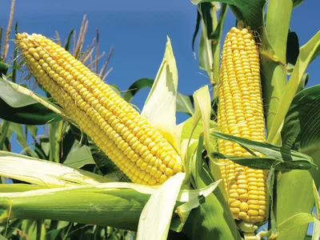

# Chapter 2; SYSTEM ANLYSIS AND DESIGN

## 2.1 system analysis

#### 2.1.1. introduction to analysis and design

The initiative to empower maize farmers through an Agricultural Management System recognizes the unique challenges faced by this community and seeks to harness the potential of technology to provide tailored solutions**.**

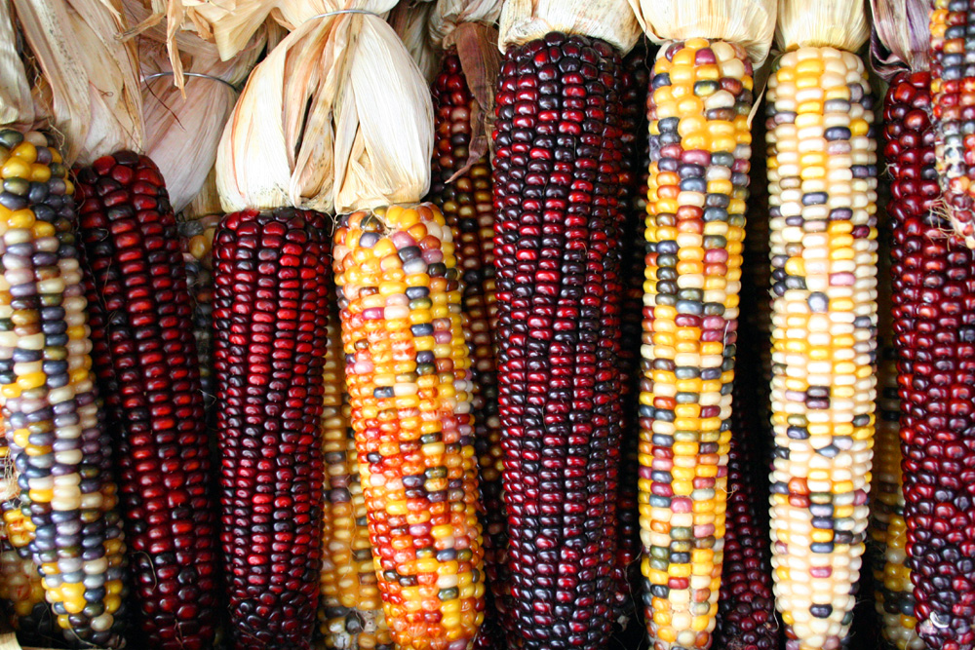

##### System Analysis:

System analysis, as the initial phase of this initiative, involves a meticulous examination of the current state of maize farming. By engaging directly with maize farmers, agricultural cooperatives, and extension workers, this phase aims to understand the intricacies of the maize cultivation process. Through surveys, interviews, and on-the-ground assessments, key challenges such as weather sensitivity, market access, and community collaboration are identified. This phase serves as the foundation for designing a system that is not only technologically robust but also deeply attuned to the realities and aspirations of the maize farming community.

System Design:

Building upon the insights gathered during the analysis phase, the system design stage focuses on crafting a technology-driven solution that aligns seamlessly with the needs of maize farmers. This involves the creation of an intuitive user interface that accommodates the diverse levels of technological familiarity among farmers. The design phase also delves into the architecture of the Agricultural Management System, ensuring the integration of features such as real-time weather updates, crop management advice, and a marketplace for streamlined transactions. Emphasis is placed on the adaptability of the system to varying local conditions and the diverse linguistic landscape, reflecting the realities of maize farming communities.

**💪💪💪💪💪💪💪💪💪💪💪💪💪💪💪💪💪**

The journey from system analysis to design encapsulates a commitment to technological innovation that is firmly rooted in the lived experiences and aspirations of those whose livelihoods depend on the maize fields of our agricultural communities.

**Top of Form**

### 2.1.2 internal and external user

In maize agriculture we have different user both internal and external

Internal Users**:**

1. Farmers:

Access the agricultural management system for real-time weather forecasts, crop management advice, and market information. Use the platform for buying and selling agricultural products.

1. Agricultural cooperatives:

Utilize the system to coordinate group activities, share resources, and collectively access market information. Facilitate community-wide agricultural practices.

1. Extension workers:

Utilize the system to disseminate timely advice, best practices, and educational materials to a broader farmer base. Use the platform for community engagement and knowledge dissemination.

#### External Users:

1. Agricultural experts and researchers:

Collaborate with the system to ensure it incorporates the latest research findings and best practices. Provide insights and recommendations for optimizing maize cultivation.

1. Meteorological services:

Partner with the system to integrate accurate and real-time weather forecasts. Contribute essential data for farmers to plan their planting and harvesting activities effectively.

1. Marketplaces and agribusinesses:

Partner with the system to enable the buying and selling of maize products. Provide market prices and facilitate direct connections between farmers and consumers.

The collaboration and engagement of both internal and external users are integral to the success of the agricultural management system for maize agriculture. Internal users directly benefit from the system, enhancing their farming practices and economic outcomes, while external users contribute expertise, data, and connections to support the overall success of the initiative.

### Flow chart of each user

Groupe activities

Market information

Crop management

Weather update

Register

Loggedin ?

login

Access web application

## 2.1.2 Functionality of project

|  |  |  |
| --- | --- | --- |
| **User** | **functionality** | **descriptions** |
| Farmers | Access web application | Log in or register to access the web application. |
| Farmers | View dashboard | Access a personalized dashboard displaying weather updates, crop management advice, and market information. |
| Agricultural project | View group dashboard | Access a dashboard displaying group activities, resource sharing, and market access. |
| Extensional worker | Access web application | Log in or register to access the web application |
| Extensional worker | Advisory hub | Provide advice, access resources, and engage in discussions within an advisory hub. |
| Agricultural cooperatives | View group dashboard | Access a dashboard displaying group activities, resource sharing, and market access. |
| Extension Workers | Access web application | Log in or register to access the web application. |

This table outlines key functionalities for different user types within the maize project. Each user type has access to specific features tailored to their role, promoting collaboration and knowledge exchange within the maize farming community. Actual implementation may involve additional features and details based on project requirements.