**Note: This is an individual assignment. While it is expected that students will discuss their ideas with one another, students need to be aware of their responsibilities in ensuring that they do not deliberately or inadvertently plagiarize the work of others.**

**Assignment 2 – SQL Query Formulation**

**Assessment weight:** 10%

**Rationale**

This assignment is designed to assess a student’s ability to write queries using Structured Query Language (SQL) to extract information specified from the database. Students will specifically use MySQL Workbench as the DBMS. This assignment is used to assess your knowledge and skills required to formulate SQL queries to retrieve information from the existing DB by applying various relational operations.

**Task 1: Database Installation**

The UniEnrol database is a simplified University Enrolment Database which keeps data on students (Student), instructors (Faculty), subjects (Course), which courses were taught by which instructor (Offering), registrations made by students (Registration), and which registrations are related to each offering (Enrollment).

The conceptual model of this database is presented in the ERD as shown below.

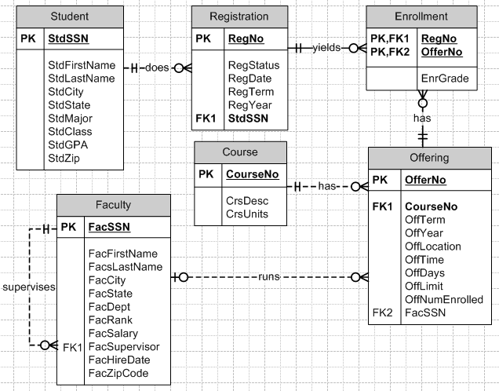

* A faculty means an academic member who usually runs (teaches) courses (subjects).
* A course means a subject run by University
* A course is offered by the schedule set by University
* A student make a registration for each term by enrolling to a number of courses offered.

The actual database file is provided as a dump file ‘**uniEnrolDB.sql’**.

You can open/see this database using MySQL Workbench by importing the dump file

provided. To import the database properly, please follow the process as guided below:

* **Step 1:** Download 'uniEnrolDB.sql' and save it on your local folder.
* **Step 2:** Run MySQL Workbench, and select any connection to connect MySQL server.
* **Step 3:** Go to the top menu 'Server' and click 'Data Import' menu. Then you will be on 'Import from Disk' tab.
* **Step 4**: Under 'Import Options', select 'Import from Self-Contained File' and reach to the dump file (uniEnrolDB.sql) you saved in your storage in Step 1.
* **Step 5:** Under 'Default Schema to be Imported To', click the button 'New...' and replace the default schema name (newschema) with another name you like (e.g. unienroldb). Click 'OK'.
* **Step 6**: Click the button 'Start Import', then you will see 'Import Progress' is completed.
* **Step 7:** Refresh the navigator section (by clicking the refresh button) to see the database imported is visible.
* **Step 8:** Check all tables (6 tables) are created with data.

**Task 2 : Write SQL Queries**

Using the UniEnrolDB database you installed, You are required to **compose 10 SQL queries** in MySQL Workbench. For each question, the sample result table is provided to help you get an idea of what the table header and data format of your query result should look like.

If you test your query using the UniEnrol database as provided/installed and your query is correct, the result of your query must match with the result provided.

**Notes:**

* Queries should be written so that they would work with all reasonable sets of test data, not just that which has been supplied as a sample data.
* Marks may be deducted if your SQL is excessively (or unnecessarily) complicated.
* Full marks will be awarded where the solution provided is correct in all respects.
* Partial marks may be allocated where students are deemed to have provided a significant effort toward a correct result, but the solution contains some error.
* No marks are awarded where either no solution is provided, or the solution provided is deemed to be mostly incorrect.

**10 Questions : 2 marks each**

1)List the First name, Last name, city, current salary and decreased salary (decrease the salary by 5 percent) of faculty hired before 1998.

Note: HireDate must display the faculty’s hire date in the form shown.

|  |  |  |  |  |  |
| --- | --- | --- | --- | --- | --- |
| FirstName | LastName | City | facsalary | DecreasedSalary | HireDate |
| LEONARD | VINCE | SEATTLE | 35000 | 33250 | 4/10/1995 |
| VICTORIA | EMMANUEL | BOTHELL | 120000 | 114000 | 4/15/1996 |
| LEONARD | FIBON | SEATTLE | 70000 | 66500 | 5/1/1994 |
| NICKI | MACON | BELLEVUE | 65000 | 61750 | 4/11/1997 |

2)Write a query to display the SSN and names of faculty members, and the course number and offering-year for which the faculty member teaches the same course number as his or her supervisor in the same year.

|  |  |  |  |
| --- | --- | --- | --- |
| facssn | Faculty Name | Offyear | CourseNo |
| 98765432 | LEONARD VINCE | 2006 | IS320 |
| 654321098 | LEONARD FIBON | 2006 | IS320 |

3)List the offer number, course number, and full name of the instructor (faculty) of all FINANCE courses (the course number’s prefix is ‘FIN’) offered in winter 2006 taught by professor. Note: professor’s rank is “PROF” in the database.

|  |  |  |
| --- | --- | --- |
| OfferNo | CourseNo | Instructor Name |
| 5555 | FIN300 | NICKI MACON |

4)Write a query to summarize the average GPA of upper-division (junior (JR) or senior (SR)) students by major. Only list the majors with average GPA greater than 2.

|  |  |
| --- | --- |
| StdMajor | AvgGPA |
| IS | 3.2 |
| FIN | 2.8 |
| ACCT | 3.4 |

5)Summarize the number of offerings run in 2006 by offering location.

|  |  |
| --- | --- |
| OffLocation | 2006OfferCount |
| BLM302 | 3 |
| BLM214 | 1 |
| BLM207 | 1 |
| BLM412 | 1 |
| BLM212 | 1 |
| BLM305 | 1 |
| BLM405 | 1 |
| BLM307 | 1 |

6)List the offering number, course number, days, location, time, and instructor’s last name, for student Tess Dodge’s course schedule in 2006.

|  |  |  |  |  |  |
| --- | --- | --- | --- | --- | --- |
| OfferNo | CourseNo | OffDays | OffLocation | OffTime | FacLastName |
| 4444 | IS320 | TTH | BLM302 | 3:30 PM | EMMANUEL |
| 5679 | IS480 | TTH | BLM412 | 3:30 PM | COLAN |
| 9876 | IS460 | TTH | BLM307 | 1:30 PM | FIBON |

7)List the course description, the course number, the number of offerings, and the average enrollment across offerings.

|  |  |  |  |
| --- | --- | --- | --- |
| CrsDesc | CourseNo | NumOfferings | AvgEnroll |
| FUNDAMENTALS OF BUSINESS PROGRAMMING | IS320 | 3 | 4 |
| SYSTEMS ANALYSIS | IS460 | 1 | 6 |
| FUNDAMENTALS OF DATABASE MANAGEMENT | IS480 | 2 | 5 |

8)For offerings beginning with IS in the associated course number, retrieve the offer number, the course number, the faculty number, and the faculty name. Include an offering in the result even if the faculty is not assigned.

(Hint: Use lpad fundtion to fill ‘0’ at the start of FacSSN value if necessary)

|  |  |  |  |  |
| --- | --- | --- | --- | --- |
| OfferNo | CourseNo | faculty.FacSSN | FacFirstName | FacLastName |
| 1111 | IS320 |  |  |  |
| 2222 | IS460 |  |  |  |
| 1234 | IS320 | 098765432 | LEONARD | VINCE |
| 3333 | IS320 | 098765432 | LEONARD | VINCE |
| 4321 | IS320 | 098765432 | LEONARD | VINCE |
| 4444 | IS320 | 543210987 | VICTORIA | EMMANUEL |
| 8888 | IS320 | 654321098 | LEONARD | FIBON |
| 9876 | IS460 | 654321098 | LEONARD | FIBON |
| 5679 | IS480 | 876543210 | CRISTOPHER | COLAN |
| 5678 | IS480 | 987654321 | JULIA | MILLS |

9)List the Social Security Number (SSN), name and city of faculty who teach in winter terms.

|  |  |  |
| --- | --- | --- |
| FacSSN | Instructor Name | FacCity |
| 543210987 | VICTORIA EMMANUEL | BOTHELL |
| 765432109 | NICKI MACON | BELLEVUE |
| 987654321 | JULIA MILLS | SEATTLE |

10)List the name and rank of faculty who teach at least one offering of all of the 2006 information systems (IS) courses and his/her supervisor’s name.

|  |  |  |  |
| --- | --- | --- | --- |
| FacFirstName | FacLastName | FacRank | Supervisor |
| LEONARD | VINCE | ASST | LEONARD FIBON |
| JULIA | MILLS | ASSC | NICKI MACON |
| CRISTOPHER | COLAN | ASST | LEONARD FIBON |
| LEONARD | FIBON | ASSC | VICTORIA EMMANUEL |

**-END-**