SQL 1

SELECT FacFirstName AS "FirstName", FacLastName AS "LastName", FacCity AS "City", FacSalary AS "facsalary", Round(FacSalary - (FacSalary \* 0.05)) AS "DecreaseSalary", CONCAT(MONTH(FacHireDate), '/',DAY(FacHireDate), '/', YEAR(FacHireDate)) AS "HireDate"

FROM faculty

WHERE YEAR(FacHireDate) < 1998;

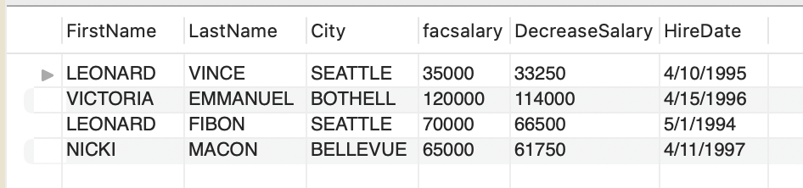

SQL 2

SELECT F1.FacSSN AS 'facssn', CONCAT(F1.FacFirstName, ' ', F1.FacLastName) AS 'Faculty Name', O1.OffYear AS 'Offyear', O1.CourseNo

FROM OFFERING AS O1

join FACULTY AS F1 on O1.FACSSN = F1.FacSSN

join FACULTY AS F2 on F1.FacSupervisor = F2.FacSSN

join OFFERING AS O2 on F2.FACSSN = O2.FACSSN

WHERE O1.OffYear = O2.OffYear AND O1.CourseNo = O2.CourseNo

ORDER BY F1.FacSSN;

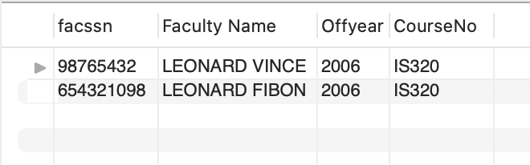

SQL 3

SELECT OfferNo, CourseNo, CONCAT(FacFirstName, ' ', FacLastName) AS "Instructor Name"

FROM offering join faculty on offering.FacSSN = faculty.FacSSN

WHERE upper(CourseNo) LIKE "%FIN%" AND upper(OffTerm) = "WINTER" AND OffYear = 2006 AND upper(FacRank) = "PROF";

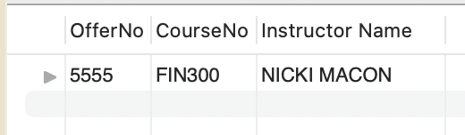

SQL 4

SELECT StdMajor, Round(Avg(StdGPA), 1) AS "AvgGPA"

FROM student

GROUP BY StdMajor, StdClass = "JR" AND "SR"

HAVING Avg(StdGPA) > 2;

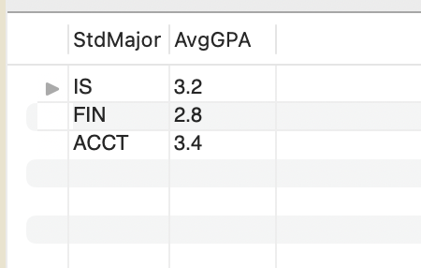

SQL 5

SELECT OffLocation, count(OffLocation)

From offering

GROUP BY OffLocation, OffYear

HAVING OffYear = 2006;

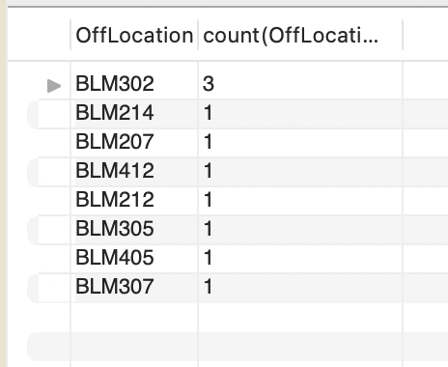

SQL 6

SELECT offering.OfferNo, CourseNo, OffDays, OffLocation, OffTime, FacLastName

FROM faculty join offering on faculty.FacSSN = offering.FacSSN

join enrollment on offering.OfferNo = enrollment.OfferNo

join registration on enrollment.RegNo = registration.RegNo

join student on registration.StdSSN = student.StdSSN

WHERE upper(StdFirstName) = "TESS" and upper(StdLastName) = "DODGE" and OffYear = 2006;

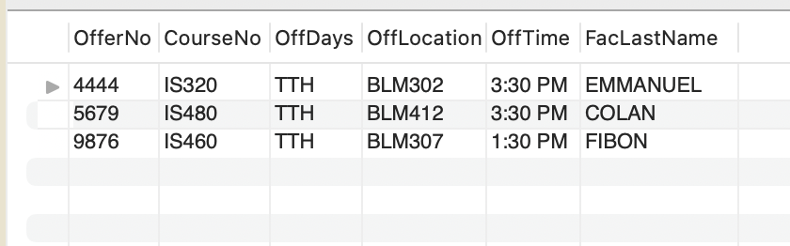

SQL 7

SELECT CrsDesc, offering.CourseNo, count(DISTINCT enrollment.OfferNo) AS "NumOfferings", Round(avg(DISTINCT OffNumEnrolled)) AS "AvgEnroll"

FROM course join offering on course.CourseNo = offering.CourseNo

join enrollment on offering.OfferNo = enrollment.OfferNo

GROUP BY offering.CourseNo;

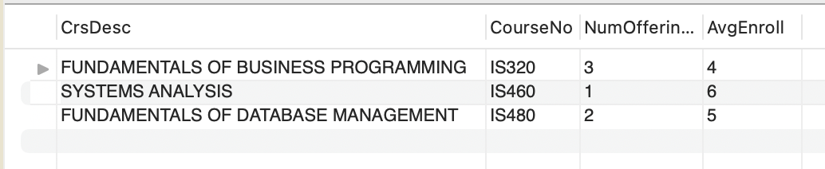

SQL 8

SELECT offering.OfferNo, CourseNo, Lpad(faculty.FacSSN, 9, '0') AS "faculty.FacSSN", FacFirstName, FacLastName

From offering left join faculty on offering.FacSSN = faculty.FacSSN

WHERE CourseNo LIKE "IS%"

Order by Lpad(faculty.FacSSN, 9, '0');

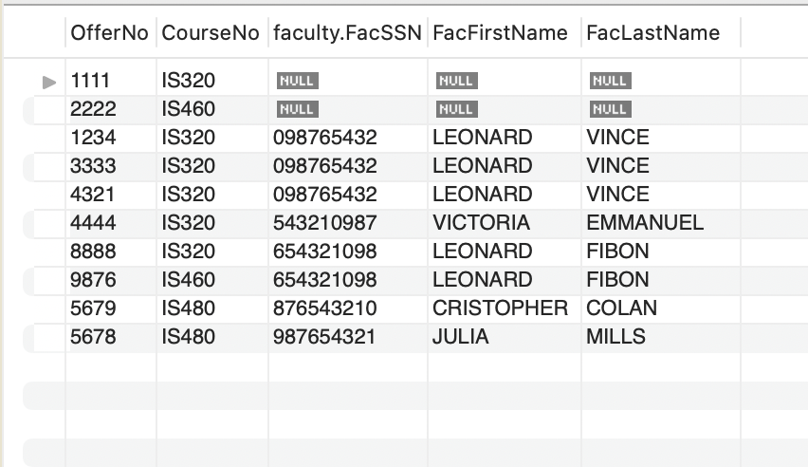

SQL 9

SELECT DISTINCT faculty.FacSSN, CONCAT(FacFirstName, ' ', FacLastName) AS "Instructor Name", FacCity

FROM faculty join offering on faculty.FacSSN = offering.FacSSN

WHERE upper(Offterm) = "WINTER";

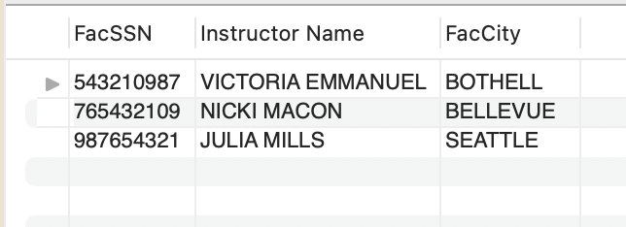

SQL 10

SELECT DISTINCT FacFirstName, FacLastName, FacRank, SV.Supervisor

FROM faculty JOIN offering ON faculty.FacSSN = offering.FacSSN

JOIN (SELECT CONCAT(F2.FacFirstName,' ', F2.FacLastName) AS Supervisor, F1.FacSSN AS FacSSN FROM faculty AS F1 JOIN faculty AS F2 ON F1.FacSupervisor = F2.FacSSN)AS SV ON faculty.FacSSN = SV.FacSSN

WHERE upper(CourseNo) LIKE "%IS%" AND OffYear = 2006

