Student ID:103219744

Name: Abdulla Shinah

# Setup Screenshot

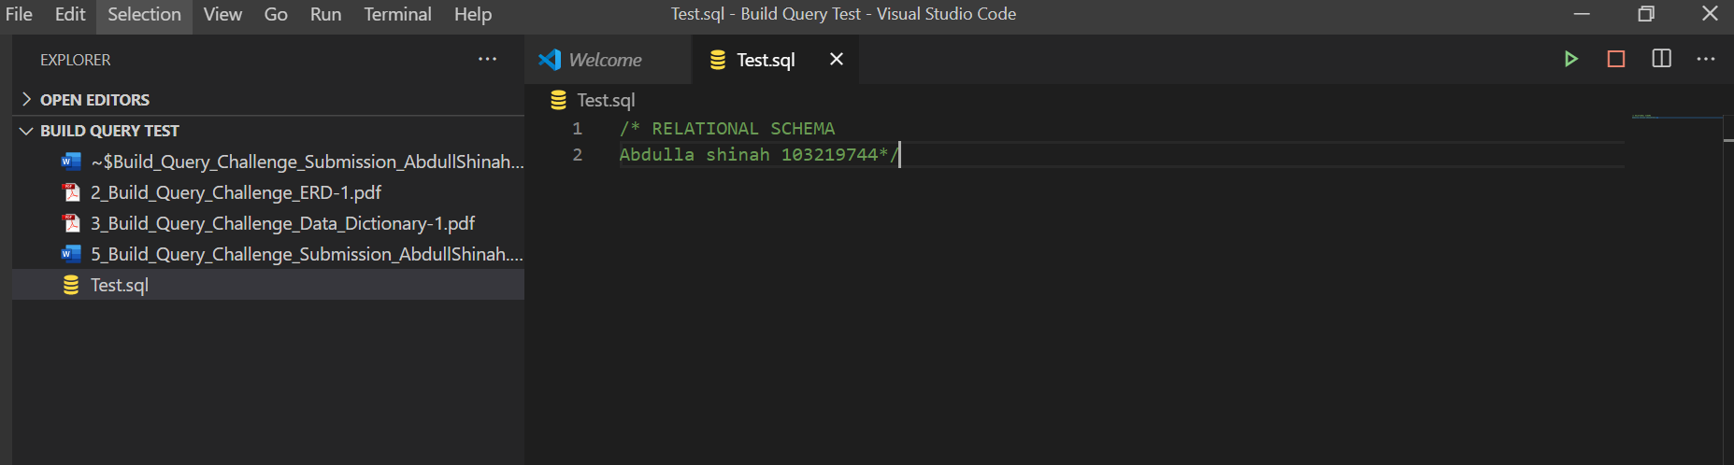

# Task 1 Screenshot

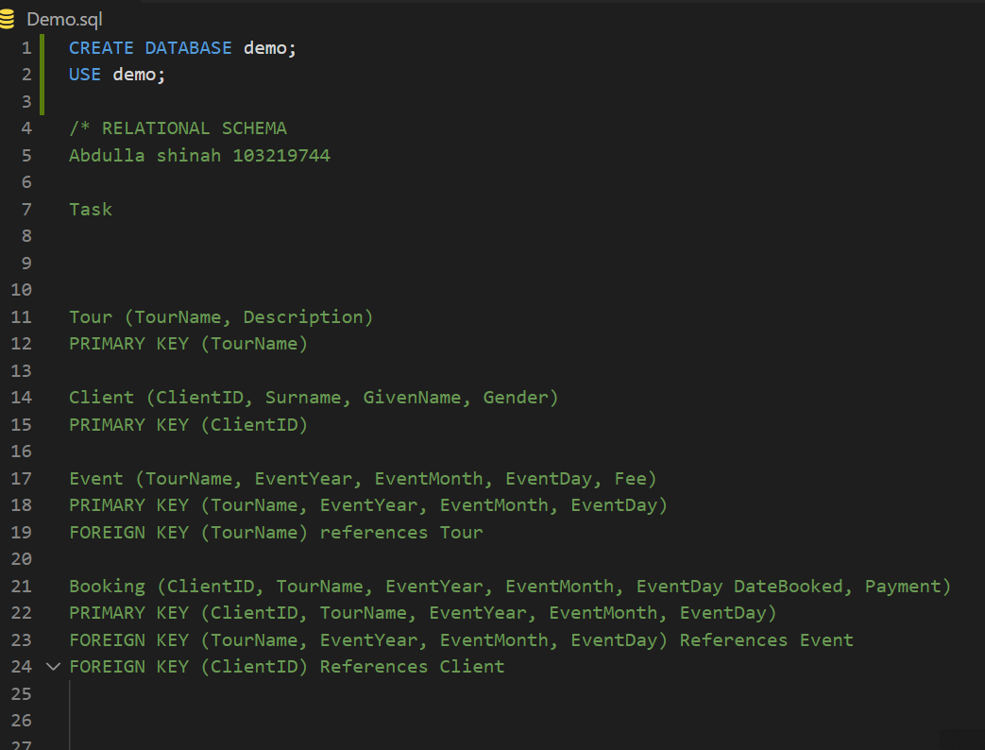

# Task 2 Screenshot

Table Client

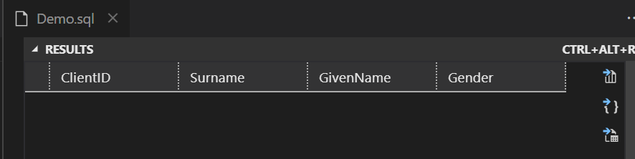

Table Tour

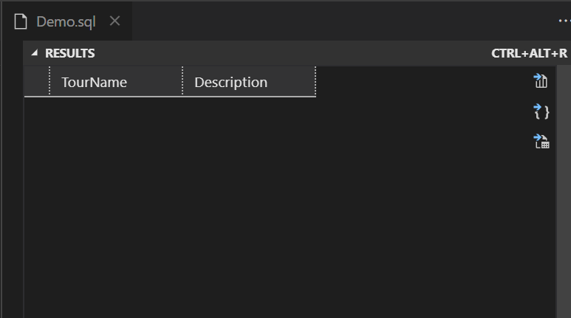

Table Event

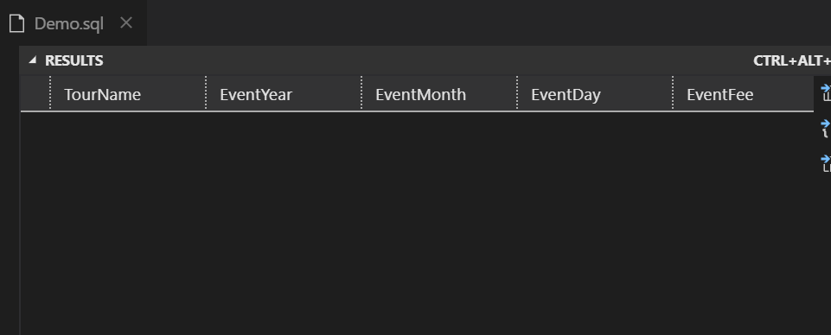

Table Booking

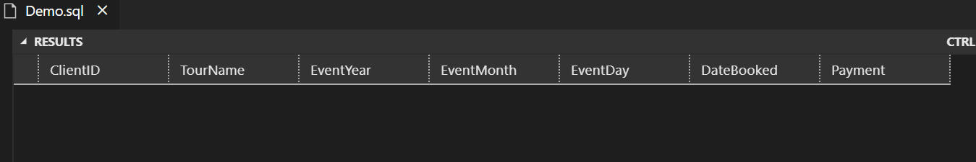

# Task 3 Screenshot

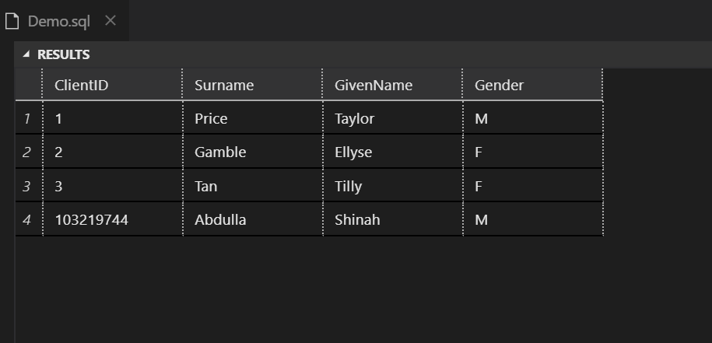

# Task 4 Screenshot

Query 1 (since query result was big took 2 screen shots)

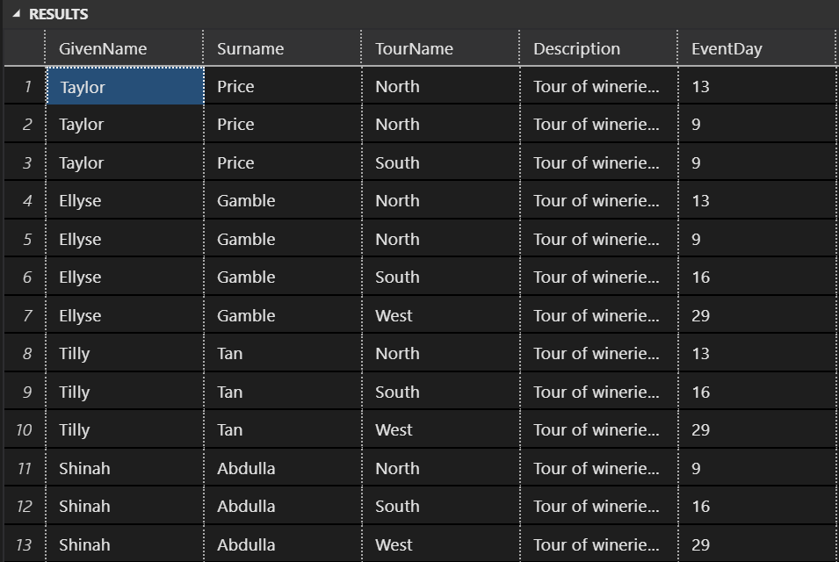

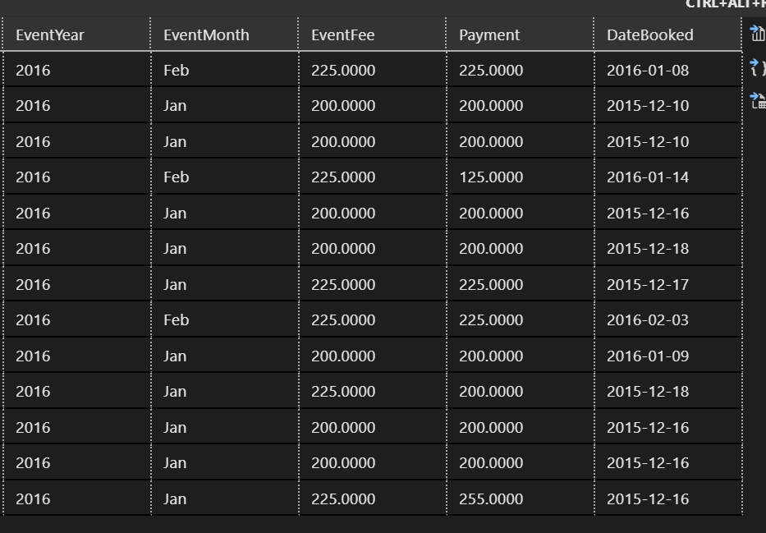

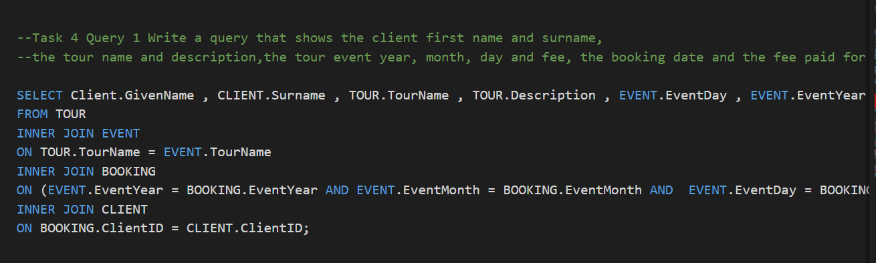

Query 2

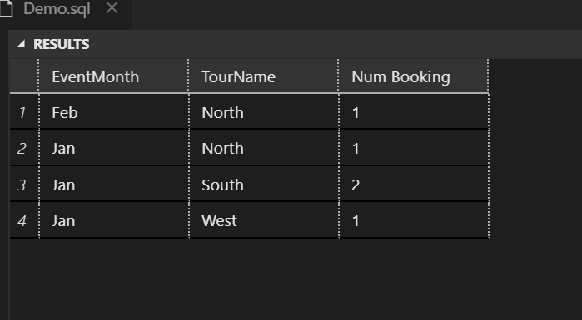

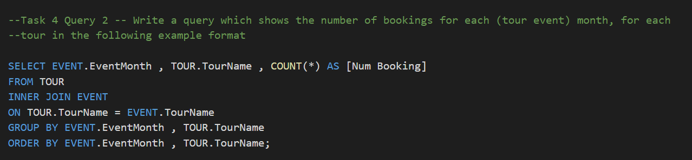

Query 3

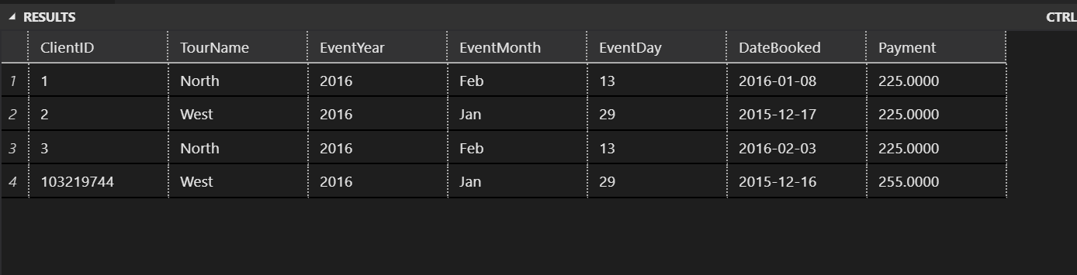

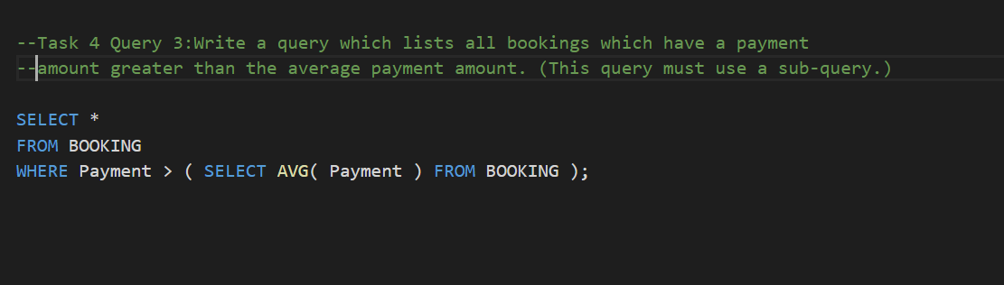

# Task 5 Screenshot

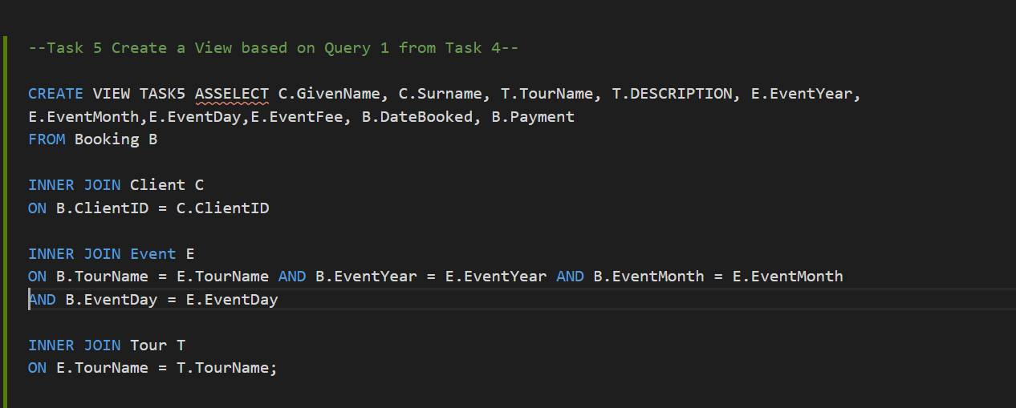

# Task 6 Screenshot

Test 1

​

-- Return same 13 rows of data as per the orginal query task 4 - Query 1

SELECT *

FROM Booking;

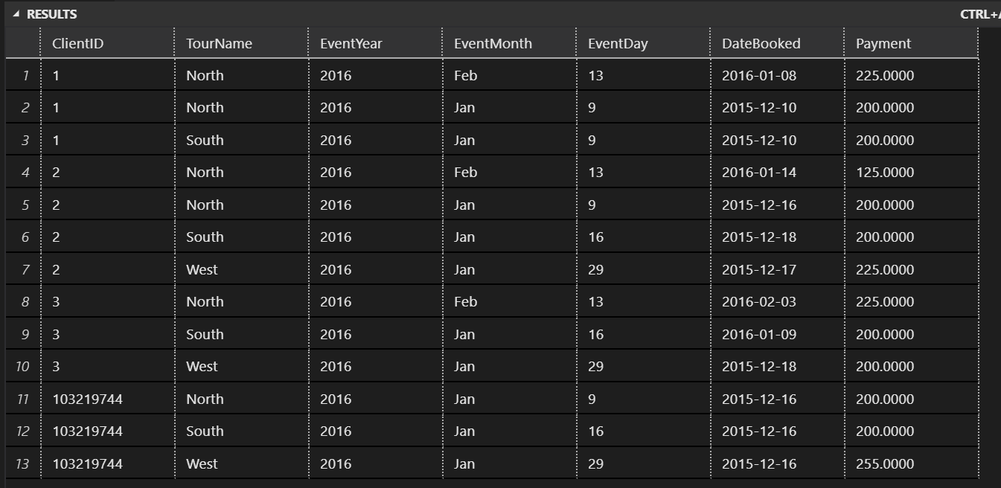

Test 2

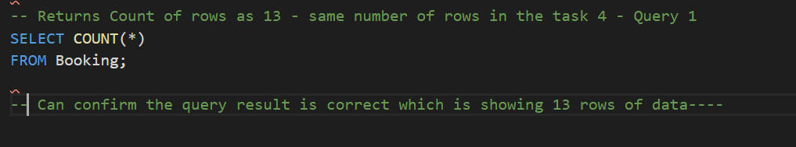

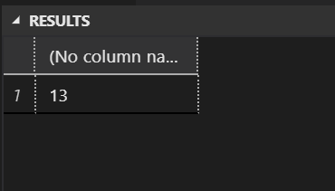

Test 3

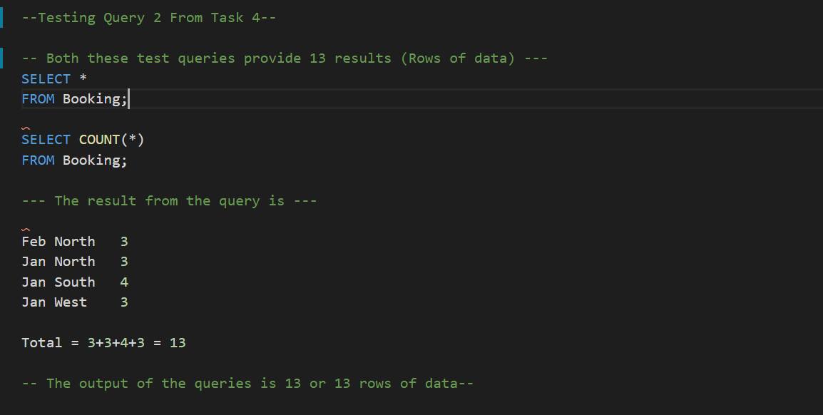

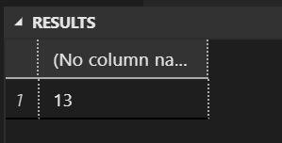



Test 4

