1.修改文件week19/week19code-CVPR19-Face-Anti-spoofing/process/data_helper.py中关于数据地址的变量：DATA_ROOT,TRN_IMGS_DIR,TST_IMGS_DIR等。week19/week19code-CVPR19-Face-Anti-spoofing/process/data_helper.py 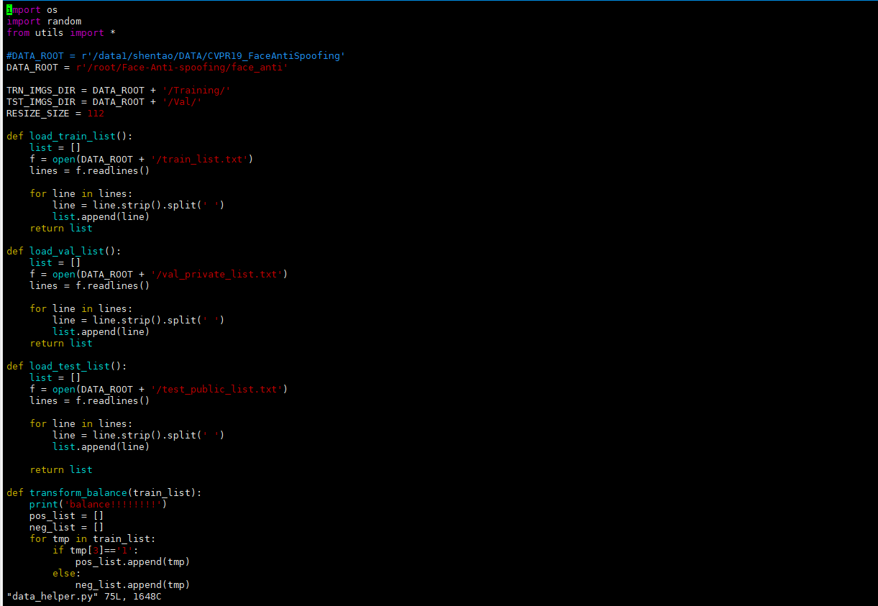

修改完成后，运行命令：python data_fusion.py 可检查数据设置是否正确!

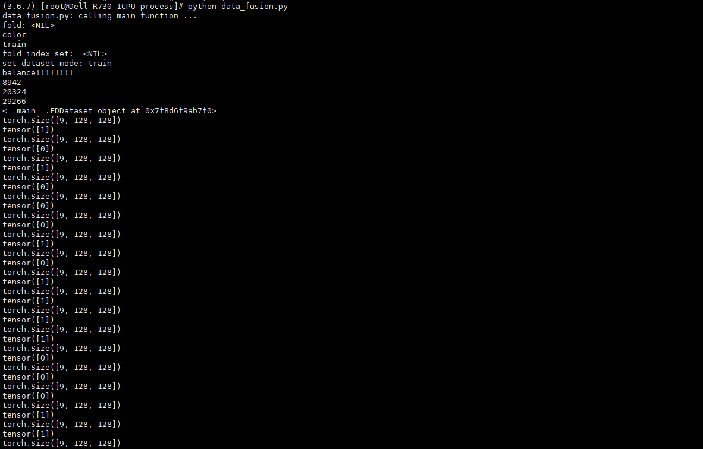

数据设置正确后，运行训练命令：CUDA_VISIBLE_DEVICES=0 python train_CyclicLR.py --model=model_A --image_mode=color --image_size=48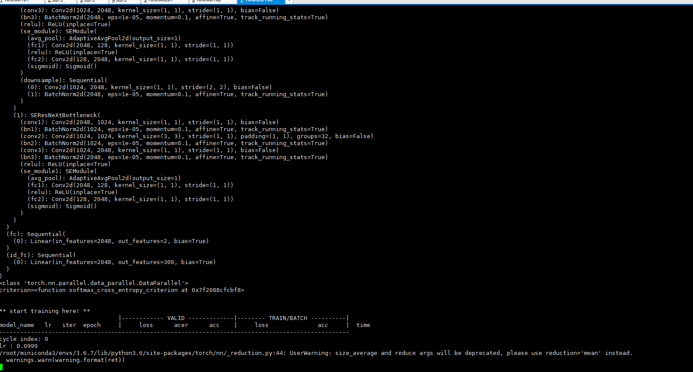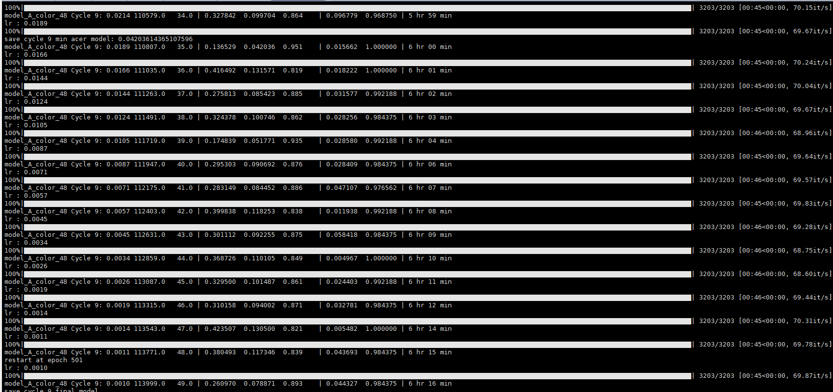

把week18_answer中的model_baseline_Fusion.py 放在week19/week19code-CVRP19-Face-Anti-spoofing/model_fusion里，然后修改train_Fusion_CyclicLR.py相关代码，并训练，得到resnet_18版本的FaceBagNet的acer

